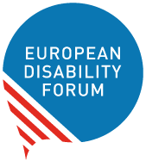

Improving Disability Assessment Procedures in the EU
  - European Disability Forum Position Paper
  - By Haydn Hammersley | September 2021

This publication has received financial support from the European Union. The information contained in this publication does not necessarily reflect the official position of the European Commission.

Table of Contents
Contents
Table of Contents 2
Introduction 3
Executive Summary 3
Making Disability Assessment Compliant with the CRPD 3
Which methods are typically used? 5
What are some of the main problems people encounter when being assessed for their disability? 8
Long waiting times and undignified processes 8
Poor diagnosis and assessment of hidden disabilities 9
Late or no assessment for women with disabilities, and lack of awareness 9
Insufficient levels of support after assessment 10
Disability Assessment fragmentation and EU freedom of movement 10
EDF policy recommendations 12
At national level 12
At EU level 13
Document credits 14

Introduction

The European Disability Forum
The European Disability Forum is an independent NGO that represents the interests of 100 million Europeans with disabilities. EDF is a unique platform which brings together representative organisations of persons with disabilities from across Europe. EDF is run by persons with disabilities and their families. We are a strong, united voice of persons with disabilities in Europe.

Executive Summary
The methods for assessing disability, granting disability allowance and providing social protection to citizens with disabilities vary substantially from one Member State to another. Some disability assessment models focus exclusively on a medical or functional model of disability without consideration of environmental or social barriers. Regardless of the system used, to some extent persons with disabilities in all Member States encounter challenges when it comes to being assessed for their disability and getting the right level of support. Furthermore, the variance of assessment systems prevents recognition of one’s disability when a person moves from one country to another.
EDF advocates for the implementation of the United Nations Convention on the Rights of Persons with Disabilities (CRPD), but how exactly would existing disability assessment methods need to change to be CRPD-compliant? In this document we will explore this question while highlighting some of the main problems we see with the systems currently used in EU Member States. We will also present some personal testimonies of how these shortcomings affect persons with disabilities personally. We will conclude by delivering policy recommendations for both the national and EU level on how to improve disability assessment.

Making Disability Assessment Compliant with the CRPD
The approach to disability assessment is addressed in the CRPD during Article 26 on Habilitation and Rehabilitation. General Comment 5 on Article 19 then delves much further into what disability assessment should look like from the perspective of the CRPD.

On the basis of Article 26 and General Comment 5, we can deduce that disability assessment should be designed in the following way in order to be CRPD-compliant:

- Assessment should focus on the requirements of the person linked to barriers within society, rather than solely on their impairment;
- Support for persons with disabilities should be assessed, through a personalised approach, and tailored to the specific activities and actual barriers that persons with disabilities face in being included in the community;
- The assessment should acknowledge that persons with disabilities require access to participate in activities that vary over time, and thus be flexible to reassessment when it is felt more support is needed;
- The process should be multidisciplinary;
- Assessment should include face-to-face assessment that fully involves the person with disabilities;
- Assessment should take into account, and follow a person’s will and preferences, and ensure the full involvement of persons with disabilities in the decision‐making process.

We can also understand more about how the CRPD and its general comments foresee disability assessment through the CRPD review of various EU Member States

- For Sweden, the CRPD Committee concluded that it was concerned about families with disabilities being subjected to additional investigations, carried out by local authorities and social services in the framework of the national adoption system, to assess their parenting ability. This echoes concerns from persons with disabilities about overly strenuous assessment processes and an approach of constant suspicion from the side of the authorities. In the case of Sweden this has extended beyond assessments to be entitled for disability allowance and services, and into assessing their eligibility to exercise adoption rights. We can conclude that the CRPD Committee sees the need for authorities not to overburden persons with disabilities with constant and overly-strenuous assessments.
- The Committee recommended to Croatia that benefits aiming at alleviating increased costs arising from disability should be based on an assessment of the individual’s support needs, and should disregard any financial assets test. Here we can conclude that the Committee rejects the lowering of disability allowance for persons with disabilities who happen to have other financial assets.
- For Czechia, the Committee called for amendments to the definitions of disability and persons with disabilities in its legislation and to make explicit reference to the barriers faced by persons with disabilities in the above‐mentioned definitions, in order to harmonise them with the definitions in the Convention.
- Regarding Portugal, the Committee recommended a review of the assessment criteria to determine the degree of disability of the individual to bring them into line with the Convention, and to adopt suitable regulations in its legislation and policies. The Committee also recommended that Portugal ensures that all persons with disabilities are able to secure their disability certificate, and that access to social protection programmes and aid is available to all persons with disabilities. Here the Committee therefore underlines the problem of persons with disabilities not being able to get the assessment they need or, even once being assessed, not having access to adequate support.
- The Committee recommended that Slovakia adopt a human rights‐based definition of disability in the regulations relating to the assessment of disability. This suggests that the Committee would like States Parties to adopt a definition of disability in line with the description agreed in the Convention, which is the following: “Persons with disabilities include those who have long-term physical, mental, intellectual or sensory impairments which in interaction with various barriers may hinder their full and effective participation in society on an equal basis with others.”

Which methods are typically used?

To give some perspective as to where EU Member States currently are regarding how closely they meet the CRPD’s requirement for a holistic approach that also takes into account additional costs posed by disability-related barriers, here we look at the methods typically used in Europe, and see which method prevails in which Member State.
The methods typically used to assess disability are the following:
Medical approach: Involves procedures relying on medical assessment and does not take account of the situation of person being assessed and the barriers they face in their life.
The Barema method: A list or table, divided into chapters covering physical or mental components of the body. It gives guidance on medical benchmarks against which assessments should be made for each of these components. On this basis, a “percentage of disability” is declared. For example, the loss of an eye might account for 40% disability and the amputation of a foot for 30% disability. The overall “percentage of disability” will be the impairment ratings for all different parts of the body combined.
Functional capacity assessment: Seeks to establish functional limitations. It involves identifying the abilities and inabilities of an individual. The assessment may involve standardised tests which measure performance and the ability of an individual to perform certain activities.
Holistic approach: A holistic assessment combines assessments related to impairment, functional capacity and environmental factors, which more closely aligns with the CRPD and will aid in its successful implementation.

Several countries leave their assessments entirely up to medical professionals or officers of the municipality or State, who often do not have an understanding of what a human-rights based model of disability entails. Assessments that only consider a medical condition or a percentage of “incapacity” do not consider the lived experience of the person with a disability or the barriers they encounter on a daily basis.

Below is a map of the EU and the UK showing which methods are used in each country:

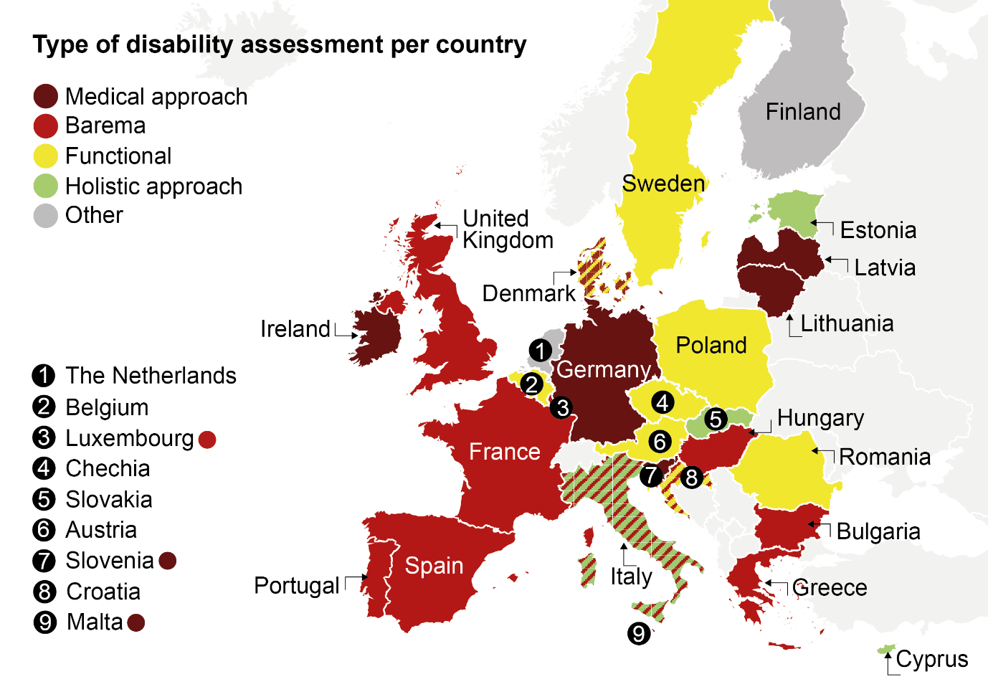
Alt text: Medical model used in Ireland, Germany, Latvia, Lithuania, Slovenia and Malta. Barema model used in the United Kingdom, France, Spain, Portugal, Luxembourg, Hungary, Bulgaria and Greece. Functional model used in Belgium, Sweden, Poland, Czechia, Austria and Romania. Holistic model used in Cyprus, Estonia and Slovakia. Italy uses a mixture of Barema and the holistic approach. Denmark and Croatia use a mixture of Barema and the functional model. Finland and the Netherlands are listed as “other”.
21 countries are described as having systems of assessment that include either some form of self-assessment by the person with a disability applying, or a face-to-face evaluation with the assessor, fulfilling at least one of the criteria underlined in the General Comment 5.

Below is a map highlighting the countries in the EU and the UK where this is the case:

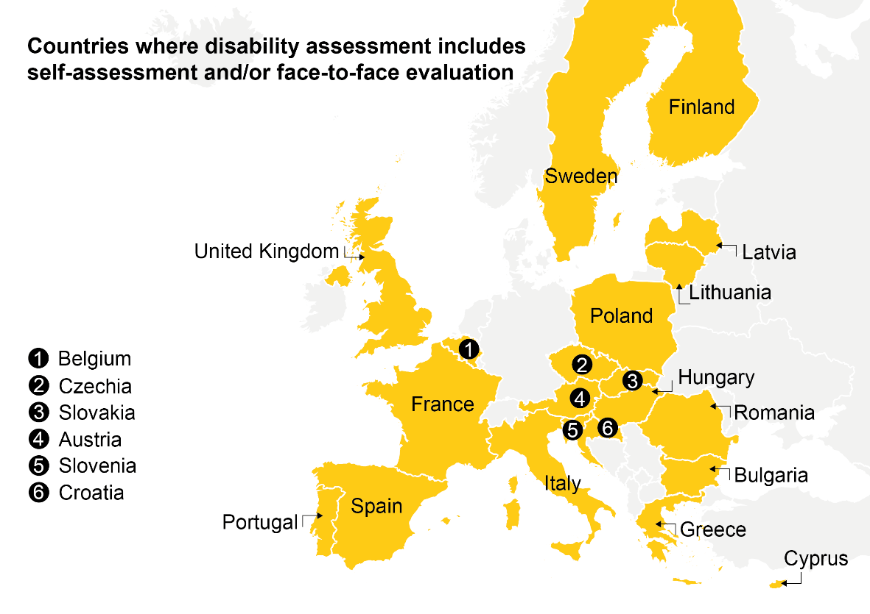

Alt text: The countries where disability assessment includes self-assessment and/or face-to-face evaluation are Belgium, Czechia, Slovakia, Austria, Slovenia, Croatia, France, Spain, Portugal, Sweden, Poland, Italy, Finland, Latvia, Lithuania, Hungary, Romania, Bulgaria, Greece, Cyprus and the United Kingdom.

What are some of the main problems people encounter when being assessed for their disability?
The challenges associated with disability assessment are numerous. To begin with, the process can be lengthy and arduous and, in some cases, undignified. The methods used can also be restrictive and fail to consider the true barriers people face in their daily lives as persons with disabilities. An assessment that does not truly consider the societal barriers the person with disabilities faces, combined with what are often restrictive social protection budgets foreseen for persons with disabilities, result in many persons with disabilities not getting the support they need after being assessed as disabled.
We also see particular difficulties for persons with “hidden” or “invisible” disabilities who can be misdiagnosed on not diagnosed at all, meaning they lose all entitlement to the support and services they require. Women are also more likely than men to have a disability or a condition misdiagnosed or left undiagnosed.
Here we will share a few personal testimonies that explain these issues in more detail:

Long waiting times and undignified processes
Testimony by Koen from Belgium who has a spinal injury
The process of applying for and being accepted for a “personal assistance budget” was long. It took two years. It was also undignified having to give many strangers from a multidisciplinary team (MDT) in-depth details about my personal life, from my financial situation to my personal healthcare. During rehabilitation, I would deliberately avoid MDT meetings because of the undignified manner in which the meetings were conducted, with five or six people around the table talking about every aspect of my life. I particularly remember, as a 27-year-old previously extremely active young person, sitting listening to a social worker telling other MDT members something to the effect of "this is great, he will have three hours per week for excursions". That sentence filled me with dread about what the rest of my life would be like. Even now, years later, these MDT systems have not improved much. Even now, when I have the freedom of this budget, there is always the underlying worry that political changes may mean it is taken away. Without this budget, it would not be long before I was financially unable to live independently and would probably have to consider living in an institution.

Testimony by Gerrit from the Netherlands
It happens regularly that you have to be re-examined by a medical examiner to see whether you are eligible for an adjustment [to make your home accessible]. All in all, it takes months and months before an adjustment is made. […] My car also had to have a special seat, but again I first had to be inspected once more to see whether I would qualify for that.
The government distrusts you as a disabled person and that is why you have to account for everything - down to the minute. But you also have to prove every time that you are still (or more) disabled.
The bureaucratic process is long and arduous. It regularly happens that the municipality does not comply with the statutory term of a maximum of 8 weeks in which the primary investigation and a formal decision must take place. There are waiting times of months and months because dozens of other people have already applied before you and this slows down the process considerably. The municipality asks you to comply with the rules exactly, but it does not comply with the legal rules itself. But you can't file a complaint anywhere, only with the same department that handles the application.

Poor diagnosis and assessment of hidden disabilities
Testimony by Stephane from France, who has Asperger’s Syndrome
Having had an illness since childhood, the doctors preferred to say that I had depressive cycles before being recognised in adulthood as having Asperger's syndrome. The teaching methods at university and high school were not designed for me who had, among other things, a problem of comprehension and slowness of writing.

Late or no assessment for women with disabilities, and lack of awareness
Testimony by Petra from Croatia, who is a Deafblind person
I have had double vision and hearing impairments since birth and cannot fully rely on vision as a person with a hearing impairment, nor can I rely solely on hearing as a person with a visual impairment. While my visual impairment (high myopia) has been known from an early age, my hearing impairment was only recognised when enrolling in primary school. My parents suspected earlier that I was not hearing well and took me for an assessment, but in my case the system of early recognition and professional support failed. The same system only recognised this at the age of 6, when I was actively involved in hearing and speech rehabilitation, which was intensive throughout primary and secondary school.
I faced new challenges when looking for a job. Ignorance of deafblindness often confused employers. During the job interview, I was asked various questions, such as whether I could walk. These were hard times re-proving to everyone who I am and what I can do, despite my disability.

Insufficient levels of support after assessment
Testimony by Marco from Italy who is quadriplegic
My economic condition is based on an old-age pension matured through twenty years of work in the public administration, an accompanying allowance and a contribution for independent life paid by the Municipality which, unfortunately, over the years has been progressively reduced in resources. Currently this economic contribution is not sufficient to support the expenses for my assistance and, therefore, I must integrate my own resources. The major problems that we encounter in our territory in this period concerning independent living are linked to the progressive impoverishment from an economic point of view, but also from an ideological point of view and the values that underlie independent living as an individual, responsible and self-managed choice. More and more frequently, in fact, the bodies in charge prefer to adopt welfare strategies rather than facilitate self-determination paths.

Disability Assessment fragmentation and EU freedom of movement
Fragmentation of disability assessment systems has led to a fractured understanding of what disability is and who qualifies for social protection and benefits. The EU provides citizens with opportunities for mobility in countries other than their own. Today, 17 million EU citizens live and work abroad in another EU country. This mobility, however, is extremely limited for persons with disabilities.

The inconsistent types of assessment, qualifications for benefits and administrative processes inherently deprive persons with disabilities of their right enshrined in the EU treaties to freedom of movement (Article 3(2) of the Treaty on European Union (TEU) and Articles 20, 26 and 45-48 of the Treaty on the Functioning of the European Union (TFEU).
While the CRPD provides a description of what constitutes a disability, the assessments of disability are not always in-line with this. A person may qualify as “disabled” in one country but not in another.
There is great variance for the process to be registered as disabled and then to begin receiving social support. There are different types of qualifying criteria, assessment methods, assessors and supporting evidence required.
This makes navigating the process and system difficult in one’s home country and even more difficult abroad. If a person with a disability were to move to a new country, it would be difficult for them to register again as disabled and to receive their social protection, meaning they may experience time with no social protection at all, often unable to keep their protection from their last country of residence.

Testimony by Isabelle, a French citizen living in Slovenia. Isabelle has difficulties walking and other complications due to Multiple Sclerosis
Following tremendous difficulties, France accepted to issue me with a disability card in 2018 but it is not recognised in Slovenia! On its side, France acknowledges my status as a disabled worker but without any financial assistance as a French citizen living abroad. In conclusion, my husband who assists me strongly in my daily life and myself are totally deprived of any help and financial support.

While a fully-harmonised and transparent system of disability assessment across the EU would be beneficial, this is a long-term goal. In the short and medium term, the problem could be alleviated by the introduction of a system of mutual recognition of the different national systems for persons that are travelling or staying temporarily in another Member State. Tourists, students and young persons on exchange programmes, or interns, could benefit from this system.
This system could be connected to the European Disability Card, a project scheme which has already been rolled out in eight Member States and could potentially be widened to the entire EU. While the Disability Card at the moment is still limited to non-essential discounts in culture, leisure, sports, and sometimes transport, this could be a good start to associate the Card to the recognition of the disability “status” one receives in his Member State of residence.

EDF policy recommendations

At national level

Reform how disability assessment is conducted:
- Adopt a holistic method for disability assessment that looks at a combination of impairment and functional considerations while also having a focus on the person’s support requirements and societal barriers.
- Provide opportunities for persons with disabilities to be part of their own assessment process. It should allow them to offer their insights and evaluations of their disability and their support needs. This could be done through a face-to-face meeting with the assessor or via a self-assessment that they complete.
- Improve the understanding of “hidden” or “invisible” disabilities, as well as rare conditions, of all professionals who are part of the disability assessment process to avoid misdiagnosis or absence of diagnosis. Professionals should also be better trained into the way different conditions and disabilities manifest themselves in women, who have a greater tendency to be misdiagnosed.
- Focus on reducing waiting times for people awaiting disability assessment and reduce excessive demands for reassessment. Continued assessment should be done in a reasonable and measured way and only when justified so as not to place the person with disability under unnecessary stress.
- Involve persons with disabilities and their representative organisations in developing and changing the systems and processes of disability assessment.

Reform the way support is offered following disability assessment:
- Invest in providing disability allowance that is sufficient for persons with disabilities to live in a safe and dignified way and avoid falling below the poverty line.
- Investment should go not only to persons with disabilities directly, but also to strengthening accessible services that they can use. These might in some cases be disability-specific services used only by persons with disabilities, and in other cases be general public services that need further investment to be accessible to everyone (including public transport services).
- Facilitate entry to work by offering person-centred and flexible support to persons with disabilities to enable them to take up work. Persons with disabilities should not lose their entitlement to future disability allocations if they have been in work. When in employment, persons should be permitted to continue receiving disability allowances needed to compensate extra disability-related costs.
- Do not push persons with disability into employment by reducing disability allowance, using so-called “incentives to work”.
- Ensure that public funds are available to contribute to covering disability-related costs.

At EU level

Facilitate the freedom of movement of persons with disabilities and the portability of services in the EU:
- Foster an agreement for mutual recognition of disability assessment in all Member States and make use of the EU Disability Card as the accepted format for proving disability assessment when in another EU country.
- Adopt the EU Disability Card in all Member States.
- Create an accessible and centralised online information platform giving persons with disabilities information on the services to contact when moving to different Member States in order to receive the support they are entitled to.

Document credits
This document was prepared by Haydn Hammersley
Assisted/Supervised by the EDF Social Policy and Inclusion Committee and the EDF Youth Committee
The European Disability Forum
Mundo Madou
Avenue des Arts 7-8
1210 Brussels, Belgium.
www.edf-feph.org
info@edf-feph.org
This publication has received financial support from the European Union. The information contained in this publication does not necessarily reflect the official position of the European Commission.

Examples given from the English Barema system: Available at https://rm.coe.int/16805a2a27
https://handicap.belgium.be/fr/reconnaissance-handicap/evaluation-handicap.htm
Finland uses a system of assessment of need (e.g. for help / support)
The Netherlands uses a mixture of assessment of economic loss (e.g. loss of income related to disability) and assessment of need.
Upon their request the person’s real name has not been used
Testimony translated from Dutch by EDF. The person has chosen not to disclose the nature of their disability
Upon their request the person’s real name has not been used
Available at: https://europa.eu/euandme/passion/work-and-live-abroad_en
Available at : https://eur-lex.europa.eu/legal-content/EN/TXT/?uri=celex%3A12012M%2FTXT
Available at: https://eur-lex.europa.eu/legal-content/EN/TXT/?uri=celex:12012E/TXT

