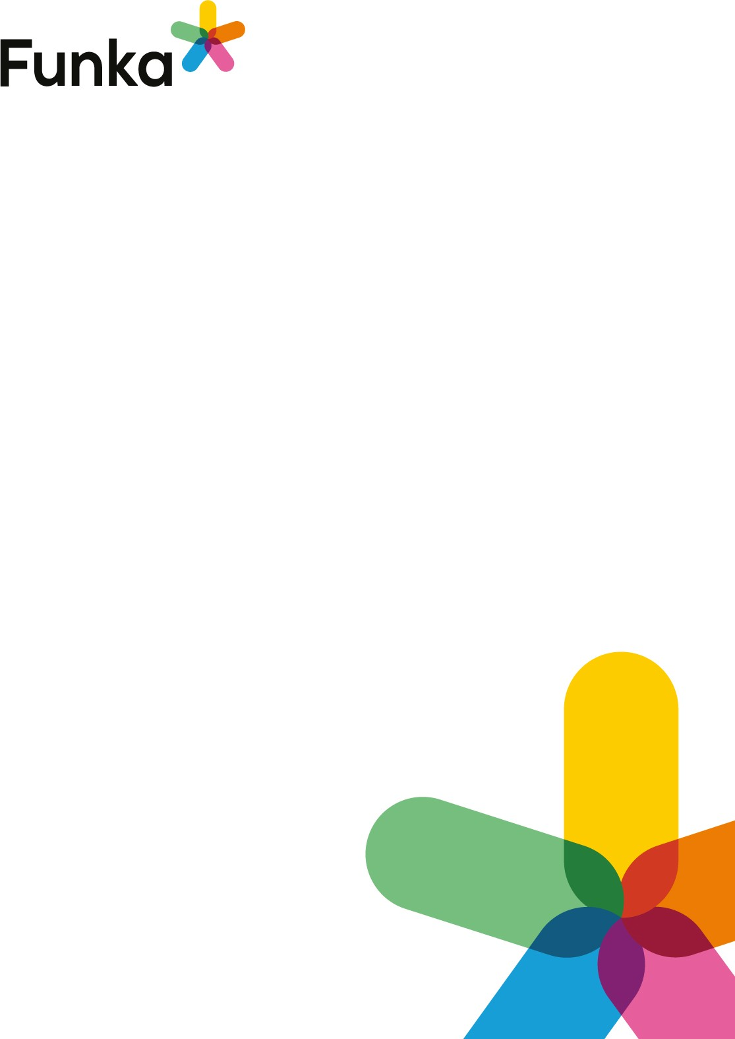

futureu.europa.eu
Accessibility audit
August 2021
Facts about the audit
Client:
European Disability Forum (EDF)
Catherine Naughton
Audit performed by:
Line Pehrson-Papadopoulou and Per Edwall
Our reference:
Susanna Laurin, susanna.laurin@funka.com
Website: futureu.europa.eu
URL:
https://www.futureu.europa.eu/
Non-audited content: PDF-documents and third-party solutions
Time of audit: 2021.07.26 - 2021.08.05
Equipment used:
- Windows 10
- MacOS
- iPhone 12 Pro
- Samsung S8
Browsers and versions used:
- Google Chrome (latest)
- Firefox (latest)
- Safari for iOS (latest)
- Chrome for Android (latest)
Background
Funka has performed an audit to test the status of compliance with the Web Accessibility Directive.
Each success criteria is scored as follows:
- No errors found. The interface adequately meets the requirement.
This may mean that the solution is very good, or acceptable. There may be room for improvement.
- No errors found but can be improved. Either the interface has a few problems in need of fixing (not a consistent error, more a result of carelessness or misunderstandings), or the interface has problems in parts that are beyond the scope of the audit, or problems that for one reason or another need to be discussed with the client.
- Fail. The interface has consistent, clear accessibility issues that need to be rectified.
- Not applicable. The interface does not contain the kind of solution the requirement applies to, or the requirement has not been scored for one reason or another.
Funka's methodology is developed in close collaboration with the disability movement and everything we recommend has been tested in a real-world setting. Our operation is based on the EN301549 and the international guidelines for accessibility, Web Content Accessibility Guidelines, WCAG 2.1.

Funka has, in our role as a Lead Translation Organisation, was asked by the W3C to carry out the authorised translation of WCAG 2.0 to Swedish. We are also in charge of the translation of WCAG 2.1.
Funka's specialists have been involved in the efforts to create the EN301549 standard on behalf of the European Commission since 2008. We are appointed experts in the ETSI Special Task Force in assigned to develop the EN standard. We are also technical experts in the Swedish Standards Institute's committee representing Sweden in the European standardisation efforts. During the transposition of the Web Accessibility Directive, we provided subject matter expert support to the European Commission as well as several Member States in the development of the official monitoring methodology and accessibility statement of the directive.
Audit summary
There are accessibility issues on the website that need to be addressed. Some of these issues are less common and others appear more consistently on the website. The problems we have found mainly affect users of assistive technology.
It is not possible to control the interface using keyboard navigation only, which may have a severe impact on users with motor impairments as well as screen reader users. The focus indicator is sometimes not distinctly displayed and sometimes invisible - on many objects. This problem makes keyboard navigation very difficult.
When it comes to forms, there are problems with labels, error messages, and elements not being used properly. Some error messages are only conveyed with colour which affects users who have difficulty perceiving colours.
There is a slight overuse of WAI-ARIA on some attributes. For example, role=menu is used for links to the pages for personal settings. Using roles in this way is not strictly incorrect, however, for screen reader users it becomes very repetitive. On the start page, the aria-live attribute is used on the image carousel. That attribute informs the screen reader user every time the image changes. That means that every five seconds, "Space Make your voice heard" is heard. Use wai-aria only where it is beneficial for the users, and always test it.

Prioritised measures
- All interactive objects should be controllable with a keyboard and have a clear visual focus indicator.
- Code forms with correct form elements and connect the labels with their corresponding form object. Describe all errors with text and tie the error messages to their respective form field.
- Ensure good contrasts for both text and clickable objects.
- Upload only accessible pdf-documents.
- Use wai-aria where it benefits users and test it.
- Turn off aria-live from the image carousel on the start page.
Comments and recommendations

General


Pages and functions are described consistently in links, references and headings

Background
An important aspect that needs to be considered for users to experience the pages in a simple and clear manner is that the website is consistent in how different functions, links and areas are described. It creates uncertainty for users if the website uses "E-services" on one page, but calls the same services "Self-service" on other pages.

Comment
In the main menu, there are links to some pages where three out of six go to a page where the main heading is "About the Conference". This can be confusing, as heading level one is also usually the name of the page.

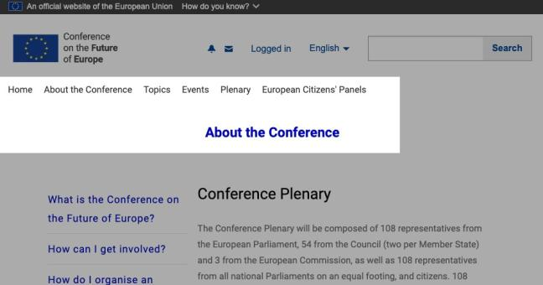
In general, the website has consistently named pages. However, on the “Login” page, the menu disappears. The user arrives at a page called "Sign in" and it looks like a completely different page. This can create confusion, especially for users with cognitive impairments.

Fail
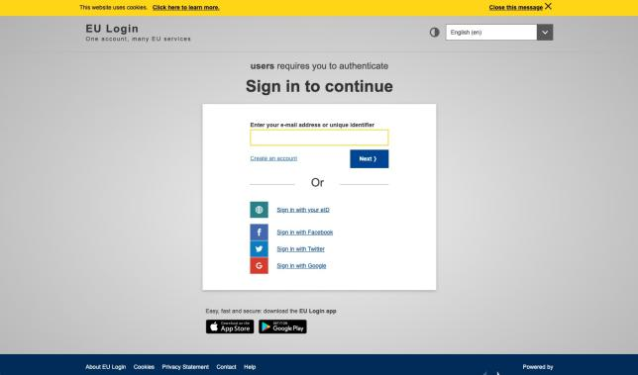

Page references:
Login Panels

Recommendation
- Be consistent on how the pages and links are named.

Links to guidelines
EN 301 549 - 9.3.2.4
WCAG 2.1 - 3.2.4 (AA)
WCAG 2.0 - 3.2.4 (AA)

Html & css


Use technologies that can be used in an accessible manner

Background
There are numerous different technologies that can be used to convey information and services. These include html, css, java, Flash, Silverlight and pdf. Some of these work better than others from an accessibility perspective. Which technologies should be used also varies over time. For several years, Flash worked well for instance, but currently, support for Flash is not sufficiently widespread for the technology to continue to be used.
We recommend that information and functions that are to be communicated on a website should primarily be created using html, css, WAI-ARIA and JavaScript. These are technologies that can be used in a fully accessible way and where support for browsers and tools is well developed.
Do not use Java applets, Flash or Silverlight. These are technologies for which certain accessibility functions are available, but they create difficulties for users in practice. There may be a specific need to use one of these technologies on the odd occasion, but only in a special context where there is no alternative and where you have full control over users and their equipment.

Which browsers and assistive technology should the website work with?
The basic principle is to leverage the advantages of more recent technologies to increase the user benefit. Having said that, many users avoid updating their operating system, browser and assistive technologies. Exactly what the system should support varies from case to case. However, starting from the premise that there are users that still have older equipment, it is recommended to support older versions of browsers and assistive technologies if reasonably possible. This does not mean something has to work perfectly in older versions, but simply that, wherever possible, the interface should continue to be manageable even with older versions.

Comment
The test is approved as the website uses technologies such as HTML, CSS, Javascript, and WAI-ARIA, which can be

No errors found
implemented in an accessible manner.

Links to guidelines
EN 301 549 - 9.4.1.1
WCAG 2.0 - 4.1.1 (A)
WCAG 2.1 - 4.1.1 (A)

Technologies are used in an accessible manner

Background
It is not enough to choose a technology that is accessible, you also need to use the technology in the correct manner. For example, using real html-elements consistently, ensuring script-based functions work with assistive technologies and that the use of wai-aria does not create problems for those who use assistive technologies.

Html
Most html-elements have a semantic meaning, including everything from control functions that define areas of navigation and content to more specific things like links and headings. Use only elements that add value to the users, while avoiding elements that are worthless.
Many elements that are valuable to users are so important, or can create problems, that they have their own sections in the audit. Other elements, however, are built into most authoring tools. These include, for example, coding links with <a>-element.
The basic rule is simple, keep it simple, use elements for what they are intended and try to keep the structure as simple as possible.

Script
Script imposes greater demands on assistive technologies compared to only using html and CSS. This means that the risk of problems is increased. We therefore recommend that all complex functions be tested using the most widely used tools to ensure no unnecessary difficulties arise.
Examples of common problems include users with assistive technology not being able to focus on layers that are opened dynamically or cannot access search suggestions in the
Fail

search function. This is because new layers and new information are often read out in the order of the page structure and in connection to the object on which the user is focusing.
Another common problem is that clickable areas are created with script instead of using links and buttons. The assistive technology does not perceive these as genuine links/buttons and therefore does not present them as interactive objects.

WAI-ARIA
WAI-ARIA is a specification of code that enables you to provide assistive technology users with information about the website. For instance, with WAI-ARIA you can mark-up dynamic content that makes it easier for assistive technology to manage and present the information to users.
We recommend using WAI-ARIA, but this needs to be done with caution. Do not use WAI-ARIA to rescue poor html. For example, it is not a good idea to use role="button" in a div element instead of using a proper button. Nor should you use WAI-ARIA without checking how it works for users. One common problem is inserting all the WAI-ARIA you can think of with the consequence that the information for assistive technology becomes unnecessarily repetitive.
Support for WAI-ARIA varies between the different versions of tools and browsers. This means that for the time being, we recommend testing all dynamic solutions in practice with different tools, devices and versions.
Information about WAI-ARIA (W3C website).

Test with assistive technology
To be certain that script does not cause problems for assistive technology users, you need to test this in practice. Exactly which assistive technolgies ought to be tested will vary depending on the
solution. It is not simply a matter of sitting down with a tool and going through the service. You need knowledge on how users operate, how they use their tools, what it feels like if you are e.g. visually impaired etc. As a developer for example, it is incredibly difficult to test a solution objectively as you have prior knowledge that the users lack.
We therefore recommend that you commission users to do the testing.

Comment
There are problems navigating with the keyboard on the website because there are elements that are not useable, and the focus target is not visible. Buttons should be coded as buttons and not as labels or span elements, read more about this under NL20. If clickable objects cannot be used with the keyboard, some users will not be able to navigate on your website. Therefore, you should also avoid functionality that requires the user to hover over different objects to reach certain information.
There is a lot of wai-aria on the website, sometimes in a good way, but sometimes it seems a bit much. If wai-aria is make sure it is is useful for and test the page with a screen reader to confirm that it helps the user. There is one example where aria-expanded is used in the opposite way. This can be confusing for the user. Read more about this under SW100.

Recommendation
- Use HTML5 and WAI-ARIA in the ways they are intended to be used.
- Follow our other recommendations in the checkpoints below.

Links to guidelines
WCAG 2.0 - 4.1.1 (A)
WCAG 2.1 - 4.1.1 (A)
WCAG 2.0 - 4.1.2 (A)
WCAG 2.1 - 4.1.2 (A)
EN 301 549 - 9.4.1.1
EN 301 549 - 9.4.1.2

The HTML code does not contain critical errors

Background
There are a few different html standards, such as html5 and xhtml 1.0 strict. Each standard has its rules covering which elements and attributes can be used and in what way. When you code in html you need to first decide which standard the code should be based on. We recommend that you start by considering html5 as this has various attributes and elements that increase accessibility compared to older standards. However, this is based on adopting caution when using html5. For example, there are problems with several attributes and elements. For example, not all browsers include support and there is no homogeneous support for different aids.
One important principle is also to make the code more efficient, for instance in breaking out of scripts and style templates into individual files and to make the structuring and formatting more efficient.

!DOCTYPE
For browsers, assistive technologies and other tools to be able to interpret the code correctly, they need to know which standard the page in question is coded in. This must therefore be the very first thing declared in the code on all html pages on the website via an !DOCTYPE declaration.
The !DOCTYPE is declared as follows in html5:
Fail

<!DOCTYPE html>
If you choose to follow xhtml rather than html5, the declaration should also include reference to the rules for the standard. A declaration of xhtml 1.0 transitional looks like this:

<!DOCTYPE html PUBLIC "-//W3C//DTD XHTML 1.0
Transitional//EN" "http://www.w3.org/TR/xhtml1/DTD/xhtml1- transitional.dtd">
The DTD file defines exactly which elements, attributes and different values are permitted according to the standard.

HTML5
If you decide to go with html5, we advise caution as support for different elements of the standard varies between browsers and tools. Add in new elements in the html5 standard when it increases user benefit and does not make things more difficult for users.
Currently, you should avoid the html elements section and articles unless there are specific reasons to use these elements. This is because they create a structure that can affect the heading structure of pages. Different tools interpret this in different ways which means users that depend on the tools to understand the page structure (e.g., users with severe visual impairment) can get different heading structures depending on which version of the tool they have.
Also, bear in mind backwards compatibility. If a slightly older browser does not support html5 technology, there should be a fall-back solution. Read more about this in T1a above.

Adhere to chosen standard
It is not sufficient with !DOCTYPE to declare the standard. The website needs to adhere to the standard that is stated in the code. The standard has been developed in such a way that all developers of websites, browsers and tools should have a common source to consult in order to ensure that the content in the website is presented in an optimal way for the visitor.
If the website does not follow the standard, there is a risk the user will have problems accessing some of the content. If the problems become too great, you risk excluding a whole group of users.
There are quite a few validation tools to check website code. W3C has its own html validator that can be accessed at the address http://validator.w3.org/.
All deviations from the chosen standard will not result in the same significant accessibility problems. Some deviations are more serious than others, but the basic rule is that all code should follow the accepted standards in full.

The following must always be correct:
- Use complete start and end tags.
- Do not specify the same ID value for two different elements on the same page.
- Do not specify the same attribute twice in the same element (e.g., two alt- attributes in the same img-element).
- Nest the elements according to the standard.
Regarding the other types of errors, these should be avoided. However, if you do use an attribute that doesn’t really belong in the standard or, in exceptional cases, use your own elements, this will usually not cause a problem for the user. Although this does need to be tested in each individual case. For example, attributes from WAI-ARIA can result in validation errors, but this should not put you off using WAI-ARIA, provided it is done correctly.

Comment
There are critical validation errors on the website.
There are duplicate IDs on the page “Meetings”.
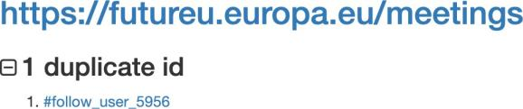

On the “idea” page, the elements are nested incorrectly. This problem occurs on other pages as well. There are:
- li element inside of div element.
- div element inside of button element.
- and div element inside of span element.
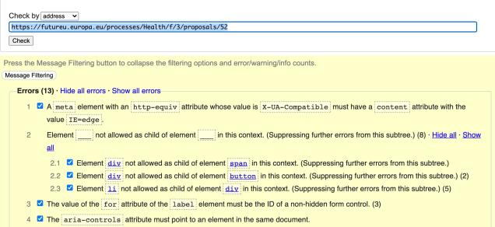

Page references
Events
Idea page

Recommendation
- Fix the critical errors regarding incorrectly nested elements and duplicate IDs.
- Avoid validation errors by following the code standard for html5 correctly.
- Validate your code and adjust errors that occur.

Links to guidelines
EN 301 549 - 9.4.1.1
WCAG 2.0 - 4.1.1 (A)
WCAG 2.1 - 4.1.1 (A)

The reading order of the content is logical Fail

Background
When layout and presentation is managed using CSS, you can position different areas visually, independently of exactly where they are placed in the html code. However, assistive technology reads the website html code from the top down which means that the order of presentation becomes the order the content in the code and not the visual order the CSS code determines. To make sense to the user, the reading order must therefore be logical and reflect the visual order.

Comment
The reading order on the web page is generally good. However, when the menu is opened with a screen reader on a small screen, it is not possible to leave the close button after activating it. In the image below, the screen reader is still focussed on the invisible button. This is shown through the text "Close menu, button" at the bottom of the image. This becomes a trap for users with assistive technology.
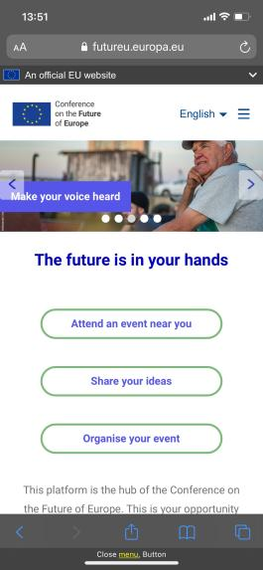

Recommendation
- Make sure the reading order is logical.
- Ensure that screen reader users do not get trapped in functions.

Links to guidelines
EN 301 549 - 9.2.8
WCAG 2.0 - 1.3.2 (A)
WCAG 2.1 - 1.3.2 (A)

Flexibility of the interface

The interface works well in different screen sizes

Background
In the case of most interfaces, it is reasonable to suppose that users will sometimes use a small, narrow screen and sometimes a wider screen. In which case, it is also reasonable to expect the interface to work well with different screen widths.
The common approach is to divide the concept into three main categories:
- Large screens, standard desktop PCs and laptops with normal size screens.
- Medium size screens, such as normal tablets or laptops with small screens.
- Small screens, such as smartphones.
There may a need to make an even finer division depending on the interface, but it is important that the interface works well across the entire spectrum from small smartphones to large desktop PCs and that it works in both portrait and landscape displays.

Important principles
Different principles and methods can be used to build responsive solutions. Line lengths and areas that adapt to the width of the display are good, but what is most important is that the interface can be used with every device from narrow screens to very wide screens and that the order of presentation is logical, regardless of screen width. This includes preventing text lines from being too short that they are unable to display whole words, or too long. Text lines should not display more than max 70 characters per line including spaces.
As soon as the menu collapses into a menu button, problems increase for the user. As such, it is important to try to keep a menu where the level is directly visible as far as possible. This means for instance, that menu level one should be visible in medium size as far as possible.
In the first instance, the interface should work whatever the screen width. However, in specific situations it can be desirable to offer an alternative, simplified interface for small displays. In this case, it is important that users are not forced to use a certain version but rather that they can choose the standard interface even on small screens. This can be resolved by providing a link to the standard

Fai
interface from the mobile version. It can also be worth providing a link to the mobile version from the standard interface even if the user is using a desktop PC. For example, some users with concentration difficulties appreciate the simplified presentation in the mobile version.

Comment
In general, the website works well on smaller screens. However, when using a smaller device, all text does not fit in their containers.
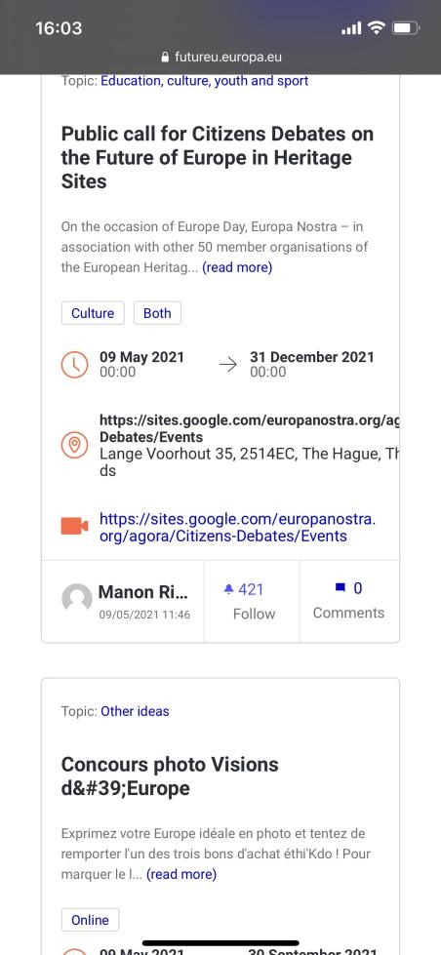
On the “ideas” page, the link texts do not have any space between them.



Recommendation
- Make sure the container and text are adaptable and not locked to a specific format.

Links to guidelines
WCAG 2.0 - 1.4.8 (AAA)
WCAG 2.1 - 1.4.8 (AAA)
WCAG 2.1 - 1.4.10 (AA)
EN 301 549 - 9.1.4.10

The interface is viewable and usable without forcing the user to scroll in more than one direction

Background
It is impossible to anticipate how a user chooses to show or use an interface. This means that the interface needs to be flexible and adapt to the screen width the user chooses to display it in. The interface should be responsive and adapt to the user’s screen width without losing content or features. If content or functionality don't fit to the user's screen, scrolling is only allowed in vertically or horizontally, not in both directions simultaneously. The interface needs to work on this premiss from 320 pixels in width or 256 pixels in height. Exceptions may sometimes be necessary for special content, for example table, charts or illustrations.

Comment
The website is possible to use with a width of 320 pixels without having to scroll in more than one direction. No errors were found.

Links to guidelines
WCAG 2.1 - 1.4.10 (AA)
EN 301 549 - 9.1.4.10
No errors found

The website is fully legible and usable when zoomed 200%

Background
Some browsers, such as Internet Explorer, offer the possibility of adapting the text size, should the texts be inserted with relative sizes (e.g. em and %). This setting has been overshadowed these days by the more widespread zoom function that magnifies everything, regardless of what dimension units the text is in.
Although websites no longer have to be built using relative dimensions, it is important that text does not become difficult to read and that functions are difficult to use if the user has changed the text size settings in the browser. If the website is designed with relative sizes, it also means this needs to be done in a way that does not distort the way the pages are displayed in the browser. One simple way of testing this is to use the Text size function in Internet Explorer. Click on the menu (if this is not displayed, click on the Alt key) and select "Display" > "Text size". Test both "Largest" and "Smallest".
Users must also be able to zoom the website up to 200% without texts overlapping each other and becoming difficult to read or functions becoming difficult to use. This does not only apply to large screens with HD resolution, but also on smaller screens and smartphones.
Bear in mind that a responsive user interface should adapt when the user zooms. In other words, even when you zoom in a responsive user interface, you should be able to access all functions and all the information. Naturally, there is a limit where too small a screen with too great a zoom will no longer work. However when the user reaches this point, they should still be able to continue to zoom, even if this can then mean having to scroll sideways to read all the text.
It is important to ensure users can also zoom in on mobile devices with the following code in the page header:
Fail

<meta name="viewport" content="user-scalable=yes">
The content attribute can contain many more sub-attributes and associated values to control the presentation on different screens. Using the maximum-scale sub- attribute can impair user scope to zoom even when you have stated user- scalable=yes. We recommend you avoid using maximum-scale. To date, we have not experienced any problems with other sub-attributes.

Although a specific solution on how to manage zooming and changing window size must be customised for each case, here are a few brief recommendations for the most common web interfaces:
- The website should adapt automatically to the window size. However, it is important to insert mechanisms that prevent line lengths longer than 70 characters (including spaces) or being so short that whole words cannot be displayed.
- If the user changes the text zoom function in the browser, this should not
affect the readability of the content or the use of functions.
- Zooming via the browser zoom function should work up to at least 200%.
- If the window or text size is reduced, you should still be able to read text and use the functions.

Comment
When zooming the text on the page up to 200 percent, some of the text is partly covered by the user icon.
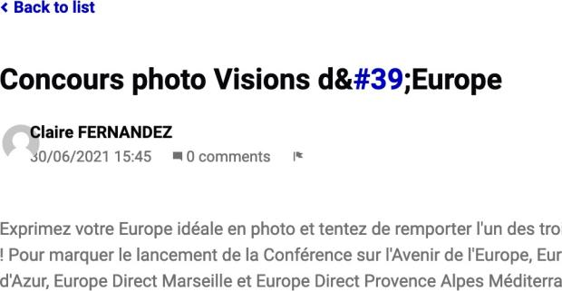
If we visit the page with a mobile device and enlarge the text, the button will no longer fit on the screen, see the image below.
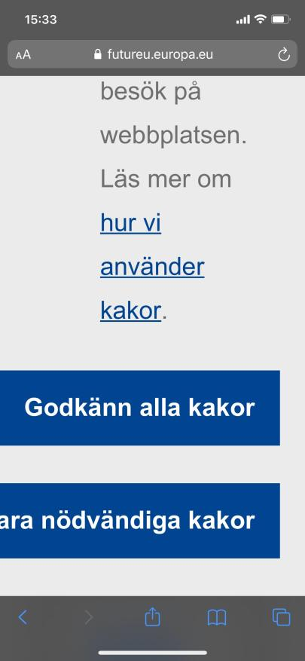
In the menu, menu options is not visible. Therefore, the test is failed.
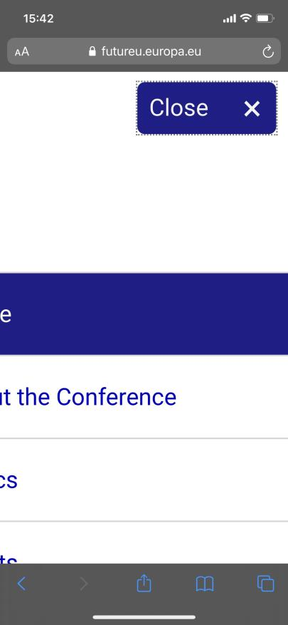

Recommendation
- The website should be useable both on small and large screens with the text zoomed to 200%.

Links to guidelines
EN 301 549 - 9.2.13
WCAG 2.0 - 1.4.4 (AA)
WCAG 2.0 - 1.4.8 (AAA)
WCAG 2.1 - 1.4.4 (AA)
WCAG 2.1 - 1.4.8 (AAA)

Users can access all content and use all functions regardless of screen orientation

Background
When content is presented to a user it should not be locked to a portrait or landscape view. The user should be able to choose how the content is displayed. Sometimes it isn't possible without the purpose of the function being lost. Films and tables must be responsive and should be displayed regardless of orientation, unless there is a special reason. Films displayed in full-screen mode often require the unit to have a landscape orientation, but should be able to be played back in portrait mode.
In different situations the user may need to use mobile phones or tablets in a particular orientation, for example if a unit is attached to a holder mounted on a wheelchair. The orientation of the user interface should be adapted to a user's condition. One consequence is that the experience is not optimal, but it should work. An example of this is film in portrait view.
This requirement doesn't apply for changes in content or features due to screen size, but does apply for screen orientation.

Comment
All functions and content can be reached regardless of screen orientation. No errors were found.

Links to guidelines
WCAG 2.1 - 1.3.4 (AA)
EN 301 549 - 9.1.3.4
No errors found

Navigation & links

The interface can be controlled with the keyboard only, on both desktop and mobile

Background
There are numerous different ways to control a computer or smartphone. There are different solutions for moving the mouse cursor, clicking and entering text. By making the interface controllable by mouse, keyboard and touchscreen, the user can decide which solution they prefer. Some users do not have any choice. Some users are unable to use a standard keyboard and must navigate using the mouse. Other users cannot use any form of mouse solution and have to navigate with a keyboard.
A basic principle in WCAG is that it should be possible to control the interface only with the keyboard, whether it is on a large or small screen. In order to be considered as following the guidelines, it must work.
Exceptions to this point can be made, for example, in the case of a function that cannot in any reasonable way be made usable independently of the input device.

Common problems
Avoid inserting functions that require the user to click on or hold the mouse cursor over different areas, e.g., menus that require the user to hover with the mouse.
Also avoid lists that update the page or switch focus as soon as a value in the list is changed. These types of solution create big problems, particularly for individuals who have to navigate with a keyboard and for users with movement disorders or who are sitting in environments with disturbances.
Be careful when changing interaction patterns that a user is familiar with. One example is a user who navigates with a keyboard and is used to using the tab key to move between links and form objects. If suddenly the user is expected to use the arrow keys instead, many users would experience problems. This action would usually only require one click of the mouse. A sudden requirement to double click on a web page would mean that many users would have problems.
Furthermore, bear in mind that the combination of responsive design and zoom not uncommonly brings up a mobile view even for users on a desktop. It is therefore important that this works independently of the input device, even in mobile view.
If the interface can be controlled by gesture recognition on a touchscreen,

Fail
It should also be possible to control the interface with a finger only, as much as possible. Avoid complex gestures and interaction patterns that are not intuitive for users.

Comment
The website is complicated to navigate and use with a keyboard. Many interactive objects do not have a visual focus. Even if an object is technically reachable with the keyboard, the user cannot see which of the objects is in focus.
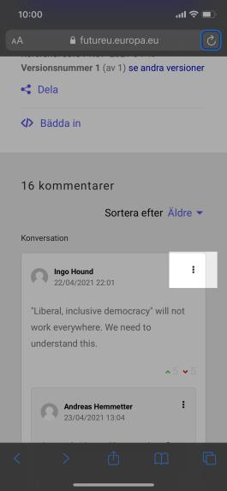
In the example below, there is an object with three dots lined up. With a computer mouse, it is clickable, but with a keyboard, it is not reachable.
In the image below, there is a view of the language page. Here it is impossible to reach the objects when using a small screen and a keyboard.
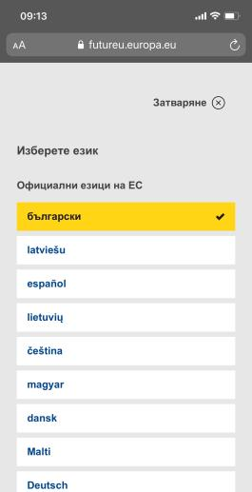

Page references
Single page event Topic

Recommendation
- Code buttons with the button element and links with the anchor element.
- Make sure all clickable objects are useable with the keyboard.
- Tab through the website and test the functionality.
- Avoid functionality only activated by hovering, as they are not controllable with the keyboard.

Links to guidelines
EN 301 549 - 9.2.15
EN 301 549 - 9.2.16
EN 301 549 - 9.2.29
EN 301 549 - 9.2.30
WCAG 2.0 - 2.1.1 (A)
WCAG 2.0 - 2.1.2 (A)
WCAG 2.0 - 2.1.3 (AAA)
WCAG 2.0 - 3.2.1 (A)
WCAG 2.0 - 3.2.2 (A)
WCAG 2.1 - 2.1.1 (A)
WCAG 2.1 - 2.1.2 (A)
WCAG 2.1 - 2.1.3 (AAA)
WCAG 2.1 - 3.2.1 (A)
WCAG 2.1 - 3.2.2 (A)

Keyboard navigation follows a logical order Fail

Background
Users who navigate with the keyboard cannot control the order in the same way as a user who navigates by mouse or touchscreen. It is the website that controls the navigation order instead. This is often purely a matter of tab order. The most common way to jump between objects using the keyboard is with the tab key. If attention is not given to the tab order, the order will reflect the order in which the content has been inserted in the code.
The tabindex attribute can be used to control the tab order. This attribute can for example be used in order to prevent an object from being in focus. However, all objects that users can navigate to ought to be in a logical order in the page structure, without using the tabindex.
Tabindex works as follows:
- Tabindex = 0 inserts inactive objects, e.g. a div, in the tab order at the point they naturally sit in the page structure. Our recommendation is to use html elements in the first instance that are interactive in themselves (e.g., links and buttons), but there may be a need on the odd occasion to let the user tab to other objects. In this case, tabindex=0 should be used.
- Tabindex > 1 prioritizes the objects and changes the navigation order such that it does not follow the page structure. The order will then be from the lowest number upwards. Once the user has reached the object with the highest tabindex setting, the tab order will continue from this object in the code. This means that the user will not access objects that are at an earlier point in the page structure unless they have tabindex stated.
- Tabindex < 0 means that the object cannot be tabbed to, but that focus can be given to it via script. This is used, for example, to set the focus on an error message via script so that this is communicated to the tool user. The value -1 is normally used for this.
In some functions, the user also navigates with other keys, such as the arrow key, to move the focus between for example radio buttons. It is important that not only the tab order should be logical, but also that the rest of the keyboard navigation has a logical order sequence.

Comment
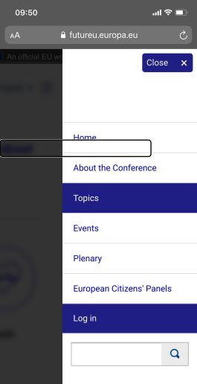
When the menu is opened with a keyboard or a screen reader on a small screen, it is possible to navigate behind the open menu. This can create problems for users with visual impairments who cannot see where the focus is.
As stated in NL40, there are some objects with no visual focus indication when navigating with the keyboard, not even the built-in focus indicator in web browsers. To see if the keyboard navigation follows a logical order, it is recommended to first solve the problems in NL20 and NL40.

Recommendation
- Follow our recommendations in NL20 to make all clickable objects controllable with the keyboard.
- All interactive objects should receive a visible focus when navigating with the keyboard, see NL40.
- Tab through the website with the keyboard, both on a small screen and a large screen, and check if the navigation follows a logical order.

Links to guidelines
EN 301 549 - 9.2.22
WCAG 2.0 - 2.4.3 (A)
WCAG 2.1 - 2.4.3 (A)

Focus is clearly displayed when users navigate with the keyboard

Background
When users navigate around a web page with the keyboard or in a function, it must be visually clear where the focus is. For example, when you tab through the menu, the menu option that is currently in focus can be highlighted with a frame or by inverting the colours. In some functions where you can navigate with the arrow keys, the same recommendation applies: The object that is in focus should be clearly indicated visually.
Concealed links and short cuts should also be highlighted and visible when they are in focus during keyboard navigation.
It is also important to provide visual feedback for users that point with a mouse cursor. Clickable objects should therefore also have a hover effect that outlines the object the user is pointing on. This can be the same as the focus during keyboard navigation, but it does not have to be.
The visual indication should be clear. For example, it is not sufficient to rely on the built-in indication in the browser. Instead, the indication could be a slightly thicker frame, a thicker underline, inversion or a different background colour.

Comment
There is no visual focus indication for many interactive elements when navigating with the keyboard.
When a focus indication is missing, users navigating with the keyboard will not be able to orientate on the web page while navigating.
Fail

This problem also applies to users of magnifying tools who can easily get lost if the focus is not clearly visually indicated. It is common to use the web browser's built-in focus indicator on the website, which is not strictly incorrect. However, in some browsers, combinations of the browser's focus indicator with colours on the website can make it difficult to see. We therefore mainly recommend that you implement a focus indicator that is visible and that has good contrasts against the background.
In the image below, when the focus is on the name, it is not visible.
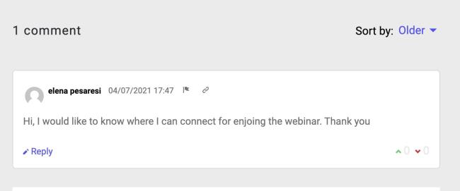
There is no visible focus when tabbing on the tabs about, ideas and events on the idea page.
In the filters on the events page, we cannot see which of the checkboxes are in focus. See the image below.
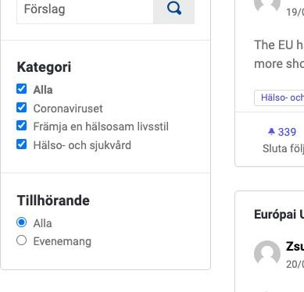

Recommendation
- All interactive elements should have a visible focus indicator.
- Consider implementing your focus indicator using CSS. Make sure it has good contrasts against the background.

Links to guidelines
EN 301 549 - 9.2.26
WCAG 2.0 - 2.4.7 (AA)
WCAG 2.1 - 2.4.7 (AA)

There are shortcuts for keyboard navigation Fail

Background
For users who navigate with a keyboard, it can be hard work having to tab through the entire menu structure on every page. Once you have found the page you were looking for, the content is what you are interested in.
To make things easier for these users, the pages should have short cuts. The most common short cut is to bypass navigation to the page content, but in different contexts it can also be worth linking back to the top of the page or to different menu groups on the page.
This type of short cut is created by inserting links that lead to elements further down on the page. Linking directly to the content bypassing navigation should be visually hidden but shown when the user tabs forward to the links.
The most common way is to link to the first heading in the content. This can be structured like this:

<h1 id="content" tabindex="-1">Content main heading</h1>
Tabindex="-1" is used to get a correct appearance in all browsers.
Links to the content are created as ordinary links but with the character # followed by the ID value of the target. For example:

<a href="#content" accesskey="s"> Jump to text content
</a>

Comment
There is no keyboard shortcut to skip to the main content.

Recommendation
- Add a keyboard shortcut "skip to main content".

Links to guidelines
EN 301 549 - 9.2.20
WCAG 2.0 - 2.4.1 (A)

WCAG 2.1 - 2.4.1 (A)

Keyboard shortcuts are not only activated with alpha-numerical keys

Background
Many users control the user interface completely or partially with keyboard navigation and shortcuts. For some users with motor disabilities or severe visual impairments the keyboard is the primary way to control the interface. Voice control in many situations also means that voice commands are converted to keyboard commands. For example, a person that controls the interface via the voice can say "tab" to move to the next link. This means that the assistive technology sends the keyboard command "tab" to the interface.
It's important that shortcuts are not based on numbers, characters or symbols only, as it may cause users navigating with the voice or keyboard to accidentally activate functions. Examples of this may be that information is deleted or contacts are being called by mistake.
If this type of keyboard shortcuts is being used, the following must be true:
- There's a mechanism to turn off keyboard shortcuts.
- Keyboard shortcuts can be changed, to be controlled by another key.
- The keyboard shortcut is only possible when the controlling object is in focus.
HTML attribute accesskey is not covered by this requirement because that type of keyboard shortcut is activated together with ctrl, alt, shift or cmd key.
Not applicable

Comment
We have not seen shortcuts being used and the checkpoint is not applicable.

Links to guidelines
WCAG 2.1 - 2.1.4 (A)
EN 301 549 - 9.2.1.4

Clicks can be cancelled or the user has an option to undo the click

Background
A click consists of two parts, one down-event and one up-event. The down-event occurs when the user presses their mouse button or the screen with the finger. The up-event is when the button is released or the finger is lifted from the screen.
When users navigate through an interface by clicking with a mouse cursor or a touchscreen, unintentional events sometimes occur. For example, a user may click or press in the wrong place. By avoiding features that occur on the down-event these types of problems are reduced. Instead, let the user activate this kind of functionality when the user releases the mouse button.
In certain cases, this is not possible. For example, in a piano application where a user is playing the piano by clicking the piano-keys.
If an event must be activated by a down-event, there should be a way for the user to undo the event. One example of this is screen keyboards for mobiles. By resting a finger on a letter, several less common characters based on the original letter appear, based on the letter the user rested over (for example you can write á â if you rest your finger on the A-key). If the user releases the screen without choosing, no character is written.
No errors found

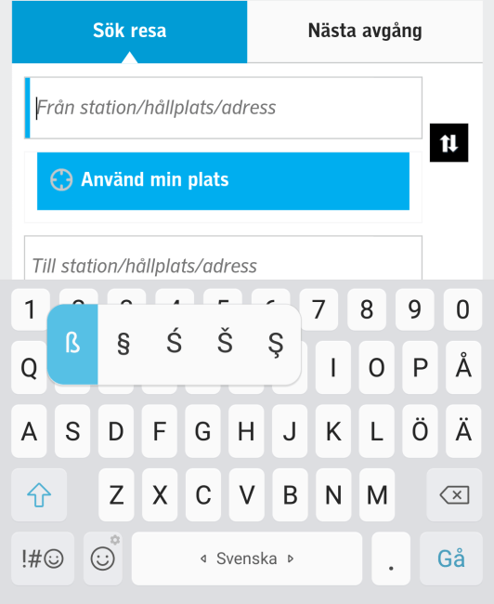

Comment
No errors were found regarding clicks that cannot be cancelled.

Links to guidelines
WCAG 2.1 - 2.5.2 (A)
EN 301 549 - 9.2.5.2

Content and functions are usable without complicated gestures

Background
Users with reduced mobility in hands or fingers may have difficulties with the precision required to control an interface. There are also input techniques where complex gestures are not possible, such as eye-tracking.
It is therefore important to create interfaces based on as simple gestures as possible, in addition to the gestures required to control operating systems and browsers. There should be alternative ways that enable these users to easily control the interface without complex gestures. Users with head mouse or eye- tracking are not helped by keyboard shortcuts via a virtual keyboard. Gestures should instead be supplemented with buttons that the user can press.
Examples on a type of interface based on gesture are server-based maps where the user zooms in or out on a map by stretching their two fingers. Another gesture is to move the geographical area shown in the map with two fingers horizontally or vertically.
The alternative for users with impaired motor skills is to control the zooming function with buttons: plus (+) to zoom in and minus (-) to zoom out. Right, left, up and down buttons allow the user to tilt and pan the map to change the geographical area.

Comment
No complicated gestures were identified for controlling the interface.

Links to guidelines
WCAG 2.1 - 2.5.1 (A)
EN 301 549 - 9.2.5.1
No errors found

Visible descriptions of clickable objects are


described in a similar way through hidden descriptions in the code

No errors found,
but can be improved

Background
There are many techniques for describing interactive objects. For common input fields, a visible label is often used in connection with the input field. It is usually enough if the label is inserted correctly, but in some situations visually hidden descriptions are also used. An example can be seen with those inserted with aria-label There may be many reasons for entering a visually hidden description. For example, a user who doesn't see the interface may need an extended description of the field.
When using hidden descriptions, however, it is important that they also include what is displayed visually. An object with a label containing the text "Buy" or "Read more", or an image illustrating the function of the object, should begin with the same text in the visually hidden label or description. A button with the description "Buy ticket" should, for example, also be initiated with the wording "Buy ticket" in the attribute aria-label or aria-labeledby.
Users with cognitive or severe motor disabilities can use the voice to control an interface, rather than using the keyboard or pointing device to navigate. When visually visible and hidden labels match, voice control also works well and is predictable.

Comment
The link to different users has a hidden text that indicates "avatar
*username*" while visually you only have the username. See the image below. This means that the visual and hidden labels are not described in the same way.

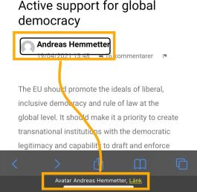

The button to agree or disagree with a comment does not start with the name in the same way as the visual. The visual text only shows a number and the hidden one says "I agree with this comment 1". See the code and the image below.
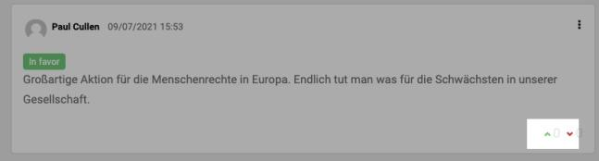

<button class="comment votes--up " title="I agree with this comment" data-open="loginModal" aria-controls="loginModal" aria-haspopup="true" tabindex="0">
<span class="show-for-sr">I agree with this comment</span>
<svg aria-label="chevron-top" role="img" aria-hidden="true" class="icon--chevron-top icon icon--small"><title>chevron- top</title><use href="#icon-chevron-top"></use></svg>
<span class="comment votes--count">0</span>
</button>

Recommendation
- Let the hidden description begin in the same way as the visible text.

Links to guidelines
WCAG 2.1 - 2.5.3 (A)
EN 301 549 - 9.2.5.3

Functionality that is activated through motion can be disabled and controlled in a different way

Background
In addition to keyboards and speech, mobile devices can also use accelerometer, gyroscope and camera as a method of input from the user, or to perform a function in the device.
For users with motor disabilities, it is problematic when functions in an interface are based on motion. This assumes that the user can move freely on their device, something that is not possible for users who have their unit mounted on their wheelchair. If an alternative is not offered, it may be impossible for some users to control an interface. Therefore, interfaces, whenever possible, should be controlled with buttons, links and other objects as alternatives to motion.
There are exceptions for functions that depend on movement to function, such as pedometer and spirit level.

Comment
Ni functions that are activated through motion have been found.

Links to guidelines
WCAG 2.1 - 2.5.4 (A)
EN 301 549 - 9.2.5.4
Not applicable

Visual indication of clickable objects and adjacent colours have a contrast of, at least, 3.0:1

Background
It is not just text that needs to be clear and have sufficient contrast in an interface. Interactive objects such as buttons, links and form fields should be clearly distinguishable, even in poor lighting conditions. For users with visual impairments to be able to distinguish interface components, it is important that frames around such objects have good contrasts with adjacent colours. Here, the contrast value should be at least 3.0: 1.
The contrast requirement between frame and background colour applies in several
Fail

situations: when users mark a clickable object or form object, when an object is in focus when the user controls with the keyboard or when the user has selected a specific object.
The contrast requirement doesn't apply to components whose design hasn't been adapted because their appearance is determined by the user's web browser. It also doesn't apply to inactive components.

Comment
When changing the focus colour from the standard, it has to have a contrast value of at least 3.0:1. In some places, there is a yellow border around the clickable object. Here the contrast is 1.4:1 which is too low.
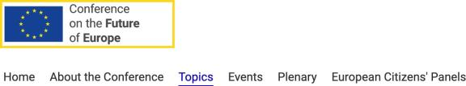

In the main menu, when an option is in focus - there is a thin dotted line on the sides of each link. It also has the same look as the active page with blue text and an underline. Here, the target focus technically has an acceptable contrast, but it is barely visible.

The contrast on the switches on the notification setting page has a contrast that is too low. When it is on, the contrast value between the green and white is 2.3:1. When it is off, the contrast value between the light grey and the background is 1.5:1.
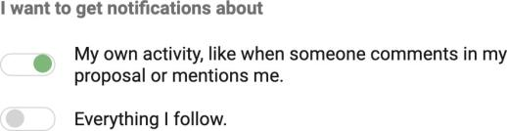

The text area seen when a conversation is started has a light grey border. Against the white background, the contrast ratio is 1.2:1.
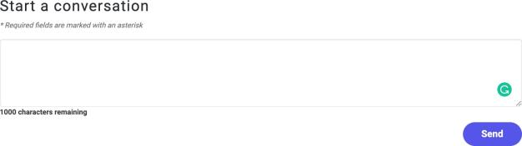

Recommendation
- Make sure the target focus has a value of at least 3.0:1.
- Make sure clickable objects have a value of at least 3.0:1.

Links to guidelines
WCAG 2.1 - 1.4.11 (AA)
EN 301 549 - 9.1.4.11

Link groups and information areas are grouped

Background
To make it easier for the user to identify groups of objects, it is important that these are grouped in a visually clear way. The user should also see and understand what is navigation, functions, content and onward linking.
Grouping should also be clear structurally. For example, by menus being grouped with the help of bullet lists in the code. The menu links will then be presented as a coherent group even in tools for severely visually impaired users. In menus where sub menus are expanded, nested lists ought to be used (lists within lists). The hierarchical structure will then also be able to be understood by severely visually impaired users.
In html5 there is an element nav that should be used to state what is navigation on the page. The element should enclose both the main menu and sub menu, or two different nav elements should be used to denote the main menu and sub menu respectively. The element can also be used for a larger menu in the page footer. How this is used:
Fail

<nav> … menu links … </nav>

Landmarks
WAI-ARIA defines different landmarks that are also used to mark-up different

types of content on a page. These will add more structure for users that cannot see the interface.
If html5 is the selected standard, the elements available in html5 should be used in the first instance. Landmarks can also be inserted. However, avoid having the element nav and role="navigation" at the same time as this can cause problems for screen readers in certain cases.
How to insert landmarks:

<div role="search"> … sökfunktion … </div>
Use the following landmarks where relevant:
- role="search", that marks the search function.
- role="main", that marks the main content on the page
- role="complementary", used for content that is complementary to the main content on the page. This includes all types of "related information", e.g., the type of content that typically sits in the right-hand column on the page.
- role="banner", used for the page header
- role="contentinfo", used for information on the content, e.g., an area with copyright information and links to confidential information.
There are several landmarks:
- role="application", used for areas with application-like interaction, e.g., a text editor. Avoid using this landmark unless you have very strong reasons for doing so.
- role="form", avoid this as it does not add anything for users at this moment in time.
Information about WAI-ARIA (W3C website)

Comment
Some landmarks are used, but a more consistent use would make the website more accessible.
Several information areas and groups of links are grouped with div elements, instead of using the semantic elements in HTML5 throughout the website. Div elements lack semantics and don't provide users with any useful meaning on what role the div elements have on the page.
You do use the element main for the main content and the element nav for
the main menu in the header, which is good. However, we recommend you also use the element nav on pages where there is a sub-menu (left menu) and use the header and footer elements to mark up these sections.
When there is more than one navigation on a page, it's good to mark what's the main navigation and what's the sub-navigation by using aria-label to provide this information to screen reader users.
We also recommend adding the attribute role="search" for the search function as there is no equivalent element in HTML to use.

Recommendation
- Use the element nav even for sub-menus.
- If there is more than one navigation on a page, use aria-label to describe what kind of navigation it is.
- Use the element header for the header.
- Use the element footer for the footer.
- Use the attribute role=search for the search function.

Links to guidelines
EN 301 549 - 9.2.38
WCAG 2.0 - 1.3.1 (A)
WCAG 2.1 - 1.3.1 (A)

The target of links is clearly stated in context

Background
Clearly formulated link texts help all users find the right link. A clearly formulated link is also a prerequisite to enable severely visually impaired users and users with cognitive disabilities to find the information they are looking for. Links must therefore provide clear information as to which pages they lead and what type of content these pages contain.
Severely visually impaired users have difficulties gaining a visual overview of the page. This means that they cannot, at a glance, identify the links located on the page and which blocks of text they are linked to. Severely visually impaired users have to navigate their way round the page instead to find out what there is with the support of their assistive technology, a screen reader.
A screen reader only presents the information the user is focusing on. If this focus
Fail

is on a link, only the link is read out, not the text around it. The user cannot visually connect the link to the context. This means that the link itself must provide all relevant information as to where it leads.
Many tools also include a function that lifts the links from their context and presents them in a separate link list. This speeds up navigation and enables the user to quickly find specific links like "Log in" or "Shopping basket". When a link is taken out of context, saying where it leads to alongside the link does not help the user and the link target must be clear from the link text itself. Links that say "Read more" are therefore not sufficient.
Linked images must provide all relevant information about the link in the alt-text (also sometimes called "description" or "tool-tip" in different publishing tools).
In the case of email links, it is important that the actual email address is stated in the link text plus information on the recipient, e.g., the recipient's role and/or name. Stating the email address is important to enable a user who is using a public or loaned computer or who does not wish to email straight away, to copy the address to use on a later occasion.

Title-text
Do not insert any title-text (sometimes called "description" or "tool-tip") in links. The link text should give the user all relevant information about the link. Some websites used to add a title-text to the link texts that would be shown when the user held the mouse cursor over the link. However, this solution cannot be used by users who use keyboard or touchscreen navigation.

Links are understandable in context
The legal requirement states that links must be understandable on their own or through their programmatically determined context. That means that it should be possible to understand the link together with any text in the same html-element.
That could mean placing a text and the link in the same paragraph-element or list- element to name a couple of examples.
The simplest way of meeting this requirement is, however, the one that makes it easiest for all users; write link texts that make it easy to understand the purpose of a link, no matter the context.

Comment
It is very important that links are understandable in and out of their context.
Many of the links are not understandable in their context. In their context
means in the same element, for example in the same table cell, list object, or paragraph.
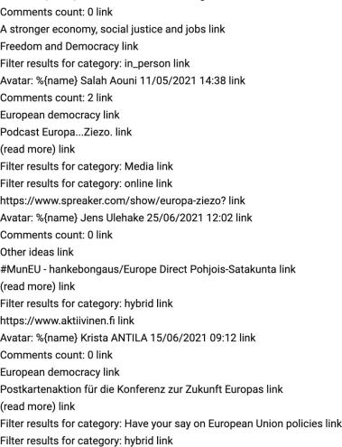
The link comment count is not clear in its context and it occurs many times on the page.
On the event page and the idea page, there are links for different pages in pagination. The link that goes to the next or previous page lacks a more descriptive link text and is only read as next link for a screen reader user.
Links for each page are only read with one number and are not easy to understand if you do not see the interface. Complete with the word page so the link text becomes "page 1" and so on.

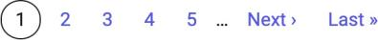

In the image below, the different events are listed in boxes. When a date is selected, the user ends up on the profile page of the user who posted, which is not obvious.
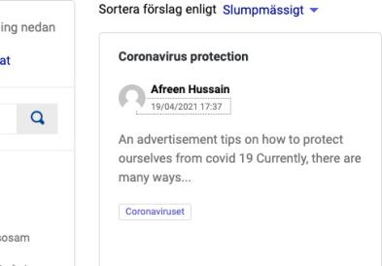

Page references
Events

Recommendation
- Make sure links are understandable in their context.
- If possible, make sure links are understandable outside of their context.

Links to guidelines
EN 301 549 - 9.2.23
WCAG 2.0 - 2.4.4 (A)
WCAG 2.1 - 2.4.4 (A)

When the same menu or link collection is shown on different pages, the sorting order should be consistent, unless users would find the order illogical

Background
Do not change the sort order when listing links, tools or menus on different pages. The same menu or link collection should be presented in the same order throughout the site, unless that would be perceived as illogical by the user.

Comment
No errors were found.

Links to guidelines
EN 301 549 - 9.2.31
No errors found

WCAG 2.0 - 3.2.3 (AA)
WCAG 2.1 - 3.2.3 (AA)

Colour & presentation

The contrast between foreground and background of content is adequate

Background
Good contrast between the text and background. Is important for many user groups On a contrast scale that goes from 1:1 (no difference) to 21:1 (black on white) the contrast should be min 4.5:1.
To measure contrasts, a complex formula that is available at the W3C website is used:
Formula for contrasts (W3C website).
If you don't want to calculate this yourself, there are several tools that can be used, for example "Contrast Analyser" that can be downloaded free of charge from the Paciello Group website: Contrast Analyser (Paciello Group website).

Comment
There is text on the website that doesn't meet this requirement. Below follows a couple of examples. The text should have a contrast value of a minimum of 4.5:1 against its background. In the cookie window, the dark grey text against the light grey background has a contrast value of 2.9:1, which is too low.

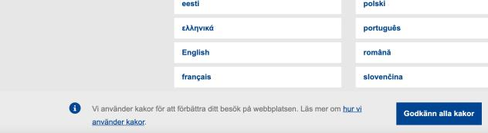
In some places there is white text with light green background. The contrast value of that combination is 2.3:1.

Fail
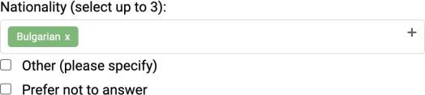

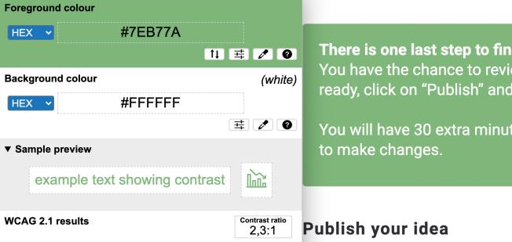
Below, you can see the testing tool colour contrast analyser reporting the low value on the white text with green background.
In some modal windows, the button has a black text on a blue background. The contrast value for that combination is 3.8:1.
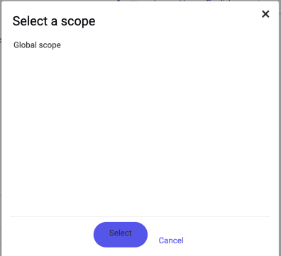
The numbers are written with a light grey colour against a white background. Here the contrast ratio is 1.2:1.

Recommendation
- The contrast value between text and background should be at least 4.5:1.

Links to guidelines
EN 301 549 - 9.2.12
WCAG 2.0 - 1.4.3 (AA)
WCAG 2.0 - 1.4.6 (AAA)
WCAG 2.1 - 1.4.3 (AA)
WCAG 2.1 - 1.4.6 (AAA)

Graphical objects conveying information, images containing text, illustrations and videos have adequate contrasts

Background
The contrasts in illustrations, charts, images, icons and films are important to many user groups. The user should be able to see and interpret the graphic information, even in poor lighting conditions and with a visual impairment. Therefore, always strive for the best possible contrasts. The limit value for contrasts in this type of material should be at least 3:1. The value refers to the colour of the graphic motif against the background. An exception to the requirement is when the subject is supplemented with text.

Comment
The green line indicating which page is active has a contrast value of 2.3:1. Make sure all graphical information-bearing objects has a value of at least 3.0:1.
Fail

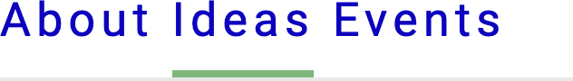

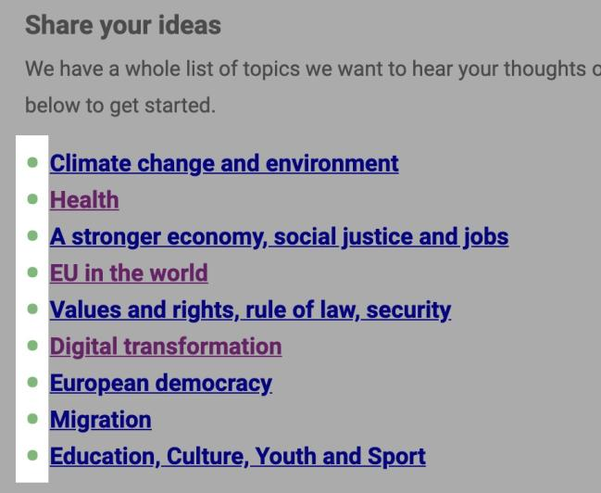
The list symbol also has a green colour with a contrast value of 2.6:1.

Page references
How can I get involved Health

Recommendation
- The contrast value on information-bearing graphical objects should be 3.0:1.

Links to guidelines
WCAG 2.1 - 1.4.11 (AA)
EN 301 549 - 9.1.4.11

All content is accessible when the user has increased spaces between words, lines or paragraphs

Background
For users with for example dyslexia or visual impairments, it is important to be able to adapt how texts are displayed. There are various plugins for browsers that allow you to control the size, font and distance between rows, words, characters and paragraphs. Changes in distance in text should be possible without the functions becoming inaccessible or the content being hidden or cut off. The results does not need to be perfect, but changes should be possible to do in the user's browser and should not be blocked. The user must be able to change the distance according to the measurements given below.
- Line height (line spacing) to at least 1.5 times the font size.
- Spacing following paragraphs to at least 2 times the font size.
- Letter spacing (tracking) to at least 0.12 times the font size.
- Word spacing to at least 0.16 times the font size.

Comment
All content can still be reached and seen in a good way when space is increased between the text.

Links to guidelines
WCAG 2.1 - 1.4.12 (AA)
EN 301 549 - 9.1.4.12
No errors found

The website is presented without disturbing screen flicker, moving and flashing elements that cannot be switched off

Background
Movements in the interface can catch the viewer's attention and make it difficult to concentrate on the text.
Movement, blinking and flickering should therefore be avoided. If you still wish to have this, it should either stop automatically within 3 seconds or there should be a clear way to disable such movement.
Please also note that blinking faster than 3 times a second is never permitted.

Comment
On the start page, there is an image carousel with text. The images are swopping automatically every five seconds, which can be seen as disruptive by users with cognitive disabilities and taking away their focus from valuable content. Given the above, an option to turn off the automatic changing of slides should be offered.
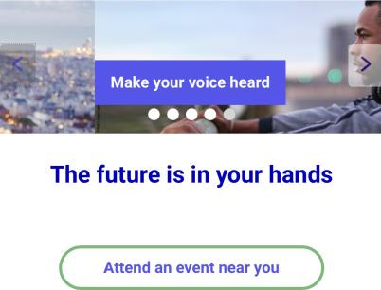

Page references
Start page

Recommendation
Fail
- Provide an option to turn off the automatic changing of slides on the carousel.

Links to guidelines
EN 301 549 - 9.2.18
EN 301 549 - 9.2.19
WCAG 2.0 - 2.2.2 (A)
WCAG 2.0 - 2.3.1 (A)
WCAG 2.0 - 2.3.2 (AAA)
WCAG 2.1 - 2.2.2 (A)
WCAG 2.1 - 2.3.1 (A)
WCAG 2.1 - 2.3.2 (AAA)

The pages have unique and relevant page titles
No errors found
but

Background
The page title is the first thing that users encounter. It is also used as text when the user adds the page to favourites and search engines use the page title when they index pages. It is therefore important that every page in a website has a unique page title that describes the page content and function in a clear way.
We recommend that you first enter the unique content of the page and then enter the name of the organisation/website.

Comment
There are unique titles on every page which is good. But for some reason, they are not being read with the voiceover screen reader. It is not working on either the phone or on the computer. Another issue is that heading level one is not used as the title. When they are not matching, it can be confusing for users with visual and cognitive impairments.
can be improved

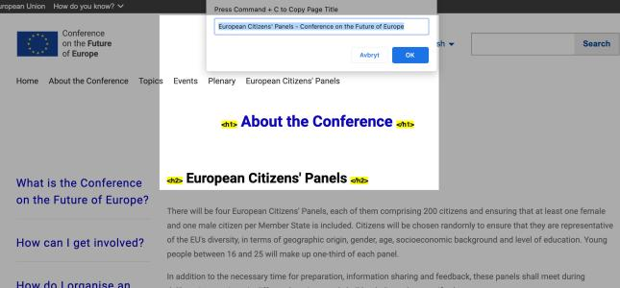

Page references:
European Citizens' Panels

Recommendation
- Let the page titles continue to be unique and consider making the title the same as heading level one.
- Make sure that the title element works with all types of screen readers.

Links to guidelines
EN 301 549 - 9.2.21
WCAG 2.0 - 2.4.2 (A)
WCAG 2.1 - 2.4.2 (A)

The main language of each web page can be programmatically determined.

Background
The main language is to be specified in the code on all pages. This enables the assistive technology to determine which language the text is written in and then choose the correct voice for the language concerned. The main language should be entered directly in the element html, at the top of the page code.
In html5, the main language is entered with the lang attribute:
No errors found

<html lang="en">
In xhtml the main language is stated with the attribute xml:lang="en". However, the older way of writing for backward compatibility should also be used (exception xhtml 1.1). Example:

<html xml:lang="en" lang="en">

Comment
The main language is set in the code on the website and changes when another language is picked.

Links to guidelines
EN 301 549 - 9.2.27
WCAG 2.0 - 3.1.1 (A)
WCAG 2.1 - 3.1.1 (A)

Language that differs from the page main language is indicated programmatically

Background
When a change of language occurs in the content, this should be marked. This could be, for example, a quote on the page that is in a different language or if the page provides information in one language while the menus and website structure are in another language. Such changes should be entered in the code. This can be done for most elements, e.g., span, li, div, a and p. Individual terms and words do not need to be marked up.
In html5 the base language is entered with the lang attribute:
Fail

<p lang="sv">
This states that the paragraph in question is written in Swedish. The attribute can be used in all html elements in html5.
In xhtml the language is stated with the attribute xml:lang="sv". However, you should also add the older way of writing for backward compatibility (exception xhtml 1.1). For example, as here:

<p xml:lang="sv" lang="sv">

Comment
In different places on the website, user driven content is visible in different languages. In these cases, you have to set a language attribute on the text, which differs from the main content. You should also set a

language attribute to let the assistive technology know which language the text should be read in.
In the first example below, the topics page and two ideas are written in other languages that are not English.
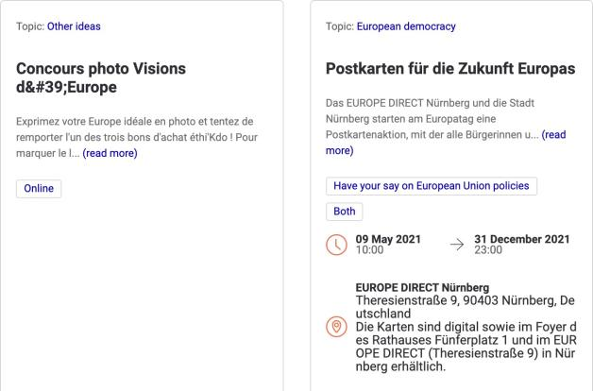
The next two examples show error messages in a different language. They are most probably bugs. One message occurs when making a mistake when signing in. The error message is not in English
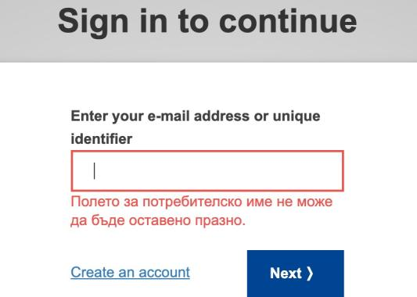

One message occurs after automatic log out.
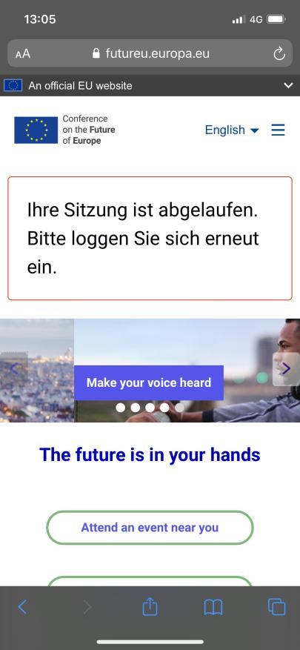

Page references
Processes Sign in

Recommendation

- Set the language attribute on content that differs from the main content.

Links to guidelines
EN 301 549 - 9.2.28
WCAG 2.0 - 3.1.2 (AA)
WCAG 2.1 - 3.1.2 (AA)

Structure & formatting

Area headings describe the area's function in a clear and precise manner

Background
Similar to the importance of content headings, area headings need to assist the user. An area heading describes the content in an area as succinctly as possible. Generic headings, such as "Footer", "Related" or "Read more", do not work well. Instead, use more specific headings, such as "E-services", "Contacts", and the like.

Comment
All headlines are specific in describing their function. No errors were found.

Links to guidelines
EN 301 549 - 9.2.25
WCAG 2.0 - 2.4.6 (AA)
WCAG 2.1 - 2.4.6 (AA)

No errors found

Headings reflect the content and encourage users to continue reading

Background
The heading is the first thing the user reads. It may also be only last thing the user reads, particularly if the heading does not provide an accurate description of the content or if it leads the user in the "wrong" direction.
Because of this, it is important that the heading provides the relevant information on the associated text. The heading should contain key words from the body text. They should also be inviting, enticing the user to keep reading.
Both the main headings and sub-headings should be short, but clear and descriptive. Often, it is good to let headings consist of a whole sentence, preferably with an active verb.

Comment
We find that the headlines reflect the actual content under the headline. No errors were found.

Links to guidelines
EN 301 549 - 9.2.25
WCAG 2.0 - 2.4.6 (AA)
WCAG 2.1 - 2.4.6 (AA)

Text that visually function as a heading is coded as a heading

Background
Headings are one of the first things the user sees and reads on a new page. Having good headings is therefore of enormous significance when reaching out with information. However, not all users can see the headings. Some are dependent on assistive technologies to access the information. In order to enable assistive technologies to understand what headings are on a page and render these to the user, they need to be correctly coded with h-elements.
There are several things that are important, but a basic premise is that what look like and therefore visually work as headings are also coded with correct headings. In HTML, headings are coded with elements h1, h2, h3, h4, h5 and h6. The
number indicates the level. It is also possible to code headers with wai-aria. Then
you give the text role = "heading" and indicate the level with the attribute aria- level. However, we do not recommend this because the support is not 100% among assistive technologies and this increases the risk of problems.
There is one exception to this requirement. If you have headings that appear as soon as the page is loaded and which are located in front of the main header in the structure, they should not be coded as headers. An example of this is a visual
Fail

header above the left menu on a web page where the navigation comes before

the contents of the structure. It should not be coded as a heading. However,

if a drop-down menu only appears when the user clicks on a button or link,

and it has visual headers, then they should be coded as real headers.

Comment
Functions as headings are not coded as headings with the correct heading elements. In the footer, the image below, the following items function as headings, but they are coded as div elements:
- Contact the EU.
- Find an EU social media account.
- and EU institution.
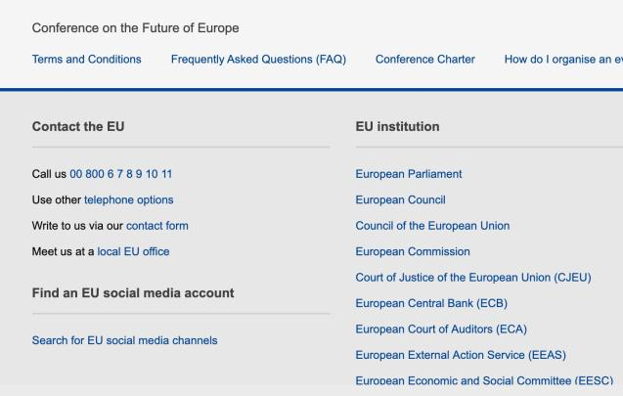
On the page where the user agree to the terms and conditions, see the image below, there are headings not coded as headings.
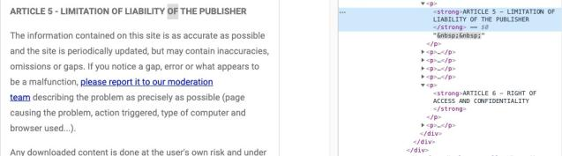
The heading for the filter box also has the wrong markup.
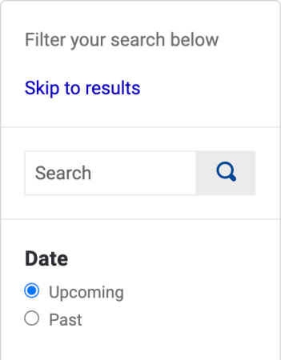

On the page “Frequently asked questions” the questions are marked as bold instead of being coded as headings.
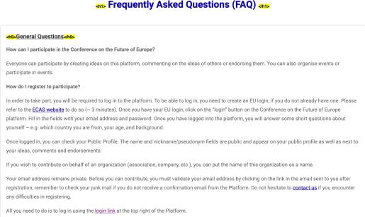

Page references
Terms and Conditions Meetings
FAQ page

Recommendation
- Code headings with the correct HTML elements.

Links to guidelines
EN 301 549 - 9.2.7
WCAG 2.0 - 1.3.1 (A)
WCAG 2.1 - 1.3.1 (A)

The heading structure begins with a main heading

Background
The header elements should form a correct structure. This means the first header should be coded as an h1-header.
Example:
Fail

<h1>Main header</h1>
<h2>Sub-header</h2>
<h3>Header level 3</h3>
<h3>Header level 3</h3>
<h2>Sub-header</h2>

Comment
The heading structure is not always hierarchically correct on the website. Some of the pages do not start with a heading level 1 - the main heading. This creates problems for users with assistive technology who may choose to navigate through the heading structure.
The first example is from the topic page where there is no heading level 1. The image below gives you an overview of the first headings on the topic page

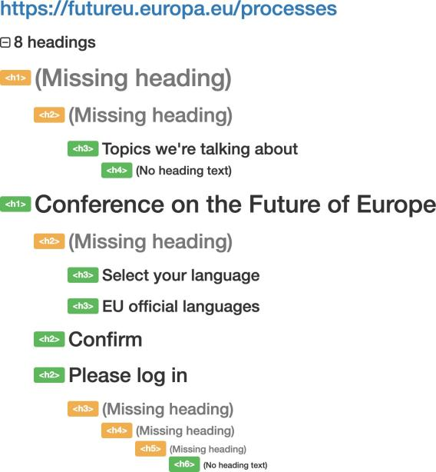

The second example is from the start page where users select a language. Here the heading level 1 is also missing.
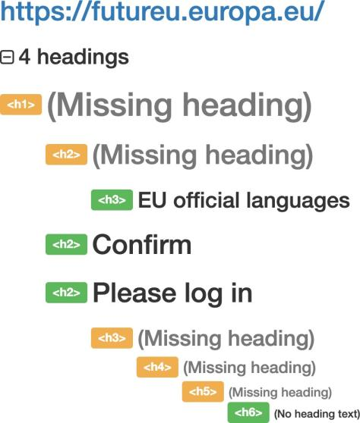

Page references
Topics
Start - pick language

Recommendation
- Begin pages with h1 headings and don't skip heading levels. Heading structure should be hierarchical and consistent.

Links to guidelines
EN 301 549 - 9.2.7
WCAG 2.0 - 1.3.1 (A)
WCAG 2.1 - 1.3.1 (A)

The heading structure is logical and represents the hierarchy of the content

Background
The heading structure should be logical and reflect the structure in the page content. Start all pages with a correct main heading (element h1) at the top of the content. All following headings should then come in a hierarchically correct order.
Keep in mind that the number should not reflect how important the heading is but how it relates to other headings. Is it a sub-heading to the previous heading or should it be on the same level?
The previous requirement was about the structure being formally correct. This requirement is that the structure matches the content on the web page.

Comment
There are pages where the heading structure skips levels. This affects how well the content matches the respective heading level and it means that screen reader users, who are using the heading structure as a way of creating a mental image of the content, can't trust the existing structure.
In the image below, in the page Conference Charter, the heading level goes straight from level 1 to 3.
Fail
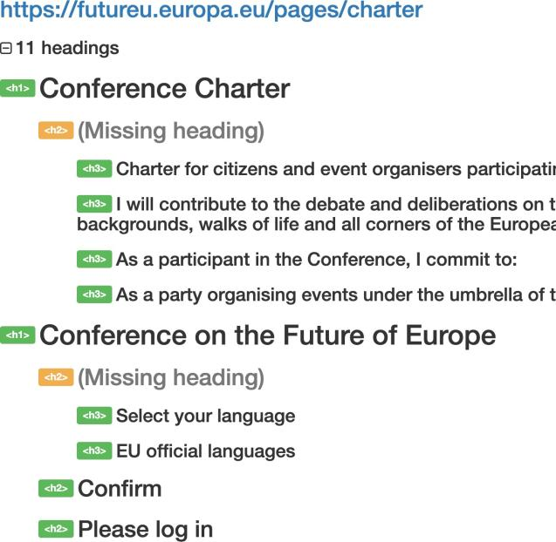

On the page “About the Conference”, see the image below, heading level 3 is skipped after the second heading.
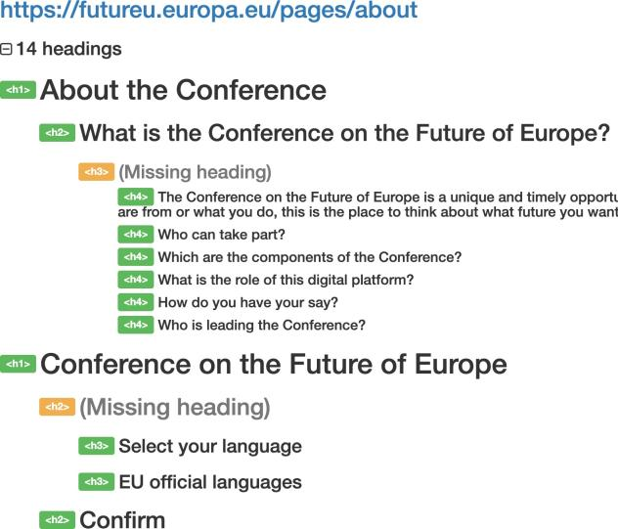

Page references
Conference Charter About

Recommendation
- Use correct heading levels to match the structure of the content.
- Do not skip levels.

Links to guidelines
WCAG 2.0 - 1.3.1 (A)
WCAG 2.1 - 1.3.1 (A)
EN 301 549 - 9.1.3.1

Lists are correctly coded and used in a correct manner
No errors found

Background
Some information is suitable for presentation in lists. This includes enumerations, definition lists and descriptions of different steps in a process.
The html elements for this purpose should be used to insert these lists. This is necessary for a screen reader to be able to interpret and present them as correct lists to the user.
The element ul (unordered list) is used to start a bullet list, the element ol (ordered list) is used to start a numbered list. Every list element is then created with the element li (list item).
In the case of definition lists, the element dl is used to start the list, dt to state the term that is to be defined and dd to describe it.
Lists can also be used to structure the menu. By inserting the menu in a nested list, you can communicate the menu hierarchy in a rudimentary way, even for users who cannot see it.
Example:
But can be improved

<ul>
<li><a href="b.hmtl">Breakfast</a></li>
<li><a href="l.html">Lunch</a>
<ul>
<li><a href="m.html">Meat</a></li>
<li><a href="v.html">Vegetarian</a></li>
</ul>
</li>
<li><a href="d.html">Dinner</a></li>
</ul>

Comment
Lists are coded correctly. The only instances where lists do not have correct code is where the users can create content.

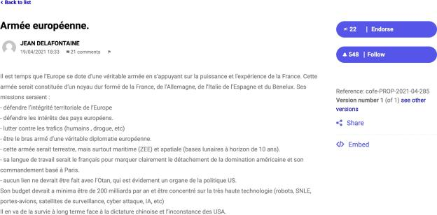

Recommendation
- Consider the possibility of granting users the opportunity to create real lists.

Links to guidelines
EN 301 549 - 9.2.7
WCAG 2.0 - 1.3.1 (A)
WCAG 2.1 - 1.3.1 (A)

Paragraphs are created correctly using the p element

Background
To insert text paragraphs on a page, the element p should be used. This makes the document easier to skim read with assistive technology. The user can then jump from paragraph to paragraph. This is especially important in layered texts where the different paragraphs must be able to be differentiated from each other.
Do not use the elements br or hr to differentiate text paragraphs.

Comment
In the preamble, heading elements instead of paragraph elements are used, see the image below.
Fail

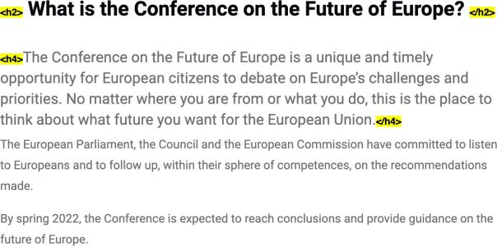

We have seen that you use the br element to create a space.
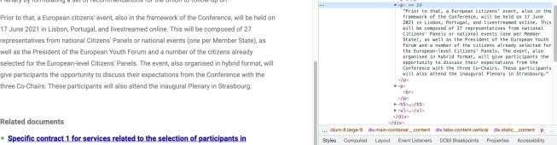
Text in the events is written in div elements instead of p elements.
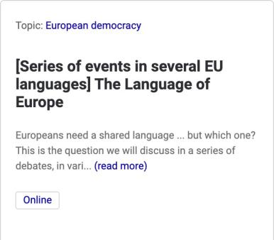

Page references
European Citizens' Panels About the conference

Recommendation
- Use the paragraph element for preambles and paragraphs.
- Use CSS to create styling as spacing and preambles.

Links to guidelines
EN 301 549 - 9.2.7
WCAG 2.0 - 1.3.1 (A)
WCAG 2.1 - 1.3.1 (A)

ST200: Quotes are marked up using q or blockquote Not applicable

Background
Mark-up longer quotes with the element blockquote.
Visually, the element creates an indent in the text, which some publication systems utilise to offer a simple function for indenting in the text editor. However, this should be avoided. Blockquote must only be used for quotes.
Use the element q to mark-up and format shorter quotes.
The attribute cite should be used in both blockquote and q to cite a source in the form of an url if there is such a source.
Example:

<blockquote cite="http://www.svt.se/vader/prognos_071224.html">
<p>Det finns en 50-50 chans för snö i södra Sverige till jul. Det bygger dock på att lågtrycket som nu ligger över brittiska öarna styr norröver.</p>
</blockquote>

Comment
No quotes found.

Links to guidelines
EN 301 549 - 9.2.7
WCAG 2.0 - 1.3.1 (A)
WCAG 2.1 - 1.3.1 (A)

Images

Text is presented as text, not images of text Fail

Background
Images are often a good way to communicate information, especially in combination with text. Images can help illustrate complex connections and difficult concepts.
Images also make it easier as they break up the text and make the text less difficult to read for the user.

Images of text
In other words, images should be used where this is appropriate, but they should not be used to represent text. When text is included in the content, in the menus or other parts of the pages, then it should be included as plain text. Images of text usually create serious accessibility problems.
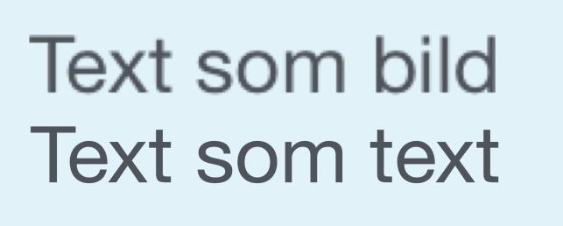
When images are zoomed, each image pixel becomes bigger, but if the text is inserted as vectors, which means each character becomes made up of several pixels when the text is magnified. The difference then is that the image of text becomes pixelated and often perceived as blurred while ordinary text remains sharp. This becomes especially apparent in magnification tools. Please see below two images: the first represents an image of text which has been created with pixel graphics and the second is an image of same text that has been created with vector graphics. They are both the same text size and we have then zoomed them by 300%.
Another problem with images of text is that the text in an image cannot be adapted to be used by assistive technologies,. Even if you insert an alt-text of the image of the text, it is by no means certain that assistive technology can handle this. Some assistive technology require the text to be copied, which is not possible if the text is just an image of text.

Exceptions
In certain situations, there can be reasons to use text in an image, such as organisational charts or various types of flow charts where the text needs to be part of the image.
When text is used in these kinds of images, it must be made at least twice as big as the ordinary text on the website (as the text in the image cannot be zoomed in a good way by browsers and tools). Of course, the contrast also needs to be good and the image must contain an alt-text.
Unless this description can hold all the information the image shows, you either need an extensive description that is inserted via the attribute longdesc or an extensive description next to the image. If for example, it is an organisational chart, the organisation's different departments can be explained with text in conjunction with the image. Use headings and lists to structure the information in a clear and understandable manner.

Comment
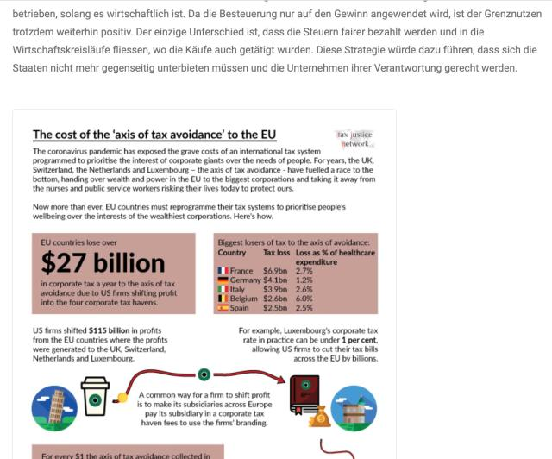
There are images with text in them, which can create problems for several user groups.
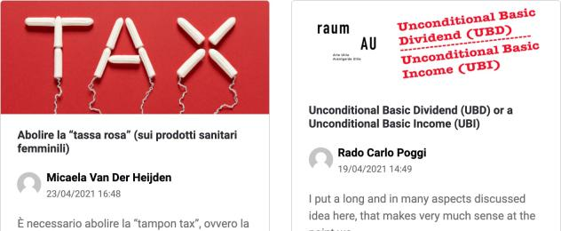

Page references
A stronger economy, social justice and jobs Single page ideas

Recommendation
- Use text as text, not images of text.

Links to guidelines
EN 301 549 - 9.2.14
WCAG 2.0 - 1.4.5 (AA)
WCAG 2.0 - 1.4.9 (AAA)
WCAG 2.1 - 1.4.5 (AA)
WCAG 2.1 - 1.4.9 (AAA)

Equivalent text descriptions are present for all meaningful graphical elements on the website

Background
If a tool is to render the content in images to the user, the images must be equipped with an alternative description. This is usually done with the aid of the attribute alt (can be called tooltip or description in other publication systems). This alternative description should briefly explain the image motif. The more important the image is for the page and comprehension, the more detailed the description needs to be.
Alt-text should be kept to less than 150 characters, but sometimes this is not enough to describe all the information in the image. In this case the alt-text must briefly state what the image shows and refer to a longer description or to corresponding information. For example:
"Graph of population growth in Sweden. See table after image".
Fail

In principle, all images that contain information, illustrations, photographs, icons, image buttons, image links etc., are meaningful graphic objects. Non-meaningful graphic objects include hyphens, empty space, coloured background lozenges etc. These kinds of images should primarily be inserted with CSS.

Comment
In general, the images have the alt attribute. But, in the page “Information material”, the images linkied to lacks alternative texts.
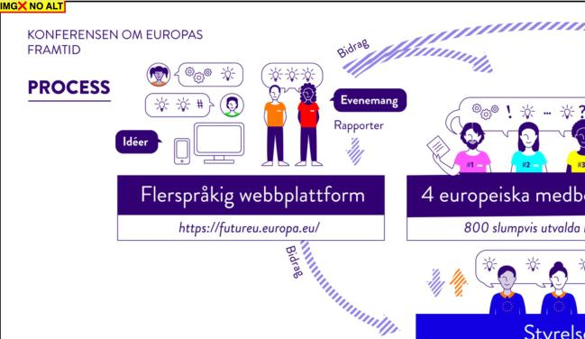

Page references
Information material

Recommendation
- All image elements should have the alt attribute.
- Write descriptive alternative texts, see IM40.

Links to guidelines
EN 301 549 - 9.2.1
WCAG 2.0 - 1.1.1 (A)
WCAG 2.1 - 1.1.1 (A)

The alternative text describes the image or the purpose of the image

Background
All meaningful graphic objects must contain an alternative description (alt text) that corresponds to the image's function or motive in the document. An alternative description should:
- Describe the subject in the image.
- Describe the function of the image (if it is clickable).
Images that are of a decorative nature can be described very briefly while images that convey important information need to be described in more detail.
It is often good to describe the type of graphic object used. For example: "Raouf Sormunen from Funka Nu AB, photo" or "Old man who paints with a brush, illustration".
Graphic objects that are not meaningful (e.g., layout elements) should not be described. It is important to ensure that there are empty alt attributes on such objects.

Comment
The text alternatives for the images do not always describe the purpose and content of the image. On the start page, all pictures in the carousel have the alt text "Space". Often when images are not essential to the page and mainly decorative, they have a purpose. Therefore, they should have a short text alternative to present the content to users with visual impairments.

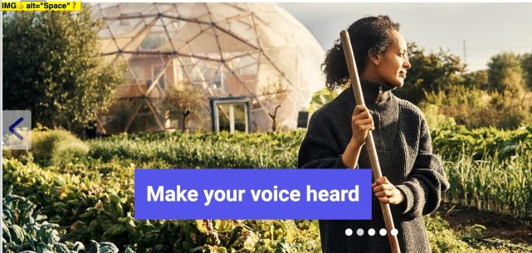
The alternative text for a logotype with a link to the start page, the function should be described. In the logotype, this information is missing.
Fail
On the information material page, some images are linked where there is no text alternative.
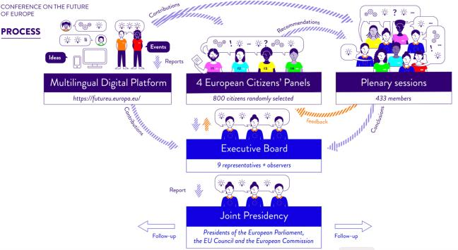

Page references
Start page Information material

Recommendation
- Give the images descriptive, alternative texts.
- If an image has a link, describe the function in the alternative text.

Links to guidelines
EN 301 549 - 9.2.1
WCAG 2.0 - 1.1.1 (A)
WCAG 2.1 - 1.1.1 (A)

Client-based image maps have text descriptions for both links and images

Background
Image maps are images with clickable areas and if possible, they should be client based.
A client-based image map is an image that has pre-determined areas that are linked. These linked areas act as ordinary links and should have a description in the title-attribute. The image that is used in an image map also needs a description in alt-attribute.
The clickable areas can also be described in the alt-attribute as a complement, but the title-attribute should primarily be used for this. Another addition can be to include ordinary text links to the same page as the image takes you to.
Example of an image map:
Not applicable

<img src="Karta.gif" usemap="#Karta" alt="Sverigekarta">
<map id="Karta" name="Karta">
<area shape="poly" coords="102,0,73,12,44,74,27,88,29,115,45,136,61,152,93,157,1
32,158,137,60,132,10,120,0" href="www.funka.com" alt="Se projekt i norra Sverige" title="Se projekt i norra Sverige">
<area shape="poly" coords="25,117,56,152,91,161,143,164,144,201,79,193,33,184,18
,165" href="www.funka.com" alt="Se projekt i mellersta Sverige" title="Se projekt i mellersta Sverige">
<area shape="poly" coords="15,165,27,180,80,192,140,204,138,247,18,249,4,171"
href="www.funka.com" alt="Se projekt i södra Sverige" title="Se projekt i södra Sverige">
</map>

Comment
No client-based image maps on the website found.

Links to guidelines
EN 301 549 - 9.2.1
EN 301 549 - 9.2.23
WCAG 2.0 - 1.1.1 (A)
WCAG 2.0 - 2.4.4 (A)
WCAG 2.0 - 2.4.9 (AAA)
WCAG 2.1 - 1.1.1 (A)
WCAG 2.1 - 2.4.4 (A)
WCAG 2.1 - 2.4.9 (AAA)

Server-based image maps are only used when they increase user benefit and when present, there are alternative ways of receiving the same information

Background
A server-based image map is an image where you can click anywhere in the image. Coordinates are then sent to the server that determines what should be sent back to the browser. This is used in many map services where you can zoom.

Comment
On the events page, a map shows the location of where different events take place. We can see where every event takes place. However, it is not possible to filter the results or search based on location, as is possible on the map. There isn't an alternative way to receive the same information.
Fail

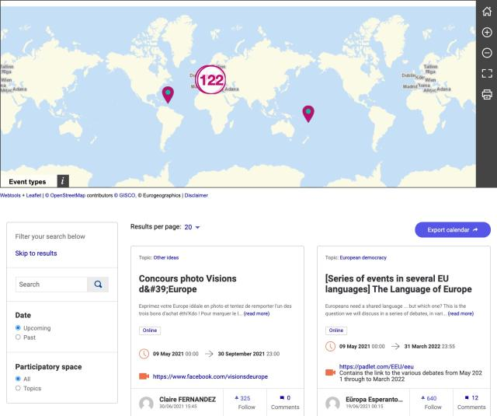

Page references
Events happening now

Recommendation
- Give an equivalent alternative to get the same information as from the map.

Links to guidelines
EN 301 549 - 9.2.1
WCAG 2.0 - 1.1.1 (A)
WCAG 2.1 - 1.1.1 (A)

Forms
FS10: Forms are coded correctly with form elements No errors found

Background
It is important that all parts of a form are inserted as correct form objects as they would otherwise not be presented together with other parts of the form in a tool. Sometimes, there can be buttons that are created as linked images instead of correct form buttons. These are not then listed with other form objects and this makes it unnecessarily difficult to send the form for some users.
It is also important that the right type of element is used. Instead of using e.g. checkboxes, but entering script that prevents anything other than a checkbox being checked at a time, radio buttons should be used.
There are several new types of form objects in html5. These have many advantages for users, not least on mobile devices where the keyboard can adapt to the type of information that is entered. An example of how different types of input fields give rise to different keyboards in a mobile is shown below.

<label for="postnummer">Postnummer</label>
<input type="number" name="postnummer" id="postnummer">

<label for="stad">Stad</label>
<input type="text" name="stad" id="stad">

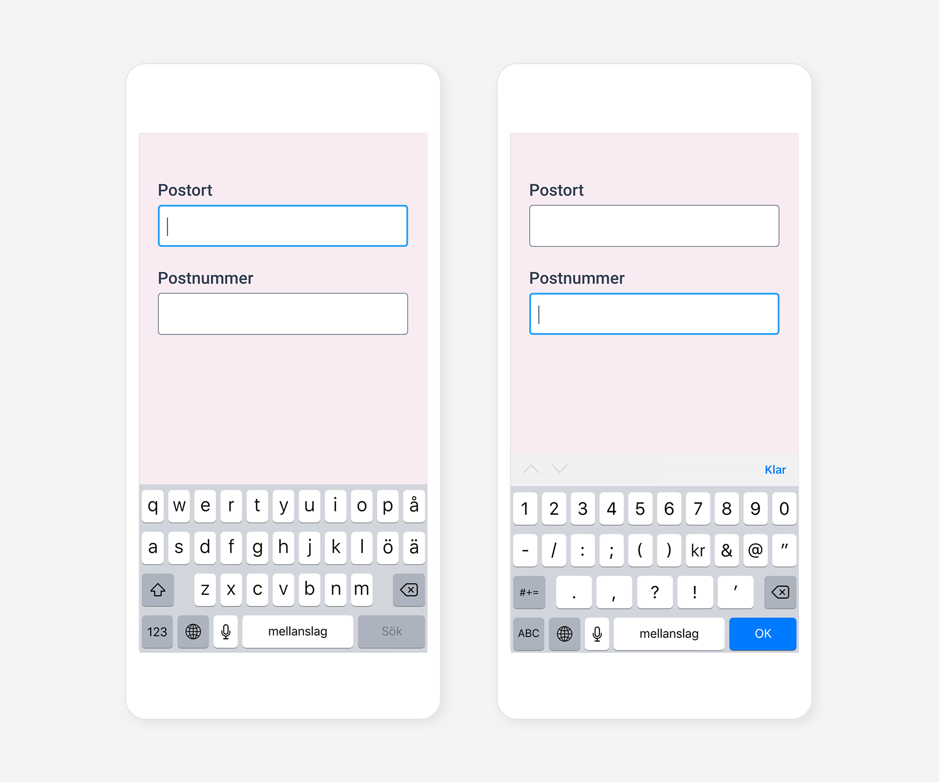

Comment
Form elements are used in all forms found.

Links to guidelines
EN 301 549 - 9.2.7
EN 301 549 - 9.2.38
WCAG 2.0 - 1.3.1 (A)
WCAG 2.0 - 4.1.2 (A)
WCAG 2.1 - 1.3.1 (A)
WCAG 2.1 - 4.1.2 (A)

There are labelled instructions that describe to the user how to complete forms

Background
When the user chooses or enters information, there must be clues and instructions that clearly indicate what to choose or enter. The instructions should also contain information about specific formats and other important information that the user needs to enter information correctly.

Comment
When searching on the “search results” page, the input field does not provide a labelled instruction (see the image below). The placeholder text is not sufficient, as many screen readers do not read them. The placeholder text disappears when the user starts to write in the field. Therefore, every input field needs to have a label.
The input field where it is possible to copy the link address is missing a label. Because of the reasons above, we consider this checkpoint as failed.

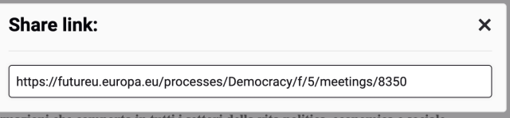

Page references
Search results Single page idea

Recommendation
- Provide a label for every form element.

Links to guidelines
EN 301 549 - 9.2.34
WCAG 2.0 - 3.3.2 (A)
WCAG 2.1 - 3.3.2 (A)
Fail

Labels are linked to corresponding form object

Background
Instructional text is text that states what the user should enter in a certain field, the significance of checkboxes/radio buttons or what the user should choose in a list. These instructional texts are often clearly positioned visually close to the form object (text field /checkbox/radio button/list/button) in the question, which means users who can see the page and read the text are clearly informed of the purpose of the form object.
In order for this to work for users who need various tools to access the information, there must be a clear connection in the code between the instructional text and the form object. This is achieved with the label element. Use label-element to insert all instructional texts. The label-element must also be correctly connected to the respective form object with the attribute for that pointing to the form object ID.
In addition to the instructional text, the label-element should also include a possible clarification and a possible error message bound to the form object. Please note that you should only have 1 label-element per form object.
If the interface is coded in html5, the form field should be labelled with what type of field it concerns.
Fail

<form action="http://www.funka.com/survey" method="post">

<label for="namn">Namn</label>
<input type="text" name="namn" id="namn" />

<label for="country">Land</label>
<select name="selectCountry" id="country">
<option disabled>Välj</option>
<option>Norge</option>
<option>Sverige</option>
</select>

<fieldset>

<legend class="hidden">Godkänn</legend>
<label for="yes">
<input type="radio" name="accept" id="yes">Ja, jag godkänner</label>
<label for="no">
<input type="radio" name="accept" id="no">Nej, jag godkänner inte</label>
</fieldset>

<label for="comments">Kommentar</label>
<textarea name="comments" id="comments">
</textarea>
<input type="submit" value="Skicka svar" />
</form>
The code is creating the following form:
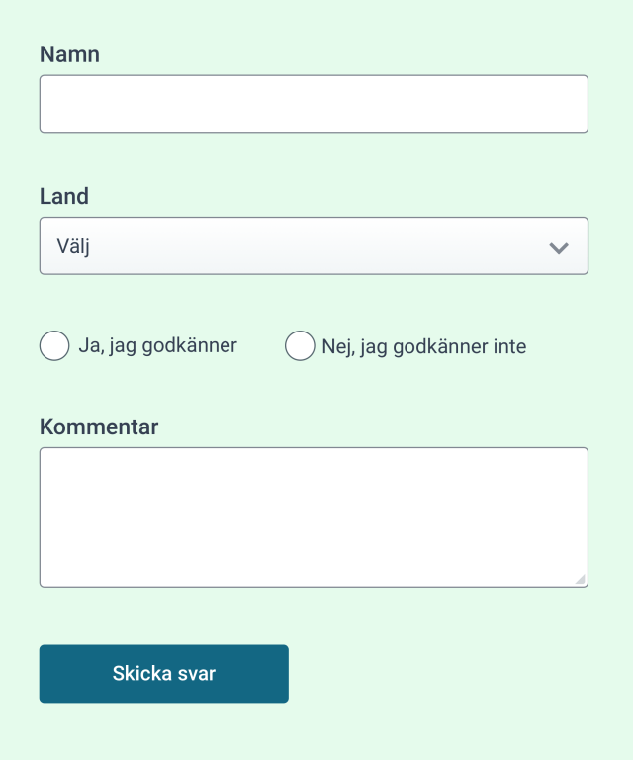

Comment
Label elements are generally used on the website. However, in seen some cases, legend elements are used instead. Every form element should have a label. Use a legend for groupng form elements that belong together or grouping of checkboxes or radio buttons.
The image below shows a profile page for a user who has sent in an idea.
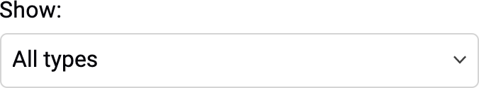

In the filter section on the “search results: page, there is a legend instead of a label.
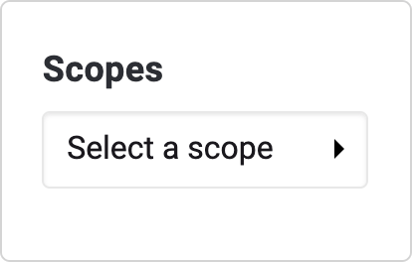

Page references
Search results Profile page

Recommendation
- Make sure that labels and form objects are linked.
- Use the label element.

Links to guidelines
EN 301 549 - 9.2.7
EN 301 549 - 9.2.25
EN 301 549 - 9.2.34
EN 301 549 - 9.2.38
WCAG 2.0 - 1.3.1 (A)
WCAG 2.0 - 2.4.6 (AA)
WCAG 2.0 - 3.3.2 (A)
WCAG 2.0 - 4.1.2 (A)
WCAG 2.1 - 1.3.1 (A)
WCAG 2.1 - 2.4.6 (AA)
WCAG 2.1 - 3.3.2 (A)
WCAG 2.1 - 4.1.2 (A)

Input fields in forms are identifiable through the correct use of the autocomplete attribute

Background
Long and complex forms often pose a major problem for many users, not least users with cognitive disabilities. The simpler the forms and the less the user needs to fill in, the less the risk of problems. There are many groups that experience problems with forms. In addition to users with cognitive impairments, they also pose problems for users with writing difficulties and users with severe visual impairments.
The autocomplete attribute makes it easier for users to fill out form fields that contain recurring information, such as name, email address and phone number. The user only needs to fill in the information once and allows the browser to save the information for the next time the user fills in the same information in other form. Autocomplete is used on input fields of various types, such as text, email, number and password.
Fail

<form action="/subscribe.html">
Given name:<input type="text" name="gname" autocomplete="given-name" />
Family name: <input type="text" name="fname" autocomplete="family-name" />
E-mail: <input type="email" name="epost" autocomplete="email"
/>
<input type="submit" value="Subscribe" />
</form>
There are some 40 possible values to use in the autocomplete attribute. In some situations, it is not desirable for the browser to fill in the form fields. Examples of such situations are when the user must enter a one-time code upon login to an e- service or a one-time password sent when a password needs to be renewed. In this case, the automatic completion can be turned off by setting the autocomplete attribute to off on specific form fields.
Assistive technology for people with cognitive impairments can capture the autocomplete attribute in form fields and provide the user with a simpler and easier-to-understand description of the information that the form field needs to

contain. An example is when autocomplete is set to the value "tel" which replaces or supplements the form field's visual label with a telephone icon.
To meet the requirement stated here, form fields included in the W3C's "Input Purposes for User Interface Components" list should have the autocomplete attribute set to the values in the list.
Input Purposes for User Interface Components

Comment
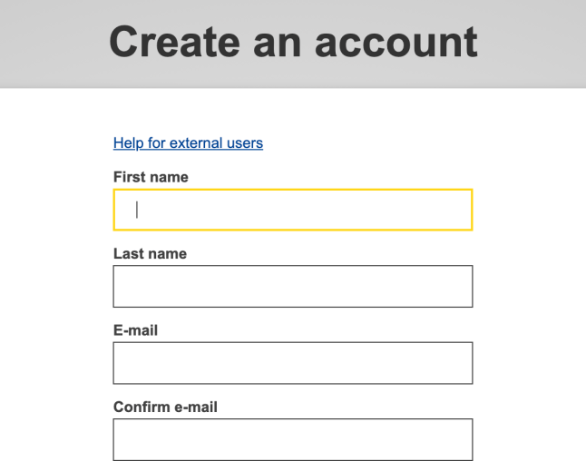
On the page where the users can create an account, the form fields do not have the autocomplete attribute. Use this attribute to make it easier for the users filling out the form. Due to the lack of the autocomplete attribute, we consider this checkpoint as failed.

Recommendation
- Use the autocomplete attribute with correct values to help users automatically complete forms with personal information.

Links to guidelines
WCAG 2.1 - 1.3.5 (AA)
EN 301 549 - 9.1.3.5

Extended descriptions of a particular form field is tied to that specific field

Background
It is not always enough to have a common label text to explain to the user what, how and why certain information in the form is required. When the need for an extended explanation arises, for example to clarify the date formats or why you ask the user to enter certain information, the explanation should be linked to the current form object. The easiest way is to let the extended description be part of the label element. This is the most robust method. You can also use the wai-aria attributes aria-labelledby and aria-describedby, but this will cause some users to miss the information. This must be sorted out on a case-by-case basis since it depends on the situation and on which users the system is addressing.

Comment
There are extended descriptions in the form where users can create a new event. The descriptions do not have a connection to the field other than visually. This can make it hard for users with visual impairments to understand what it is for.
Therefore, this checkpoint is considered as failed.
Fail

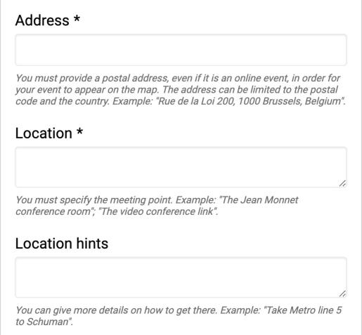

Page reference
Create an event

Recommendation
- Tie the descriptions to the form fields.

Links to guidelines
EN 301 549 - 9.2.7
WCAG 2.0 - 1.3.1 (A)
WCAG 2.1 - 1.3.1 (A)

Important forms give the users an opportunity to review the submitted information before confirming and submitting the form

Background
When a web-based function is used for legally binding commitments or to transfer money, it is especially important that the user understands what is going to happen. A user may click on "OK" in a web service by mistake without being certain of the consequences. To avoid unnecessary problems, users ought to have the opportunity to read a summary at the final stage and then confirm. This can be in the case of:
- Legally binding commitments.
- Financial transactions.
- Stored information that is amended or deleted.

Comment
Not applicable.

Links to guidelines
EN 301 549 - 9.2.36
WCAG 2.0 - 3.3.4 (AA)
WCAG 2.1 - 3.3.4 (AA)
Not applicable

The function of buttons is clear Fail

Background
It is important that users understand what will happen when they click on a button. Therefore, buttons ought to be self-explanatory, so the user understands the purpose of a button. The purpose of a button that says "OK" is, for example, not as obvious as a button that says "Comment" or "Subscribe".

Comment

On the start page, there are buttons to change slides in the carousel. Both the arrow buttons and the dots have their names written in English, so when the language of the page is changed, this information is still in English.
The image below shows that if he user decides to follow or unfollow an idea, the options say unfollow in different ways. It makes it hard to understand.
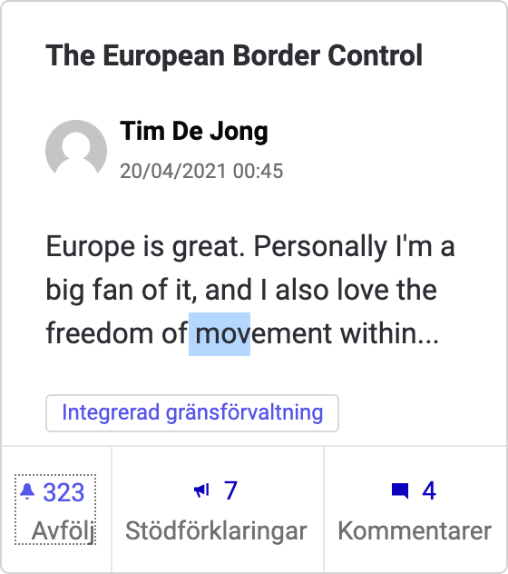

Page references
Start page Topic page
Single page idea

Recommendation
- Provide every button with an understandable alternative text for screen reader users.

Links to guidelines
WCAG 2.0 - 1.1.1 (A)
WCAG 2.1 - 4.1.2 (A)
WCAG 2.1 - 1.1.1 (A)
WCAG 2.1 - 4.1.2 (A)
EN 301 549 - 9.1.1.1
EN 301 549 - 9.4.1.2

Sections of forms are grouped Fail

Background
Longer forms must be split and grouped. This makes it easier to see which parts belong together, both visually and with assistive technology. Grouping objects is done with fieldset and legend elements.
Example of a form with groupings:

<form action="http://funka.com/survey" method="post" onsubmit="return checkForm(f);">

<fieldset>

<legend>Leveransadress</legend>
<label for="name1">Namn:</label>
<input type="text" name="name1" id="name1">
<label for="adress1">Adress:</label>
<input type="text" name="adress1" id="adress1">
<label for="pnum1">Postnummer:</label>
<input type="text" name="pnum1" id="pnum1">
<label for="ort1">Ort:</label>
<input type="text" name="ort1" id="ort1">
</fieldset>

<fieldset>
<legend>Faktureringsadress</legend>
<label for="name2">Namn:</label>
<input type="text" name="name2" id="name2">
<label for="adress2">Adress:</label>
<input type="text" name="adress2" id="adress2">
<label for="pnum2">Postnummer:</label>
<input type="text" name="pnum2" id="pnum2">
<label for="ort2">Ort:</label>
<input type="text" name="ort2" id="ort2">
</fieldset>

<input type="submit">
</form>
As soon as you have a group with radio buttons or checkboxes, you should use fieldset and legend to give the group a common description. Without this, you could say in very simplified terms, it is like asking the user to answer a question without hearing the question first.

Comment
In some places on the website, there are sections of forms that are not grouped. Grouping forms make it easier for a screen reader user to navigate and understand what is expected. There are many settings to be changed for users and some of them appear to have the same heading but are not grouped together. On the page Demographic data, the country of residence has three fields, therefore, they should have a fieldset element and a legend.
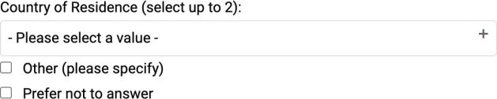

The image below is from the page “My notifications”. Here the checkboxes should have a fieldset wrapping the form fields.

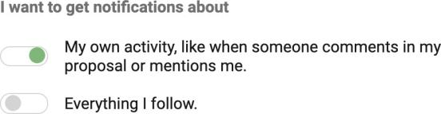

When reporting a user, there is a group of radio buttons with alternatives. A fieldset element is not wrapping the radio buttons.
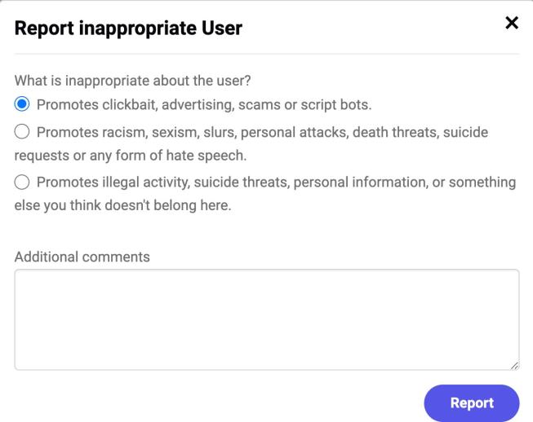

Page references
Demographic data My notifications

Recommendation
- Use the fieldset element to group related form objects. Primarily, we mean groups of radio buttons and checkboxes.
- Use the legend element to give fieldsets a description.

Links to guidelines
EN 301 549 - 9.2.7
WCAG 2.0 - 1.3.1 (A)
WCAG 2.1 - 1.3.1 (A)

When an error is made, the user is made aware of this in a clear manner

Background
If there is a possibility that an error occurs, errors most likely will. If this happens, it is important that the user is notified that something has gone wrong.

Provide a combined error message at the top.
There are several different ways of showing that an error has occurred. However, to ensure as many users as possible understand this, most forms should offer a combined error message. This should clearly state:
- An error has occurred. We recommend using both a heading and an icon to say that it is an error message.
- The errors that have occurred. Ideally in a bullet list.
- Where the errors have occurred. Name the form objects where the errors can be found.
- If possible, also what the user should do to correct the errors.

Describe the error by the respective field
Provide clear and distinct error messages next to the invalid form fields, preferably combined with an icon. The error should also be described to the user here.

What more can I do?
It would be even better to offer live validation, so errors are detected while the user is completing the field. However, keep in mind that not all users will see this; it must therefore also be possible to submit the form even if the user has not corrected the errors. When the user has submitted the form, a combined error message (as above) should be shown.
It may also be worth linking each error message to the corresponding form field, so that users do not have to search for them.

Other types of error
Another example of errors that can arise is when the user tries to load a page that does not exist. Thus, the website must provide a clear error message that states that the page in question does not exist and provide the user with an opportunity to find the information in some other way.
Fail

Comment
We recommend you to provide a comprehensive summary above the form. Include what errors have occurred in the form and the solution to fix these.
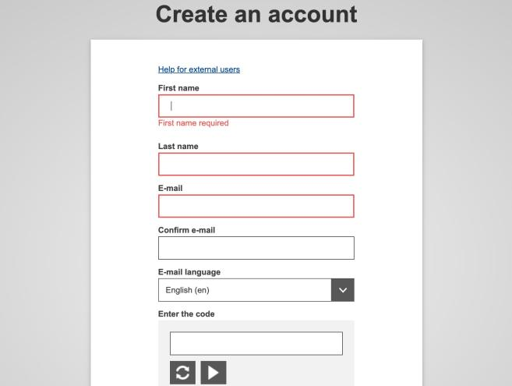
However, what makes this test a fail is that sometimes an error message next to the invalid form fields is not provided. For many users, especially users with magnifying tools, it will be difficult to understand what has gone wrong and where. In the image below, the only thing indicating that something went wrong is the change of border colour.
In the error message seen on the page “Login”, the error is also in a different language.

Page reference
Create an account Log-in

Recommendation
- Provide error messages next to the invalid form fields, preferably combined with an icon.
- Provide a summary of the errors at the top of the page.

Links to guidelines
EN 301 549 - 9.2.33
WCAG 2.0 - 3.3.1 (A)
WCAG 2.1 - 3.3.1 (A)

Error messages are tied to their respective form field

Background
When error messages are inserted in a form and relate to a specific form object or a group with objects (for example a group of radio buttons), these must be tied to the form object or group. This is normally done by inserting the error message as part of the label or legend element.
This can possibly require that the error message is embedded twice, firstly to be displayed visually and secondly to be hidden in the existing instructional text. In this situation, it is advisable to conceal the visual error message for the tool and make
Fail

sure the visual concealed error message is read. This can be done like this, for example:
Html-code:

<label for="namn">Namn: <span class="dold">Fel: You have omitted to enter your name</span></label>

<input id="namn" type="text">
<span aria-hidden="true">You have omitted to enter your name</span>

CSS-code:

.concealed { position: absolute; left: -20000px;}
Preferably, the error message should be entered only once and be visible for all users.

Comment
As noted under FS140, the website does not provide a combined error message above the form fields, and rarely have any written error messages next to the invalid form fields. As the error messages are not tied to their respective form field, this checkpoint is not approved.
When implement ingan error message next to the invalid form field, tie it to the form field. The most robust way of doing it is to insert the error message as part of the label element. See the example above in the background text.
On the page “Create an account”, the error message is not heard to screen reader users. Therefore, it is not clear to the user where the problem is or if a problem has occurred at all.
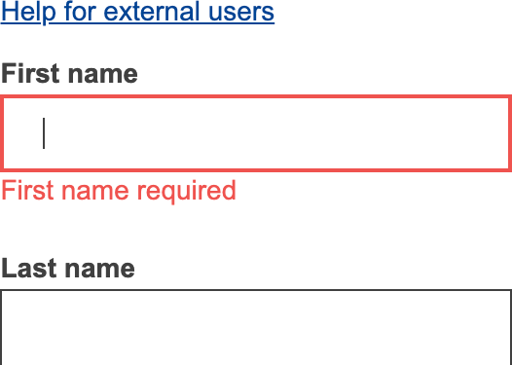

Page reference
Create an account

Recommendation
- Tie error messages with the label element for the most robust solution possible, see the example in the background text.

Links to guidelines
EN 301 549 - 9.2.7
WCAG 2.0 - 1.3.1 (A)
WCAG 2.1 - 1.3.1 (A)

All errors are described with text Fail

Background
Error messages may contain pictures or even movies, but it is important that there is always an error message in text. Therefore, it is not enough to use an icon to highlight that something is wrong, this should always be explicitly stated in text.

Comment
In some forms, text is not always used to display an error.
Using colour only to convey an error, makes it difficult for users who have difficulty perceiving different colours. Do not only use colours to show where an error has occurred, see US10.

Page reference
Create an account

Recommendation
- Describe all errors in forms with text.
- Don't use colour as the only way to convey information, see US10.

Links to guidelines
EN 301 549 - 9.2.33
WCAG 2.0 - 3.3.1 (A)
WCAG 2.1 - 3.3.1 (A)

When possible, an explanation on how to rectify errors is provided

Background
Describe the error as clearly as possible and how the user can fix it. For example, you can suggest what might be wrong:
Fail

You must enter an email address that contains an @ character
Instead of

You must enter a valid email address

Comment
When a user wants to share an idea and does not fill out the correct information, they get an error message without any suggestion of a solution.

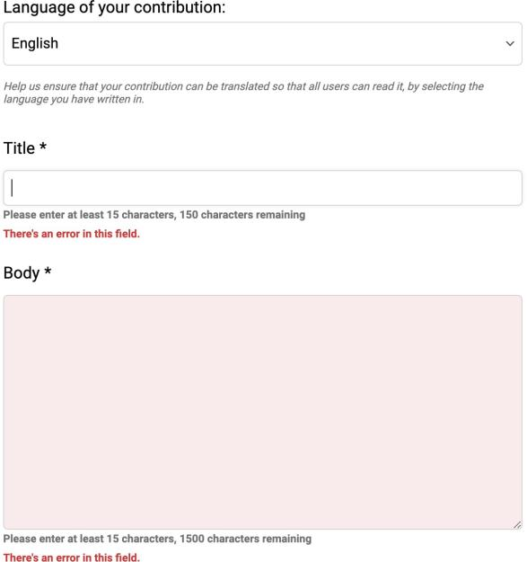

When users send in the create an account form, they receive an error message saying just first name required, see image below. Give a clearer hint on how to solve the problem.

Page reference
Share your idea Create an account

Recommendation
- Describe errors as well as possible ways on how the user can fix them.

Links to guidelines
EN 301 549 - 9.2.35
WCAG 2.0 - 3.3.3 (AA)
WCAG 2.1 - 3.3.3 (AA)

Tables
Table data is correctly coded with table code Not applicable

Background
Use correct code to create tables. It is possible to create tables that look like tables but are not coded as correct tables. There are also roles and wai-aria attributes in HTML5 that can be used to create tables instead of traditional html code, but these solutions do not always work well for users with assistive technology. Tables should therefore be built up with the elements table, tr, td and th.

Comment
We have not found any tables. Therefore, this checkpoint is not applicable.

Links to guidelines
EN 301 549 - 9.2.38
WCAG 2.0 - 4.1.2 (A)
WCAG 2.1 - 4.1.2 (A)

Headings for tables are coded with the caption element

Background
Tables are one of the most complex techniques available to present content within html. To give users the opportunity to understand the table, there must also be a correctly coded table header.
If there are no special reasons, the caption element should be used to insert a header in the table. This heading should explain what kind of information the table contains. A table could only have one Caption element and it must be inserted directly after the table element.
Example with caption element:
Not applicable

<table>
<caption>Flight Prices Stockholm-London</caption>
<tr>
...

Comment
No tables found.

Links to guidelines
EN 301 549 - 9.2.7
WCAG 2.0 - 1.3.1 (A)
WCAG 2.1 - 1.3.1 (A)

Row and column headings are coded with the the element

Background
For users to be able to interpret the contents of the tables correctly, it is important that the tables have clear column and row headings. These headlines should not only be visually clear, they must also be structurally correct with the th element instead of td elements. Th means that a table cell is a "Table Header", unlike the td element which states that the cell is a "Table Data cell". All table headings must be coded as th element.

Comment
No tables found.

Links to guidelines
EN 301 549 - 9.2.7
WCAG 2.0 - 1.3.1 (A)
WCAG 2.1 - 1.3.1 (A)
Not applicable

The scope attribute is used to set a direction for all line and column headings

Background
Table headings must be correctly associated with the data cells (and sub-headings) to which the cell is subordinate. For simple tables, it is enough if the table heading uses scope attributes to indicate that it refers to the column (scope="col") or the row (scope="row"). For tables in more than two logical levels, a more advanced marking is required (see TB100).
Example table with row and column headings:
Not applicable

<table>
<tr>
<td></td>
<th scope="col">Frukter</th>
<th scope="col">Grönsaker</th>
<th scope="col">Bär</th>
</tr>

<tr>
<th scope="row">Röda</th>
<td>Persikor</td>
<td>Rödbetor</td>
<td>Jordgubbar</td>
</tr>

<tr>
<th scope="row">Gröna</th>
<td>Äpplen</td>
<td>Isbergssallad</td>
<td>Krusbär</td>
</tr>

<tr>
<th scope="row">Gula</th>
<td>Bananer</td>
<td>Paprika</td>
<td>Hjortron</td>
</tr>

<tr>
<th scope="row">Blå</th>
<td>Plommon</td>
<td>Aubergine</td>
<td>Blåbär/td>
</tr>
</table>
;
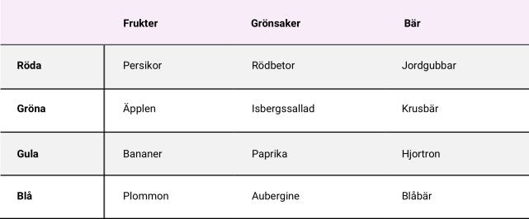

Comment
No tables found.

Links to guidelines
EN 301 549 - 9.2.7
WCAG 2.0 - 1.3.1 (A)
WCAG 2.1 - 1.3.1 (A)

Complex tables are supplemented with the relevant code

Background
Complex tables must have more specific connections between headers and data cells than simple tables. This can be done by giving each header a unique ID and then referring to it in each cell using the headers attribute.
In complex tables, logical categories can also be created using the axis attribute, which is used to group headings into common categories.
Examples of a more complex table where header cells and data cells are connected together:
Not applicable

<table>
<tr>
<th></th>
<th colspan="2" id="birds">Fåglar</th>
<th colspan="2" id="fish">Fiskar</th>
</tr>

<tr>
<th></th>
<th id="d071223a" headers="birds">Svenska</th>
<th id="d071224a" headers="birds">Afrikanska</th>
<th id="d071223b" headers="fish">Svenska</th>
<th id="d071224b" headers="fish">Afrikanska</th>
</tr>

<tr>
<th id="oneColor">Enfärgade</th>
<td headers="birds d071223a oneColor">Kråka</td>
<td headers="birds d071224a oneColor">Svart drongo</td>
<td headers="fish d071223b oneColor">Sill</td>
<td headers="fish d071224b oneColor">Guldanthias</td>
</tr>

<tr>
<th id="striped">Randiga</th>
<td headers="birds d071223a striped">Grågäss</td>
<td headers="birds d071224a striped">Härfågel</td>
<td headers="fish d071223b striped">Aborre</td>
<td headers="fish d071224b striped">Äkta kejsarfisk</td>
</tr>

<tr>
<th id="dotted">Prickiga</th>
<td headers="birds d071223a dotted">Jorduggla</td>
<td headers="birds d071224a dotted">Rödgul barbett</td>
<td headers="fish d071223b dotted">Bäckröding</td>
<td headers="fish d071224b dotted">Muräna</td>
</tr>

</table>
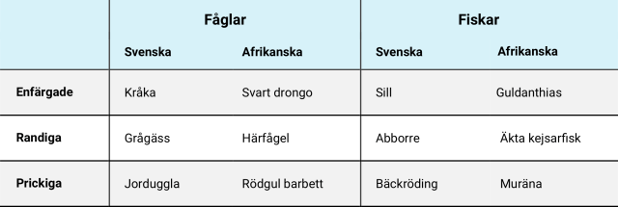

I such a complex table, dividing it into several, simpler tables or to simplify the layout in another way so that scope is sufficient to associate headings and data cells.

Comment
No tables found.

Links to guidelines
EN 301 549 - 9.2.7
WCAG 2.0 - 1.3.1 (A)
WCAG 2.1 - 1.3.1 (A)

Script & wai-aria

Use wai-aria to convey information that cannot be conveyed using HTML and that benefits users

Background
Script imposes greater demands on assistive technology (AT) compared to only using html and CSS. This means that the risk of problems is increased. We therefore recommend that all complex functions be tested using the most widely used tools to ensure no unnecessary difficulties arise.
Examples of common problems include users with assistive technology not being able to focus on layers that are opened dynamically or cannot access search suggestions in a search form. This is because new layers and new information are often inserted in the bottom of the page structure and not nearby the object on which the user is focusing. Another common problem is that clickable areas are created with script instead of with links and buttons. Assistive technology does not perceive these as genuine links/buttons and therefore does not present them as interactive objects.

Fail

WAI-ARIA
WAI-ARIA is a specification of code that enables you to provide users of assistive technology with information about the website. For instance, with WAI-ARIA you can mark-up dynamic content that makes it easier for assistive technology to manage and present the information to users.
We recommend using WAI-ARIA, but this needs to be done with caution. Do not use WAI-ARIA to rescue poorly written html. For example, it is not a good idea to use role="button" in a div element instead of using a proper button. Nor should you use WAI-ARIA without checking how it works for users; one common problem is inserting all the WAI-ARIA you can think of with the consequence that the tools become extremely vocal unnecessarily.
Support for WAI-ARIA varies between the different versions of assistive technology and browsers. This means that for the time being, we recommend testing all dynamic solutions in practice with different versions of assistive technology, devices and versions.
Information about WAI-ARIA (W3C website).

Test with assistive technology
To be certain that script does not cause problems for users of assistive technology, you need to test this practically. Exactly which kind of assistive technology ought to be tested will vary depending on the solution. Nor is it simply a matter of sitting down with an assistive technology and going through the service. You need knowledge of how users operate, how they use the assistive technology, what it feels like if you are visually impaired, etc. As a developer, for example, it is incredibly difficult to test a solution objectively as you have knowledge that the users lack.
We therefore recommend that you commission end users and/or experts to do the testing.

Comment
Wai-aria is used on the website. Wai-aria is used to improve the experience for users with screen readers. Use it in the right way, because excessive use can lead to double presentation.
For a screen reader user, the experience of the start page is frustrating. This is because every five seconds, the picture carousel gives information every time it changes slides. It occurs because of the aria-live attribute. Only use wai-aria when it enhances the experience for the user.
The aria-expanded attribute is used to inform when a field is visible and not. But
in some places, it is used in the opposite way. See SW100.
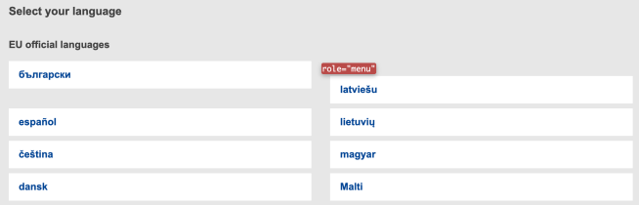
On the page where a language can be selected, the menu role is used without having any object with the role attribute with the value menu item.

Recommendation
- Only use wai-aria where it benefits users.

Links to guidelines
WCAG 2.0 - 4.1.2 (A)
WCAG 2.1 - 4.1.2 (A)
EN 301 549 - 9.4.1.2

When new elements are added to the page,
No errors found
but

they are placed in the right order, both structurally and visually

Background
Sometimes new content or new functions are added to a page without it being reloaded. When this happens, it is important that the new function or information appears in the right place both visually and structurally. If search results suddenly appear in a new area on screen when the user starts writing in the search field, it is important that this area is clearly positioned visually where it belongs. It should also appear in the right place in the structure so that assistive technology structurally present the information in the right place. It is best if this is done so that the new code is included in the right places, for example:
can be improved

<label for="sok">Sök:</label>
<input type="search" id="sok">

<!- Sökförslag läses in här -->
<input type="submit" value="Sök">
There are also other ways to resolve this, such as sensing via script what the user is doing and switching focus so that the effect is the same for the user. How this works in practice should also be tested with the most used assistive technology.
One common problem is that a new area is positioned correctly visually, but ends up last on the page structurally. If a tool does not find something until after the page footer, there is a big risk that the user will never find it.

Comment
Most new content is placed correctly in the structure, except when it comes to changing language. The covering layer is not directly after the link which opens it in the code, but at the bottom, after the footer. The focus is moved into the layer and it works well. However, as it is not structurally correct.

Recommendation
- Consider structurally placing the language content next to the link which opens it.

Links to guidelines
EN 301 549 - 9.2.8
EN 301 549 - 9.2.22
WCAG 2.0 - 1.3.2 (A)
WCAG 2.0 - 2.4.3 (A)
WCAG 2.1 - 1.3.2 (A)
WCAG 2.1 - 2.4.3 (A)

When new content or areas are loaded, focus is moved to it immediately

Background
If a covering layer or a new area opens dynamically on the page, it is important that the user focus is immediately directed onto this (unless it is a disturbance to the user). Examples of exceptions are search suggestions. The user's focus should not automatically be switched to the search suggestions as soon as they appear, as this would be interruptive.
In the case of users that navigate via the keyboard, it is important that they come directly to the new layer or content without having to tab to the bottom of the page. If this is a form, the focus can be set on the first field, otherwise the first tab step should be after the link that opened the layer or resulted in the new area being read in, leading into the first link in the area.
Also bear in mind that the reading order must be correct for users with reading aids. When they continue to read downwards on the page from the link that opened the layer, reading should continue into the layer in question. You may need to test this with assistive technology.
If it relates to messages and dialogue boxes, WAI-ARIA roles for messages and message dialogues ought to be used. If it is a form, it ought to be the alertdialog role:
Fail

role="alertdialog"
Otherwise, the alert role:

role="alert"
Information about WAI-ARIA (W3C website Problems to view HTML-tag: u
.

Comment
When sorting the comments with voiceover activated, the focus is sent to the end of the main element, even though the page did not reload. This event can be very confusing for users with assistive technology.

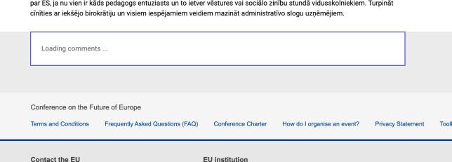

Page references
Single idea page

Recommendation
- Ensure that focus is moved to the content that opens dynamically.

Links to guidelines
EN 301 549 - 9.2.22
WCAG 2.0 - 2.4.3 (A)
WCAG 2.1 - 2.4.3 (A)

When status is changed, users of assistive technologies are informed without focus being moved

Background
Updates in the interface that take place without the page being reloaded are particularly difficult for users with severe visual impairment to perceive. It may be that there is a change in an ongoing process, such as an updated queue on a website for the sale of concert tickets. It can also be about informing the user about how many search results have been generated, or validating errors in a form. It is problematic for the user to quickly move to another part of the interface to be able to read a status message before it is outdated or has been updated.
Examples of status changes are:
- Information about the number of search results in a search.
- A change occurs in a waiting application.
- A change takes place in an ongoing process.
- Errors occur in a form.
When a status message is displayed on the screen, the user should be informed
Fail

about it without having to move to another area on the page. Attributes role = "alert", aria-live and aria-busy can be used to inform screen reader users of status messages displayed in other parts of the page than where the user currently is.
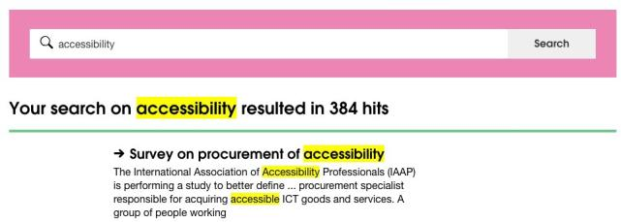
This means that the user gets status messages, without having to search for changes or to update the page. Assistive devices for users with cognitive impairments can clarify, delay, or suppress status messages, depending on the user's preference.

<div class="medium-12 columns">
<h2 aria-live="assertive" aria-atomic="true"> Your search on
<strong><mark>accessibility</mark></strong>resulted in 384 hits
</h2>
</div>

Wai-aria attributes can be used in combination to make it clearer to users that a status update is particularly important. An example of this is to use the role = "alert" and aria-live = "assertive" attributes in messages that inform the user that they are being logged out.
The attribute aria-live has three modes that determine how high priority an update in an area should have:
- Assertive = An important message that must interrupt assistive technology as soon as possible.
- Polite = A less important message that should be presented as soon as the user pauses.
- Off = A message that doesn't need to be presented to the user.
This requirement doesn't apply to error messages in modal windows, content
displayed or hidden by foldable objects or content that requires user input. Information about cookies thus doesn't count as a status message, because those require users to confirm their consent.

Comment
There are updates in the interface which occur without a page reload. When this happens, screen reader users do not receive any information about it. These updates need to be notified to screen reader users. By using aria-live or role="alert" on areas that update without a reload, this problem can be solved.
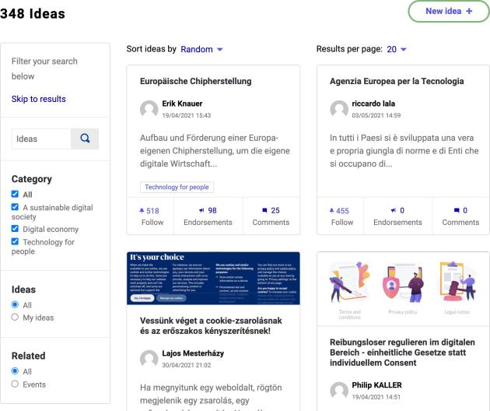
When filtering the information on a topic page, no information about this is given.
When the follow button is pushed, no information for the new status is given.
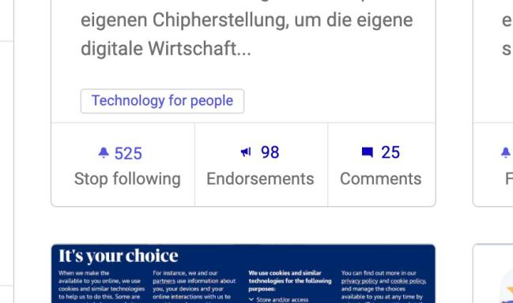

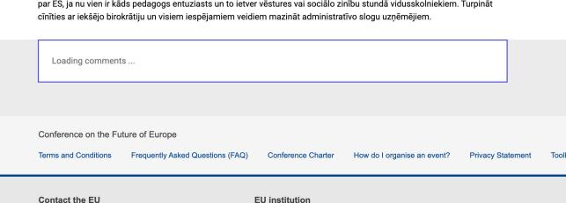
When sorting the comments, the view is first loading. When it is ready, no information that the comments are being presented in a different way is given.
When searching for a user to start a conversation, a screen reader user does not get information on how many matches there are.
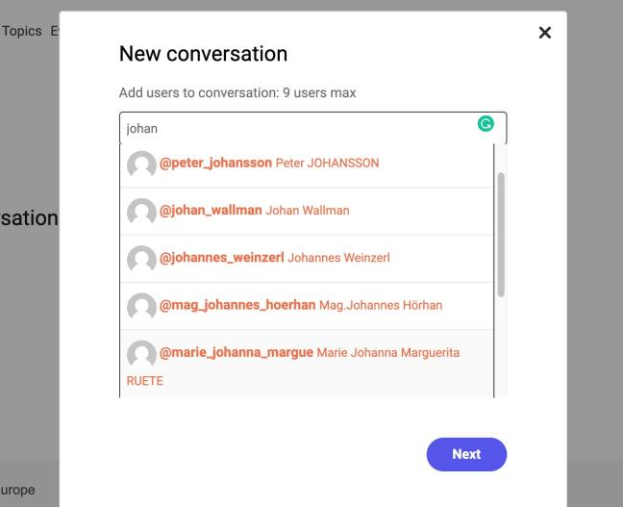

Page references
Topic page Single idea page Conversations

Recommendation
- Use aria-live or role="alert" for areas that update without page reload.

Links to guidelines
WCAG 2.1 - 4.1.3 (AA)
EN 301 549 - 9.4.1.3

Content that is shown when an object receives focus is fully usable and reachable until the user shifts focus

Background
Users with magnifying tools only see a small part of the screen, at a time, which make it hard to view large areas. It's also problematic for users to find content that is outside the area currently enlarged. Users who navigate with a mouse or a keyboard and magnifying tools that track mouse cursors and keyboard movement, must be able to move the focus without an area disappearing. This requirement applies both on hover with mouse and keyboard focus.
An example is mega menus, that is menus consisting of several levels and that are displayed in large areas shown when the user hovers over the menu. They usually cover other content and disappear when the user’s cursor moves outside the area. In order for users with magnifying tools to access all content, the user must be able to move focus freely within the area without closing it. The user should also be able to close the area in a simple way, for example with the escape key.
Areas not obscuring other content need not have a closing mechanism. An example is a menu that, instead of being opened in a covering layer, is opened above the page's content which is moved down and placed below the menu. Also, error messages describing input errors need to have a closing mechanism.
This requirement does not apply to modal windows or tooltips added with the title attribute, as these are implemented in the browser.

Comment
When hovering over the writer's name, a new layer is visible with the possibility to contact the person, see the image below. This view is hard to reach if you use assistive technology or a keyboard. For users with magnifying tools, hovering over the name to access the information can be hard. Especially when the visible layer disappears when moving away from the name. There is also no possibility to close the layer with the escape key.
Fail
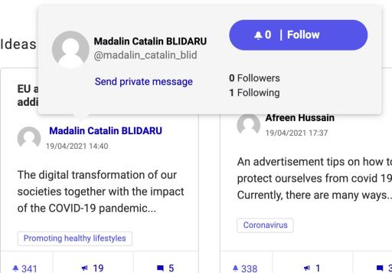

Recommendation
- Only have areas that are controllable with keyboard and assistive technology, so information and functionality are perceivable.

Links to guidelines
WCAG 2.1 - 1.4.13 (AA)
EN 301 549 - 9.1.4.13

When a modal window is shown, focus stays on the window until it is closed

Background
If you use modal windows in your interface, it is important that all users can easily return to the main content without getting stuck in the modal window.
A common error when using modal windows is that the user can end up behind the window when using keyboard navigation for example, even though it is not closed. In other words, it is a requirement that users navigating with keyboards can only orient themselves within the window until the user has closed it.
When it comes to blocking access to the "background", we recommend using the aria-hidden = "true" attribute, which you can put as high in the structure as possible to include all content that is not in the modal window.
However, blocking the background for keyboard navigation is more demanding because you have to cancel the default behaviour for each individual object, that is put as tabindex = "- 1" on all links, buttons and form objects, and whether it is relevant to other types of objects as well that already have the tab index attribute.
Fail

Comment
There is a possibility for users navigating with the keyboard or screen readers to end up behind modal windows while they are still open. When the navigation does not stay in the modal window, it is a problem for screen reader users especially, as they may find it hard to identify which information belongs to which part of the website. Therefore, the focus needs to stay in the modal window until it is closed.
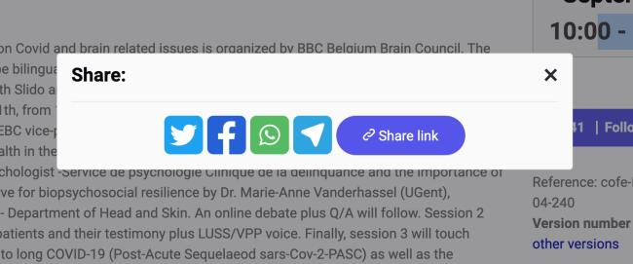
This error occurs on many of the modal windows found.

Page references
Single idea page

Recommendation
- Make sure that users navigating with the keyboard or assistive technology can't receive focus behind modal windows while they are open.

Links to guidelines
EN 301 549 - 9.2.22
WCAG 2.0 - 2.4.3 (A)
WCAG 2.1 - 2.4.3 (A)

Use aria-expanded for areas that can be expanded and collapsed

Background
The aria-expanded attribute should be used in areas that can be expanded and collapsed. The attribute states if the area is expanded or not. This can apply to an FAQ list where the answers are expanded when the user clicks on the question, or a menu that dynamically expands the next level. Aria-expanded should only be used if this is done dynamically, i.e., it should not be used with page reloading.
Fail

<h3><a aria-controls="svar1" aria-expanded="true" href="#svar1" onclick="javascript:expand-svar1();" > When should I use aria-expanded?</a></h3>
<p id="svar1">You should use this when an area can be expanded and collapsed dynamically without page reloading.</p>
<h3><a aria-controls="svar2" aria-expanded="false" href="#svar2" onclick="javascript:expand-svar2();"> Another question?</a></h3>
<p id="svar2">Another question.</p>

Comment
The aria-expanded attribute is used on some elements, but they are used in the opposite way than intended When the information is hidden - aria-expanded="true" is used, and when it is visible - aria-expanded="false" is used. It should be the other way around.

<span class="collapsible-list see-more" data- toggle="collapsible-list-7223" aria-expanded="true" aria- controls="collapsible-list-7223">(see more)</span>

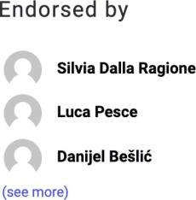

Page reference
Single page idea

Recommendation
- Use aria-expanded correctly - set as true when the area is expanded.

Links to guidelines
EN 301 549 - 9.2.38
WCAG 2.0 - 4.1.2 (A)
WCAG 2.1 - 4.1.2 (A)

Automatic events

New windows and covering layers are not opened unless the user has chosen to open them

Background
New windows and layers that partly cover the web page itself create problems for several groups of users. They create confusion and are often difficult to close.
Users should therefore always be told that a new window or covering layer is going to be opened. Users should also be able to choose if a new window or layer should be opened.
This checkpoint is aimed at layers and windows that open automatically, for example website surveys that open on top of the main window when the visitor opens a page, or advert windows that are opened when the user accesses the website. Ordinary links that open new windows should announce this to the user, however an evaluation of this information is made in checkpoint NL240 in the Navigation & links section of the audit.
New windows and covering layers should not pop up without

No errors found

the user actively clicking on a link that clearly states what is going to happen. However, an option is to let the user accept this type of occurrence in browser settings.

Comment
No windows or covering layers that open automatically found.

Links to guidelines
EN 301 549 - 9.2.29
WCAG 2.0 - 3.2.1 (A)
WCAG 2.0 - 3.2.2 (A)
WCAG 2.0 - 3.2.5 (AAA)
WCAG 2.1 - 3.2.1 (A)
WCAG 2.1 - 3.2.2 (A)
WCAG 2.1 - 3.2.5 (AAA)

If automatic events or time limits are present, there is an option to pause or increase the time span

Background
In the case of time limits, users should be offered at least one of the following alternatives:
- Disabled.
- Extended. Users can personally decide how long the time limit should last and the max value should be at least ten times longer than the default value.
- Expanded. For example, by displaying a warning a few minutes before the time limit expires, the user has an opportunity to extend this.
Users can, for example, have the option of disabling, expanding or extending the time limit via a button that is displayed next to the time limit. Another alternative is to display a message a minute or so before logging out where the user can choose to extend the log in time.
The time limit should always be related to the latest user activity that the system can recognise, not to the entire time of log in. If, for instance, the user goes from step 1 to step 2 in a service, this should set the count to log out back to zero.
If the nature of the time limit is such that the whole point of the feature would be
Fail

nullified if it were postponed or changed, this can be an acceptable exception. The same is true, if the time limit is 20 hours or longer.

Comment
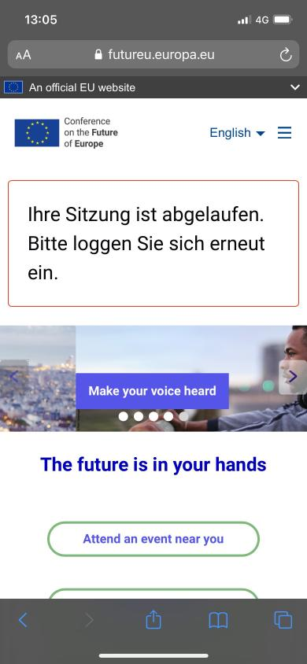
The website is automatically signing users out after a while, without any chance to extend the time limit. To meet this test, users need to have the possibility to either turn off, adjust or extend the time limit.

Recommendation
- Give users an option to either turn off, adjust or extend the time limit.

Links to guidelines
EN 301 549 - 9.2.17
EN 301 549 - 9.2.18
WCAG 2.0 - 2.2.1 (A)
WCAG 2.0 - 2.2.2 (A)
WCAG 2.0 - 2.2.4 (AAA)
WCAG 2.0 - 3.2.5 (AAA)
WCAG 2.1 - 2.1.1 (A)
WCAG 2.1 - 2.1.2 (A)
WCAG 2.1 - 2.1.4 (A)
WCAG 2.1 - 3.2.5 (AAA)

If an area is updated without the page
No errors found
but

reloading, this should be indicated with WAI-ARIA

Background
Aria-live states how important changes are in the interface. For example, it decides whether assistive technology should interrupt the user.
Use the following values:
- Off: Use for something that is updated frequently, for example stock price information.
- Polite: Use if a change only needs to be notified if the user is not doing anything important.
- Assertive: Use when something important happens that the user should be notified about as soon as possible.

Comment
On the start page, the picture carousel uses aria-live to inform when a slide changes automatically. Since the same text is used on every slide, which is not very informative, please consider if a user of assistive technology is benefitting from repeatedly hearing "Make your voice heard" as they navigate through the start page.
can be improved

Page references
Start page

Recommendation
- Use aria-live in a way that benefits the user.

Links to guidelines
EN 301 549 - 9.2.38
WCAG 2.0 - 4.1.2 (A)
WCAG 2.1 - 4.1.2 (A)

Frames

Every frame's purpose is described with the title attribute

Background
The purpose of each frame must be described in the title attribute. This information is presented by assistive technology for visually impaired users and helps them understand whether they should go into the frame and read the web page or remain on the current web page outside the frame.

Comment
No iFrames found.

Links to guidelines
EN 301 549 - 9.2.38
WCAG 2.0 - 4.1.2 (A)
WCAG 2.1 - 4.1.2 (A)

Not applicable

Search functions

There is a search function, unless there is a specific reason to not have one

Background
Many users see a search function as the simplest way of finding something on a website. For certain users it might be the only way. For example, users that think it is difficult to click their way through a menu structure step by step prefer to use a search function.
A search function is therefore one of the most important functions in a website. A small website with limited content can manage without a search function, but there is often no real reason to not have one.
Search functions can work in many different ways and it often takes an effort to get the search function to work well. A good way of testing how a search function works is to search for something you know exists on the website and then analyse the hit list.
If you do not offer a search function, then you need to offer another alternative way to find a page on the website. This can be a site map or an A-to-Z function. However, to meet the requirements of WCAG 2.0 at level AA, there should be two different ways to find a specific page in the interface if it is not about steps in an e-service or process.

Comment
There is a search function, but it does not offer the user an alternative way of navigating your web page. It is only possible to search for ideas and events, not pages.

Recommendation
- Offer a second way to navigate your webpage. It can be through an A-Z page, sitemap, or a search function.

Links to guidelines
EN 301 549 - 9.2.24
WCAG 2.0 - 2.4.5 (AA)
WCAG 2.1 - 2.4.5 (AA)

Fail

Documents & other forms of media

Background noises can easily be switched off or stopped within 3 seconds

Background
Just as movements in the interface affect the visitor's ability to understand the information, background noise also affects their ability to concentrate. Therefore, background sounds that start automatically should stop after a maximum of 3 seconds, or there must be a clear and easy way to stop the sound.

Comment
No background noise found.

Links to guidelines
EN 301 549 - 9.2.11
WCAG 2.0 - 1.4.2 (A)
WCAG 2.1 - 1.4.2 (A)

Not applicable

There is an adequate text description of complex content in connection to the content

Background
Complex formats are often good for the user. It gives the opportunity to explain complicated relationships in a more understandable way. However, the user might not be able or want to take part in complex formats. This may be because the user's equipment does not support the technology or that the connection is poor. Therefore, there must always be a clear description of the content of these complex formats. When linking to, for example a movie, one must therefore describe the film's content in text. The extent of the description depends entirely on the relevance of the film. A description can also contain links to other parts of the website where you can read the corresponding information like the one given in the film.

Sound
When information is presented using a sound clip, the corresponding information must also be in text form on the website. There must also be a clear link between
Fail

the audio clip and the alternative text.
In live broadcasts, there should at least be a clear description of what is being broadcasted, and if possible, a text reproduction should also be given. This can be done, for example, by transmitting the protocol notes from a meeting live with the sound.

Film
For pre-recorded movies, there must be a text version of the content clearly linked in connection with the film. A text version does not have to be an exact representation of the content, but should provide equivalent information.

PDF
PDF is also a complex media format that sometimes creates difficulties for users. Therefore, it is also important to have clear link texts for pdf files and consider whether the information should be in html, or if there should at least be a summary of the content in html. Also, keep in mind that the pdf file itself must be available.

Comment

Films
There are links to films on the page “Information material”. Every film should have a short description so that the user knows what to expect of the film. No descriptions were found.

PDF-documents
There are many pdf-documents uploaded on the website. To make it clear what the documents are about, there should be a description of each document. This should be clarified by making the link text better. Instead of just writing "digital platform", please add
- file type
- file size
- and be more descriptive of the file content.
We also found many examples of inaccessible documents (out of scope of this audit).

Tested documents:
The future is in your hands (pdf, 686 kb)
Agenda (pdf, 561 kb)
Rules of Procedure of the Conference on the Future of Europe (pdf, 295 kb)

Recommendation
- Give complex formats an adequate description.
- Control your documents and check their accessibility.

Links to guidelines
EN 301 549 - 9.2.1
EN 301 549 - 9.2.2
WCAG 2.0 - 1.1.1 (A)
WCAG 2.0 - 1.2.1 (A)
WCAG 2.1 - 1.1.1 (A)
WCAG 2.1 - 1.2.1 (A)

Information presented as audio in pre- recorded video is transcribed with captions

Background
If you have audio as part of a video or as an audio file, then the content should be subtitled. For video, a subtitle that is synchronized with the sound is enough. If you have a sound clip, it may be difficult to insert a subtitle. Instead, you can offer the user a text of the audio information.
Keep in mind that the subtitling should reproduce audio information, meaning speech, but it can also include other information. If, for example, the doorbell rings and the actor goes to the door and opens it, the subtitles should also indicate that it the doorbell is ringing.

Comment
No videos embedded found.

Links to guidelines
EN 301 549 - 9.2.3
WCAG 2.0 - 1.2.2 (A)
WCAG 2.0 - 1.2.9 (AAA)
WCAG 2.1 - 1.2.2 (A)
WCAG 2.1 - 1.2.9 (AAA)
Not applicable

Information presented as audio in live broadcasts is transcribed with captions

Background
Even if you have audio information in live broadcasts, the information should be subtitled. We recommend that you make an assessment to see if it is reasonable to offer live texting in the current case. However, to meet the requirements of WCAG 2.1 at level AA, it is required that live broadcasts are texted.

Comment
No live broadcasts found.

Links to guidelines
EN 301 549 - 9.2.5
WCAG 2.0 - 1.2.4 (A)
WCAG 2.1 - 1.2.4 (A)
Not applicable

Visual information in video is explained with audio

Background
A video should be audio described so that a user who does not see the video can understand what is happening. This can, in many cases, be done by an ordinary speaker voice who explain the visuals, text shown in the video etc. In more complex films, a separate audio track may be needed for the audio description.
Even in this case, you should make a reasonable assessment.

Comment
No embedded videos found.

Links to guidelines
EN 301 549 - 9.2.4
EN 301 549 - 9.2.6
WCAG 2.0 - 1.2.3 (A)
WCAG 2.0 - 1.2.5 (AA)
WCAG 2.1 - 1.2.3 (A)
Not applicable

WCAG 2.1 - 1.2.5 (AA)

It is made clear where users can find alternatives to content presented in another way other than text

Background
A video, image or audio file can often provide complex information in a simpler way than text. You should therefore aim to use graphics and audio to provide information where appropriate.
As soon as you use graphics, video or audio to provide information, you also need to offer an alternative to users who have a visual or hearing impairment. For example, a text version of a video can be offered and a graph shown in tabular form with the same data. In the case of ordinary images, an alt-text (attribute alt) is sufficient. The description will then be directly from the image; however, as soon as you work with more complex alternatives than ordinary alt-texts, you need to clearly link the various alternatives together.

Comment
On the page “Information material”, there are two images that are showing complex information, but no alternative text is provided.
Fail

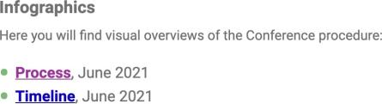

Page references
Information material

Recommendation
- Make it clear where users can find alternatives to complex formats.

Links to guidelines
EN 301 549 - 9.2.1
WCAG 2.0 - 1.1.1 (A)
WCAG 2.1 - 1.1.1 (A)

Help & transition to manual service

If there is a description on how users of assistive technologies manage a specific function, the description and the function should be tied together

Background
Sometimes an explanation is needed for severely visually impaired users about how a function should be used. Include such an explanation with any of the WAI- ARIA attributes aria-describedby or aria label:
- Use aria-describedby if the explanation is visible to all users. For example, if the explanation lies as a body text during the function.
- If this is an explanation for a form object, it should instead be in the label element. Note that the support for aria-describedby is lacking today and that you should not rely solely on it.
- Use aria-label to add an explanation that is hidden to all users except screen reader users.

Comment
No descriptions of how users with assistive technology should manage specific functions found.

Links to guidelines
EN 301 549 - 9.2.7
WCAG 2.0 - 1.3.1 (A)
WCAG 2.1 - 1.3.1 (A)

Not applicable

Understandability

Understandability is not dependent on the user’s ability to perceive colour

Background
Many times colour is a clear and functional way of conveying information. Red colour indicates warning texts and error messages and blue colour is strongly associated with links. Even if it is good to use different colours to convey information, one should not completely rely on colour. About 350,000 Swedes are considered colour blind. It does not mean that everyone looks in greyscale. In this group, for example, everyone who is only red-green colour blind is included. However, it is a significant group and you do not have to be counted as colour-blind to have problems perceiving different colours in different situations. For example, it is considerably more difficult than normal to perceive colour changes in continuous text if you are sitting with a mobile or tablet outdoors on a sunny day.
In order for the user's ability to perceive colours not to be decisive, it is always necessary to supplement with at least one other way of giving the information. For example, links can be underlined, buttons in different colours can be provided with text and so on.
It should also not be required that the user's computer be set "correctly". In many browsers there is a setting for "always" underlining links, which means that if the website has not indicated that links should be underlined or that they should not be underlined, the links are underlined. For a person who borrows a public computer, for example at the library, it is not always possible to influence the settings, and you cannot be sure that the "correct" setting is made. Therefore, you should clearly indicate in the style templates (CSS) that links should be for example both underlined, bold or in a specific colour.

Comment
Errors in forms are shown with a red frame around the input fields indicating that something has gone wrong (see the image below). Using colour only to convey that there is an error makes it difficult for users who have difficulty perceiving different colours to understand where the error has occurred. Colour must be complemented with text.

Fai

Recommendation
- Don't use colour as the only way to convey information.

Links to guidelines
EN 301 549 - 9.2.10
WCAG 2.0 - 1.4.1 (A)
WCAG 2.1 - 1.4.1 (A)

Understandability of instructions or references are not dependent on the user's ability to see or hear

Background
To enable all visitors to understand instructions and descriptions, it is important that this is not dependent on the visitor's ability to see or hear. To describe something using colour can be a good way of making this clear to users, but this must be complemented by other information. Instead of writing "click on the green button" the instructions could be "click on the green button with the word 'Accept'
Fail

underneath". Then, in addition to the colour, you will have text and a position to help users locate the button.
Nor should you refer to objects that are located "to the right". This kind of reference cannot be understood by users who are unable to see the interface. Furthermore, objects sometimes end up somewhere else depending on the width of the screen in a responsive interface.
Most instructional videos assume that users can both see and hear. Such videos must therefore always be complemented by a text version.

Comment
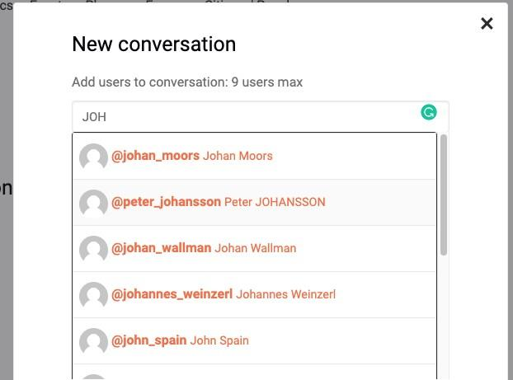
Search suggestions is provided in the message function. However, a screen reader user will not be able to understand that they are presented because they only appear visually below the search field (see the image below).
Therefore a hidden instruction to screen reader users that suggestions are displayed and how they can reach them, is needed. The instructions must follow the language of the page and the easiest way is to place the instructions in the label element.

Recommendation
- Provide instructions on where to find the search suggestions and how to reach them in the label element of the search field.

Links to guidelines
EN 301 549 - 9.2.9
WCAG 2.0 - 1.3.3 (A)
WCAG 2.1 - 1.3.3 (A)

