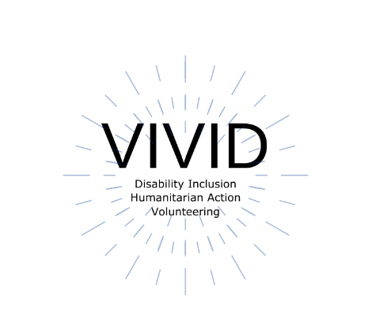

Toolkit

Accessible Meetings and events
  - European Disability Forum
  - By Roberta Lulli – Raquel Riaza
  - September 2021
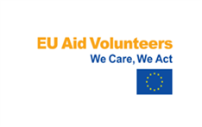 | This publication has received financial support from the European Union. The information contained in this publication does not necessarily reflect the official position of the European Commission.  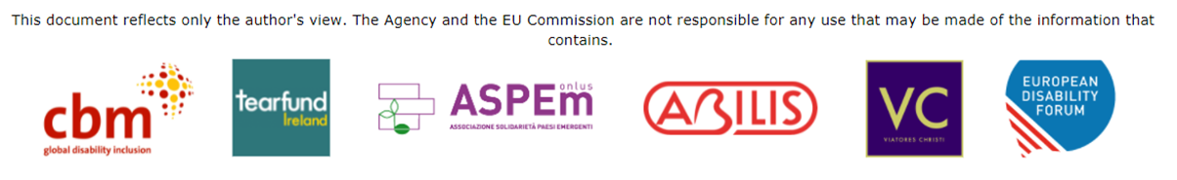
Contents

Introduction 3
Online meetings and events 4
Online events. Make your check list! 4
Online event platforms: Comparison table 5
Accessibility Features 6
Real-time captioning 6
Sign interpretation 6
Other accessibility features 6
Before the event 7
Date and time, format of the event 7
Invitations and registration form 8
Agenda and structure of the event 9
During the event 10
Present in an accessible manner 10
How to take questions 10
After the event 11
Zoom 12
How does Zoom score? 12
How to create an event on Zoom. Small tips 12
Platform Accessibility Links 13

Introduction
When meetings and events are held remotely or in person, accessibility is important to ensure that all attendees, including people with disabilities, are able to participate and engage with the content and audience.
- Be accessible from the beginning!
- Planning is key
With a little pre-planning, event organisers can structure an inclusive and functional environment for all participants.
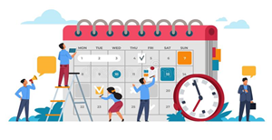

Online meetings and events

“For most people, technology makes things easier.
For people with disabilities, however, technology makes things possible.”
Mary Pat Radabaugh
Director of IBM’s National Support Center for People with Disabilities 1998

Online events. Make your check list!

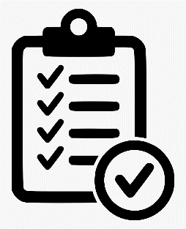
- Online event platforms: Comparison
- Accessibility features
  - Real-time captioning
  - Sign interpretation
  - Other accessibility features
  - Budget!
- Before the event
  - Date and time, format of the event
  - Invitations and registration form
  - Agenda and structure of the event
- During the event
  - Present in an accessible manner
  - How to take questions
- After the event
  - Survey

Online event platforms: Comparison table

- We are going to focus on how to make online events as inclusive as possible for all persons with disabilities.
- There is a lot of online platforms available in the market, but not all of them are fully accessible or allow us to create accessible meetings and events.
- First thing to consider: your budget!

Platforms | Signing deaf participants visible | Sign language interpreter visible | Captions can be added | Screen reader compatibility | Good for large meeting | Good for small meeting | Additional barriers
GoToMeeting |  | ✓ | ✓ | ✓ | ✓ | ✓ | Keyboard shortcuts only work in Windows
Zoom | ✓ | ✓ | ✓ | ✓ | ✓ | ✓ | Requires a good internet connection
Skype | ✓ | ✓ | ✓ | ✓ |  | ✓ | Video quality inconsistent
Skype for business | ✓ | ✓ | ✓ | ✓ |  | ✓ | Not accessible for blind facilitators
Microsoft Teams | ✓ | ✓ | ✓ | ✓ |  | ✓ | Challenging when signed and spoken languages are used with larger groups
Google Hangouts | ✓ | ✓ | ✓ | ✓ |  | ✓ | Meeting creators must have a G-Suite
WhatsApp | ✓ | ✓ |  | ✓ |  | ✓ | Requires Wi-Fi or 4G connection
Be.live | ✓ | ✓ |  |  |  | ✓ | Keyboard shortcuts only work in Windows

Source: CBM

Accessibility Features

There are some basic accessibility features that your event needs to provide:

Real-time captioning
- Allows participants to follow the event simultaneously and in text
- Useful for many participants and interpreters
- Integrated in the platform and through an external link
- Shown in the platform as subtitles and/or full transcript
- Possibility to provide it in different languages (only one in the platform and the rest through the external link)
- One captioner per language

Sign interpretation
- Allows participants to follow the event with sign interpretation
- Useful for deaf and hard of hearing participants
- Usually two interpreters switching every 10 minutes
- Possibility to pin, spotlight and resize the images

Other accessibility features

- Screen reader compatibility
  - Labelled buttons all over the platform
  - Allows participants to access all the platform utilities
- Shortcuts for the basic functions, such as camera, microphone, raise hand, chat, share screen, etc.
- Accessible in both desktop and phone/tablet versions
- Easy to use
  - Steps to register
  - Steps to download or launch the platform
  - Main functions during the event and pop-up windows

Before the event

Date and time, format of the event
- Availability of speakers and interpreters
- Max. length of the event 2h30 hours recommended
- Format: meeting or webinar
  - Meeting: ideal for hosting more interactive sessions where you’ll want to have lots of audience participation or break your session into smaller groups.
  - Webinar: ideal for large audiences or events that are open to the public. Typically, webinar attendees do not interact with one another.
  - Consider your budget! Larger capacity means extra cost.
Features | Meeting | Webinar
Audience | Small-medium audience | Large audience
Roles | Host, Co-Host, participant | Host, Co-Host, Panelist, Attendee
Audio | Everyone can control audio | Attendees in only -listen mode
Video | Everyone can control video | Only host and panelists can control video
Partecipants list | Everyone can see participants | Only host and panelists can see attendees
Chat and Q&A | Only chat box | Chat and Questions Box
Email reminders | No email reminders | Email reminders when registration form enabled
Polls | Polling available | Polling available
Surveys | Post- event survey available | Post- event survey available
Registration | Registration form for meeting | Registration form for webinar
Close Captioning | Available | Available
Recording | Available | Available
Breakout Room | Available | Not Available
Password | Availabe | Available

Invitations and registration form

- The invitation may have multiple graphical elements, ensure that images and logos have alt text and documents/programs are accessible
- Send the link to register via email /post on social media
- If you are including a registration form, ensure that the form and the platform are accessible, especially to users who might not be using a mouse, or use a screen reader,
- Include a statement letting individuals know that they can request accommodations
- Include privacy statement for personal data and recording permission.
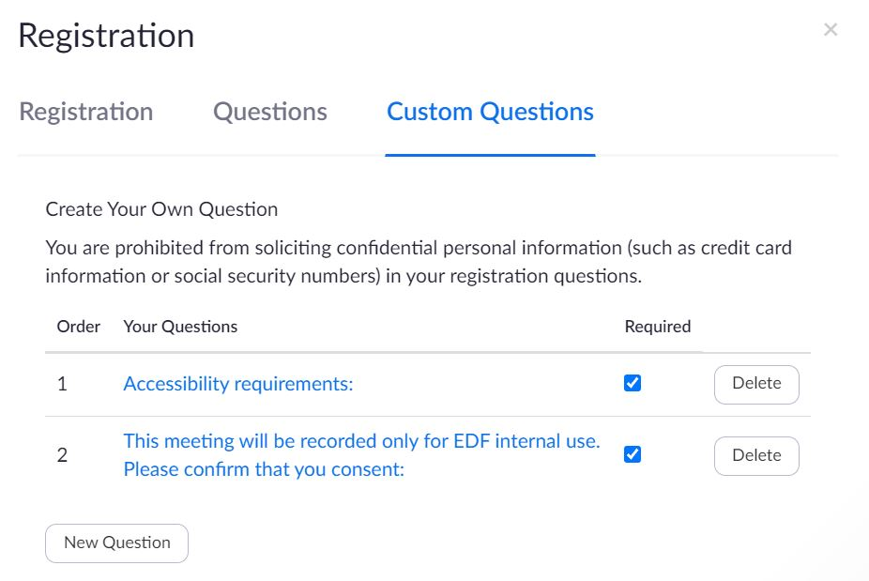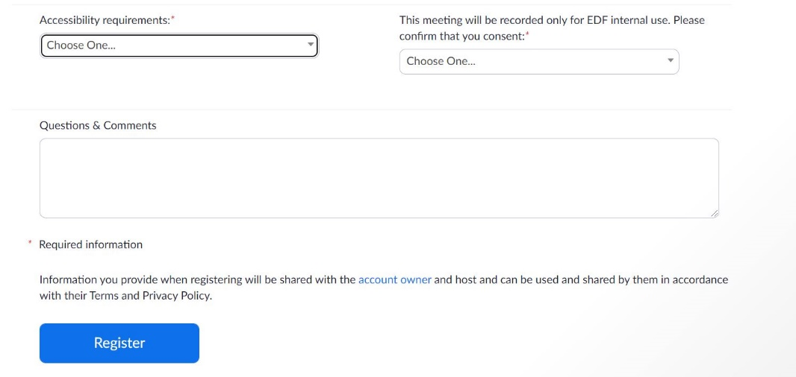

Agenda and structure of the event

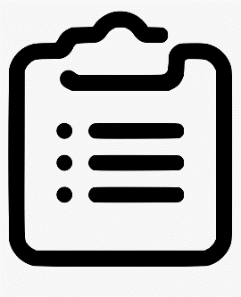
- Agenda
  - Contact speakers and moderator in advance
  - Deadline for presentations and speaking notes. Create in advance all documents in an accessible format
  - Propose a test at least one week before the event with interpreters and speakers
  - Plan a break of 15 min. at least
  - Make room for at least 20 min. Q&A during the event
  - Plan a practice session of at least 45 min. before the event with panelists and interpreters to check on connection, screen sharing and last-minute questions

- Structure of the event
  - General slides to be prepared in advance
    - Accessible format
    - House-keeping rules slides at the beginning
    - Speakers profile slide with picture
    - Share in advance with interpreters and participants so they can prepare the vocabulary.
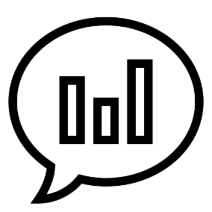
  - Create post-event survey in advance
  - Polls: decide if you will use polls during the event and make sure they are accessible
  - Videos
    - Format compatible with the platform
    - Captioning integrated or send to the captioner in advance
    - Send to the sign interpreters in advance
  - Establish a single point of contact for technical and content questions in advance.
  - Establish clear roles:
    - Host, Co-host, moderator, speaker
    - Control over the presentations
    - Management of content questions
    - Management of technical questions and issues

During the event

Present in an accessible manner

- Encourage all attendees to identify themselves by name before speaking. Give a physical description is very useful.
- Speak slowly and not too fast. Captioners need to be able to follow-up correctly
- Turn on your video and face the camera. Seeing the speaker helps participants maintain attention, and it can be helpful for anyone who is reading lips.
- Be descriptive and describe visual content (including videos)
- Keep in mind that expressions such as, “right here” or “here we see” or "in the upper-right" will not translate well to participants who cannot see the screen.
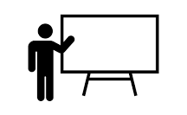

How to take questions

Participants have a few options for asking questions during an online event. These options vary depending on the event format (meeting or webinar).
- Q&A dedicated box (not always available)
- Chat box
- Raise their virtual hands and unmute themselves
Did you know… Repeating the questions helps anyone who can’t access the chat visually during the session, and it can even improve quality of captioning.
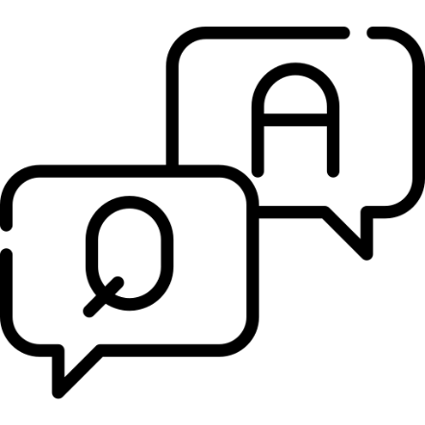

After the event

Follow up after the meeting and sharing materials (notes, transcript, recording, links, resources) always in an accessible format.
- Post a Video Recording of the event with accurate captions
  - Recording should include the sign interpretation and the subtitles
  - Share the materials used during the event as an attachment
  - Consider a video and subtitles editor to correct and time the transcript
- Post-event Survey
  - Available as an integrated function in the platform or you can use an external program
  - Do not exceed 15 questions if possible
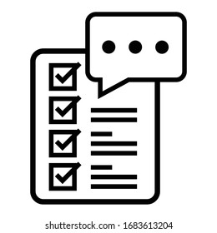
  - Collect feedback from participants on the content and accessibility of your event.

Zoom

How does Zoom score?

Zoom is the most widely used platform for online meetings and events and one of the most accessible ones.
- Possibility to multi-pin and resize cameras for sign interpretation
- Real-time captioning integrated as subtitles and full transcript modes
- Screen reader compatible
- Meeting and Webinar formats
- Language interpretation up to 9 different languages
- Breakout rooms
- Buttons large and with icons
- Does not require download, launches on Browser
Requires a good internet connection and mobile version less accessible than desktop. US based.

How to create an event on Zoom. Small tips

- Meeting or webinar? It depends on the budget, level of interaction and the capacity needed for the event.
- Be careful with the time zone you indicate
- Customize your registration form including the accessibility requirements and permission to record questions (make them required)
- Create your polls, breakout rooms and post-event survey in advance
- Establish your alternative hosts and language interpreters in advance
- Make sure you invite all your panelists and interpreters:
  - In meeting send them all the registration link by email
  - In webinar add them manually in the dedicated section
- For the practice session before the event:
  - In meeting enable the “waiting room”
  - In webinar enable the “practice session”
- Choose destination of your recording: in the cloud or in your computer
- If you know from which countries your participants are going to be using the phone to attend your event, customize the “Dial” countries in “Audio”.

Platform Accessibility Links

- Zoom: Zoom – Accessibility
Zoom – Getting Started with Closed Captioning
- Microsoft Teams: Microsoft Teams Accessibility
- GoToMeetings: Accessibility Features
- Google Hangouts: Using Hangouts with a Screen Reader;
Keyboard Shortcuts for Hangouts
- Google Meet: Google Meet Accessibility

Roberta Lulli
Digital Accessibility Trainer VIVID-T project
Roberta.lulli@edf-feph.org - Twitter: @robiula

Raquel Riaza
Events and administration Officer
Raquel.riaza@edf-feph.org

The European Disability Forum
Avenue des Arts 7-8
1210 Brussels, Belgium.
www.edf-feph.org
info@edf-feph.org

