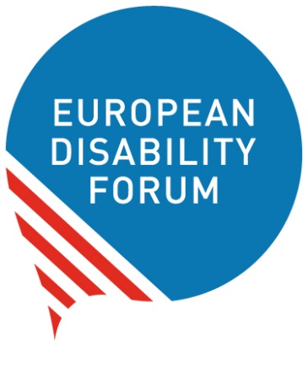
Preparing for the Global
Disability Summit


Easy-to-read version
Easy-to-read is information
that is written in a simple way
so that people with intellectual disabilities
and all people can understand it.
You can find more information at
www.inclusion-europe.eu/easy-to-read

The Global Disability Summit

On 16 and 17 February 2022,
an important meeting will take place online
about the rights of people with disabilities
in poorer countries of the world.

The meeting is called
the ‘Global Disability Summit’.

People and organisations from all over the world
will take part in this meeting.
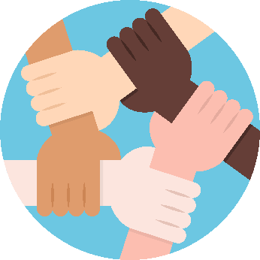
For example,
people who make decisions for different countries
and organisations of people with disabilities.
They will talk about
how the situation is for people with disabilities
in poorer countries of the world
and how they can work together
to make a difference.

This is the second time this meeting happens.
The first time was in 2018 and had many good results.

The meeting helps to make
the ‘UN Convention on the Rights of Persons with Disabilities’
happen.
In short, we call it ‘UN Convention’ or ‘CRPD’.
This is an agreement many countries in the world have made
to protect the rights of people with disabilities.
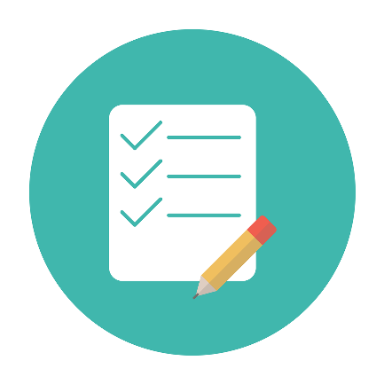
Also, the meeting helps to achieve
the ‘Sustainable Development Goals’.
These are goals set
by many countries in the world
to look after the planet and its people.
We want to achieve these goals by 2030.
In short, these goals are called ‘SDGs’.

SDGs can make a difference for people with disabilities too
and especially those who live in poorer countries of the world.

Amongst others, the Global Disability Summit aims to:
- Make sure countries take into account

the needs and rights of people with disabilities.
- Help organisations of people with disabilities
in poorer countries
to be stronger and be heard
by their government.
- Show the progress that has been made
since the meeting of 2018.
- Agree on new aims for the future
to make things better
for people with disabilities in the world.


If you are interested in these topics
and you want to take part
in the Global Disability Summit,
please fill the form here.

Preparing for the Global Disability Summit

Many European organisations
will take part in the Global Disability Summit.
They are working to make the most
of this important world meeting.
Amongst others, they:
- Collect the views of people with disabilities
so they can represent them at the meeting in the best way.
- Discuss the aims of the Global Disability Summit
and how they can have an active role
in making them happen in Europe.

On 8 February 2021,
European organisations will come together
to discuss all this
and plan their participation
in the Global Disability Summit.

You can also take part in this meeting
by filling this form here.

EDF has an active role in these meetings
representing all people with disabilities
and their organisations in Europe.

We made a useful document
to support our members
to take part in the Global Disability Summit
and get their governments to take part too.

We want the voices of all people with disabilities
to be heard at the Global Disability Summit

and to leave no one behind.

If you have questions,
please send us an email at:
ansofie.leenknecht@edf-feph.org.

