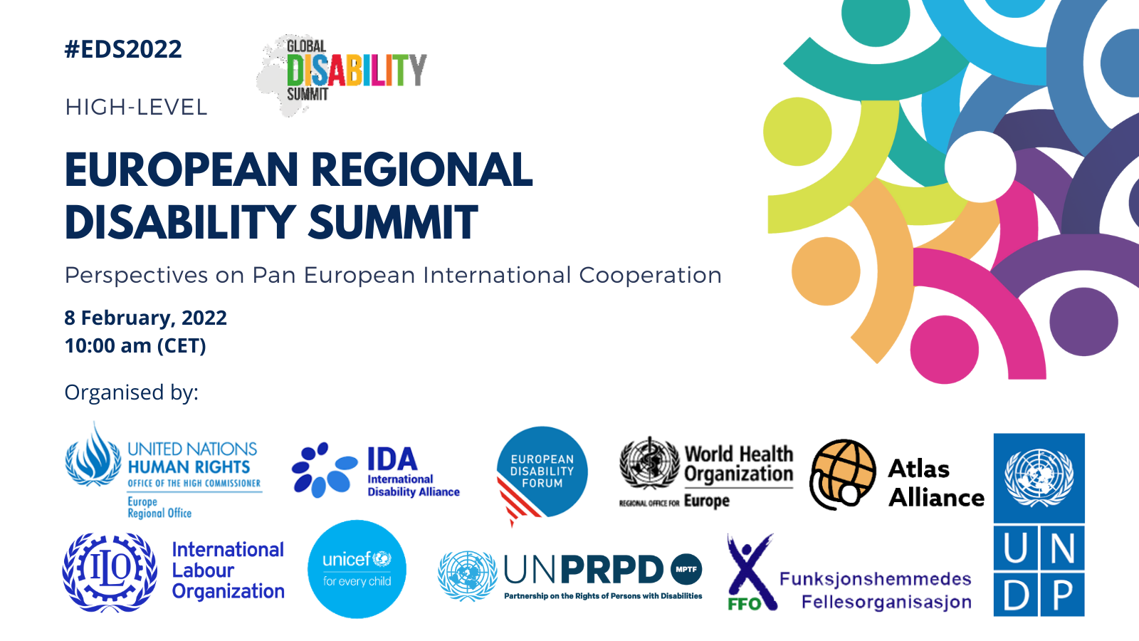

PORTRAIT MODERATORS AND SPEAKERS

Opening session

Moderator: Dr Ola Abu Al Ghaib, Manager UN Partnership on Persons with Disabilities Fund at UNDP

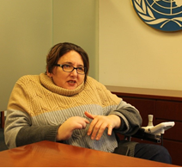
Dr. Ola Abualghaib was appointed Manager of the Technical Secretariat of the UN Partnership of Persons with Disabilities Multi Partner Trust Fund in August 2019. Ola has over twenty years of experience working on gender and disability in development including in fragile and crisis affected settings in the Arab States, Africa and Asia. Previous to her appointment in the UNPRPD she has been the Director for Global Influencing and Research at Leonard Cheshire Disability in London, UK. During the last 10 years she has worked with the UN system at global, regional and country level to support disability inclusive policies and programmes. She also served as the Vice Chair of the International Disability and Development Consortium (IDDC) and a board member of the Disability Rights Funds. Ola was recently featured in the Gender Equality Top 100 list of most influential people in global policy in 2019. She has a PhD on Social Protection from the University of East Anglia, UK. Ola is originally from Palestine.

State Secretary Ms Bjørg Sandkjær, Norway
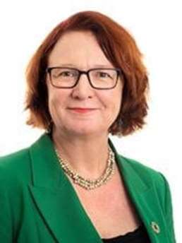
Ms Bjorg Sandkjær is the State Secretary for International Development. Her background is in global health, with particular focus on access to products and services, as well as human rights and population issues. Most recently, Ms Sandkjær served as the deputy leader of the Standing Committee on Health and Welfare of the Oslo City Council. Previously, Ms Sandkjær worked on global health and human rights at the Norwegian Agency for Development Cooperation (Norad), as well as at Gavi, the Vaccine Alliance, the UN Economic Commission for Africa, and the Church of Norway. Ms Sandkjær holds a Master’s degree in Demography.

Mr Yannis Vardakastanis, President of the International Disability Alliance and the European Disability Forum

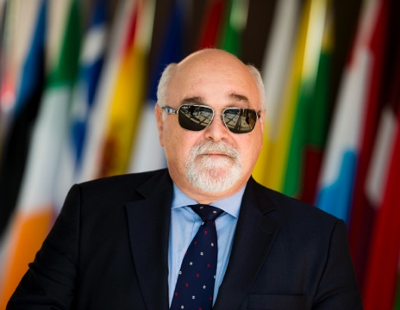
Yannis is the President of the National Confederation of Disabled People of Greece (N.C.D.P.), which is the umbrella organization of the Greek disability movement, since 1993.
He is the President of the European Disability Forum (EDF), the umbrella organization of the European disability movement since 1999. He was recently elected President of the International Disability Alliance. He is also a member of the European Economic and Social Committee (EESC) representing the N.C.D.P. in Group III (since 2010). He is one of the Vice-Presidents of this Group. Moreover, he is a member of the Economic and Social Council of Greece as well as a member of the National Commission for Human Rights of Greece.

Lilly Ann Elvestad, Secretary General, Norwegian Federation of Organisations of Disabled People (FFO)

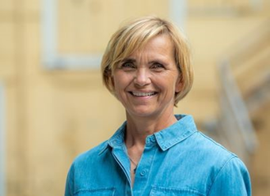
Lilly Ann has been employed as Secretary General for The Norwegian Federation of Organisations of Disabled People (FFO) in December 2015. Due to FFOs long lasting commitment in supporting the establishment of similar federations of DPOs in both Nepal (NFDN) and the southern parts of Africa (SAFOD), she has held the position as board member, and for the past 4 years, the chairman of board of the Atlas-alliance. Before joining FFO, Lilly Ann had long work experience in both public service on both governmental and municipal level, following by 10 years with management positions in Norwegian Air Ambulance Foundation. Lilly Ann holds both a master degree in Economics (university of Bergen, Norway) and a master of business administration (MBA) (Weber state university, Utah, USA).
Mr Martin Seychell, Deputy Director-General, Directorate General for International Partnerships, European Commission
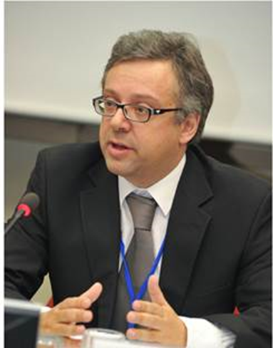
Mr Seychell is a graduate in chemistry and pharmaceutical technology. He occupied the post of Head of Directorate for Foodstuffs and Chemicals at the Malta Standards Authority between 2001 and 2006, and that of Director of Environment Protection at the Malta Environment and Planning Authority between 2006 and 2011. He was appointed Deputy Director General for Health and Consumers at the European Commission in March 2011. Between 2014 and 2020 he was Deputy Director-General for Health in the Health and Food Safety Directorate-General (SANTE), responsible for directorates dealing with public health and health systems and products, covering a number of policy areas including health security, health systems, pharmaceuticals, medical devices, tobacco control and digital health. He also represented the Commission on the Management Board of the European Centre for Disease Prevention and Control (ECDC) between 2011 and 2020. He was appointed Deputy Director General responsible for Directorates G & R (Human Development, Migration, Governance and Peace (G), and Resources (R) in DG INTPA in June 2020.

Session 2: High level plenary discussion

Moderator Ms Catherine Naughton, Director of the European Disability Forum
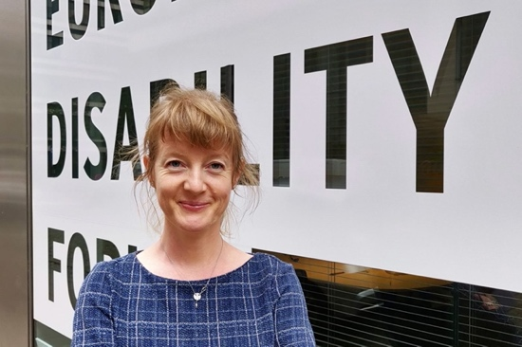
Catherine Naughton is the Director of the European Disability Forum (EDF), a unique platform which brings together representative organisation of persons with disabilities from across Europe. She is also the Vice President of the Social Platform. Social Platform is the largest network of European rights- and value-based civil society organisations working in the social sector.
Catherine has an academic background in public health, and 25 years of experience in the field of disability- with a particular focus on inclusive development: the rights of persons with disabilities in low and middle income countries.
She has worked in many countries, and at the EU and International level in promoting the inclusion of person with disabilities in mainstream development and humanitarian programmes.

Ms Mirjana Spoljaric Egger, UNDP, Regional Director for Europe and the Commonwealth of Independent States, United Nations Development Programme (UNDP) Europe and Central Asia
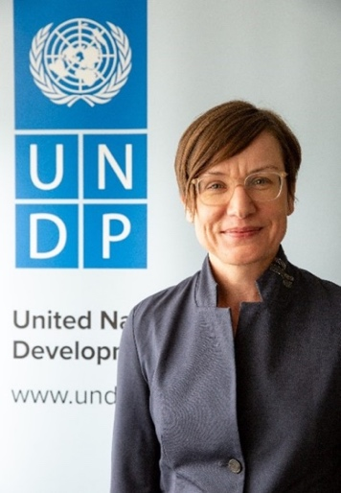
Ms. Mirjana Spoljaric Egger is Assistant Secretary-General of the United Nations, Assistant Administrator of UNDP, and Director of the UNDP Regional Bureau for Europe and the CIS. She assumed her duties in October 2018.
Ms. Spoljaric Egger previously served as Ambassador, Head of United Nations and International Organisations Division of the Swiss Federal Department of Foreign Affairs, where she has been instrumental in shaping Swiss UN policies and host country affairs.
Ms. Spoljaric Egger combines a strong policy background with field experience and has had several assignments in the Swiss Federal Department of Foreign Affairs in Berne, New York, Cairo, and with the Office of UNRWA's Commissioner-General.
Ms. Spoljaric Egger holds a Master's Degree in Philosophy, Economics and International Law from the University of Basel and the University of Geneva.

Dr Hans Kluge, Regional Director, World Health Organisation, Regional Office for Europe
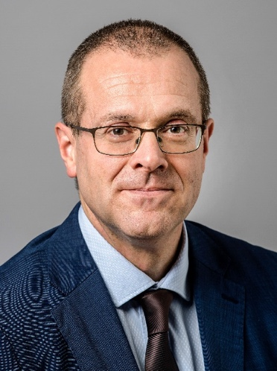
Dr Hans Henri P. Kluge is the WHO Regional Director for Europe. His term began on 1 February 2020, following his nomination by the WHO Regional Committee for Europe and appointment by the WHO Executive Board.
Throughout his career, beginning as a family doctor in Belgium, along a journey to Somalia, Liberia, the prisons in Siberia, former Soviet Union countries, Myanmar and the Democratic People’s Republic of Korea, and most recently leading the Division of Health Systems and Public Health at WHO/Europe for a decade, Dr Kluge has always been committed to achieving better health for all with a focus on the vulnerable.
As Regional Director, Dr Kluge’s vision for the WHO European Region is “United action for better health”, working in partnership to achieve universal health coverage, address health emergencies and promote healthier populations. Dr Kluge is from Belgium. He is married and has two daughters.

Ms Afshan Khan, UNICEF Regional Director for Europe and Central Asia, and the Special Coordinator for the Refugee and Migrant Response in Europe
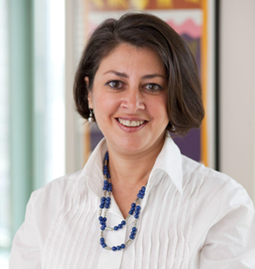
Afshan Khan is the UNICEF Regional Director for Europe and Central Asia, and the Special Coordinator for the Refugee and Migrant Response in Europe. She is based in Geneva.
Ms. Khan has been an international public servant for over 30 years. Previously she was the Director of Emergency Programmes for UNICEF, and she has also held other senior positions including Director of Public-Sector Alliances and Resource Mobilization; Associate Regional Director for Eastern and Southern Africa; and the UNICEF Representative in Jamaica. Ms. Khan has extensive field experience including assignments in Kenya; Mozambique; Democratic Republic of Congo; and Colombia. She also has broad United Nations-wide expertise stemming from assignments with the Inter-Agency Standing Committee for Humanitarian Affairs (IASC) in Geneva; the Executive Office of the Secretary- General; and the United Nations Development Group. From 2012 to 2014 Ms. Khan took leave from the United Nations to become the CEO of Women for Women International. In that role, she was responsible for setting the strategic vision and mobilizing the necessary resources for women rebuilding their lives after war.

Mr Heinz Koller, Assistant Director General, Regional Director for Europe and Central Asia , International Labour Organisation (ILO)
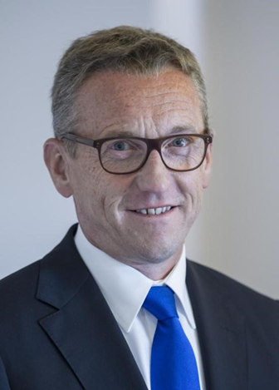
Appointed Regional Director of the ILO Regional Office for Europe and Central Asia at the Assistant Director-General level, based in Geneva, with effect from 1 June 2014. Heinz Koller’s responsibilities cover relations with the tripartite constituents from 51 ILO Member States in the EU/European Economic Area, Central and Eastern Europe, Russia and the Community of Independent States (CIS), Israel and Turkey, as well as relations with the European institutions. He is also Member of the Global Management Team of the ILO. In 2010, Mr Koller was appointed Director General at the Federal Ministry of Labour and Social Affairs in Berlin, where he managed the Directorate General for European and International Employment and Social Policies and the European Social Fund. In this capacity he was also responsible for ILO relations.

Mr Christian Salazar, Director Field Cooperation and Technical Cooperation Division Office of the United Nations High Commissioner for Human Rights, (OHCHR)
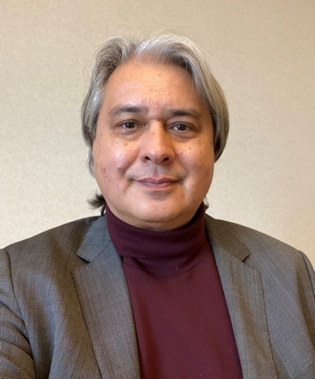
Mr Christian Salazar Volkmann works as Director for Field Operations and Technical Cooperation for the Office of the High Commissioner for Human Rights in Geneva. Before that, he served as Regional Director for Latin America and the Caribbean in the newly established UN Office for Development Cooperation (DCO) in Panama. In this role, he oversaw the Resident Coordinators in the region, supporting the development of new UN Cooperation Frameworks and the implementation of UN reform.

From 2015-2019 he led the UN work in El Salvador and Belize as UN Resident Coordinator and UNDP Representative. Prior to this assignment, Mr. Salazar Volkmann held the position of Deputy Director, Programme Division at UNICEF HQ (2012 – 2015), serving, amongst others, as UNICEF´s programmatic lead for the Agenda 2030, and divisional focal point for emergencies, peacebuilding, resilience and migration. From 2009-2012, Mr. Salazar represented the Office of the High Commissioner for Human Rights in Colombia.

Previous experience further includes working as UNICEF Representative or Deputy Representative in Iran, Vietnam and Guatemala as well as Deputy Executive Director of the German Committee for UNICEF. He also served as Senior Advisor on Youth and Human Rights for the German Agency for Development Cooperation GIZ.
He initiated his professional career in the private sector, in the trade fair business as well as in the film industry. Mr. Salazar Volkmann has obtained a PhD in Political Sciences at Marburg University and an M.A. in Communications, Economics and Philosophy at the Ruhr-University Bochum. He has been invited as Research Fellow by Harvard Law School and held guest lectures at The New School University and at New York University. He has published research on development and human rights in numerous academic magazines

Mr. Jaroslaw Ponder, Head of the ITU Office for Europe, International Telecommunication Union (ITU), Switzerland
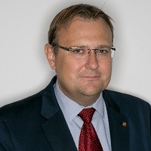
Jaroslaw K. Ponder, is the Head of the Office for Europe at the International Telecommunication Union (ITU), representing ITU in Europe and directing actions, projects, initiatives and experts groups targeting 46 countries of the Europe Region. His portfolio includes Regional Initiatives for Europe, designed by the European Member States and focusing on the ICT Infrastructure, Digitization, Digital Inclusion, Accessibility, Innovation and Cybersecurity.

During his professional career, Mr. Ponder has held official positions in the public sector and has been a leading contributor to legislative projects, which influenced public policy. Since 2004, he has been working for ITU holding diverse positions in the General Secretariat, Telecommunication Development Bureau, and Regional Presence, addressing the complexity of information society development and digital transformation at national, regional, international level, including United Nations level.

For several years, Mr Ponder has managed ITU’s work in the United Nations World Summit on the Information Society (WSIS) process, establishing the annual WSIS Forum, WSIS Prizes, WSIS Stocktaking, and others. In his current role, Mr Ponder has established several formal coordination mechanisms facilitating the work of UN agencies in advancing digital transformation at the national and regional level. For several years, Mr Ponder has been also leading the roll out of the ITU Regional Initiative for Europe focusing on digital accessibility, resulting in creation of Accessible Europe being the platform for 46 member states and relevant stakeholders to advance digital inclusion agenda across the region.

Ms Paraskevi Michou, Director General, Directorate-General for European Civil Protection and Humanitarian Aid Operations (ECHO), European Commission

Since 16 January 2020, Ms Michou is the Director-General of the Directorate General for European Civil Protection and Humanitarian Aid Operations of the European Commission.
Between March 2018 and January 2020, Ms Michou was the Director-General of the Directorate-General for Migration and Home Affairs of the European Commission.
She joined the European Commission in 1995 and has worked in several Commission departments.
Between November 2015 and February 2018 she held the position of the Deputy Secretary-General in charge of coordinating the Commission's work on migration and security as well as steering a number of other policy areas, such
as the Digital Single Market, Transport and Mobility and Institutional and
Administrative Policies within the Commission. Between October 2014 and October 2015, she was the Acting Director-General in the Commission's Justice and Consumers department where she was also the Director for Civil Justice. Before that she headed various units in the
Directorate-General for Communication Networks, Content and Technology
and also worked in the Directorates-General for Enterprise and for the Internal
Market.

Session 3: National good practices as contribution to commitments

Moderator: Dr Cathal Morgan, Technical Officer, Disability and Rehabilitation Heath Services, World Health Organisation, Regional Office for Europe

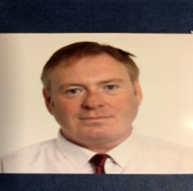
Cathal is a Technical Officer working in the Division of Country Health Policy & Systems,
WHO Regional Office for Europe. In this role, Cathal provides policy and advisory support to WHO member states relating to rehabilitation health services and disability inclusion measures.
Prior to taking up his current role, Cathal held several senior management positions within the Irish Health Service including as National Head of Disability Operations. He is also a member of the Board of Irelands National Disability Authority, an independent statutory body that provides information and advice to the Government on policy and practice relevant to the lives of persons with disabilities.

Cathal is a passionate advocate for the full implementation of the UNCRPD and how advancing the use of Digital and Assistive Technology is critical in enabling people to live independent lives. He believes strongly in the inclusion of people with lived experience in the design, implementation and monitoring of health and social care services. In his spare time, Cathal enjoys reading, walking and travel.

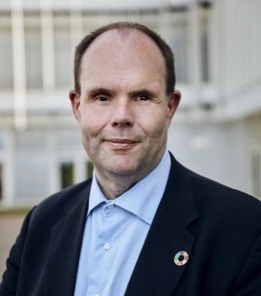
Mr Thorkild Olesen, Chairperson of Disabled People's Organisations Denmark (DPOD)

Thorkild Olesen has a long career in the disability movement, including chair person of DPOD since 2014, current vice chair person of the National Disability Council, Denmark and former chair person of Danish Association of the Blind (2009-2021). He has a Master degree in history from University of Aarhus.

Ivanka Jovanović, Executive Director of National Organization of Persons with disabilities of Serbia (NOOIS)
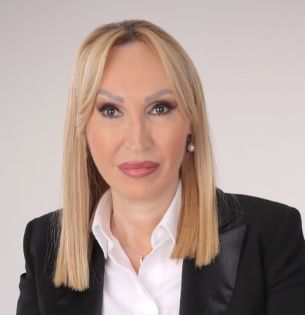
Ivanka Jovanovic from Serbia is Executive Director of National Organization of Persons with disabilities of Serbia (NOOIS) with excellent knowledge of disability policy and human rights advocacy for people with disabilities. She is one of the prominent leaders of the Disability Movement in Serbia with years of experience in the domestic and international disability movement.
Disability movement activist since the age of 18; youth activist within EAMDA’s (European Alliance of Neuromuscular Disorders Associations) Youth group of people with Muscular Dystrophy, Full-time working engagement in 1993 in Muscular Dystrophy Association of Serbia – still engaged there as an expert associate. She has cooperation with the UN from 2013 and especially with the Committee on the Rights of Persons with Disabilities, in the field of monitoring the UN Convention implementation and working on harmonizing Serbian regulations and practices.
Currently very active at international level as NOOIS representative in EDF (European Disability forum), in EFNA (European Federation of Neurological Associations) and EAMDA.
She has University level degree from Faculty for political science, University of Belgrade, Degree – Journalist, BA. Informal education: degree for the trainer in the field of NGO management and human rights, non-discrimination, lobbying and advocacy.
She is the author or co - author of many manuals and researches.

Laura Kyrke-Smith, UK Executive Director of the International Rescue Committee (IRC)
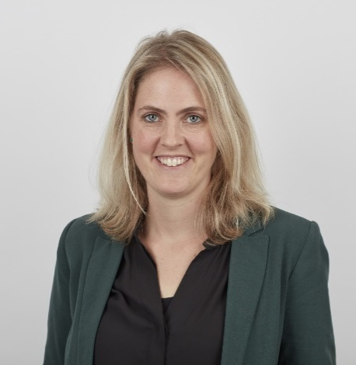
Laura Kyrke-Smith is the Executive Director of the International Rescue Committee in the UK. She leads IRC’s work to raise funds, raise awareness and deliver policy and practice change to help people who are caught up in conflict and disaster to survive, recover and rebuild their lives.
Laura has been with IRC since 2016 as the IRC’s Director of Communications in Europe. Before joining IRC, Laura was a Partner at Portland Communications. She started her career in the UK Foreign and Commonwealth Office where she worked as a policy analyst and speechwriter.

Laura has a MSc in International Relations from the London School of Economics and a MA in History from the University of Cambridge.

Mina Mojtahedi, Senior Adviser on Non-Discrimination and Disability Inclusion, Ministry for Foreign Affairs of Finland
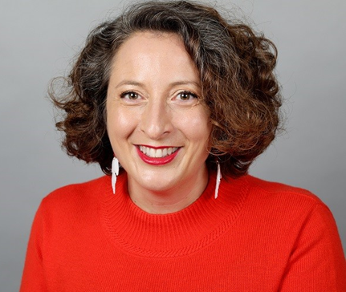
Mina Mojtahedi, PhD, is the Senior Adviser for non-discrimination and rights and inclusion of persons with disabilities, at the Department of Development Policy, Ministry for Foreign Affairs of Finland. Prior to her current position, Mina worked for The Finnish League for Human Rights where she led a project on promoting human rights in sports in Finland. Mina has also worked as Disability Inclusion Adviser in Geneva for the International Committee of the Red Cross and the International Federation of Red Cross and Red Crescent Societies, promoting inclusion of persons with disabilities in humanitarian contexts, as well as for Threshold Association, a Finnish organization of persons with disabilities, where she managed development cooperation projects promoting rights of persons with disabilities in developing countries. In addition, she has been a consultant on rights and inclusion of persons with disabilities for UNICEF and Abilis Consulting

Tamila Barkalaia, Deputy Minister of Internally Displaced Persons from the Occupied Territories, Labour, Health and Social Affairs of Georgia

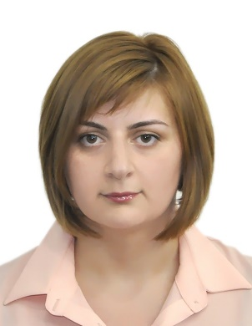
Tamila Barkalaia is a Deputy Minister of Internally Displaced Persons from the Occupied Territories, Labour, Health and Social Affairs of Georgia since December 2017, responsible for the areas of social protection, labor and employment. Under her leadership, key reforms were implemented, transformation of disability assessment and status determination system, advancement of social assistance measures for vulnerable social groups, revision of labor legislation and policies, development of the Social Code.
Tamila was a director of the State Fund for Protection and Assistance of Victims of Human Trafficking (2015-2017), head of New Life Global Network, or World Vision Georgia, and she also worked for Care International or International Rescue Committee.
Tamila has a Master’s degree in international development from the University of Pittsburgh, (Pennsylvania, USA) and bachelor’s degree in international business from the Mushkhelishvili State Technical University (Kutaisi, Georgia).

Anar Bayramov, Chairman of the State Medico-Social Expertise and Rehabilitation Agency under the Ministry of Labour and Social Protection of Population of the Republic of Azerbaijan

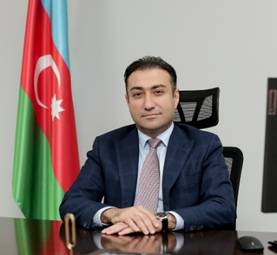
Anar Bayramov is the Chairman of the State Medico-Social Expertise and Rehabilitation Agency under the Ministry of Labour and Social Protection of Population of the Republic of Azerbaijan. Before being appointed a Chairman in June 2021, Mr Bayramov performed as the Advisor to the Minister of Labour and Social Protection of Population. Before working in the Ministry, Mr Bayramov served in the private insurance sector.

Being an alumnus from Azerbaijan Medical University’s “Medicine” faculty (1991-1997), Mr Bayramov also graduated from the Azerbaijan State University of Economics with a master’s degree in "Economics and Management" (2004-2006). Mr Bayramov has a PhD degree in Medicine since 2003.

Mr Bayramov continued his career as a doctor at “MediClub Private Medical Centre”. With his experience in the fields of medical work, health reform, insurance and leadership Mr Anar Bayramov held senior positions in "A-Group Insurance Company" from 2002-2020. Mr. Bayramov started his career as a Chief medical expert and continued as a Deputy General Director, General Director, and Chairman of the Board.

He held positions of the Head of the Caspian European Club Insurance Committee, President of the Caspian European Integration Business Club (CEIBC) Financial Club, he has also been a Chairman of the Medical Insurance Committee of the Azerbaijan Insurers Association for 2006-2020 years.
Mr Bayramov is the author of more than 25 articles and 2 rationalization proposals.

Ms Tatiana Lomakina, Advisor-commissioner of the President of Ukraine on a barrier-free society issues
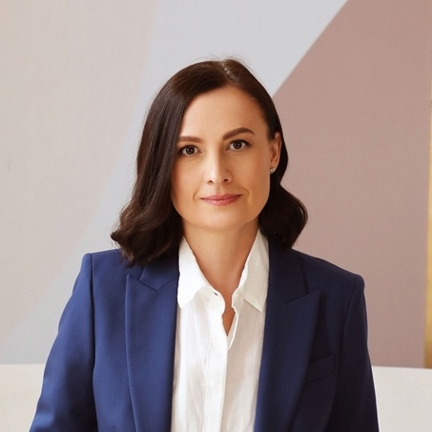
She was the chairwoman of the NGO "Barrierfree" engaged in research, programs and policies for the barrier-free society. She has more than 20 years of experience in public sphere, and as well as experience of work in the social sphere and local government (Mariupol, Ukraine). Ms. Lomakina holds a Master’s Degree in Public Administration from Donetsk State University.

Closing remarks

Dr Bernd Schramm, Project Manager, Global Project Inclusion of Persons with Disabilities, Deutsche Gesellschaft für Internationale Zusammenarbeit (GIZ)

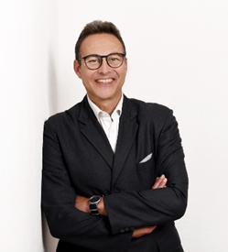
Head of Global Project “Inclusion of Persons with Disabilities” Deutsche Gesellschaft für
Internationale Zusammenarbeit (GIZ)

Bernd Schramm (PhD) heads the GIZ Global Project "Inclusion of Persons with Disabilities", commissioned by the German Federal Ministry for Economic Cooperation and Development. He has been working in development for 18 years, most of the time for the German development agency GIZ in Cambodia and Germany, but also for an EU project in Vietnam. As a social scientist focusing on social coherence, equitable access to services and universal social protection, he strongly advocates for the principle of ‘leaving no one behind’ and the need for empowerment of marginalized groups, including persons with disabilities.

Gunta Anca, EDF Secretary
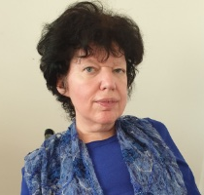
Gunta Anca has been a proactive disability rights activist throughout her career. Since 2002, she is the Chair of the Latvian Umbrella Body for Disability Organisations (Sustento).
Since 2005, she is a Board member within the European Disability Forum. She is also very active in promoting gender equality not only in her capacity of member of the EDF Women’s Committee, she was also a Board member of the European Women’s Lobby (the largest umbrella organisation of women’s associations in the European Union (EU)).

Since 2006, she is a member of the European Economic and Social Committee (EESC), an EU consultative body that gives representatives of Europe’s socio-occupational interest groups, and others, a formal platform to express their points of views on EU issues. It has a key role to play in the Union’s decision-making process.

Since 2008, she is Advisor in the Disability Rights Fund – a collaboration between donors and the disability community to advance the new UN Convention on the Rights of Persons with Disabilities (CRPD). The members of the Panel come from five continents and reflect a broad cross-section of the disability community.

