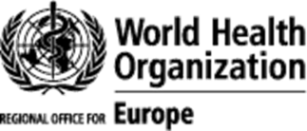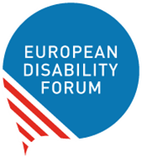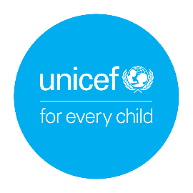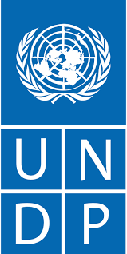


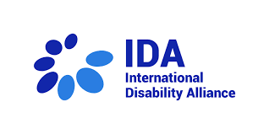

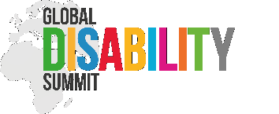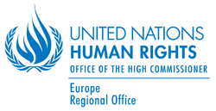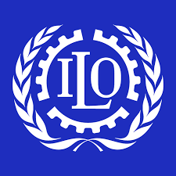

Concept note
High-level European Regional Disability Summit
Perspectives on pan-European international cooperation

Background
The 2007 United Nations Convention on the Rights of Persons with Disabilities (CRPD) gives the disability movement a strong legal framework to advocate for the rights of persons with disabilities, including during the COVID-19 pandemic.
In the WHO European Region, policies related to inclusive international cooperation remain complicated, due in part to the complex geographical landscape of the Region. Fifty-three Member States constitute the WHO European region, comprising 27 European Union (EU) countries, Nordic and western European countries that are not part of the EU, and eastern European and central Asian countries, which are located both on the European and Asian continents.
European data on disability are limited. An estimated 100 million persons with disabilities live in EU countries, while 6–10 of every 100 people in the 53 Member States of the WHO European Region – approximatively 135 million people – live with disability. With population ageing and the rising prevalence of noncommunicable conditions, including injuries, this number is set to increase in the future.
When it comes to international cooperation, the EU is one of the biggest donors of development aid in the world (with a focus on Africa and Asia), while eastern European and central Asian countries receive disproportionally lower financial and technical assistance support. This means persons with disabilities in these countries, particularly women, girls and children with disabilities, face high rates of poverty, discrimination and limited access to universal health coverage. Persons with disabilities have poorer health outcomes, lower education achievements and are less likely to be included in the labour market than peers without disabilities. Access to health, education, employment, transport and information is limited, and there is little or no representative organizations of persons with disabilities (OPDs) to strengthen the disability movement.

The Global Disability Summit
The first Global Disability Summit (GDS) was organized by the governments of the United Kingdom and Kenya and the International Disability Alliance (IDA) in 2018. It was an historic moment for the global disability movement and the rights of persons with disabilities. The GDS “inspired unprecedented engagement in disability inclusion and generated commitments that will help deliver Agenda 2030’s vision to ‘Leave No One Behind’ as well as existing obligations under the CRPD”. More than 1000 delegates from governments, donors, private sector organizations, civil society organizations (CSOs) and OPDs participated in the GDS in London, United Kingdom. The principal legacy document of the GDS, the Charter for Change, was launched and 170 commitments were made.

The governments of Norway and Ghana as well as IDA will now co-host the second Global Disability Summit (GDS22) on 16–17 February 2022. Another successful GDS has the potential to further accelerate implementation of the CRPD and promote successful achievement of the United Nations Sustainable Development Goals and the commitments made during the first GDS. Ultimately, it can deliver real and lasting change in the lives of persons with disabilities around the world, including new strong commitments to support recovery from the COVID-19 pandemic.

High-level European Regional Disability Summit
The co-hosts of the GDS22 have encouraged development partners, United Nations agencies, governments and CSOs to organize regional pre-summits to galvanize international cooperation and focus on region-specific discussions that will result in the formulation of commitments by 26 January 2022.

Based on this, the WHO Regional Office for Europe, United Nations Children’s Fund (UNICEF) Regional Office for Europe and Central Asia, United Nations Development Programme (UNDP) Regional Bureau for Europe and the Commonwealth of Independent States, and the European Disability Forum (EDF) propose to organize a High-level European Regional Disability Summit to focus on international cooperation.

Aim of the High-level European Regional Disability Summit
The aim of the summit will be to discuss how international cooperation in the broader European Region can become inclusive of persons with disabilities.

The high-level speakers and participants will be taking stock of the lessons learned from the COVID-19 pandemic and building on the shared experience of years of disability-inclusive development. The event will gather a range of stakeholders working on disability rights in the Region in preparation for the GDS22, including representatives of governments, donors, United Nations country teams, CSOs and OPDs. These stakeholders will have full information about the GDS22, including updates on implementation of global commitments in the Region and in European international cooperation. A summary of discussions during the High-level European Regional Disability Summit will be presented to the GDS22.

Themes
The themes of the European regional summit will mirror those of the GDS22. The themes were announced in September 2021 and are:
- inclusive employment and livelihoods
- capacity-strengthening of OPDs in the global south
- inclusion in situations of crises and conflict, including a focus on climate change
- inclusive education
- inclusive health.

Gender will be reflected across all five thematic areas.

Objectives of the High-level European Regional Disability Summit
The objectives are to:
- introduce the GDS22 and explain its relevance for European international cooperation;
- discuss with the audience key challenges and opportunities related to inclusive development for the European Region, including financial aid supporting neighbouring countries of the EU and central Asia;
- present findings from the European OPDs consultation; and
- use the summit to discuss how global organizations and European Region Member States can support implementation of global commitments on disability-inclusive development (across health, education, employment, humanitarian situations and civil society strengthening, including women’s rights).

Outcome of the High-level European Regional Disability Summit
An outcome document proposing implementation of commitments in the European Region and in European international cooperation will be presented for adoption during the European Regional Disability Summit. The outcome document will be shared at the GDS22.

Date of the High-level European Regional Disability Summit
The summit will take place on 8 February 2022, 10:00–13:00 Central European Time.

Co-partners
Co-partners for the summit (in alphabetical order) are:
- Atlas Alliance
- EDF
- Global Disability Summit Secretariat
- IDA
- International Labour Organization
- Norwegian Federation of Organisations of Disabled People
- UNDP Europe
- UN Human Rights Regional Office for Europe
- UNICEF Europe and Central Asia
- UN Partnership on the Rights of Persons with Disabilities Fund
- WHO Regional Office for Europe.

Audience
The audience will include representatives of:
- the EU and its delegations around the world
- United Nations agencies and country teams active in the Region
- governments in the Region and key provider organizations
- CSOs, international organizations and other development partners
- OPDs.

Online platform and accessibility
The event will be delivered via a Zoom platform. International Sign interpretation and captioning will be provided. The working language will be English with translation available in French, Russian and Spanish.

Contact
Marion Steff, International Cooperation Manager: marion.steff@edf-feph.org

Welcome to EDF. In: EDF [website]. Brussels: European Disability Forum; 2021 (https://www.edf-feph.org/, accessed 9 December 2021).
Disability. In: WHO Regional Office for Europe [website]. Copenhagen: WHO Regional Office for Europe; 2021 (https://www.euro.who.int/en/health-topics/Life-stages/disability-and-rehabilitation/areas-of-work/disability, accessed 9 December 2021).
United Kingdom Foreign, Commonwealth & Development Office, International Disability Alliance. Global Disability Summit +2 years. Geneva: International Disability Alliance; 2021 (https://www.internationaldisabilityalliance.org/events/gds2-years-report-launching-march-25, accessed 9 December 2021).
The Global Disability Summit 2018 Charter for Change. Geneva: International Disability Alliance; 2018 (https://www.internationaldisabilityalliance.org/gds-charter, accessed 9 December 2021).
Commitments. In: International Disability Alliance [website]. Geneva: International Disability Alliance; 2018 (https://www.internationaldisabilityalliance.org/commitments, accessed 9 December 2021).
The menu of commitments for the Global Disability Summit is online! In: Global Disability Summit [website]. Geneva: Global Disability Summit; 2021 (https://www.globaldisabilitysummit.org/blogs/the-menu-of-commitments-for-the-global-disability-summit-is-online, accessed 9 December 2021).

