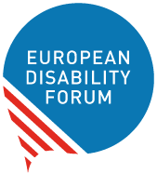

2021 Report of EDF Women’s Committee

  - European Disability Forum
  - Published in January 2022

Report on EDF Women’s Committee work and achievements
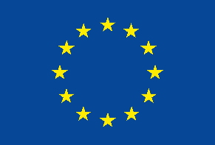 | This publication has received financial support from the European Union. The information contained in this publication does not necessarily reflect the official position of the European Commission.

Table of Contents
Table of Contents 2
Introduction 2
Highlights 3
Committee meetings 3
Reporting under 2020 Action Points 4
Action area 1 - gender mainstreaming in EU disability policies 4
Action area 2 - mainstreaming disability in EU gender equality policies 5
Action area 3 - combating violence against women and girls with disabilities 5
Action area 4 - advancing the human rights of women and girls with disabilities 7
Action area 5 - Women’s Committee position papers, statements and other documents 8
Action area 6 - monitoring international human rights treaties relevant to women and girls with disabilities 8
Action area 7 – networking 9
Action area 8 - external representation 9
Action area 9 – communication 9
Annex 1: participation in external events and meetings 11
Annex 2: main challenges and success reported by Committee’s members 12
France 12
Greece 14
Contact 16

Introduction
In January 2021, EDF Women’s Committee adopted its action points for 2021, following its workplan for 2019-2021.
The Committee communicates and works essentially by e-mail. Meetings continued to take place online due to the COVID-19 pandemic.
This report gives an overview of the activities undertaken by the Committee in 2021 in accordance with its workplan and 2021 action points.

Highlights
- 2 online meetings of the Committee in May and December 2021
- Organisations of 3 webinars in relation to the rights of women and girls with disabilities:
  - Webinar on the use of CRPD and CEDAW Optional Protocols to protect the rights of women and girls with disabilities (with IDA)
  - Webinar “Feminists with disabilities take the floor” as shadow event in the Generation Equality Forum (with IDA and Women Enabled)
  - Webinar on women and girls with disabilities in the face of trafficking and sexual exploitation (with CERMI Women’s Foundation)
- Position paper on violence against women and girls with disabilities in the European Union and EDF statement on the International Day for the Elimination of Violence against Women
- Submissions to consultations of the European Commission on violence against women, Council of Europe's Group of Experts on Action against Violence against Women and Domestic Violence (GREVIO) on its General Recommendation on the topic of digital component on violence against women, the Special Rapporteur on Health on sexual and reproductive health and rights and UN Women on its Disability Marker Initiative
- Creation of a webpage on CEDAW, with countries up for review and resources to contribute and update of the guide for organisations of persons with disabilities on engaging with the CEDAW Committee
- Support 4 EDF members with the review of their countries (Denmark, Hungary, Italy and Sweden) by the UN Committee on the Elimination of Discrimination Against Women
- Participation of members in 6 external events
- 10 EDF Women’s Voice newsletters sent to 242 subscribers

Committee meetings
Two meetings of the Committee took place via Zoom on 10th of May and 1st of December. Captioning and Sign language interpretations was provided to the members.
Photo 1 Screenshot from the Women's Committee meeting in May 2021
In both meetings, a representative of the European Women’s Lobby (EWL) was invited to give an update of the work of EWL.
Photo 2 PowerPoint presentations from EWL

Reporting under 2020 Action Points

Action area 1 - gender mainstreaming in EU disability policies
The European Disability Strategy for 2021-2030 was adopted in March 2021. The Committee published a reaction on the gender perspective in the strategy (also in the Women’s Voice newsletter of March).
Members of the Committee actively participated in events related to the rights of persons with disabilities to bring the perspective of women and girls with disabilities. For example, on the 15th of November Ana Pelaez spoke about the legal capacity of women with disabilities in a hearing on “The right to make decisions: Progressing Legal Capacity for persons with Disability” organised by the European Economic and Social Committee. Members of the Committee participated in the European Days of Persons with Disabilities that included several topics and initiatives covered in the Disability Rights Strategy, in relation to health, digitalisation and children with disabilities. They prepared and asked questions related to women and girls with disabilities.
Because of the COVID-19 pandemic, the Committee’s postponed the proposal of a hearing on women and girls with disabilities by the Disability Intergroup of the European Parliament.

Action area 2 - mainstreaming disability in EU gender equality policies

EC consultations and new legal and policy initiatives
The Committee provided inputs to EDF’s recommendations on various strategies and policy initiatives concerning women’s rights, in particular:
- EDF’s Position paper on violence against women and girls with disabilities (see Action Area 3)
- EDF’s Amendments to the proposed Directive on Pay Transparency

Advisory committee on equal opportunities for women and men
EDF sent a new request to receive information on how to join the Advisory committee on equal opportunities for women and men of the European Commission in November 2021. This request was not successful.

UN Women – NEW ACTIVITY
The Committee gave input to the UN Women Disability Marker Initiative.

Action area 3 - combating violence against women and girls with disabilities

Monitor initiatives to combat violence against women and provide supports to victims
EDF published a position paper on violence against women and girls with disabilities in the EU. This contributed to the consultations of the European Commission on the topic. The Committee provided feedback to all consultations. EDF Secretariat took part in a meeting organised by the Head of the Gender Equality Unit and the Victims’ Rights Coordination on gender-based violence, in the framework of the Victims’ Rights Platform.
Members of the Committee actively participated in meetings and events on combating gender-based and domestic violence. On 20th of May, Pirkko Mahlamäki represented EDF in the meeting on violence against women, with a focus on women with disabilities of the Working Party on Fundamental Rights, Citizens Rights and Free Movement of Persons (FREMP) of the Council of the EU. On 30th November, Ana Pelaez Narvaez spoke at an event of the European Parliament’s Inter-parliamentary committee (ICM) on “Combatting violence against women and girls with disabilities.”

Istanbul Convention
EDF published the agenda of the countries reviewed by GREVIO and informed members about the review process for 2021 and 2022.
To give more visibility on the Istanbul Convention, EDF published a web article on the 10th anniversary of the Convention on the 6th of April.
The Committee provided input to the consultation for the first General Recommendation on the topic of digital component of violence against women. The General Recommendation includes 8 mentions to disability and 7 to accessibility.

Webinar on trafficking and sexual exploitation
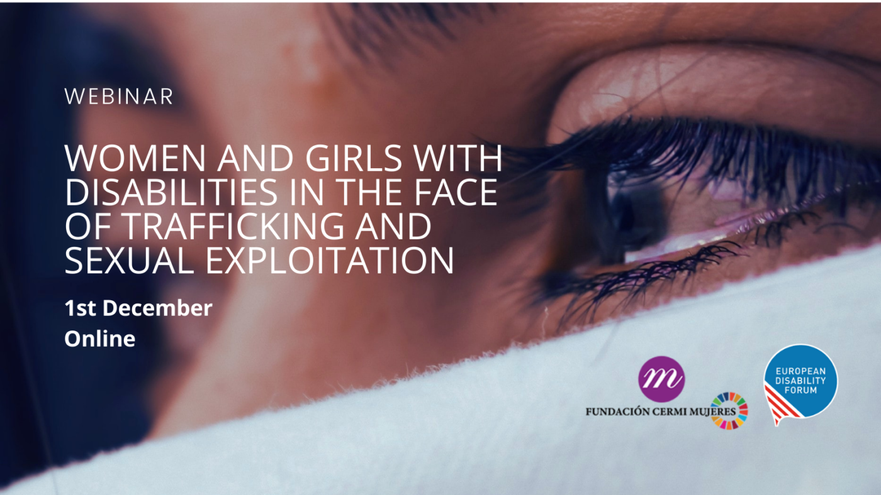
Photo 3 Banner of the event on trafficking and sexual exploitation
On 1st December, EDF and CERMI Women’s Foundation organised a webinar on women and girls with disabilities in the face of trafficking and sexual exploitation. The webinar included speakers from EDF, the Special Rapporteur on Trafficking in Person, the Chair of the CEDAW Committee working group on the General Recommendation concerning trafficking in women & girls in the context of global migration, the team leader of the office of the EU Anti-Trafficking Coordinator and Spanish experts from CERMI Women’s Foundation and the National Police.

Action area 4 - advancing the human rights of women and girls with disabilities

Commission on the Status of Women
EDF and the Committee were involved in the Commission on the Status of Women (CSW), including:
- Input to the CSW Agreed Conclusions and participation of EDF Secretariat in a meeting organised by the EU delegation to the UN on the Conclusions
- IDA-EDF statement on political participation of women and girls with disabilities during the CSW: Video statement by Ana Pelaez Narvaez
- Web article on how to engage in CSW
- Women’s voice newsletter of March included information on side-events including women and girls with disabilities
- Members of the Committee participated in 2 side-events (see Annex)

Beijing +25
EDF organised jointly with IDA and Women Enabled International a shadow event titled “Feminists with Disabilities take the floor” at the Generation Equality Forum concluding the Beijing+25 process. Unfortunately, most the Forum was not accessible and inclusive to women and girls with disabilities. A joint letter was sent to the Secretariat of the Forum, the French Ambassador and UN Women on the inaccessibility of the Forum. EDF also published a web article about it.

EU CRPD review
The Committee was consulted on the draft alternative report of EDF for the review of the EU by the CRPD Committee. An overview of the issues faced by women and girls with disabilities in the implementation of the Convention will be published in 2022, as the review of the EU was postponed.

Other activities
The Committee replied to a questionnaire of the UN Special Rapporteur on health, to feed into her Report on “Sexual and reproductive health rights: challenges and opportunities during COVID-19.” The Report makes 8 mentions to disability and refers to the need of access to education and information in accessible formats for adolescents with disabilities.

Action area 5 - Women’s Committee position papers, statements and other documents
EDF published an overview of the impact of COVID-19 on women and girls with disabilities in Europe, in light of EDF Human Rights Report on COVID-19, on EDF’s website for international women’s day and in EDF Women’s Voice of March.
The Committee published a Position Paper on violence against women and girls with disabilities in the EU. It was used to contribution to the EC consultations and to raise more visibility about violence against women and girls with disabilities. In addition, the Committee published a statement on the occasion of the International Day for the Elimination of Violence against Women on 25th of November (NEW ACTIVITY).
The publication of an overview of the implementation of the rights of women and girls with disabilities by in the EU, in light of EDF alternative report to the CRPD Committee, was postponed to 2022. This is because the review of the EU was postponed and EDF will finalise and submit its report in February 2022.

Action area 6 - monitoring international human rights treaties relevant to women and girls with disabilities
EDF supported DPOs from Denmark, Italy, Hungary and Sweden in submitting alternative reports to the CEDAW Committee. Representatives from Denmark, Italy and Sweden participated in the private meeting with the Committee.
Alternative reports:
- Denmark: Disabled People's Organisations Denmark (DPOD)
- Hungary: Federation of Associations of Persons with Physical Disabilities (MEOSZ)
- Italy: The Italian Disability Forum (FID) / Forum Italiano sulla Disabilità
- Sweden: Swedish disability movement
On 10th of May, EDF co-organised by IDA an online workshop on the use of the CEDAW and CRPD Optional Protocols to protect the rights of women and girls with disabilities.

Action area 7 – networking
EDF was informed about an organisation of women with disabilities from the Netherlands (Feminists Against Ableism), and several French organisations of women with disabilities, including women with Autism (AFFA Association Francophone de femmes autistes).
EDF hired a Grant and Fundraising Officer. This will allow EDF to apply for more projects related to women and girls with disabilities, and foster networking between organisations.

Action area 8 - external representation

European Women’s Lobby
EDF and the Committee supported the nomination for re-election of Pirkko Mahlamäki and Luisa Bosisio.
Pirkko Mahlamäki continued to represent EDF in the European Women’s Lobby Executive Committee until June 2021. Pirkko is still active in the Observatory on violence against women, the Women in Politics Working Group and the Taskforce on SRHR and sexual exploitation. Luisa Bosisio continues to represent EDF in EWL’s Feminist Economics Working Group. For example, thanks to the work of Luisa, all recommendations from EDF have been include in the position of EWL on the Pay Transparency Directive.

External events and meetings
Members of the Committee’s participate in 6 external events on disability, gender and other relevant issues to include the perspective of women and girls with disabilities at European and international levels. The full list of events is available in annex.

Action area 9 – communication

Newsletters
The Committee contributed to the newsletter EDF Women’s Voice and EDF Disability Voice annual issue on gender and ensured a gender dimension to all our newsletter.
Women’s rights issues were included in the Disability Voice and EDF Board mailing.
EDF sent 10 EDF Women’s Voice newsletters in 2021.

International Days
- International Women’s Day included a wide communication on EDF’s website and twitter, with a web article, a feminist statement “We are women too!” and testimonies from members of the Committee “Women leadership in the disability movement”
- International Day of Sport, with a focus on women: blog testimony on being a black woman with disabilities in para-swimming; article in Women’s Voice on women with disabilities in sport
- International Day for the Elimination of Violence Against women: article on EDF’s website and posts on social media related to disability specific violence faced by women and girls with disabilities and the Istanbul Convention; EDF statement on EDF’s website

Website
EDF created a webpage on CEDAW, with countries up for review and resources to contribute and updated the guide for DPOs on engaging with the CEDAW Committee.

Annex 1: participation in external events and meetings

EVENT | PLACE | DATE | WHO IS INVOLVED
CSW side event of Poland on political participation of women with disabilities | Online | 18 March | Ana Pelaez Narvaez, Pirkko Mahlamäki
CSW side event on Feminist Alliances for a new civil society | Online | 23 March | Luisa Bosisio
Working Party on Fundamental Rights, Citizens Rights and Free Movement of Persons (FREMP)  Meeting on violence against women, with focus on women with disabilities | Online | 20 May | Pirkko Mahlamäki
Shadow event Paris Generation Equality Forum – with IDA and WEI | Online | 30 June | Ana Pelaez Narvaez
EESC hearing on “The right to make decisions: Progressing Legal Capacity for persons with Disability” – presentation on Women and girls With Disabilities | Online | 15 November | Ana Pelaez Narvaez
Inter-parliamentary committee meeting (ICM). Committee on Women's Rights and Gender Equality (FEMM). Session “Combatting violence against women and girls with disabilities” | Online | 30 November | Ana Pelaez Narvaez

Annex 2: main challenges and success reported by Committee’s members
Members of the Women’s Committee reported on the main challenges and success in their country and work for 2021.

France

Violence against women
The Working Group on women with disabilities worked on the implementation of the 3 measures selected by the “Grenelle” to combat domestic violence:
- The drafting of the specifications for the creation in each French region of a regional resource centre for the emotional, intimate and sexual life and support for parenthood of people with disabilities was completed at the end of January and entrusted to the ARS (regional health agencies). 10 centres are currently open.
- A circular on the respect of intimacy, sexual and reproductive rights of people supported in medico-social establishments and services in the field of disability and the fight against violence was sent on 6 July 2021 to all the managers of establishments receiving people with disabilities. A follow-up questionnaire is currently being drawn up.
- The specifications for an online training course leading to certification, which will enable the various professionals working in medico-social establishments and services to improve their skills on a massive scale, have been drawn up and the creation of this e-training course has been entrusted to the association Mémoire traumatique et victimologie
Since the end of August, the national telephone number for reporting violence, 3919, has been accessible to deaf and hard-of-hearing people 24 hours a day, 7 days a week.
The delegation for women's rights at the National Assembly, on the occasion of the 25 November day of the fight against violence against women, organised a symposium on the theme of the fight against violence against women with disabilities. FDFA spoke about its actions.
Judicial impunity: in several trials involving violence against young girls or women with disabilities, the perpetrators continue to enjoy impunity, either because of the so-called consent of the victim, or because the aggressor said he did not realise that she was a woman with a disability. The associations are therefore calling for training for judicial personnel on this subject.

Access to health
An action programme called Handigynéco: access to gynaecological care for women with disabilities - has been deployed by the ARS (regional health agency) in Ile-de-France. It consists of the intervention of midwives in medico-social establishments in Ile-de-France for gynaecological and oral care and monitoring. The presence of midwives in the living environment has made it possible to make up for the lack of gynaecological follow-up for a quarter of the women seen in consultation, and to detect gynaecological pathologies and violence against women that were previously unknown.
Given the success of these actions, they will be extended throughout France.

Financial autonomy
A major demand was made by disabled people's associations for the deconjugalisation of the disabled adult allowance (AAH), the amount of which depends on household income, and therefore on the spouse's income. This makes it more difficult to escape from situations of abuse and family violence and keeps people dependent. This is why the Senate voted for this deconjugalisation, but the government opposed it, arguing that family and social solidarity are the basis of our solidarity system. It just increased the flat-rate deduction for the spouse's income. The associations protested widely. Two departmental experiments are being carried out so that disabled women who are victims of domestic violence can quickly benefit from an individual AAH. But the AAH still remains below the poverty line at 903 euros per month.

Greece
In September 2021, the National Confederation of Disabled People (NCDP) signed a protocol of cooperation with the General Secretariat for Demographic and Family Policy and Gender Equality (GGDOPIF) of the Ministry of Labor and Social Affairs. Considering the multiple barriers and the multiple and/or intersectional discriminations that girls and women with disabilities face as well as women as partners, sisters, and mothers of persons with disabilities experiences in their daily lives, this cooperation aims to promote their equal and non-discriminatory participation in society.
The protocol contains several actions that seek to promote and protect the rights of girls and women with disabilities and to improve the daily life of girls and women with disabilities and women as partners, sisters, and mothers of persons with disabilities. The actions can be classified into three categories: i) the development of policies for protecting and promoting the rights of girls and women with disabilities, ii) data collection, both quantitative and qualitative, and iii) raise awareness on the rights of girls and women with disabilities.
More specifically, among the actions that this cooperation seeks to implement are:
- the disability mainstreaming into gender policies and actions as well as the gender mainstreaming into disability policies and actions,
- the collection of qualitative and quantitative data regarding the situation of girls and women with disabilities and women as partners, sisters, and mothers of persons with disabilities through the designing specific research studies that live in Greece,
- the designing and implementation of interventions for Roma girls and women with disabilities, for immigrant, refugee, and asylum seekers girls and women with disabilities, for women and girls with disabilities living in institutions, for the older women with disabilities, etc.
- the design and implementation of actions to prevent and combat gender-based violence against women with disabilities as well as multiple and intersectional discrimination they
- the collection of statistics regarding girls and women with disabilities as well as the development of indicators concerning girls and women with disabilities/chronic diseases, mothers of persons with disabilities/chronic diseases, and carers of persons with disabilities/chronic diseases.
- the organization of conferences, seminars, and workshops on issues related to disability and gender,
- the training of medical staff, social workers, psychologists, police officers, and the staff of the General Secretariat on methods combating violence against girls and women with disabilities.
- the development of public awareness campaigns for the elimination of negative stereotypes and prejudices regarding gender and disability and, the promotion and respect of the rights of persons with disabilities, the prevention, recognition, and report gender-based violence incidents
- the development of public awareness campaigns for women and girls with disabilities regarding their reproductive and sexual rights, the prevention, recognition, and report of gender-based violence incidents and the available support services to them

Contact
Marine Uldry, Human Rights Officer: marine.uldry@edf-feph.org
The European Disability Forum
Mundo Madou
Avenue des Arts 7-8
1210 Brussels, Belgium.
www.edf-feph.org
info@edf-feph.org
This publication has received financial support from the European Union. The information contained in this publication does not necessarily reflect the official position of the European Commission.

