DOC-EXEC-22-01-03

EDF 25th Anniversary
Document for discussion

Purpose of this item
To discuss the next steps for EDF 25th anniversary, which already started.

Questions for the executive Committee
Do we have an actual date for the 25th anniversary? (June 1997 was the first EDF elections.)
Book:
- Do you have comments on the plan?
- Do you agree with the chapter layout and plan for publication on December 3rd?
- Do you have editors or contributors to recommend? Do you have social economy or inclusive publishers to recommend? Do you have previous texts you think can help build up the content?
- Do you want to be part of the Editorial team? Are you happy to be interviewed?
Events:
- Do you agree to aim for a high-level political event on December 3rd? (meeting of the 3 presidents?)
- Are there events you would like to plan? Are there 25th anniversary elements which should be included in our existing meetings

Introduction
The EDF executive committee has been discussing the 25th anniversary throughout 2021, and 2022 is the year in which this anniversary is marked. Till now certain decisions were taken- the 25th anniversary logo and visuals were decided by the Board through consultation and a vote. It was decided by the Executive Committee that there should be a high-level political event for the EU level, but this has not yet been concretely decided. The day of action was also not generally supported by members or the Board as no members volunteered concretely to run national actions, so this action is not well developed yet. The 5th European Parliament of Persons with Disabilities has been postponed to 2023 due to COVID. This has all been discussed by the executive and also the Board in its November meeting.
- Key messages and objectives
- Historical perspective: 25 years of united activism and achievements; the strength and achievements of our disability movement
  - Objective: publish historical material in a range of accessible formats, reach wide audiences with the material, generate conversation and feedback to learn from the past
- Advocacy goal: Increase public investment to underpin the inclusion of persons with disabilities- creating an accessible society and supporting the full participation of persons with disabilities
  - Objective: outline at the EU and national level the need for funding for an accessible Europe and to ensure participation of persons with disabilities, demanding that EU and national funding is dedicated to the priorities of persons with disabilities
- Movement building: moving forward together for an inclusive Europe
  - Objective: strengthen EDF as a network- increased number of joint initiatives and actions with EDF members in all their diversity; joint initiatives with key partners

What has already been done:

Political campaign
2022 marks one quarter of a century since EDF formed and will be a time to reflect on achievements and strengthen our advocacy for the future. We are in a time of pervasive distrust in government and institutions with increasingly polarized politics across the union. The CRPD and disability rights advocacy is a uniting principle which also brings benefits to the whole of society- measures take to increase citizen participation, create captioning for media, make transport, buildings and ICT more accessible make our whole society more inclusive. EDF will infuse these messages and demands across the full year. We will draw on the past and the future in our anniversary events to create a vision for the next 25 years in the movement.
Since large scale mass events cannot be planned right now our focus will be on a meeting of the 3 presidents of the union.

Communication campaign:

Visual identity
During the month of September to November 2021 we opened a tender to communication agencies to make a visual proposal of 3 elements: a new logo adapting the 25th anniversary, an illustration to complement the online actions related to the anniversary and a claim or phrase that could give visual support to the two previous elements. After the deadline for this tender, the best proposal came from the Visual Thinking agency, which has been in charge of developing the visual elements.
In December 2021, during the Board, we opened an online survey to get feedback and decide on several proposals for logos and claims. Finally, these were the final choices:
Logo
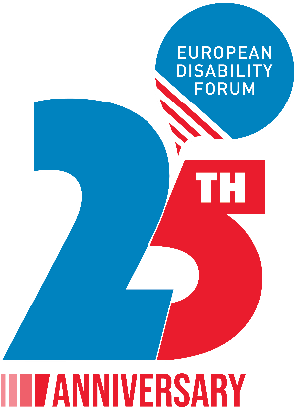

Claim: Nothing About Us Without Us
Although we had two other options that complemented our motto, the majority voted only to use this one, since it is a sign of identity of the whole movement.
Illustration
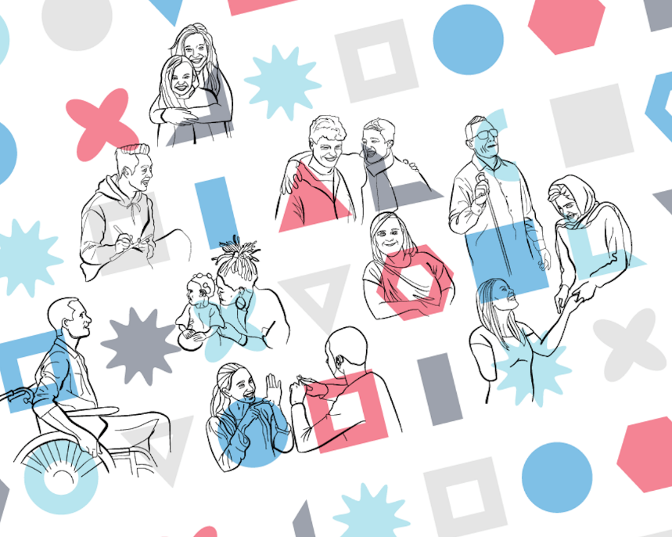

Website
In December 2021, a web page was created on which we will include all the initiatives of the 25th anniversary. Although it has been created, it is not yet live for all users.
https://www.edf-feph.org/25-years-european-disability-forum/

Podcast
One of the actions to be carried out will be a series of podcasts to commemorate the past, present and future of EDF. Meetings have been held with podcast editors to give us technical support in the realization of the podcasts. Finally, and after this initial research, it was decided to work with Benvox (podcast editors), Acast (hosting platform) and cleanfeed (recording platform).
Name of the podcast: For the record. Past, present and future of EDF
We are developing the following:
- An annual plan that allows us to work in advance with guests and topics.
- A jingle: or introductory sound that gives identity to the podcast.
- The first scripts: to begin, hopefully, recording in early February

Book
Board members suggested the importance of documenting EDF history in book form. The DARE researcher Claudia Coveney has been researching our archives for 2 years and interviewing many senior figures with the European Disability Movement, so the work required will be less for this task. It is not started yet as the proposal came in the November board but a plan is presented in Annex 1.
We have not done this before so we are ambitious to create the book but we will also require resources, input and support in order to launch this this year.
We would aim for December 3rd and have a book which is published in accessible electronic format, audio version and easy to read.

Annex 1 EDF 25 years book
Purpose: To present a simple history of EDF in book form marking 25 years of existence
Scope of the book:
An organisational history which highlights key achievements; the foundation of EDF would be described, and also the future directions of the movement within the European project
Length of the book: 80-100 pages
Proposed chapters:
- The founding of EDF: Securing independence as an organization
- Landmark campaigns – Invisible citizens, passengers directive, 1million4disability, freemove
- EDF growth – new countries and new members
Expansion of the organisation to include new members
- Growing diversity in the movement
- EDF role in CRPD- EU accessible to the CRPD
- Shifting EU focus to disability issues with 10-year disability strategy?
- Pandemic
- Future of organisation and Europe (?)
- Structure of the organisation/something about the story of the organisation and its link to the story of European citizenship?
Proposed visual components:
Cover: using 25-year visual identity ; illustrations for the easy-to-read version
Publication steps
Book + ebook
Audio book- readers for different chapters
Timeline to be developed
Budget to be developed

Annex 2 Events
EVENT | PLACE | DATE | Purpose/25th anniversary element
EDF Executive Committee meeting | Greece- Thessaloniki | January 21-22 | Discussion and decisions
EDF Board meeting | Paris, France | March – the week of March 9th
EDF Annual General Assembly | Greece | June (dates TBC)
EDF Board meeting | Ireland | October-November (TBC)
Meeting of 3 EU presidents | Brussels | Tbd- Aim for december 3rd | Political highpoint- highlighting demands

Annex 3- Table of activities with timelines
Objective | Activities | Resources | Oct/Nov 2021 | December 2021 | Q1 | Q2 | Q3 | Q4
Celebrate the progress of the disability movement in the past 25 years | Visual identity (adapted logo, slogan)- 2021 | logo development | X
 | Webpage and blog posts about main events of the last 25 years- |  |  | x
 | Short leaflet (2 pages) in 27 languages |  |  | x | x
 | Blog posts and newsletter features |  |  | x | x | x | x | x
Day of action - prep | Discussion and decisions at the Board |  | x
Day of action - prep | Support to members to plan action day |  |  |  | x | x
Day of action: | EU + national based demo on COVID 19 recovery funds |  |  |  |  |  | x | x
 | Manifesto- to be adopted at 2022 AGA |  |  |  |  | x

