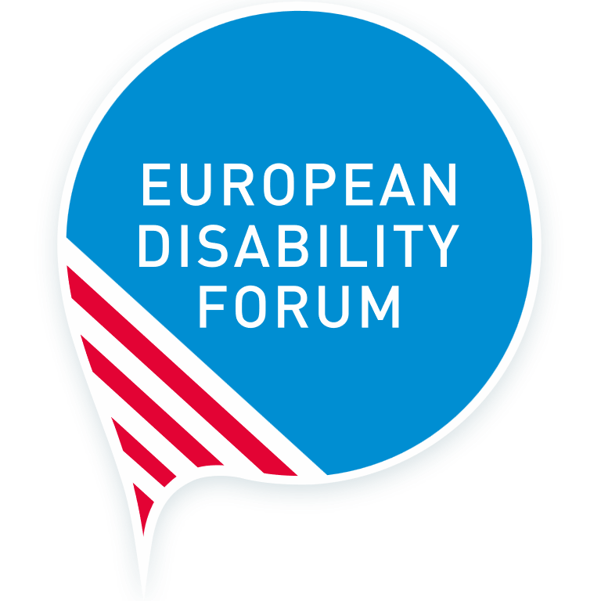
EDF report for the 2nd review of the EU by the CRPD Committee
European Disability Forum
February 2022
List of issues to tell the CRPD committee
This publication has received financial support from the European Union. The information contained in this publication does not necessarily reflect the official position of the European Commission.
Easy read version

European Disability Forum
 | The European Disability Forum is also known as EDF. It is made up of over 100 organisations who speak up for persons with disabilities.
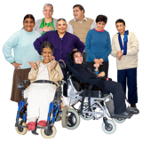 | We are run by persons with disabilities and their families.
 | We are a strong and united voice in Europe.

Background
 | The European Union is made up of 27 countries.
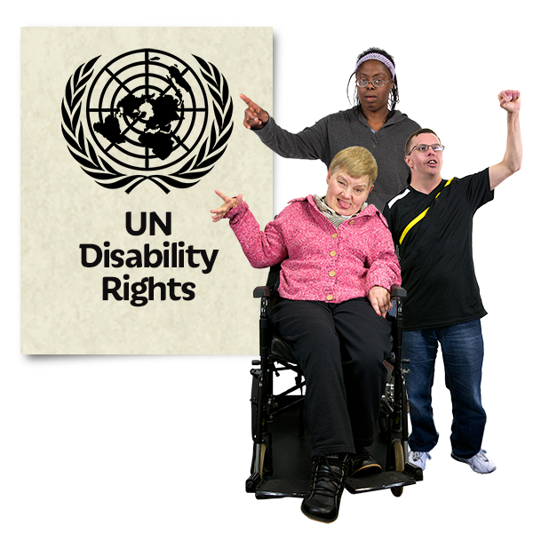 | It was the first regional organisation to agree to and sign the UN Convention on the Rights of Persons with Disabilities (CRPD).
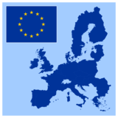 | By March 2018 every country in the European Union had signed to agree to the CRPD.
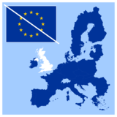 | There were 28 countries in the European Union (EU) before the United Kingdom left in January 2020.
 | Helena Dalli is the Commissioner for Equality in the European Commission. This is the government of the European Union. It is her job to make sure that persons with disabilities get their rights thanks to the EU.

EDF’s report about how the EU is doing to make sure the CRPD happens in member countries
 | The UN Committee on the Rights of Persons with Disabilities did their first report in 2015. This is the 2nd report.
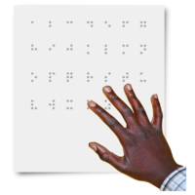 | Since then some good things have happened. For example;  the European Accessibility Act  - a 10 year plan on disability rights  - an agreement to make sure partly sighted and blind people can get printed information. This is known as the Marrakesh Treaty
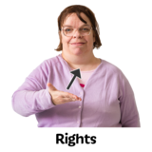 | But not all persons with disabilities are enjoying the rights they are entitled to.  EDF still has these concerns:
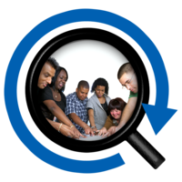 | Not all laws have been checked to make sure they give the rights listed in the CRPD.
 | Some EU laws about the rights of persons with disabilities to use public transport have not always happened.
 | The EU does not ask the opinion of persons with disabilities well enough. They do not always make sure there is information available.
 | Some anti-discrimination laws are better than others. The law against discrimination in employment is good. There are no other laws which protect persons with disabilities. They can experience other discrimination because of things like their gender, race or religion.
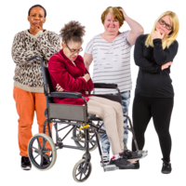 | Women and girls with disabilities face more violence than other women. They need better protection in the law. They can suffer human rights abuses like forced sterilisation so they can’t have any children.
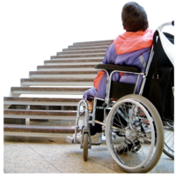 | There is an Accessibility law, but some persons with disabilities still do not have equal access to buildings, transport, computer technology, information, and services. This can stop persons with disabilities from getting jobs and living and working in other EU countries.
 | Persons with disabilities in Europe and across the world are affected more than other people by countries fighting and also by Covid-19 and climate change, which make more floods and heatwaves. The EU should do more to protect persons with disabilities.
 | Persons with disabilities often don’t get the benefit of protection from EU law. For example, the EU does not do enough to make sure persons with disabilities can make their own decisions, and that other people do not make them for them. They should have the right to a fair trial, to decide where to live, to vote, and to decide how to spend their money.
 | The justice system in the EU and in individual countries is not completely accessible to persons with disabilities. This could be if they are a victim or a witness, or are accused of a crime. They do not get their rights.

Persons with disabilities, especially persons with intellectual disabilities, autistic people and people living in hospitals and institutions are more likely to be victims of violence. The EU must do more to stop this.
(Intellectual disability is also known as learning disability in some countries.)
 | Persons with disabilities can’t transfer their social security benefits to other EU countries, if they go to live in another EU country for a short time. This means they cannot move freely between countries like persons without disabilities. This is also a problem for young people on exchange programmes.
 | Some countries in the EU have used money to keep people in institutions instead of living in the community with support. This is against the human rights of persons with disabilities. The EU needs to count how many people are still living in institutions.
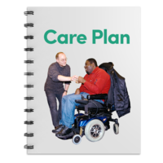 | The EU needs to do more to include the rights of persons with disabilities in its health plans and how services are delivered. This includes plans about Covid-19 and cancer. Only half of the EU countries ban discrimination for persons with disabilities in health care.
 | In half of the EU countries persons with disabilities can vote. Persons with disabilities can stand for election in only 7 of the EU countries.
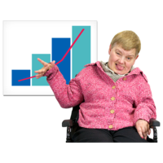 | The EU does not have good information about the experiences of persons with disabilities. The EU doesn’t know how many still live in institutions, how many are gay or lesbian and how many are from minority groups like Roma.
 | The EU is the biggest giver of money to improve conditions in poorer countries. But it has not made sure that persons with disabilities are also involved and included.
 | The EU has not made a special team to help the different bodies and the government of the EU work together.

More information is available in the full alternative report in English language.

