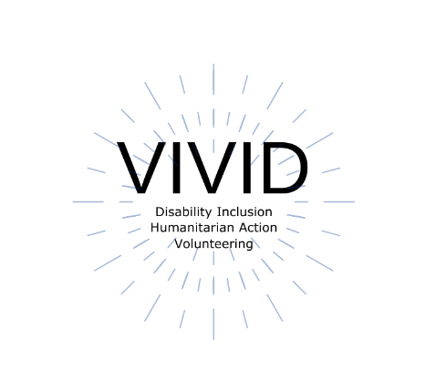
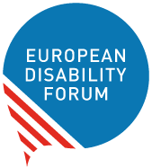

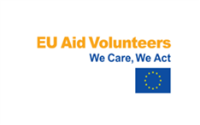
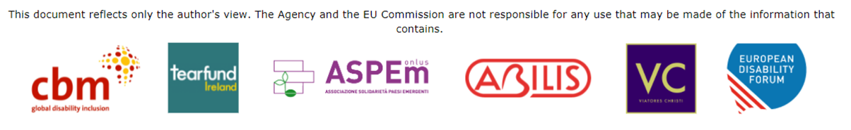

Toolkit Accessible website
  - European Disability Forum
  - By Roberta Lulli – Natalia Suarez
  - February 2022

EU Aid Volunteers initiative of the European Union. The information contained in this publication does not necessarily reflect the official position of the European Commission.

Introduction

What is web accessibility?
- Web accessibility is about making sure that digital content can be accessed and used by everyone, including people with disabilities.
- It’s also a practice that involves opening up digital content, so that it can be accessed, understood, and used without barriers.
Web accessibility barriers can be experienced for a number of reasons.

What are the barriers?
Shocking statistic
97.4% of home pages have detectable accessibility failures to the web accessibility standards of WCAG
Top accessibility failures/barriers are:
- Color contrast (86.4% of homepages)
- Missing alt text on images - 60.6%
- Missing form input labels - 54.4%
- Empty links - 51.3%

Web accessibility benefits everyone
Accessibility barriers exist for many groups of people.
Did you know… recent research shows that 1 in 4 people aged over 50 face problems accessing products and services online.
Improving web accessibility helps us to be more welcoming to a wider audience online

Make your check list!
- Creating and uploading accessible content
- Creating accessible digital documents
- Page styling and layout
- Banner, images with Alt - text
- Add accessible video (at least with captioning)
- Meaningful hyperlinks

Create accessible content

- Use a clear and simple language
- Use short paragraphs and short sentences.
- It’s best practice to keep sentences between 8-20 words, and paragraphs between 1-2 sentences
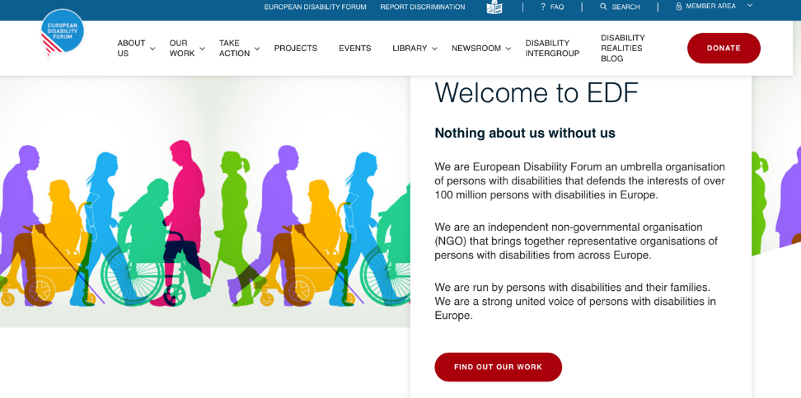

No complex language

Free from complex language and unnecessary technical jargon.
!! If your content requires you to include abbreviations, acronyms, or technical jargon, explain the meaning.
Example:
The Global Disability Summit (GDS22)
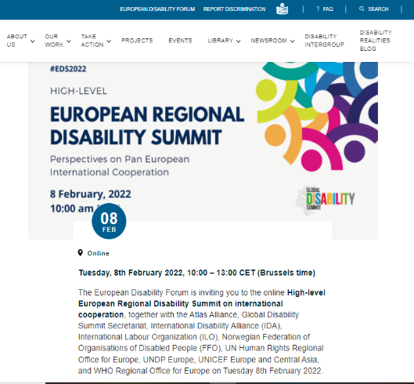

Create accessible digital documents

- Choose a sans-serif font, such as Verdana, Arial or Tahoma, and minimum font size of 12pt/16px.
- Left-aligned text
- Use tags:
    - Headings <H1>, <H2> etc.
    - Paragraphs <P>
    - Tables <Table>
    - Images <ALT Text >
    - Bullet points (or lists) <LI>

Download the toolkit!

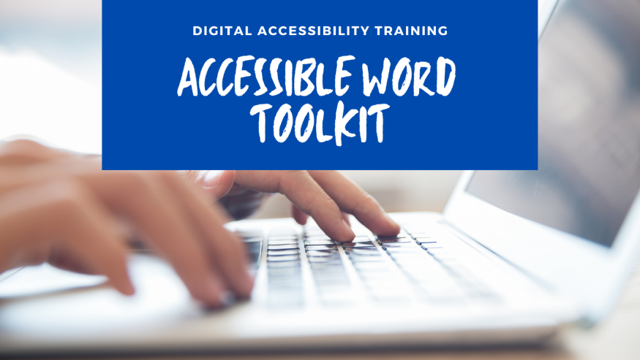

The toolkit on accessible Word Document is a resource for creating your documents more accessible working with Headings, style, and Colors, Formatting with columns, Hyperlinks, objective, Alt Text, adding Document’s properties, and running the Accessible Checker

Page styling and layout

Organizing web pages by headings helps users get a sense of the page’s organization and structure.
Use good heading structure
- Headings <h1> through <h6>
Do not skip heading levels
Example from <h2> to <h5>

Why headings?

- Visually, headings are presented as larger and more distinct than surrounding text.
- Using headings and making them visually visible is especially helpful for users with intellectual disabilities.
- Screen reader users can navigate a page according to its headings, listen to a list of all headings, and skip to a desired heading to begin reading at that point.

Common accessibility mistake

Do not use bold instead of a heading.
Did you know…One of the most common accessibility mistakes is making text bold when a heading is needed.
Though the text may look like a heading, the underlying code is not set correctly, and screen reader users will not benefit.

Be organised
It is best to plan out a heading structure before composing a page.
Doing so will help you both select:
- Appropriate heading levels
- Keep your thoughts organised overall.

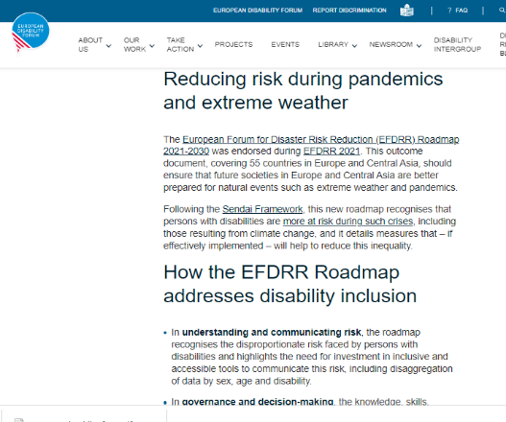

Banner, images, pictures

Add ALT Text – Alternative text
ALT-text is a description you can add to images in web pages to assist people who are blind and screen reader users.
Did you know…
The best time to add alt text to an image is when you upload it to WordPress/ or your website. This way, the image has alt text right from the start, and the text is already there every time you add the image to a web page.

Create accessible video

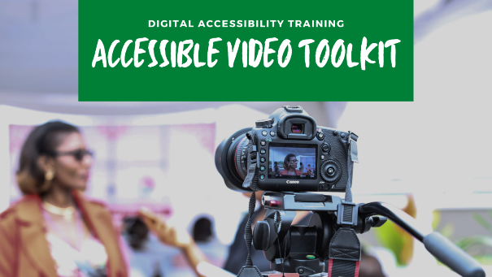
When you create and upload videos on the website, make sure there are accessible. Download the Toolkit on accessible video and have your check list:
- Video design (content, fonts size for your text, colors)
- Contrast between main subject and background
- Captions
- Audio and voiceover
- Sign language interpretation

Meaningful Hyperlink Text
Give your links unique and descriptive names.
- Keep it concise and clear
- Should be visual distinct (blue and underlined)
- Give your links unique and descriptive names.
When including links in your content, use text that properly describes where the link will go. Using "click here" is not considered descriptive and is ineffective for a screen reader user.
Just like sighted users scan the page for linked text, visually impaired users can use their screen readers to scan for links. As a result, screen reader users often do not read the link within the context of the rest of the page. Using descriptive text properly explains the context of links to the screen reader user.

- Avoid words: Click here; Read more; Learn more, More info
- Avoid the word “Link” in your link and naked URL:
Link to https://www.edf-feph.org/
Do not capitalize links: WWW.EDF-FEPH.ORG

Tables
When it comes to displaying data, tables are handy. They make it much easier for all users, including those using assistive technology, to parse a large amount of data.
- Keep your tables as simple as you can.
- Avoid using tables for anything but tabular data. For example, you should never use a table for lists, or anything else. This can be confusing to screen readers and similar devices.

Media and navigation
- Avoid automatic navigation, such as carousels and sliders.
- Avoid automatic media: figuring out how to turn off the media can be difficult when using a screen reader, while other users could simply be confused or even frightened by the sudden noise.

Web design check list
- Choose a content management system that supports accessibility. Once you've chosen a CMS that suits your needs, make sure to choose a theme/template that is accessible. Consult the theme's documentation for notes on accessibility and tips for creating accessible content and layouts for that theme. Be sure to follow the same guidelines when selecting modules, plugins, or widgets.(WordPress)
- Use good colour contrast
- Add text zoom
- Ensure that all content and website can be navigated with the keyboard. This step is also the most important. Put simply: for a website to be accessible, it must work without the use of a mouse. This is because many assistive technologies rely on keyboard-only navigation. As such, it must be possible to use all of your site’s major features via a keyboard and nothing else. This includes accessing all pages, links, content, and so on.

Good colour contrast
Remember: The simpler, the better!
You need to make sure the colors you select on your site contrast well to ensure that everyone can distinguish between various elements on the page.
The most pressing issue is making sure text stands out against the background. Ideally, you should set a dark color against a light one, making sure that they don’t bleed into each other.
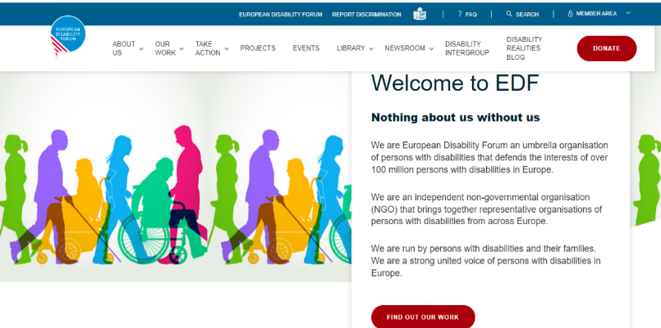

Avoid poor colour contrast

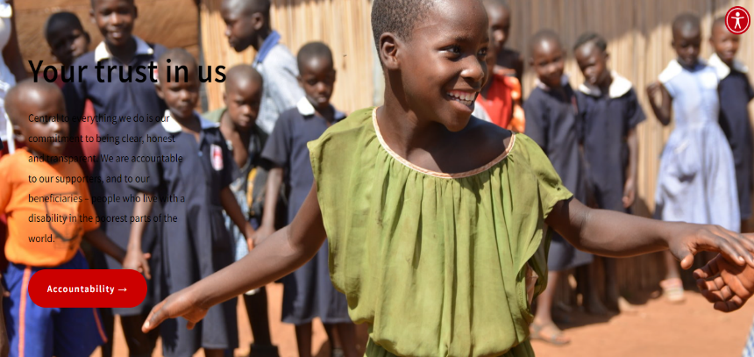

Text Zoom

Text size enlargement is used by many users and is able to enlarge the text up to 200% without loss of information.

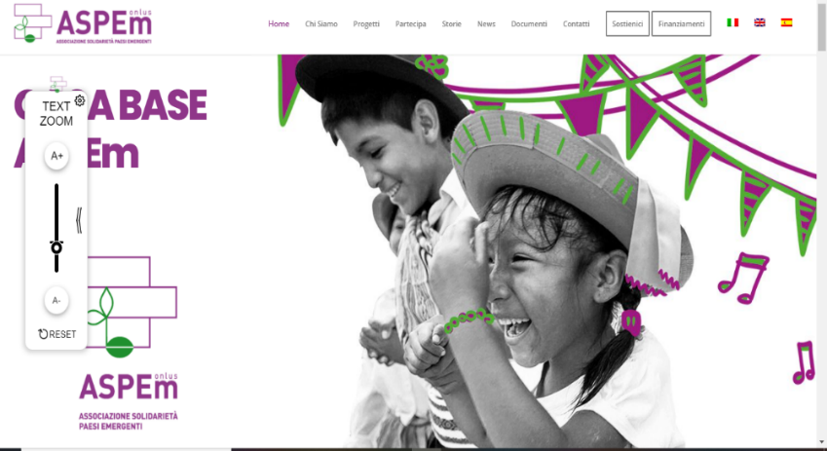

Accessibility tools/menu

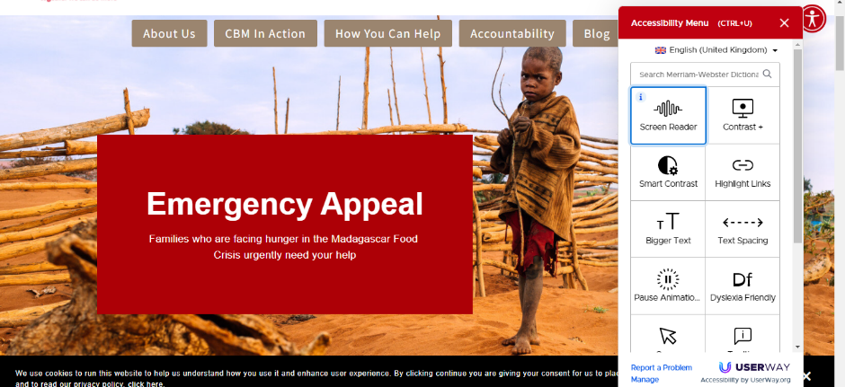

Keyboard navigation

- Keyboard accessibility is one of the most important aspects of web accessibility.
- Many users rely on a keyboard.
- A keyboard user typically uses the Tab key to navigate through interactive elements on a web page—links, buttons, fields for inputting text, etc
- The focus indicator is typically shown as a border or highlight (called an outline) around the focused element.

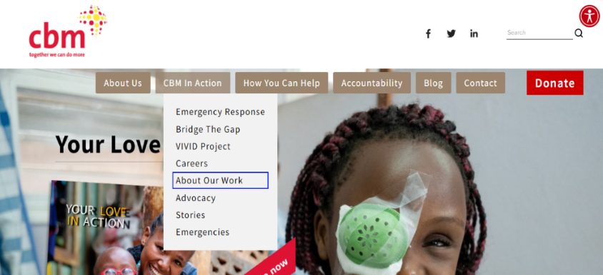

Resources

- Web Content Accessibility Guidelines (WCAG) 2.0
- W3C and Accessibility
- Web Access Berkeley
- Designing for Web Accessibility
- CBM Ireland website
- Aspem associazione solidarietà paesi emergenti

Roberta Lulli
Digital Accessibility Trainer VIVID-T project
Roberta.lulli@edf-feph.org

Natalia Suarez
Communication Officer
natalia.suarez@edf-feph.org

The European Disability Forum
Avenue des Arts 7-8
1210 Brussels, Belgium.
www.edf-feph.org - info@edf-feph.org

