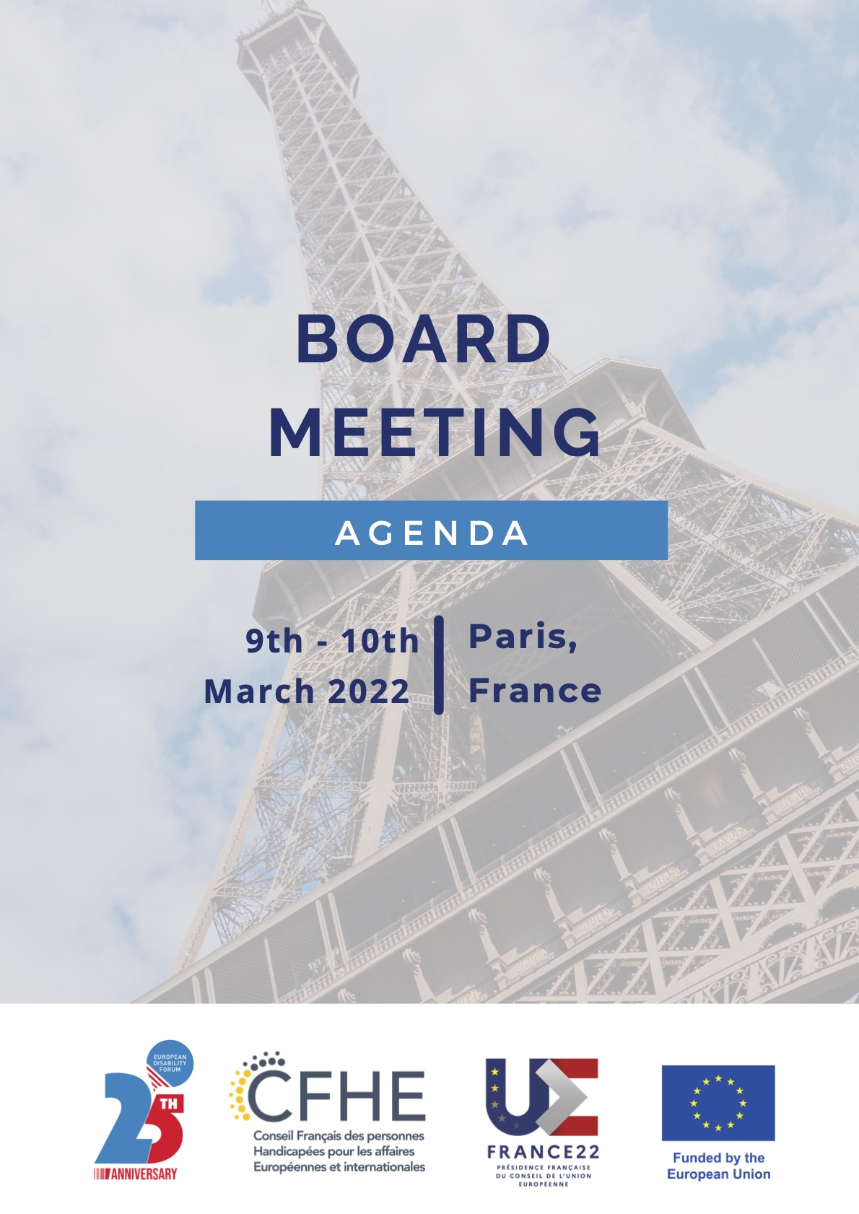
Un événement organisé dans le cadre de la présidence française du Conseil de l’Union européenne *
* Cet événement n’est pas organisé par le Gouvernement français. Il est cependant autorisé par celui-ci à utiliser l’emblème de la présidence française du Conseil de l’Union européenne.

EDF Board Meeting and Conference

March 10th and 11th 2022

Paris, France

Venue: Novotel Paris Centre Eiffel Tower Hotel
61 quai de Grenelle
75015 PARIS
FRANCE
Tel.: +33140582000

Committees in advance of the board meeting

Online. Zoom platform
Friday, 25th February 10:00 – 12:00 Human Rights and Non-Discrimination Committee
Thursday, 3rd March 10:00 – 12:00 Social Policy and Inclusion Committee

Wednesday, 9th March

Morning: Arrival members of the Executive Committee
All day: Arrival EDF Board members
Ministerial meeting on Disability on the same day in Paris, EDF president attending

Novotel Paris Centre Eiffel Tower Hotel (Room TBC)

17:00 – 18:30 Finance Committee (for Committee members only)
Membership and Credentials Committee (for Committee members only)
18:30 – 19:30 Executive Committee meeting (for Committee members only)

Thursday, 10th March

Room: Salon Rhin-Volga-Douro-Amazone

08:30 – 09:00 Registration

09:00 – 09:30 Opening and keynote speeches
- Bernadette Pilloy, President of the CFHE
- Yannis Vardakastanis, President of EDF
- Bruno Gaurier, opening words on the foundation of EDF

09:30 – 10:30 Board Session 1

Chairperson: Yannis Vardakastanis, EDF President
- Welcome by the President, apologies and adoption of the agenda
- Remembering Pekka Tuominen
- Health protocol for the meeting- verbal update (COVID Safe Policy)
- EDF green policy (DOC-BOARD-22-03-01)
- EDF 25-year anniversary (DOC-BOARD-22-03-02)

10:30 – 11:00 Coffee break
11:00 – 12:00 Board session 2
- Policy update (DOC-BOARD-22-03-03)
- Combating violence against women (DOC-BOARD-22-03-04)
- Follow up on the European and Global Disability Summits (DOC-BOARD-22-03-05)

12:00 – 13:00 Lunch break

13.00 – 14:00 Transport to the Ministry and registration

14:00 – 15:30 Conference on “Persons with disabilities in the city” Participation in political and public life. Part 1

15:30 – 16:00 Break

16:00 – 17:00 Conference on “Persons with disabilities in the city” Participation in political and public life. Part 2

17:00 Free evening

Friday, 11th March

Room: Salon Rhin-Volga-Douro-Amazone
08:30 – 09:00 Registration
09:00 – 11:00 Board Session 3
- Update from the Women’s Committee, and new terms of reference (DOC-BOARD-22-03-06) (plus vote for adoption of terms of reference)
- Update from youth committee and new terms of reference (DOC-BOARD-22-03-07) (plus vote for adoption of terms of reference)
- Membership update (including report on Membership Review) (DOC-BOARD-22-03-08) (plus vote for adoption of the report)
- Finance update (DOC-BOARD-22-03-09)
- AGA draft agenda (DOC-BOARD-22-03-10)
11:00 –11:30 Coffee break

11:30 – 13:00 Board session 4
- EDF elections 2022 (DOC-BOARD-22-03-11)
- Review of EDF statutes to align to Belgian NGO law (DOC-BOARD-22-03-12)
- Upcoming Meetings and events in 2022 overview (DOC-BOARD-22-03-13)
- Any other Business:
  - Announcing the winners of our 2021 photo competition
  - Discussion and resolution on Ukraine (Document to be distributed later)
13:00 Closure of the meeting
13:00 – 14:00 Departure of participants

