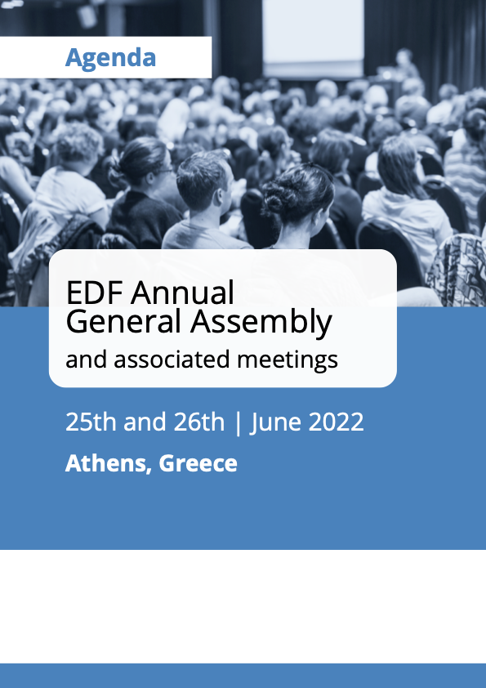
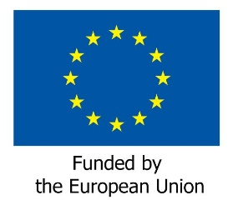

EDF Annual General Assembly and associated meetings

June 25th and 26th 2022

Athens, Greece
Venue TBC

Thursday 23rd June

Arrival members of the Executive Committee

Friday 24th June
All day - Arrival of elected Board members and AGA participants
Room TBC

TBC Welcome coffee and refreshments for Elected Board members only

TBC Board meeting
Free evening

Saturday 25th June

Room TBC

08:00 – 08:45 Registration of participants

09:00 – 10:00 Official opening of the AGA
Keynote speeches
- Helena Dalli, Commissioner for Equality
- Dimitrios Papadimoulis, European Parliament Vice President

10:00 – 11:00 AGA Business session 1
Chairperson: Yannis Vardakastanis, EDF President
- Roll Call
- Adoption of the agenda
- Health protocol for the meeting + introduction from the Hotel management (DOC-AGA-22-06-01)
- Appointment of the Scrutiny Committee and presentation of elections procedure (DOC-AGA-22-06-02)
- Election of the EDF President
- Elections of Board members, Finance, and Membership and Credential Committees

11:00 – 11:30 Coffee break

11:30 – 13:00 AGA Business session 2
Chairperson: Yannis Vardakastanis, EDF President
- Financial issues
- Adoption of EDF final accounts 2021 (DOC-AGA-22-06-03)
- Vote of discharge to the Board for 2021
- Appointment of internal auditors for 2022 (DOC-AGA-22-06-04)
- Adoption of EDF budget (DOC-AGA-22-06-05)
- Adoption of final activity report 2021 (DOC-AGA-22-06-06)
- Activity plan 2023 (DOC-AGA-22-06-07)
- Results of elections (possible second round at a time to be confirmed)

13:00 – 14:30 Lunch break

14:30 – 16:30 Conference on “Disability and Sustainability”

Moderator: Nadia Hadad
Debate with participants

16:30 – 17:00 Coffee break

17:00 – 18:00 AGA Business session 3
Chairperson: Yannis Vardakastanis, EDF President
- Membership issues
- Revision of EDF statutes (DOC-AGA-22-06-08)
- Adoption of terms of reference (TOR) for the EDF Women’s Committee and EDF Youth Committee after the AGA (DOC-AGA-22-06-09)

Evening Official dinner marking 25 years of EDF, with all Delegates and invited guests

Sunday 26th June

Room TBC

08:30 – 10:30 Meeting of the newly elected Board and election of the Executive Committee

10:30 – 11:00 Welcome coffee

11:00 – 13:00 AGA Business session 4. Policy Session
Chairperson: Yannis Vardakastanis, EDF President
- Announcements of the Executive Committee elections
- Policy items (to be confirmed)
- Any other business
- Date of the next meeting
- Collection of evaluation forms of the General Assembly

13:00 End of the meeting and departure of participants

