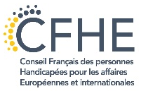
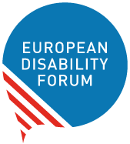
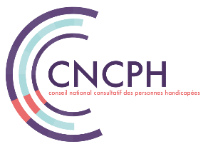
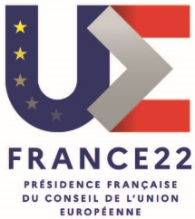

Conference
“Persons with disabilities in the city”
Participation in political and public life

An event organised in the framework of the French Presidency of the Council of the European Union *.
Thursday 10 March 2022 (14:00 - 17:00)
In person at the French Ministry of Solidarity and Health (Salle Laroque) and by videoconference

The number of persons with disabilities is now estimated at 15% of the European population. Persons with disabilities face a multitude of barriers in their daily lives that affect their full participation in the city - accessibility of buildings, transport, services - but also in public and political life.
The purpose of this conference is to share national and European reflections and experiences, in the light of the principles set out in the UN Convention on the Rights of Persons with Disabilities (CRPD) to which the European Union and its members are signatories. The focus will be on citizenship as a particular issue for persons with disabilities, and more particularly with regard to
- Participation in democratic, political and institutional life.
- Representation in democratic and associative bodies.
- Accessibility of election campaigns and candidacy
- Mobility in an accessible city and transport.

These themes are closely linked to current European policies:
- European Strategy on the Rights of Persons with Disabilities (2021-2030),
- Reform of the European electoral law,
- Proposal for two directives on the rights of mobile voters,
- European Sustainable Mobility Strategy,
- European Mobility Card and Parking Card,
- European Accessibility Act
- Conference on the future of Europe.
In the framework of the French Presidency of the Council of the European Union, the European Disability Forum (EDF) will have a meeting of its Board of Directors in Paris on 10 and 11 March 2022, with the support of the French State Secretariat for People with Disabilities and EDF's French member, the Conseil Français des personnes Handicapées pour les affaires Européennes et internationales (CFHE).
EDF would like to take advantage of its statutory meetings in the countries holding the Presidency of the Council of the European Union to meet the representatives of the civil society. It is in this spirit that this conference has been initiated with the CNCPH and its members.

Provisional programme

Conference facilitation:
- Catherine Naughton, EDF Director.
- Bernadette Pilloy, Member of CNCPH & President of CFHE.
14.00 - 14.30 - Opening
- Sophie Cluzel, Secretary of State to the Prime Minister, responsible for persons with disabilities.
- Ana Peláez, EDF Vice President.
- Jérémie Boroy, President of the CNCPH.
14.30 - 15.10 - Panel 1: "Being political, doing politics”
- Moderator: Fernando Pinto da Silva, Vice President of the CNCPH.
Opening sequence: the French context, by Jean-Luc Simon, Vice-President of the CNCPH.
- Alejandro Moledo, EDF Head of Policy.
- Joan Ramon Riera, member of the Barcelona city council responsible for the Local Institute of Persons with Disabilities.
- Denise Cresso, local politician and activist, Sweden.
- Katrin Langensiepen MEP, Member of the European Parliament, and co-chair of the Disability Intergroup.
15.10 - 15.30. Discussion
15h30 - 15.50. Break
15.50 - 16.30 Panel 2: "Accessibility and mobility, preconditions for active citizenship”
- Moderator: Catherine Naughton, EDF Director.
Opening sequence: the French context, by Fernando Pinto da Silva, Vice-President of the CNCPH.
- Pierre Gyselinck, Member of the EDF Board, User of the Disability Card.
- Anne-Laure LeMerre, Senior Advisor on EU affairs - Mobility expert, UITP.
- James Thurston, Vice President G3ICT, Smart Cities for all - online.
16.30 - 16.50. Discussion
16.50 - 17.00 Closing
- Jérémie Boroy, President of the CNCPH.
- Pat Clarke, EDF Vice President.

* This event is not organised by the French Government. However, it is authorised by the Government to use the emblem of the French Presidency of the Council of the European Union.

