EDF Board Meeting and Conference

March 10th and 11th 2022

Paris, France

Practical & logistic information

Conference and Board Venue and Accommodation
Rooms for all participants attending the event in person are booked by EDF. The rooming list is now closed and has been shared by email with all participants.
At your arrival, the hotel may ask you for a credit card to guarantee the extra charges during your stay. You will be requested for payment during the check out for extra charges.
Hotel information:
Novotel Paris Centre Eiffel Tower Hotel
61 quai de Grenelle
75015 PARIS
FRANCE
Tel.: +33140582000

Check-in from 15:00 p.m.
Check out up to 12:00 p.m.
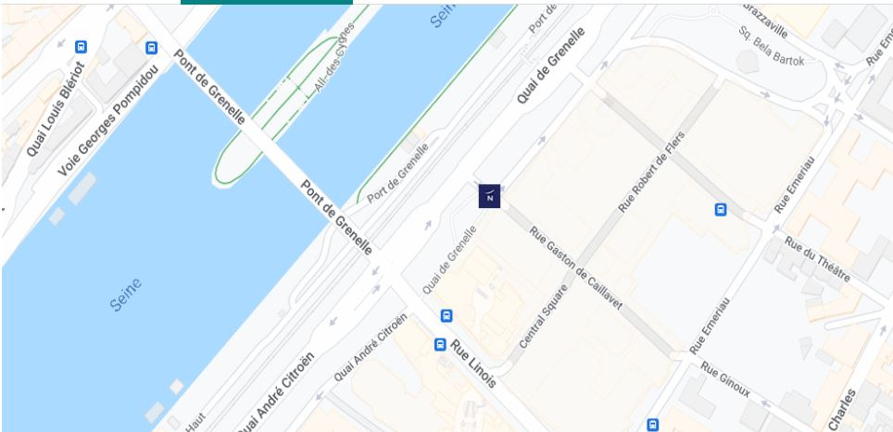

Meetings on 10th in the morning (08:30 to 12:00 CET) and 11th in the morning (08:30 to 13:00 CET) will take place at the hotel, in room “Salon Rhin-Volga-Douro-Amazone”.
Conference on 10th March in the afternoon (14:00 to 17:00) will take place at the French Ministry of Solidarity and Health in the “Salle Laroque”.

Transport

From the airport/ train station to the hotel
Paris Orly Airport is 15km from the hotel.
Paris Roissy Charles de Gaulle Airport is 25km from the hotel.
Paris Nord Train Station is 7.5km from the hotel.
For more information about the transport options please visit “Access and transport” section on the hotel Website.
EDF will provide transport from the airport/ train station to the hotels and return for wheelchair users and their personal assistants. Confirmation of the adapted transport has been sent to participants.
For the other delegates and participants, we advise taking public transport, taxi or Uber taxi from the airport to the hotel and return. The expense claim form has been uploaded in the Members Area dedicated page.

From the hotel to the Ministry
EDF will provide transport for all participants from the hotel to the Ministry on Thursday 10th March at 13:00. Please be at the main entrance of the hotel on due time.

COVID-19

COVID 19 policy for events. EDF

The EDF board adopted this guidance for EDF events in November 2022. This is applied during our meeting. The COVID-19 safe guidance for EDF events has been uploaded in the Members Area dedicated page.

Here is additional information about the rules in France and to travel to France.

Travel to France requirements
All participants are required to bring their Covid-19 vaccination certificate. This certificate will be needed frequently during your travel and stay. You can be asked for it entering France, at the hotel registration desk and at the Ministry security check.
These are the measures currently in place to enter France:
- For travellers vaccinated within the meaning of European regulations, no more tests are required on departure. Proof of a complete vaccination schedule is sufficient to arrive in France, regardless of the country of origin.
- For unvaccinated travellers, the obligation to present a negative test to travel to France remains, but the measures on arrival (test, isolation) are lifted when they come from countries on the "green" list, characterized by a moderate circulation of the virus.
- When unvaccinated travellers come from a country on the "orange" list, they must continue to present a compelling reason justifying the need for them to
come to mainland France and may still be subject to a random test on arrival. Travelers who test positive will have to isolate themselves, in accordance with the recommendations of the Health Insurance.
More information can be found through this link. (available in English and French)
Additionally, a Digital Passenger Locator Form must be filled by each person arriving by air. The eForm will be asking for flight details including seat, departing and arriving schedule, airline and flight number. It is recommended to have them booked prior to fulfilling these documents.
You will find the form on https://app.euplf.eu/#/. Once completed, they will provide you with a QR code and a PDF Certificate. Please remember that this is a legal requirement from the Government of France, hence compulsory.
Also, do not forget to check with your local authorities if you need to fulfil any other documentations upon your return to your countries.
For travellers arriving and departing by train please check this dedicated page.

Meals
Breakfasts are included for those accommodated at the hotel.
On Thursday 10th March, lunch will be provided in the hotel for participants of the Conference and the EDF Board meeting. Dinner is not foreseen as part of the programme, so you are free to make your own arrangements.
Coffee breaks will be provided for participants on both days of the Board meeting in the hotel.
Please note that due to Covid-19 restrictions, there will be no coffee or beverages during the break of the Conference at 15:30 in the Ministry. We suggest that all participants bring water with them.

Meeting Documents and Interpretation
For Members Only, Board meeting documents are available in English and French on EDF’s Website, Members area.
Please note that EDF does not provide the documents printed, so make sure that you bring all your documents with you if you require paper copies.
The Board meeting will have simultaneous interpretation in French. Headsets will be available at the beginning of the meeting, please note that your ID card or passport will be requested as a guarantee for the device.

International sign interpretation and real-time captioning in English will also be provided. Real-time captioning in English and automatic captions in other languages will be accessible through this links on Text-on-tap platform:
Text-on-tap link for Board Sessions.
Text-on-tap link for Conference.

Remote participation
Both the Board sessions and the Conference will be livestreamed on Zoom for remote participants.
Link for the Board Sessions. (Registration required) Only for Board members and Observer members.
Link for the Conference.

Registration
The registration for the Board Sessions will start at 08:30 in front of the meeting room “Salon Rhin-Volga-Douro-Amazone” on both days. Please note that your signature is compulsory to attest your attendance. Desks will be organized following category of members and alphabetical order (One desk for National Council and one desk for NGOs).
During the registration, EDF will give all participants individual sticker badges.
Due to Covid-19 restrictions, participants will be asked to choose a spot in the meeting room and keep it during the whole event. Thus, one sticker badge will also be used to identify each person’s table.
Finally, for the registration at the Ministry, please don’t forget to bring with you your ID card or passport and a printed copy of your invitation to the Conference (you can download the Concept Note in the Conference dedicated page). This will all be required at the security check in the entrance of the building.

Voting process
During the Board Sessions, participants will be required to vote for different items on the agenda. This process will also help us all practice for the upcoming AGA elections in June.
The voting will be done digitally through ChoiceVoting platform. More information will be shared soon.
We kindly ask all participants to please bring a computer, tablet or smartphone with you during the Board Sessions on both days where you can access the email which you use for communication with EDF and registration for the Board. Also please bring it charged, as there will be a limited amount of power sockets available in the room.

Contacts
EDF will be available to provide you with any support and reply to your questions.
- General issues related to organization of the meetings: Raquel Riaza, mobile: +34 633 79 25 45
- Financial and administration issues: Muriel Da Via mobile: +32 470 96 52 78
- The agenda of the meeting: Catherine Naughton

Reimbursement of Expenses
Expenses will be reimbursed upon receipt of expense claims. The expense claim form is available through EDF dedicated page.
Your main travel costs will be reimbursed according to real costs (documented with plane, train tickets, invoices, etc.).

Hotel Green policy
You can find information on the Hotel Green Policy in place through this link.

Tourism in Paris
If you would like to visit Paris in your free time, please find here some useful links:
- Official website of the Convention and Visitors Bureau.
- Accessibility at the Louvre Museum

Emergency contacts
Emergency: 112
Medical care in France: SOS Médecins

