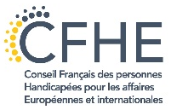
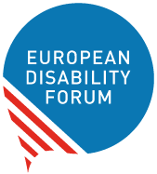
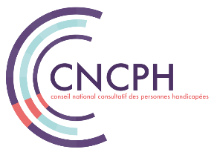
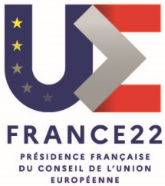

Conference
“Persons with disabilities in the city”
Participation in political and public life

An event organised in the framework of the French Presidency of the Council of the European Union *.
Thursday 10 March 2022 (14:00 - 17:00)
In person at the French Ministry of Solidarity and Health (Salle Laroque) and by videoconference

Conference Report

Opening
The conference was moderated by Catherine Naughton, EDF Director and Bernadette Pilloy, Member of CNCPH & President of CFHE.
It was opened by Sophie Cluzel, Secretary of State to the Prime Minister of France, responsible for persons with disabilities. She mentioned the new European Strategy on the Rights of Persons with Disabilities and relevant initiatives in France on topics such as assistive devices, access to higher education and professional training, innovative housing solutions, and accessibility.

Following Mme Cluzel, EDF Vice-President Ana Pelaez addressed the audience on behalf of the European Disability Forum and reminded everyone that decisions about persons with disabilities should always be taken with the involvement of persons with disabilities, according to the motto “Nothing about us, without us”.

Finally, Jérémie Boroy, President of the CNCPH underlined the importance of access to information to enable persons with disabilities to participate in elections, mentioning the example of the French election observatory.

Panel 1: "Being political, doing politics”
The first panel of the conference was moderated by Fernando Pinto da Silva, Vice President of the CNCPH. To set the scene of the discussion, Jean-Luc Simon, Vice-President of the CNCPH, presented the French context, underlining that persons with disabilities are obliged to become political to achieve their rights.
Alejandro Moledo, EDF Head of Policy, presented the results of the EDF’s new Human Rights Report on the topic of political participation, which will be published soon. The report focuses on the European elections, and provides comparative data from the 27 Member States on key elements of the political rights of persons with disabilities. For example, there are 14 Member States in which persons under total or partial guardianship can be denied of the right to vote. Among these countries, in 7 Member States any person under guardianship automatically loses their voting rights. Concerning the right to stand as candidate, this is only upheld in 8 EU countries. The report also looks at the accessibility and reasonable accommodation measures put in place, taking into account the wide variety of voting systems used for the European elections. This report will support the advocacy campaign of the disability movement to amend the EU Electoral Law that is taking place in the European Parliament, and national reforms aiming at ensuring equal participation in political life for all persons with disabilities.
Joan Ramon Riera, member of Barcelona city council and responsible for the Local Institute for Persons with Disabilities, presented the objectives and the work of this Institute. The Institute gathers elected city council officials and elected persons with disabilities among Barcelona’s population with disabilities. The Institute sets the political agenda as for decisions concerning persons with disabilities. As an example, Mr Riera mentioned that Barcelona has recently won an Access City Award, and is proud to have a 100% fleet of accessible buses.
As an example of active political participation of persons with disabilities, Denise Cresso, local politician and activist from Sweden, explained why and how she got involved in local politics. Raising awareness of disability issues, especially accessibility, is a big part of the job.
Katrin Langensiepen MEP, Member of the European Parliament, and co-chair of the Disability Intergroup also shared her experience as an elected official. While she pointed out the barriers to political participation that still exists, she also mentioned that having a disability does not mean that one should become the spokesperson for all persons with disabilities but create a feeling of responsibility among other Member of Parliament instead.

Panel 2: "Accessibility and mobility, preconditions for active citizenship”
The second panel was moderated by Catherine Naughton, EDF Director and the opening sequence to set the scene and relate to the French context was given by Fernando Pinto da Silva, Vice-President of the CNCPH. His main remark was that while in France there are already many good initiatives for accessibility in place, it still has to go a long way to become fully accessible.
Pierre Gyselinck, Member of the EDF Board, and user of the European Disability Card presented the importance of such a Card and why binding legislation will be needed to make the Card available in all EU Member States.
Anne-Laure LeMerre, Senior Advisor on EU affairs - Mobility expert, UITP, presented the point of view of public transport operators and outlined the possibilities of the EU’s New Mobility Framework for persons with disabilities. She also described the remaining challenges to achieve fully accessible urban transport.
Finally, James Thurston, Vice President G3ICT, Smart Cities for all, presented how the “Smart Cities for All” project helps to bridge the digital divide. While digitalisation is a big opportunity to make our cities more accessible, we also have to ensure that technologies such as Artificial Intelligence do not create new obstacles to inclusion.

Discussion and Closing
A lively discussion with numerous interventions from the floor followed the panel presentations. Issues such as inaccessible train platforms, unwillingness of transport staff to assist persons with disabilities, or deaf persons being refused a driving license in some EU member states were mentioned.
But also some possible solutions such as involving persons with disabilities and their representative organisations, guidance material, labelling systems, or common standards were mentioned. All participants agreed that a common, EU-wide approach will be of benefit to advance participation of persons with disabilities in public life.
The conference was officially closed by Jérémie Boroy, President of the CNCPH and Pat Clarke, EDF Vice President.

* This event is not organised by the French Government. However, it is authorised by the Government to use the emblem of the French Presidency of the Council of the European Union.

