European Semester 2020: a first reaction from EDF

On the 17 December the 2020 European Semester cycle got off to a start with the release of the “Autumn Package”. This consists primarily of the release of four key documents:

- Annual Sustainable Growth Strategy: the Commission's main tool for setting out the economic and social priorities for the EU for the following year. It provides analysis of European economy and sets the appropriate policy response to the identified challenges, in order to foster growth, inclusiveness and convergence in the EU
- Joint Employment report: provides an annual overview of the main employment and social developments in the EU as a whole, as well as Member States' reform actions. In addition, the Joint Employment Report monitors Member States' performance in relation to the European Pillar of Social Rights.
- Alert Mechanism Report: Aims to identify and address imbalances that might hinder the normal functioning of the economies of Member States or the EU and endanger the economic and monetary union.
- Euro area recommendation: provides tailored advice to euro area Member States on issues relevant for the functioning of the euro area as a whole.

What disability issues we see mentioned in the Autumn Package
Disability issues are addressed to the largest extent in the Joint Employment Report. Here are the elements mentioned that EDF see to be the most crucial and that we would urge strongly to be followed up clearly in the Country Reports and the CSRs:

- Low employment and activity rates of persons with disabilities indicate an untapped potential to use their talents.
- In the EU in 2017, the employment rate of people with disabilities was 50.6% versus 74.8% for those without. It has nonetheless slightly increased as compared to 2016 (48.1%).
- The gap varies substantially across Member States, from 13.7 percentage points in Italy to 42.1 percentage points in Ireland. In addition, only 61% of persons with disabilities in the EU were economically active, compared to 82.3% of those without disabilities, suggesting that significant barriers exist for persons with disabilities in accessing the labour market.
- Countries with similar activity rates for persons without disabilities can have greatly different activity rates for persons with disabilities.
- In terms of gender, the employment rate of women with disabilities (48.3%) was only slightly lower than that of men with disabilities (53.3%).
- The quality of work is also an important issue: in 2018 persons with disabilities were more likely to face in-work poverty risk than those without disabilities (11% versus 9.1% on average in the EU).
- A Eurofound study confirms the crucial importance of employment as a primary inclusion factor. It shows that the extent to which people with disabilities feel left out of society varies considerably depending on whether they are employed or not. Those who have a job report far less often feeling left out of society than, for instance, the long-term unemployed or those who are unable to work because of their disability.
- High level of early school leaving and low level of tertiary education attainment among people with disabilities negatively affect their employment. In the EU in 201785, early school leaving of young persons (age group 18-24) with disabilities was 19.6% compared to 9.5% of those without disabilities (that is a gap of about 10.1 percentage points). This gap was smallest in Slovenia (1.8 percentage points) and relatively high in Czechia (25.5 percentage points), Romania (23.5 percentage points), Bulgaria (21.9 percentage points) and Germany (21.1 percentage points). As concerns tertiary education, 32.4% of persons with disabilities completed a tertiary or equivalent education as compared to 42.5% for those without disabilities (it means a gap of about 10.2 percentage points).

Some things the Autumn Package overlooks
- 28.7% of persons with disabilities in the EU are at risk of poverty and social exclusion compared to 19.2% among the general population. Some countries such as Ireland, Estonia, Latvia, Lithuania, Romania and Bulgaria have extremely high risks of poverty for persons with disabilities:
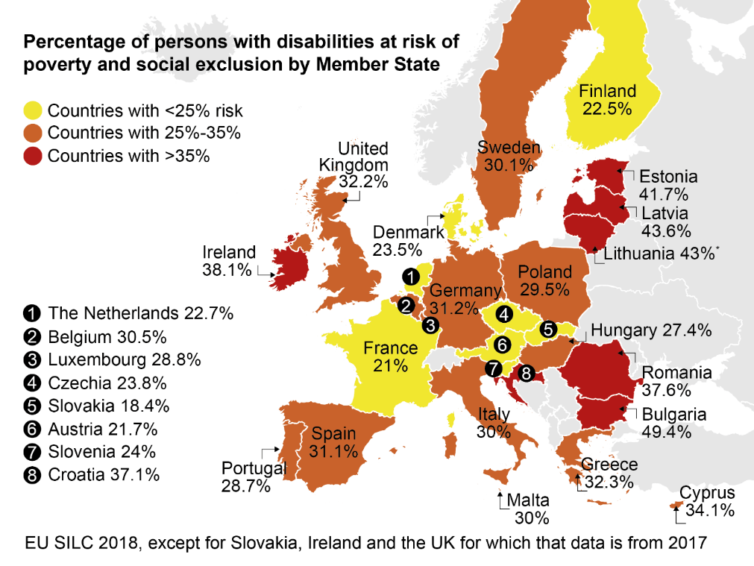
See endnote for Lithuania regarding the map above.

- Ireland, UK, Belgium, Germany, Croatia, Bulgaria, Estonia, Latvia and Lithuania have the biggest gaps in poverty between persons with and without disabilities
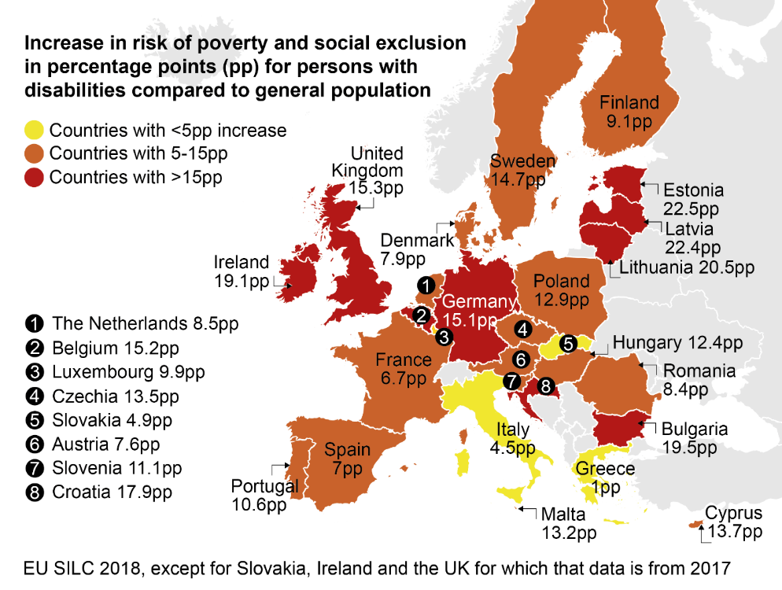
See endnote for Lithuania regarding the map above.

- 29.5% of women with disabilities in the EU are at risk of poverty and social exclusion compared to 27.5% of men with disabilities.

- 11 Member States have seen poverty rates go up for persons with disabilities since 2010. These countries are Estonia, Luxembourg, Germany, Sweden, Ireland, Czechia, Lithuania, Italy, Netherlands, Malta and Spain.
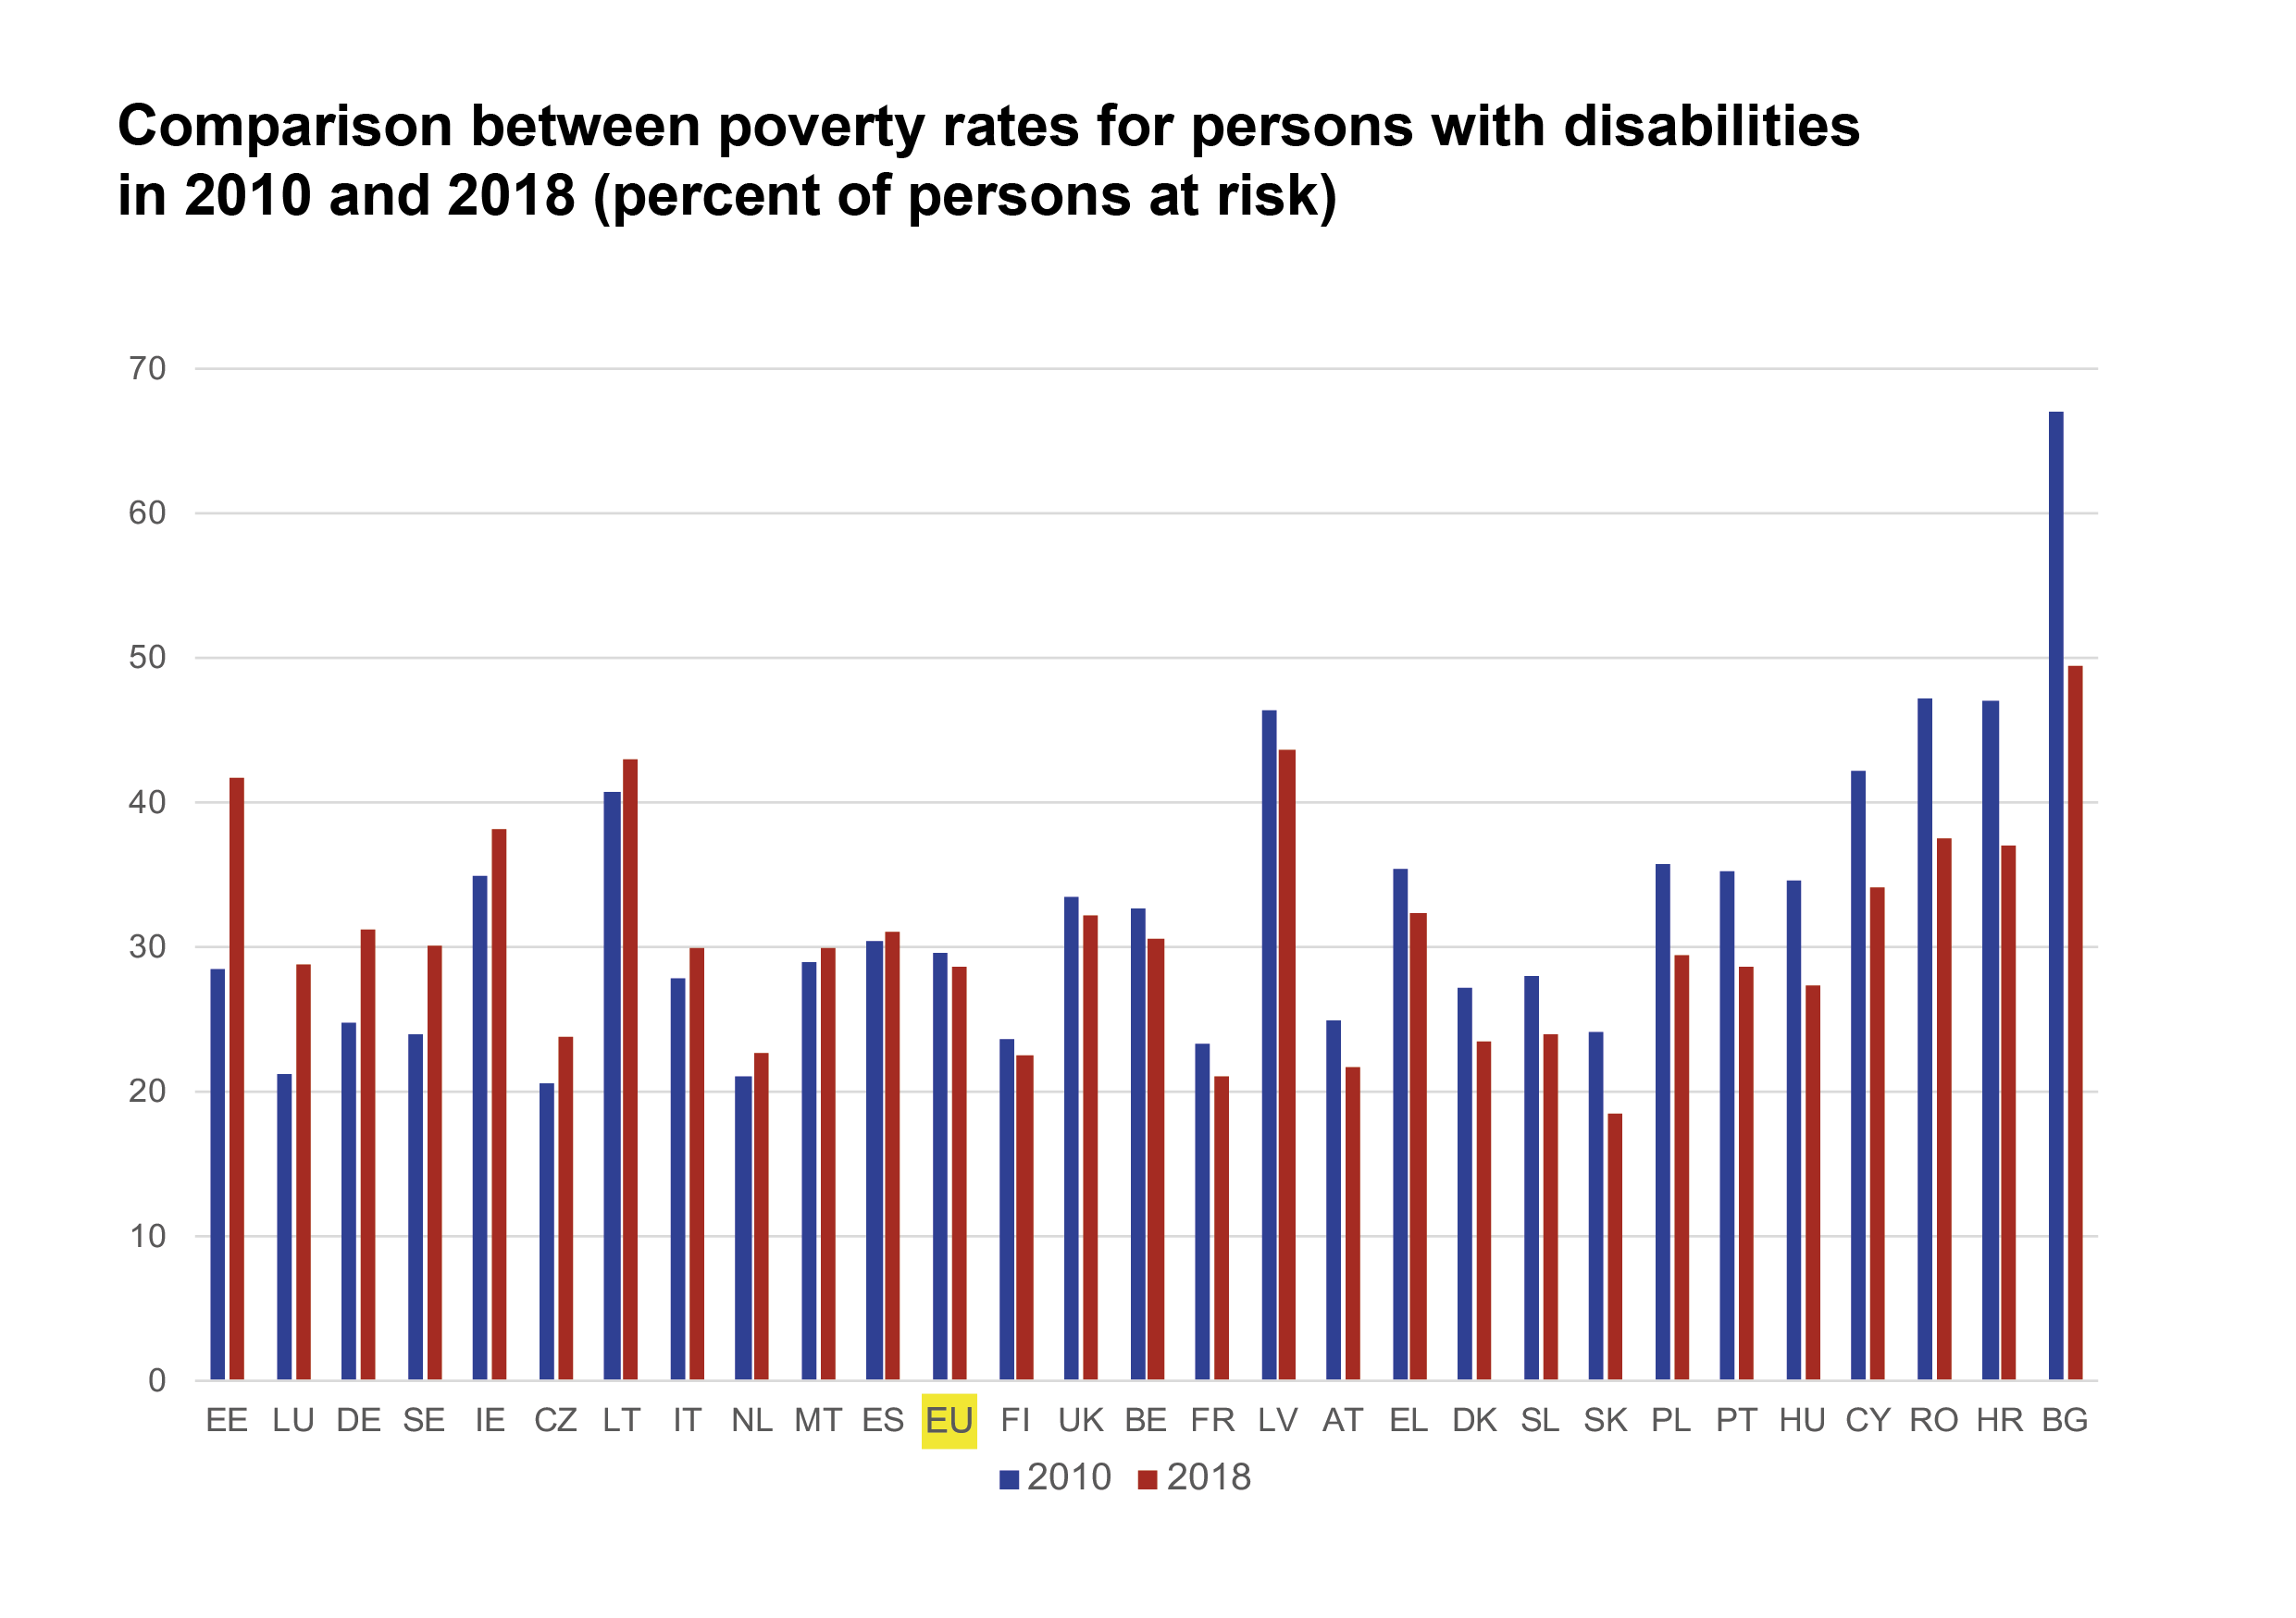

- Extra disability-related costs, even after social payments, are significant. They are estimated at 23,012 euros/year in Sweden or 14,550 euros/year in Belgium, for example. More support needs to be given to persons with disabilities to prevent extreme poverty and homelessness. Research shows persons with disabilities to be highly overrepresented among homeless people. A study carried out in the Netherlands in 2014, for example, found that 29.5% of homeless people had an intellectual disability, whereas the prevalence of intellectual disabilities among the population as a whole is around 0.7%.

EU SILC 2018 except for Slovakia, Ireland and the UK for which that data is from 2017.
Map by Agnieszka Juszczyk
According to the data from official Statistics of Lithuania in the year 2018 this figure is 35,9%
EU SILC 2018, except for Slovakia, Ireland and the UK for which that data is from 2017.
Map by Agnieszka Juszczyk
According to the data from official Statistics of Lithuania in the year 2018 the difference is 18 percentage points
EU SILC 2018, except for Slovakia, Ireland and the UK for which that data is from 2017.
Ibid
Chart by Agnieszka Juszczyk
Antón, J.I., Braña. F.J. and Muñoz de Bustillo, R. (2014). An analysis of the cost of disability across Europe using the standard of living approach. Available at: https://link.springer.com/content/pdf/10.1007%2Fs13209-016-0146-5.pdf
Out of a pool of 387 participants observed.
Van Straaten, B., Schrijvers, C. T. M., Van der Laan, J., Boersma, S.N., Rodenburg, G., Wolf, J.R. and Van de Mheen, D. (2014). Intellectual Disability among Dutch Homeless People: Prevalence and Related Psychosocial Problems. Erasmus medical centre, Rotterdam, Netherlands.

