European workshop on youth employment

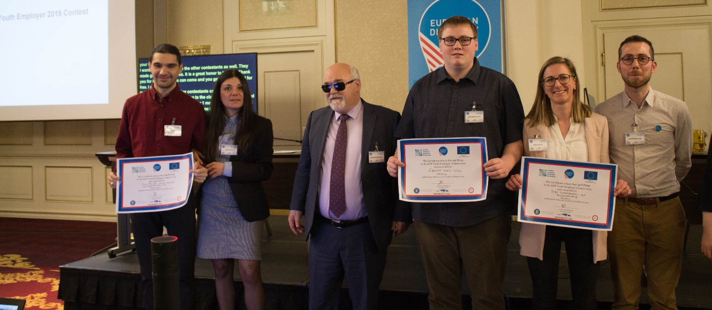
1 Winners of the “Youth Employer 2019” contest with EDF President Yannis Vardakastanis
- Agenda of the workshop
- Minutes of the workshop
- The web-based resource on youth employment which was planned for 2019 was not launched yet due to the delay in the overall launch of the new EDF website

1)
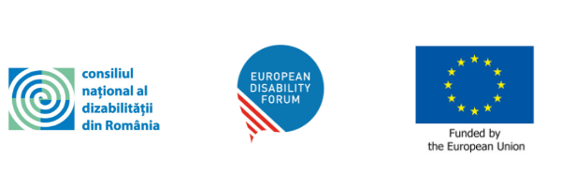

Seminar on youth (un)employment of persons with disabilities
EDF Board

Saturday 23rd March 2019, Bucharest, Romania

Venue: JW Marriott Bucharest Grand Hotel
Room: Foyer Salon BCD

08:00 – 09:00 Arrival and registration of participants

09:00 - 09:30 Official opening of the Board
Daniela TONTSCH, CNDR (Romanian National Council of Persons with Disabilities)
Yannis VARDAKASTANIS, European Disability Forum
Mr. Marius BUDĂI, Minister of Labor and Social Justice.
Traian VRASMAS, RENINCO (National Information and Cooperation Network for Community Integration of Children and Youth with Special Education Needs)
Panel 1: Youth employment and disability in Europe
Moderator: Sorin ŢAŢA, CNDR
09:30 – 09:40 Framing the topic
Matthieu CHATELIN - Youth Committee Member
09:40 - 09:55 Personal experience finding employment
Luminita CALDARAS, self-advocate, Inclusion Europe
10:05 – 10:15 What is the EU doing to support the employment of young people in the EU?
Nikita SANAULLAH, European Youth Forum

10:15 – 10:20 Questions and discussion

Panel 2: EDF Youth Employer 2019 Contest
Moderator: Francesca SBIANCHI - Youth Committee Member

10:20 - 10:30 Contestant 1: Dafür Unternehmens- und Personalberatung, Austria
10:30 – 10:40 Contestant 2: EasyPay AD – money transfers and payment services, Bulgaria
10:40 - 10:50 Contestant 3: Lippischer Kombi-Service, Germany

10:50 – 11:35 Coffee break

Panel 3: Employment of young persons with disabilities in Romania

Moderator: Mihait TOMESCU, Ministry of Labour and Social Justice
11:35 – 11:45 The role of education and training
Ecaterina VRASMAS, RENINCO (National Information and Cooperation Network for Community Integration of Children and Youth with Special Education Needs)
  - 11:45 – 11:55 Preparing for (assisted) employment in the labour market
  - Diana CHIRIACESCU, FONSS (Federation of NGO's for Social Services)
11:55 – 12:05 The role of public counselling services
Elena BABOI, ANOFM (National Agency of Employment)
12:05 – 12:15 Discussion
12:15 – 12:25 Prize giving for the ‘Youth Employer 2019 Contest’
3rd prize presented by Sigríður FOSSBERG THORLACIUS, Member of the EDF Youth Committee
2nd prize presented by Erica BECERRA, Member of the EDF Youth Committee
1st prize presented by Yannis VARDAKASTANIS, EDF President
12:25 – 12:30 Closing remarks
Kamil GOUNGOR, Chair of the EDF Youth Committee
Mihai TOMESCU, Ministry of Labor and Social Justice

12:30 – 14:00 Lunch (Foyer Salon BCD)

2)
Minutes from the EDF Seminar on Youth Employment
23 March 2019, Bucharest, Romania

President Vardakastanis explained that the conference had been designed in collaboration with the CNDR and the Ministry of Labour and Social Justice. He explained that the conference would be divided into three panels. He underlined that the points raised during discussions would be integrated in EDF’s future work on employment.

Panel 1: Youth employment and disability in Europe
Panel 1 was dedicated to youth employment and disability in Europe and was moderated by Sorin Tata from the CNDR.
Matthieu Chatelin from the EDF Youth Committee began by giving a general overview of the topic. He presented some statistics showing that the employment rate of young people with disabilities was much lower that for the rest of the population. He went through the statistics in different Member States. He underlined the importance of ensuring that young people with disabilities can enjoy their freedom of movement in the EU and pursue a career in other Member States. Mr Tata then emphasised the importance of considering the experience of individual people beyond the statistics presented.

Luminata Caldaras, a self-advocate from Inclusion Europe, talked about her personal experience of finding a job. She explained that she was born in small village in Romania and that she spent many years in various families and orphanages. She also spoke about how difficult her childhood was, particularly in light of her lack of education. She explained about the support she received from a foundation that helps people find work, as well as the long and difficult process she went through to find a job in a restaurant. She told participants about how she experienced exploitation, about the distance she had to travel to commute to the workplace and about her long search for a more suitable job. She expressed her hope that, in the future, young people will have an easier time finding suitable work.

Nikita Sanaullah from the European Youth Forum explained what the EU was doing to support the employment of young people. She explained that the unemployment rates in the EU showed that young people were the more affected by unemployment than other age groups. She explained that the EU had taken a series of measures, such as the Youth Guarantee (guaranteeing an offer of employment or a traineeship), the European Pillar of Social Rights, the Work-Life Balance Directive and the Youth Employment Initiative. While she welcomed the aforementioned initiatives, she voiced her regret about their ineffectiveness regarding young people who are part of marginalised communities and already excluded from the labour market. She underlined the improvements needed to assist young people before, during and after finding a work placement.

The moderator opened the floor for questions and comments. The participants expressed some reservations about the target age of the EU’s initatives being set at 25. They also mentioned the need to check how the Youth Guarantee would include accessibility measures, and a parallel was drawn between the EU’s approach and the existence of an Active Youth Programme financed by Norway.

Panel 2: EDF Youth Employer 2019 Contest

Panel 2 was dedicated to the Youth Employer 2019 Contest and was moderated by Francesca Sbianchi from the EDF Youth Committee. She explained the criteria used by the Committee when shortlisting contestants for the prize. She explained the voting procedure, whereby participants at the seminar could vote for the winner. She then gave the floor to the finalists to present themselves and their good employment practices for young people with disabilities.

The first contestant was a representative from the employer Dafür Unternehmens und Personalberatung from Austria, which is an enterprise dealing with private social business, targeting an inclusive labour market.

The second contestant was an employee from EasyPay AD, a company dealing with money transfers and payment services in Bulgaria.

The third contestant was an employee from Lippischer Kombi-Service, based in Germany, which is an enterprise offering mostly catering and laundry services services.

Panel 3 : Employment of young persons with disabilities in Romania
Panel 3 was dedicated to the employment of young people with disabilities in Romania and was moderated by Mihait Tomescu from the Ministry of Labour and Social Justice.

Ecaterina Vrasmas, representing RENINCO (National Information and Cooperation Network for Community Integration of Children and Young People with Special Education Needs) talked about the role of education and training. She explained the global approach put in place in Romania regarding inclusive education and special needs. Nevertheless, she highlighted the huge gap that remains between mainstream education and inclusive education, and underlined the work that still needs to be done to adapt the Romanian system. Her main recommendations addressed the issue of access to university, better training for teachers, enhanced social rehabilitation, assistance or mentoring in education, family support, reinforced legislation on the rights of persons with disabilities, the promotion of a national strategy, etc.

Diana Chiriacescu from FONSS (the Federation of NGO’s for Social Services) talked about how to prepare for (assisted) employment in the labour market. She highlighted the need to respect and implement the UN Convention. She mentioned the need to make improvements in relation to anti-discrimination. She also explained some existing legislation that was not being respected in practice.

Elena Baboi from ANOFM (the National Agency of Employment) talked about the role of public counselling services. She highlighted the fact that the right to work for persons with disabilities was linked to the implementation of the UN Convention and that the National Agencies of Employment should to take measures to stimulate employment for all. She mentioned the importance of subsidies for employing persons with disabilities, as well as young people with disabilities at risk of social exclusion.

The moderator opened the floor for discussion. The Secretary of State mentioned a set of legislative measures that were being prepared in order to improve the situation in Romania. Following questions from the floor, more information was provided on national agencies’ actions to help employers recruit persons with disabilities. It was also pointed out that there is a need to inform parents of children with disabilities of their rights and available support measures in order to reduce the number of children excluded from the education system.

The Prize for the “Youth Employer 2019 Contest” was given. Third prize was presented by Sigríður Fossberg Thorlacius from the EDF Youth Committee and went to Dafür Unternehmens und Personalberatung. Second prize was presented by Erica Becerra from the EDF Youth Committee and went to EasyPay AD. First prize was presented by President Yannis Vardakastanis and went to Lippischer Kombi-Service. The President concluded that the employment of young people should be a top priority at the EU and national level, particularly for young people with disabilities.

Kamil Gungor, Chair of the EDF Youth Committee and Mihai Tomescu from the Ministry of Labor and Social Justice made some closing remarks. They thanked the participants for their involvement in the conference. They repeated the importance of inclusive education and assistive employment for persons with disabilities. Kamil highlighted that it had also been a great opportunity to meet and get to know each other. They explained that this conference was a good starting point and would lead to promising improvements. They also thanked the Romanian colleagues and the EDF Secretariat for the organisation of the event.

