Toolkit: Accessible Word Documents
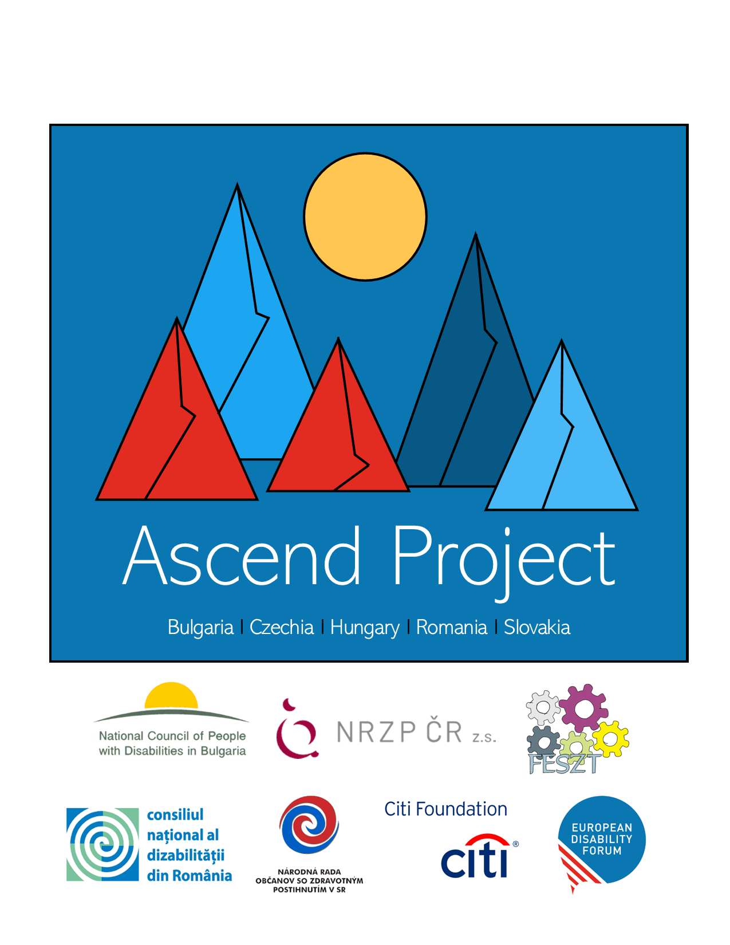

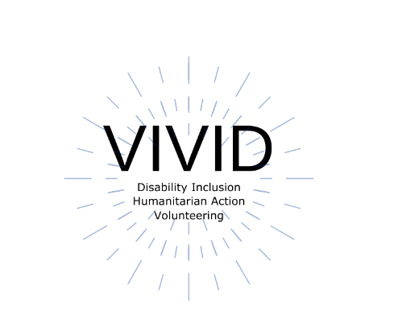
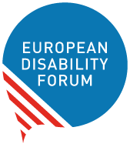

This toolkit was originally developed by Roberta Lulli, EDF Digital Accessibility Trainer on the VIVID-T Project and represents a collaboration with many partners.
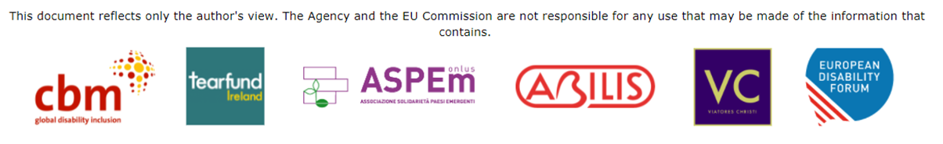
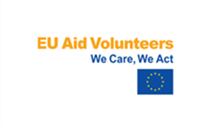 | This publication has received financial support of the EU Aid Volunteers initiative of the European Union. The information contained in this publication does not necessarily reflect the official position of the European Commission.

Introduction

Accessible Word Documents

Equal access to information, regardless of ability, is a human right and is essential for all individuals to participate fully in society.
Accessible Word Documents:
- Benefit individuals and society as a whole.
- Can be read using any of a variety of assistive technologies, such as screen readers, magnification software, or speech recognition programs.
- Can reach a wider audience.

Make your check list!

Is my document accessible to all people who might use it?
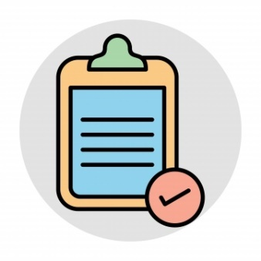
- Give documents a heading structure.
- Use accessible and large fonts.
- Provide alternative text (Alt-Text) for all images.
- Use pre-set formats
- Create meaningful hyperlinks.
- Color contrast check.
- Use Tables wisely.
- Set the language of your document
- Run the Accessibility Checker.

Headings and structure
Headings provide the organisation of the content which is the most important accessibility consideration in Word documents.
- Screen readers give users the ability to navigate a document using headings as long as the headings are organized properly.
- Semantic structure through headings provides individuals using assistive technology with valuable information.

Give documents a structure using Heading styles
Word Styles contain preconfigured headings understood by assistive technology (e.g., Heading 1- Heading 6). These headings are available under the Styles section in the Home tab of the Ribbon.
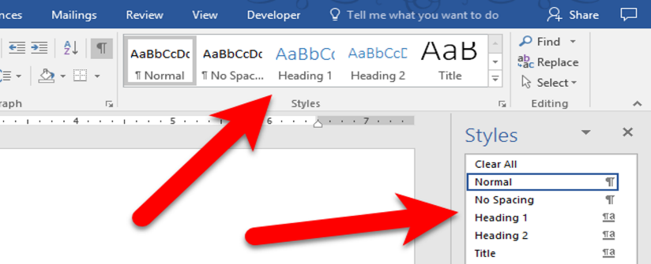

- Apply the “Heading 1” style for the main heading and “Heading 2” for sub-headings.
Every heading in a document can be verified using the Navigation Pane, located in the View tab of the Ribbon. This pane also allows users to navigate to any section of the document by clicking on the corresponding heading.
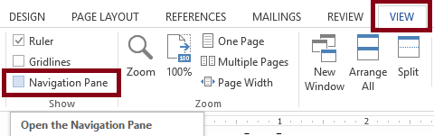

Fonts and size fonts
✔ Recommended 12 point or large
✔ Use a Sans Serif Font – such as Arial, Helvetica or Verdana, Calibri
✔ Be consistent with the fonts used in the document
✔ Use bold to add emphasis rather than italics or UPPERCASE
✔ Double or 1.5 spacing between lines
✖ Underlining large blocks of text as it reduces readability
✖ Avoid justified text but use left aligned text
✖ Avoid italics or UPPERCASE letters

Serif Fonts / Sans Serif Fonts

Times New Romans
Garamond
Perpetua
Cambria
✖
Verdana
Arial
Calibri
Helvetica
✔

The small features on the ends of strokes are known as “Serifs.”
“Sans serif” means “without the decorative line” and it’s considered accessible.
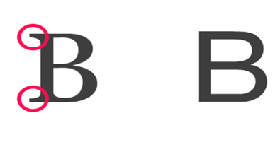

Colors Contrast
Ensure that colours for the text, graphics, and the background have sufficient contrast when viewed by someone with colour-blindness or when viewed on a black and white screen.
- Be particularly mindful when choosing colours for graphs and charts.
- Text and background colors have a contrast ratio of at least 4.5:1 (large text that is ≥14 point and bold or ≥18 point can have a ratio of 3:1).

This is 4.5:1 the minimum required by WCAG

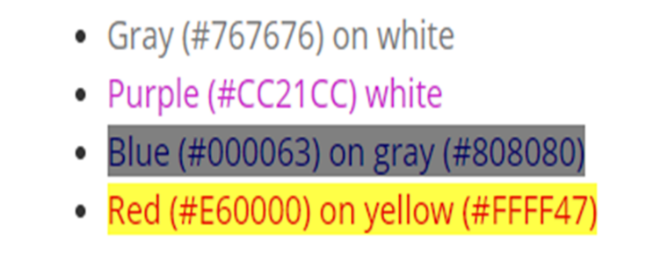

Example of good and bad color contrast

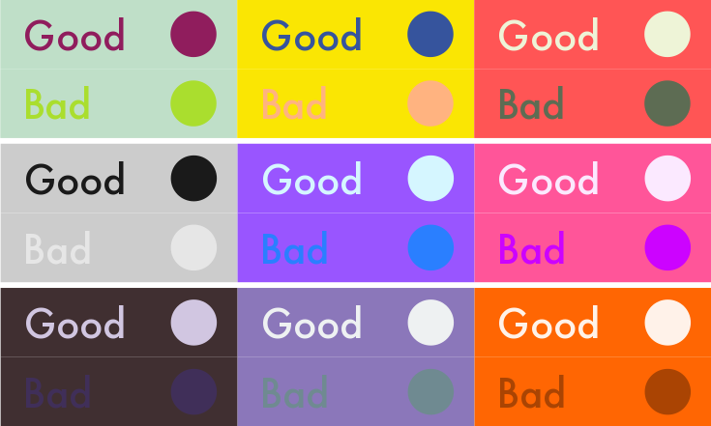

Alt -Text (Alternative Text)
Alt-text is a short-written description of an image and provides a textual alternative to non-text content. Don’t forget to add alternative text to any images you add.

How to add Alt Text

Right-click the picture - Click on Edit Alt Text
In the "Description" field, enter a description of the image.

Alt text: example
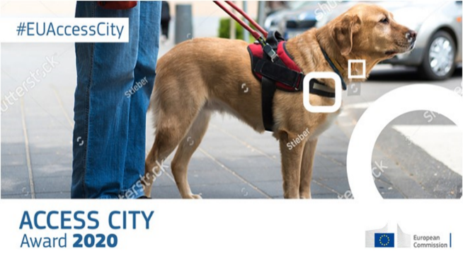
Access City Award 2020 poster
Poster of the Access Citi Award 2020 with an image of a guide dog, the hashtag #EUAccessCity and the European Commission logo.

Words bring image to life! Write an effective Alt-Text:
- Avoid flowering language.
- Be descriptive and keep it simple.
- Exclude words such as “picture of” or “image of”.
- Include all text of the images.

Did you know…
You can also add alt text to the images you upload to Twitter.

Hyperlinks
You can make hyperlinks more accessible by changing their display text to something more natural and meaningful.
- Text link should be descriptive and meaningful.
- Keep it concise and clear.
- Should be visual distinct (blue and underlined).
- Avoid words: Click here; Read more; Learn more; More info.
- Avoid the word “Link” in your link and naked URL like:
Link to https://www.edf-feph.org/
- Don’t capitalize links: WWW.EDF-FEPH.ORG
- Front-load with the most important words, e.g. instead of “Learn more about barriers to inclusion in the workplace,” use “Barriers to inclusion in the workplace.”
- If the link’s purpose is a download, include details about the type and size of what will be downloaded, e.g. “Disability strategy 2021”(PDF, 7MB).”

Table
Tables are a great way to organize data but remember to:
- Include a Header Row.
- Use a simple Table structure.
- Add Alt Text to the table/summary.
- Avoid blank cells if possible.
- Don't use screenshots of tables.

Check Accessibility
The accessibility checker allows you to check for accessibility issues. You can check the accessibility of the document by clicking Review in the top menu > Check Accessibility. Passing the Accessibility Check does not mean the document is fully accessible, but it does mean that it passes all the accessibility criteria that Word checks for.
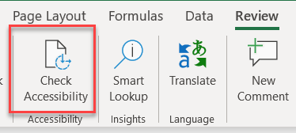

If you don't see the Check Accessibility button on the Review tab, follow these steps: select File > Info > Check for Issues > Check Accessibility.
However, it will not catch everything. It will:
- Alert you to issues (Error) that would be a barrier to accessibility.
- Explain why you should fix issues and how to fix them.

The checker’s Inspection Results

You can find three categories of issues:
Errors: content that makes a document very difficult or impossible to access. Example: an image with no alt text.
Warnings: content that in most cases makes the document difficult to access. Example: a link with text that is not descriptive of its function.
Tips: accessible content, but that might be better organized or presented. Example: skipping from a first-level heading to a third-level heading.

Convert Word Document to PDF

Make sure the original Word document is accessible

Make the document as accessible as it can be, and then converting it correctly to a PDF. A document created in Word should contain almost all the information necessary for an accessible PDF.
The exported PDF will preserve the accessible features of the Word document, including:
- Heading structure
- Alternate text for images
- Lists
- Tables
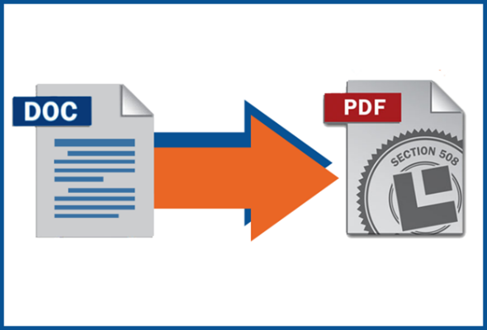
The process of creating an accessible PDF requires the installation of Adobe Acrobat Pro.

Did you know… Before you convert the Word document to a PDF remember to set the language of your document.
Go to Review> Language > Set proofing language and there you choose the language. You can even set different languages for different part of the document.

Keyboard Shortcuts
Keyboard shortcuts are keys or combinations of keys that provide an alternative way to do something that you'd typically do with a mouse.
Not all people are using a mouse to work with their computer. It is important that what they make is operable with a keyboard.
Important: Shortcuts may be different from language to language.

Shortcuts in Word

Create headings: select the line and ALT+ Shift + arrow right or left.
(When you have a screen reader you hear in which level of heading you are)
Make text bold: select the text and press CTRL+B,
Make a link: select your text press CTRL+K and paste the URL inside that you must copy before.
You can use Keyboard shortcuts in Word directly for any operation you wish to make. You can find shortcut lists in the help menu of your software.

Supporting resources

- Introduction to Web Accessibility by WebAIM
- Introduction to Web Accessibility Course by W3C
- Digital Accessibility Toolkit by CBM.
- Make your Word documents accessible by Microsoft 365
- Web Content Accessibility Guidelines (WCAG) 2.0 recommendations for making Web content more accessible.
- Web accessibility Tutorials Structuring content by W3C
- Effective Alternative Text by WebAIM
- WebAIM contrast checker for testing text colors for accessibility.
- Contrast checker based on Web Content Accessibility Guideline.
- Color Oracle a colour blindness simulator.
- Fonts readability by WebAIM
- Improve accessibility with the Accessibility Checker by Microsoft 365
- Rules of Accessibility Checker by Microsoft 365

The European Disability Forum
Avenue des Arts 7-8
1210 Brussels, Belgium.
www.edf-feph.org
info@edf-feph.org

