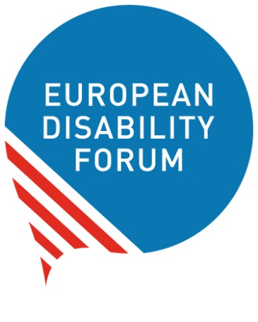

The right to vote
and stand for elections

Easy-to-read
Easy-to-read is information
that is written in a simple way
so that people with intellectual disabilities
and all people can understand it.
You can find more information about easy-to-read
at www.inclusion-europe.eu/easy-to-read.

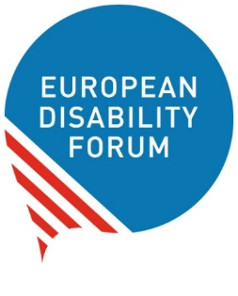
Who we are
We are the European Disability Forum.
We are an organisation
of people with disabilities in Europe.
In short, we are called ‘EDF’.

At EDF, we work to protect the rights
of all people with disabilities in Europe.
We think that people with disabilities
should have the same chances in life
as everyone else.
We also think that people with disabilities
should make their own choices.
Nothing should be decided about us without us!

What this booklet is about
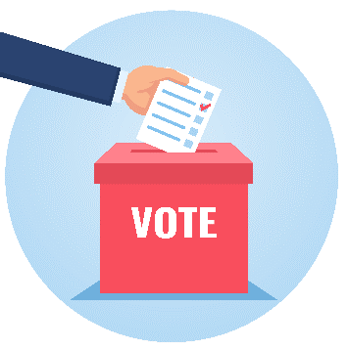
We made this booklet to talk about
the right of people with disabilities
to vote and stand for elections.

Reading this booklet will help you
to know more about:
- What does it mean to vote
and stand for elections?
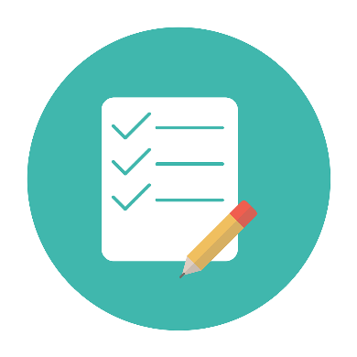
- How is the situation in Europe?
- What problems
do people with disabilities face
to vote and stand for elections?
- How do countries try to help
people with disabilities to vote?
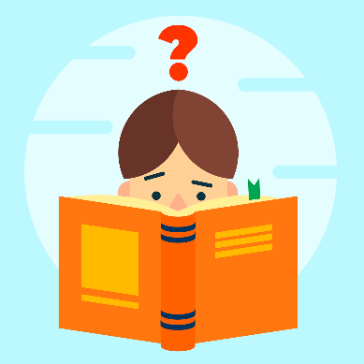
- What can be done better?

All the difficult words in the text
are marked in bold
and you can find their explanation
at the end of this booklet.

What does it mean to vote
and stand for elections?
To vote in the elections means
you can choose which people
will represent you
and make decisions and laws in Europe.

To stand for elections means
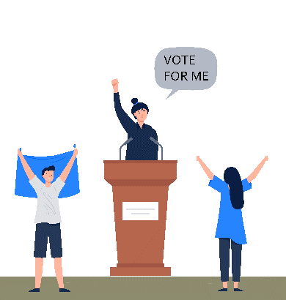
you ask people to vote for you
so that you can represent them
and make decisions and laws in Europe.

The right to vote and stand for elections
is very important for all people.
People with disabilities
should have the right to vote
and stand for elections too.
Their voice counts like everyone else’s!
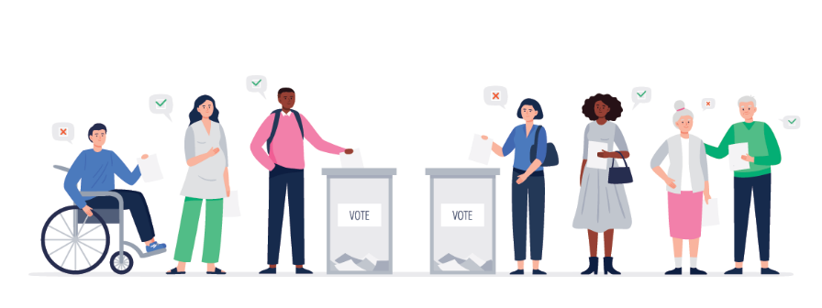

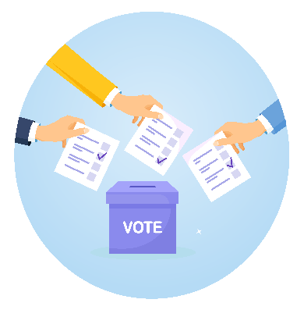
How is the situation in Europe?
Every 5 years, there are European elections.
This means that people in Europe vote
and choose who will make decisions and laws
in Europe.
The last European elections took place in 2019.
The next European elections will be in 2024.

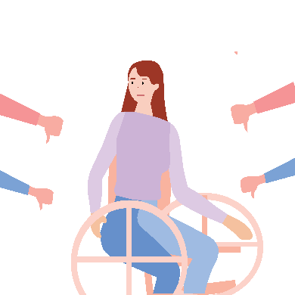
Sadly, it is hard or impossible
for many people with disabilities in Europe
to vote or stand for elections.
Things are even harder
for women with disabilities
as they are at higher risk of being left out.

Not being able to vote or stand for elections
means that your voice is not heard.
This is unfair.

What problems do people with disabilities face
to vote and stand for elections?
People with disabilities may not be able to vote
or stand for elections because:

- Elections are not accessible for them
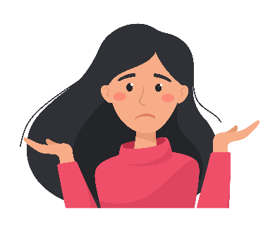
For example,
if information is not easy-to-read,
people with intellectual disabilities
may not be able to understand
how to vote.
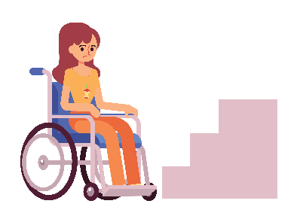
Or if the buildings
where the elections take place
do not have ramps,
people in wheelchairs
will not be able to go vote.

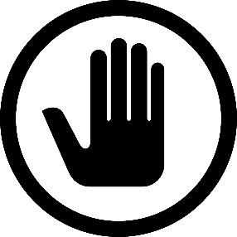
- Some countries do not allow
people with disabilities
to make their own choices in life.
They do not allow them to vote either.

- Most countries do not give
people with disabilities
the support they need
to be able to vote
or stand for elections.

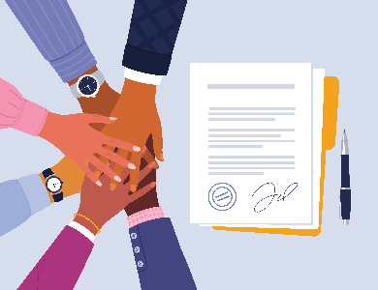
How do countries try to help
people with disabilities to vote?
The European Union and all its countries
have signed the UN Convention.
That means they agreed to protect the rights
of all people with disabilities.

Amongst others,
the UN Convention says
that all people with disabilities
have the right to vote
and stand for elections.

So the European Union and its countries
should work to make sure that
all people with disabilities can enjoy this right.

Most countries in the European Union
have taken action to make it easier
for people with disabilities
to vote in the European elections.

For example,
some countries allow people with disabilities to:
- Send their vote by post.
- Choose where they want to vote
based on their needs.
- Vote earlier than the election day
in a calmer way.
- Ask a person they trust to vote
on their behalf.
- Get information in accessible formats
like easy-to-read.
But not all the countries in the European Union
offer these choices
to help people with disabilities to vote.
Many people with disabilities
are still left out from the European elections.
This should change!

What things can be done better?
At EDF, we believe that all people with disabilities
should have the chance to vote and stand for elections
like everyone else.

For that to happen,
the European Union and all its countries should:
- Take into account the rights
in the UN Convention
when they make laws and decisions
about the elections.
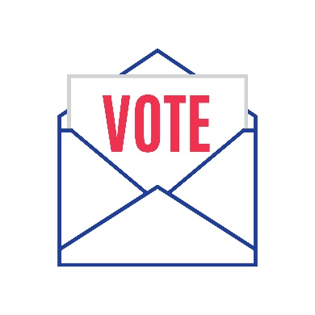
- Recognise the right
of all people with disabilities
to vote and stand for elections.
- Make sure people with disabilities can vote
in ways that fit their needs.
For example, sending their vote by post
and not having to vote in person.
- Make the European elections accessible
so that all people with disabilities
can vote and stand for elections
without problems.

- Allow people with disabilities to choose
the support they need
to be able to vote and stand for elections.
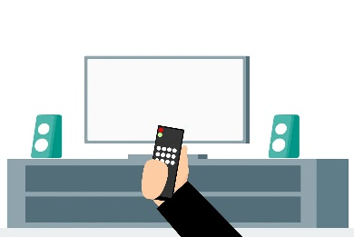
- Make all the material and information
of the European elections
accessible to people with disabilities.
For example,
leaflets should be available in easy-to-read
so that people with intellectual disabilities
can understand them.
Or the news on television
should be in sign language too
so that deaf people can be informed as well.

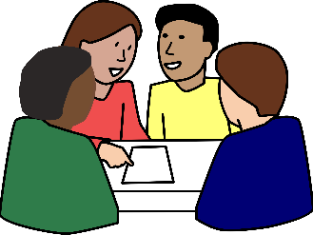
- Talk with organisations
of people with disabilities
and listen to their needs.

We hope that more people with disabilities
will be able to vote and stand for elections
in the next European elections in 2024.

More information
To know more about our work,
you can check our website at:
www.edf-feph.org

If you have any questions,
you can send us an email at:
info@edf-feph.org.

Explanation of difficult words

European Union
The European Union is a group of 27 countries in Europe
that work together to make things better for their people.
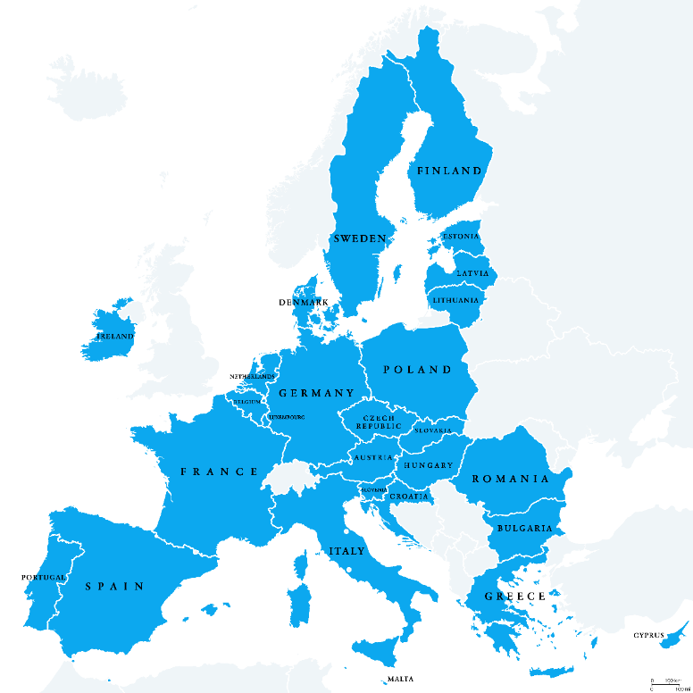

UN Convention
The UN Convention
on the Rights of Persons with Disabilities
is an agreement that says
what rights people with disabilities have
and how countries should protect these rights.
In short, we call it ‘the UN Convention’.
Many countries in the world
have signed the UN Convention
and agreed to work to protect
the rights of all people with disabilities.

Accessible
Things are accessible
when they are easy to use
for people with disabilities and all people.
For example, when buildings have ramps
that people in wheelchairs can use to get in.
Or when information is easy to read
and people with intellectual disabilities
can understand it.

