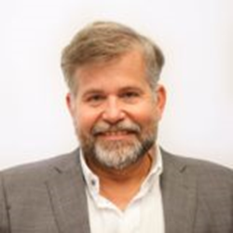
Cato Lie cato.lie@ffo.no, 0047 98626837
Buskerudveien 145 B, 3027 Drammen, Norway
Oslo, 28.03.2022
CV-letter
I am a man, 60 years old from and a father of two, born with Spina Bifida and I am a wheelchair user. I have grown up in the Netherlands and moved back to Norway in 1979. I speak Dutch, Norwegian, English and basic French and German,
I have a masters’ degree in business administration (MBA) from Handelsakademiet in Oslo. I have extensive experience of working in both the private and public sector with marketing of assistive technology, financial management and logistics.
Since 2002, I have worked for FFO, the Norwegian Federation of Organizations of Disabled People, a member of EDF. For the past ten years, I have been responsible for FFOs policy on universal design and accessibility in all areas of society, buildings and housing, transport and ICT. I aim to influence politicians in the Norwegian Government and Parliament on accessibility. I was board member of FFO for about one year, before I started working at the FFO secretariat.
I have been a board member of IF for the past 6 years and I am currently president of the organization. I have also been leading IFs working group on ageing for the last couple of years. That work resulted in a report, covering the situation of older people with Spina Bifida in many European countries, which was presented last year. I have a large SBH network internationally and have worked actively to expand this. In 2021 I was appointed board member of IDA.
In addition to my work, I have been leading the Municipal Council on disability of Nesodden for 10 years but stepped back 3 years ago. I have been a representative on several boards, including the Norwegian Spina Bifida Association and I have been chairman of TRS at Sunnaas hospital, which provides services to people with SBH.
Kind regards,
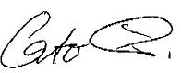
Cato Lie

