Toolkit: Accessible Video

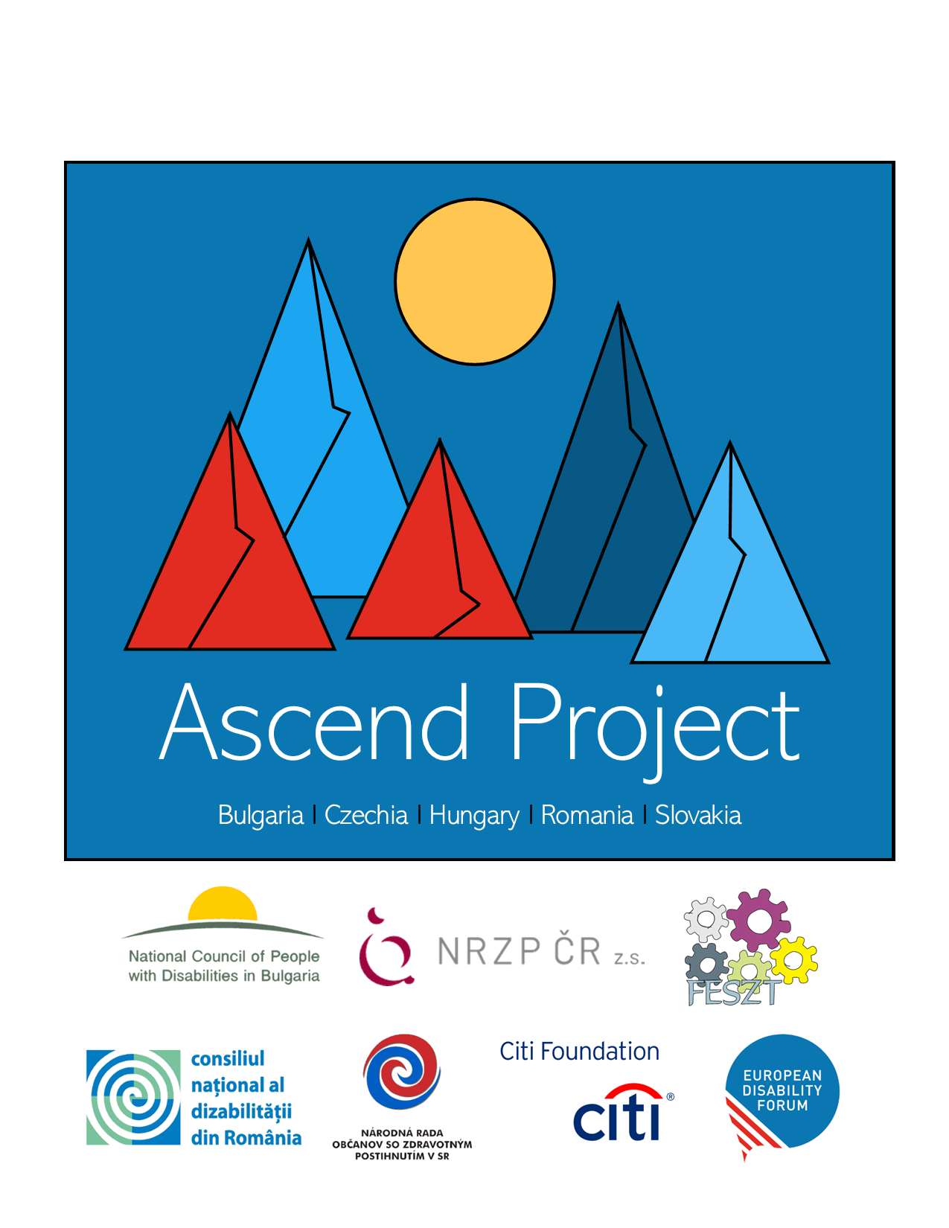

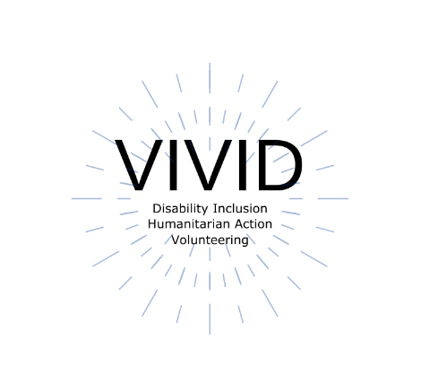
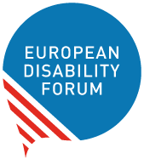

This toolkit was developed by Roberta Lulli, EDF Digital Accessibility Trainer on the VIVID-T Project and represents a collaboration with many partners.

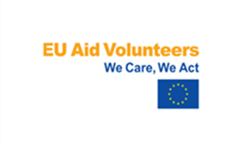 | This publication has received financial support of the EU Aid Volunteers initiative of the European Union. The information contained in this publication does not necessarily reflect the official position of the European Commission.

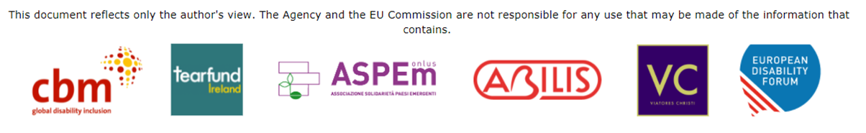

Introduction

Videos are everywhere and are being regularly consumed by more people every day (from social media to web pages and YouTube).
How can you ensure everyone can access the content you've created?
- Accessibility is important for many reasons, especially when it comes to video.
- All viewers are actually more likely to engage with your content.

Build accessibility from the start

Make your check list!
When you create the video consider the following elements:
- Video design (content, fonts size for your text, colors)
- Contrast between main subject and background
- Captions
- Audio and voiceover
- Sign language interpretation

Video Design – Content structure
- Be clear about the purpose and the message of your video
- It’s often good to keep it short and succinct.

Your content should have a logical flow.
Script the flow of your video:
- Introduction
- The main content
- Make sure you have a call to action at the end of your video.

Video design
- Make sure fonts are large and easy-to-read (Sans Serif Fonts)
- Most widely available fonts like Arial, Verdana, Calibri or Helvetica.
- The font size recommended for video is 24

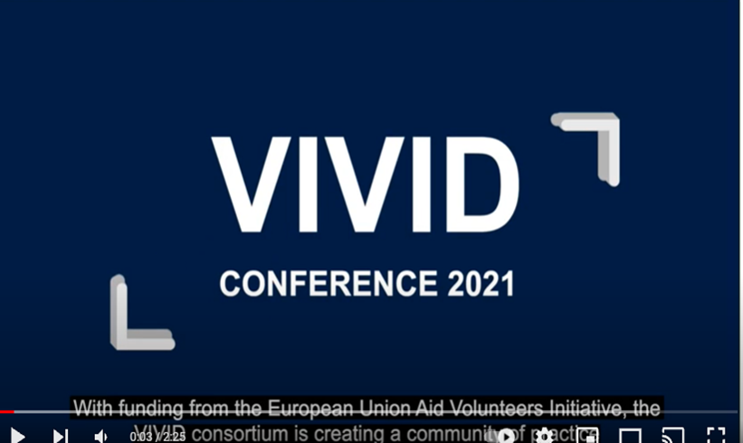

No flashing content!!!
The best practice is to avoid using any content that flashes, flickers or rapidly changes colours.
- It’s likely to be annoying or distracting
- It can provoke seizures in some users

W3C requirements

If you must use content that flashes or flickers…
The W3C Web Content Accessibility Guidelines 2.0 includes specific technical requirements for determining whether content flashes or flickers at an unsafe level.
In general if the content flashes more than three times per second:
it is unsafe!

Colour contrast
Provide high contrast colours between main subject and background to make text and images more visible.
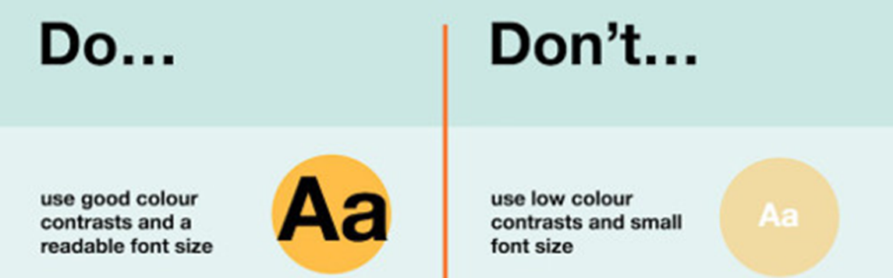

Contrast checker
- Use a free Contrast checker
- The minimum ratio should be of 4:5:1

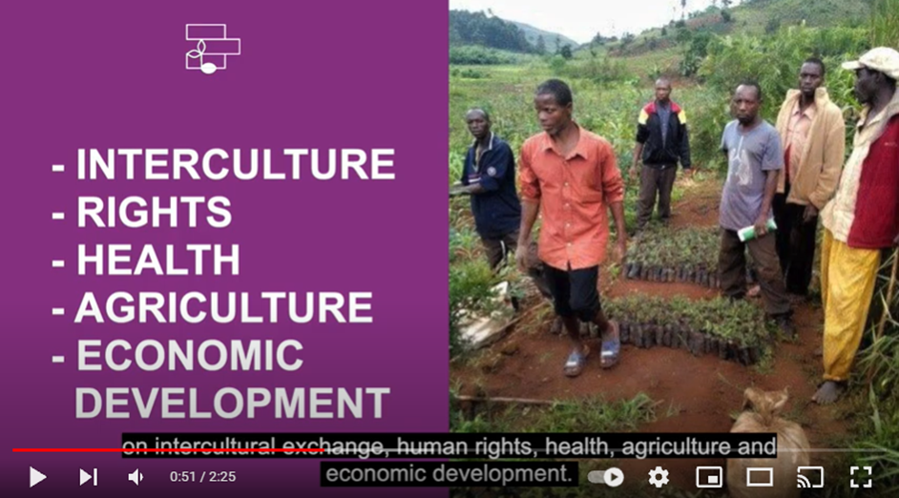

Choose the right format and video player
Consider its size and compatibility with the location you want to use (ex. some social media channels).

Accessible video media player
Your media player should support captions, transcripts, and audio descriptions. It also must be fully keyboard, screen reader, and mouse accessible. An accessible video player gives users the tools to pause, stop, and control the volume of the video.

Captioning
Captions are a text version of the speech and sound on the video.
- These are displayed over the video, typically at the bottom and they are synchronized with the audio.
Did you know…
- Besides providing accurate captions, video producers should also consider the placement, font and size of the captions, and their background, to make sure they are legible.
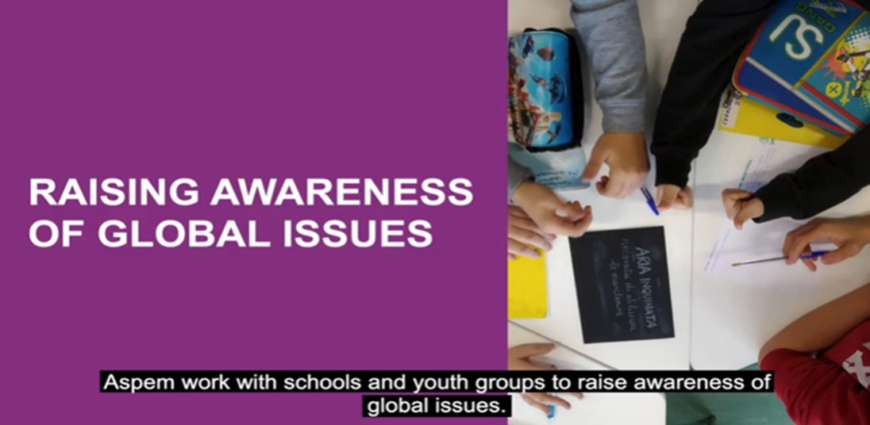

Don’t rely on automatic subtitles

Captions are not subtitles!

- Subtitles are a direct translation of the speech (and the speech only) from one language to another and they do not include any other sounds that are in the video.
- Automatic subtitles are not accurate.

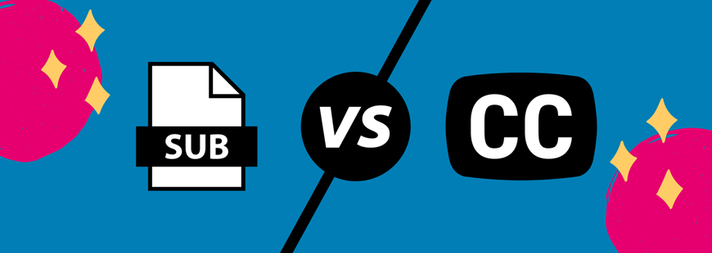

Audio and voiceover

- The video should have an appropriate audio voiceover and use low background audio.
- When the main audio is a person speaking and you have background music, make it at least 20 decibels lower than the foreground speech content.

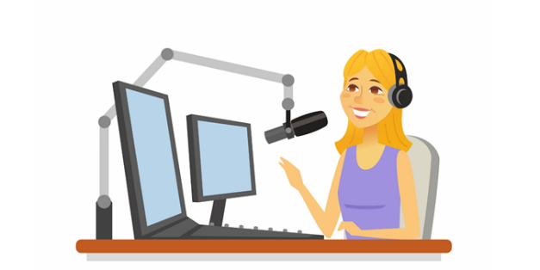

Sign Language interpretation

- When choosing language, consider target audience (International Sign or the national sign language for one country, or make multiple versions of the video with blank version where appropriate sign interpretation can be added)
- Leave enough space left or right of the captions block for the sign interpreter.

Transcript

- Transcripts are a text version of the speech and non-speech audio information needed to understand the content.
Keep in mind that the main purpose of a transcript is to provide the information to people who cannot get it from the audio and/or video.

Add information to make the transcript more useful.

Video using Zoom interviews

Disability inclusive climate justice

One example could be the video that EDF and CBM Global have created on Disability inclusive Climate Justice.

- Initial purpose - Bring the voice of persons with disabilities to the European Development Days (June 2020)
- Target audience - Climate and development actors
- Challenges - Time, budget and COVID (no travel)

Preparation

- Ensure full accessibility
- Identify the top priorities to address (3 to 5)
- Identify key interviewees PLUS public call
- Ensure balance (location, gender, age, and diversity of disability)
- Limit number of interviews (2-3 hours/interviewee)
Send simple (one page) preparatory instructions that include:

  - Brief background information
  - The questions
  - Camera/microphone/background set up
  - Consent form

Interviews
- Aim for 30 minutes (can vary)
- Record, with automatic transcript
- Ensure interviewee understands purpose, and gives consent
- Style - informal chat round questions sent in advance
- Focus on getting any specific expertise that the interviewee has
- Stop and repeat/rephrase is okay
…but all messages must be interviewee’s own
- Answers should be able to stand alone (avoid yes/no)

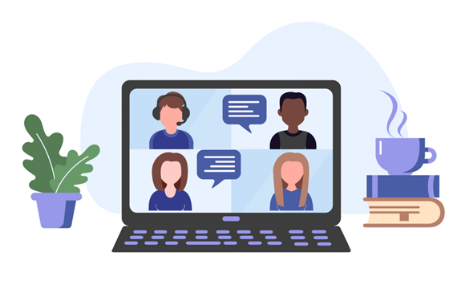

Production

- Identify key comments from each interview (go through transcript and video together)
- List these (with exact time slot) in Excel
- Assign to Topics/themes
- Choose best
- Reorder to make a storyline
- Calculate total time (add time for opening & closing)
- Refine the text, cutting unnecessary words/phrases without changing message

Development
Ensure that the developer
- Understands accessibility requirements
- Is prepared for multiple revisions
For transcript, captions and sign interpretation
- Use the storyline - make sure it is word perfect with spoken text
For voiceover
- All visible (non-spoken) text
- Important visual descriptions

Final product
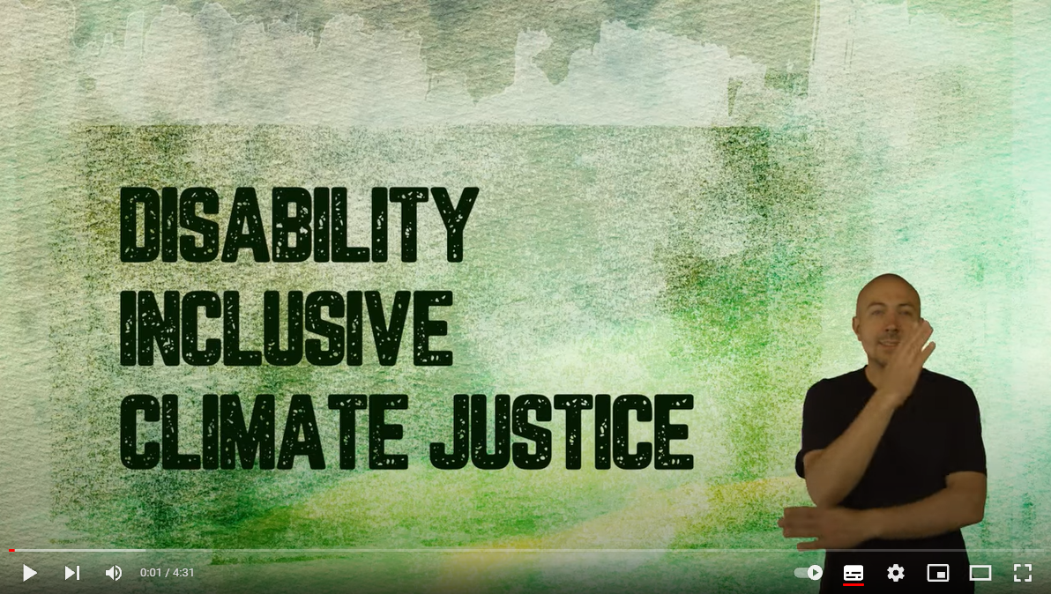

Resources
- Making Audio and Video Media Accessible, W3C Web Accessibility
- Initiative
- Media Players, W3C
- Best Practices for Creating Accessible Video, 3 Play Media

The European Disability Forum
Avenue des Arts 7-8
1210 Brussels, Belgium.
www.edf-feph.org
info@edf-feph.org

