DOC-EXEC-22-05-02

Update on Ukraine programme
Document for information/ for discussion and approval

Purpose of this item
- Update the executive members about EDF’s Ukraine programme
- Seek approval for a programme supporting 2 Ukrainian DPO networks: Ukrainian National Assembly of Persons with Disabilities (National Assembly of Persons with Disabilites, 3 months) and League of the Strong (6 months)
- Approve EDF’s possible work on defending the rights of refugee children with disabilities from Ukraine
- Receive guidance regarding recognition of disability, registration or confirmation of disability, available services and benefits for Ukrainians with disabilities in their new host country

Questions for the executive Committee
- Do you have any questions relative to the overall EDF Ukraine programme?
- Do you approve of the projects with NAPD (3 months) and League of the Strong (6 months)?
- Do you approve EDF’s work on defending the rights of refugee children with disabilities from Ukraine?
- Should we proceed with linking our members and the NAPD regarding the recognition of disability, registration or confirmation of disability, available services and benefits for Ukrainians with disabilities in their new host country?

Introduction
EDF expresses its support and solidarity with the people of Ukraine. EDF started its advocacy action on February 24th and its official programmatic support to EDF members developed in March.

We are working to ensure persons with disabilities and their representing organisations (OPDs) are supported in the response and recovery in Ukraine and neighbouring countries. We keep the Board updated each Monday, and report back in detail on members work in the members mailing. Each significant programme decision is also reviewed by the EDF executive and discussed in advance with the President. We have regular meetings with members, partner, UN agencies, IDA and EU institutions.

In the Board meeting on May 27th there will be an interactive discussion with members and Ukrainian DPOs on their work.

Our programme
- Our response is supported financially by CBM International and Wellspring Philanthropic Trust
  - CBM: 2.1 million Euros for 12 months (with a possible one-year extension)
  - Wellspring: 100,000 US dollars.
- Our three objectives (in line with the UN Convention on the Rights of Persons with Disabilities and humanitarian principles):
  - Support persons with disabilities in collaboration with organisations of persons with disabilities (DPOs)
  - Advocate for disability inclusion in the broader humanitarian response in Ukraine and in the countries of the EU as people flee the war (now over 4 million children and adults)
  - Ensure recovery of persons with disabilities, and build the capacity of the disability movement in the long-term

- Countries
  - Implemented by our members in Ukraine, Latvia, Lithuania, Hungary, Slovakia, Poland and Romania (funded through CBM)
  - To be implemented by partners in Moldova (funded through Wellspring)
- Staff
  - Ukraine Programme Coordinator: Gordon Rattray (previously International Cooperation Officer, also working on the i2i project which is now finished). Manager of:
    - Humanitarian Support Officer: Mariya Yasenovska
    - Humanitarian Advocacy Officer: Should start on June 1st; currently in Ukraine.
    - Administrative and Reporting Officer: to be recruited
  - Support of a consultant for Moldova: Georgette Mulheir
- Activities are proposed by our members and partners and include:
  - Identify immediate and urgent needs
  - Support local organisations in the set up accessible transit shelters in Lviv and Uzhhorod
  - Provide accessible information for receiving organisations/ persons with disabilities and their families (website, helpline, information leaflets)
  - Deliver hygiene products, medicines and food
  - Ensure the purchase of the necessary aids, including wheelchairs, crutches, walkers, pressure-relieving mattresses, etc.
  - Provide accessible vehicles to transport refugees with disabilities
  - Advocate for governments to welcome adults and children with disabilities arriving from Ukraine and provide them with the right support.
  - Help link people with disabilities with accessible places to stay, with food, medical support and technical equipment they may need
  - Advocate for disability inclusion in the wider humanitarian response
  - Work with the media to ensure the situation of persons with disabilities is adequately represented

- Potential risks and mitigations
  - Risk - Lack of human resource and financial capacity to fulfil planned activities and negative impact on ongoing DPO work
    - Mitigation – EDF members developed their own plans, based on what they felt they could do in their context. They have the budget available to hire staff and all have an appointed focal person to support in EDF. Tools for monthly monitoring have been developed to ensure that the extra workload does not negatively impact DPO capacity to continue its basic objectives.
  - Risk - Lack of impartiality, neutrality and independence
    - Mitigation - Partners encouraged to include all most at-risk people and families of persons with disabilities in their work, as well as persons with disabilities themselves. Partners are aware of their freedom to make decisions based on need alone. Monthly reporting includes questions about changes made to planned programme, and reasons why.
  - Risk – Safeguarding
    - Mitigation - There are many risks to children and adults due to the war, institutionalization, displacement and isolation poverty, language barriers. EDF will carry out safeguarding training for our partners to help identify and deal with safeguarding concerns, and link closely with UN agencies working on protection- including through the protection cluster to report and avert risks.
  - Risk- Security
    - Mitigation - This is a war situation with our partners and members in Ukraine sometimes under fire, and always at risk. We will also run security training and encourage members to ensure that develop a security and safety approach . Reports to us of people with disabilities at risk in the war zone are communicated to the UN for acting through the UN humanitarian system.
  - Risk- Corruption
    - Mitigation – Donors have increasingly recognised the imperative to address corruption in humanitarian aid. Risk management related to corruption has been considered, with the signature of short term contracts, budget being transferred in several instalments, with receipts need to be provided and monthly reporting.
- Next steps - Majority of partners have planned and are implementing short-term (three month) activities. Next steps are to consider priorities up to 12 months and beyond, including capacity building activities (training, eg. safeguarding and safety and security, use of Washington group questions, humanitarian action and disaster risk reduction) and to make meaningful partnerships with 'mainstream' humanitarian responders. Such collaborations will strengthen DPOs capacity and improve disability inclusiveness of humanitarian community in the longer term.
- Success and quantitative outcomes. Since the beginning of the programme we have:
  - To date, EDF and members have organised, participated in, or made official statements at, at least 27 events/meetings
  - To date, 9 official advocacy letters have been sent and EDF has stimulated attention to persons with disabilities within the UN system and the EU (as seen through new documents like DG Home guidance on borders or for reception of Ukrainians under the temporary protection directive).
  - To date, 366,650 euros has been committed to EDF members.
  - With IDA we organised a private briefing of NADP with the CRPD committee, after which the committee issued a statement.
  - We organised a private meeting between EDF, the CRC committee, the CRPD committee and President´s Zelensky´s advisor in children´s rights.
  - EDF facilitated NADP to speak directly to policy makers at EU and international level on 8 occasions. They include the Equality Commissioner, the Disability Platform, the CRPD Committee, the GLAD network, the UN Special Rapporteur on the Rights of Persons with Disabilities’ meeting, the ECOSOC meeting, the European Humanitarian Forum and the Humanitarian Networks and Partnerships Weeks.

Communication impact
Since the beginning of the war, EDF has reported the situation of persons with disabilities in the country through its external and internal channels. A communication strategy based on informing members, the general public and stakeholders has been implemented in order to raise awareness, call for our demands, inform about our steps and provide first-hand testimonies from the field.
Webpage: Due to the volume of information and communication needs, a web page was created to help gather all the information.
Since its creation in March, the webpage has received a total of 4.300 visits. At the moment this page is the second most visited content of the web. In order to facilitate access to the information, different sections, included a FAQ, have been created in which all the information continues to be updated.
https://www.edf-feph.org/ukraine/
Articles/ Posts:
Thanks to EDF's early reaction all the posts that have been published since the beginning have had a large response. However, EDF's first statement has become - so far - the most impactful content on the web. It currently has about 10.950 visits.
https://www.edf-feph.org/protection-and-safety-of-persons-with-disabilities-in-ukraine/
The rest of the articles were as follows:
- Appeal from the National Assembly of People with Disabilities of Ukraine: 3.900 visits
- Information for Ukrainians arriving in the European Union: 1.453 visits
- EDF and NADP request a meeting with Commissioner Dalli to discuss EU actions to support children and adults with disabilities in the Ukraine war: 338 visits
- Ukraine Crisis: A Collaboration for an Inclusive Humanitarian Response: 337 visits
- Joint contribution to Commissioner Dalli meeting with civil society on support to Ukrainians: 181 visits
- EDF and NADP meet Commissioner Dalli to discuss EU actions to support persons with disabilities and their families in the Ukraine war: 182 visits
Social media:
As information amplifiers, social media have helped us in this case not only to disseminate our information but also to promote the work of members as well as our joint work.
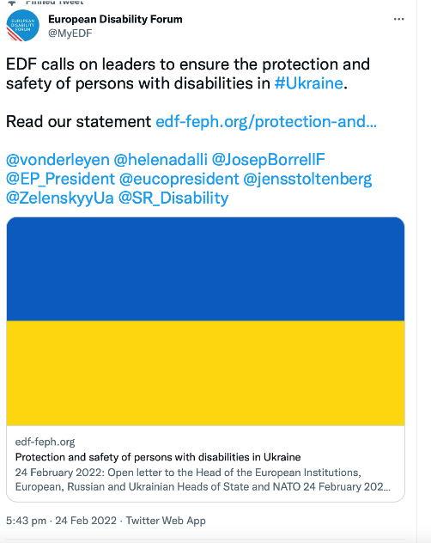
The post with the highest impact has been the publication of EDF first statement
- 103 RT
- 138 Likes
- 11 quote tweets

During this time we have also given visibility to the work of members, mentions in the press and meetings about our advocacy work.
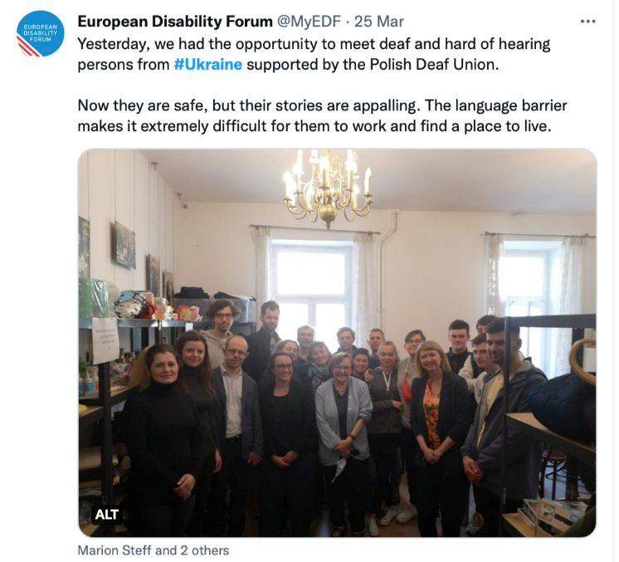
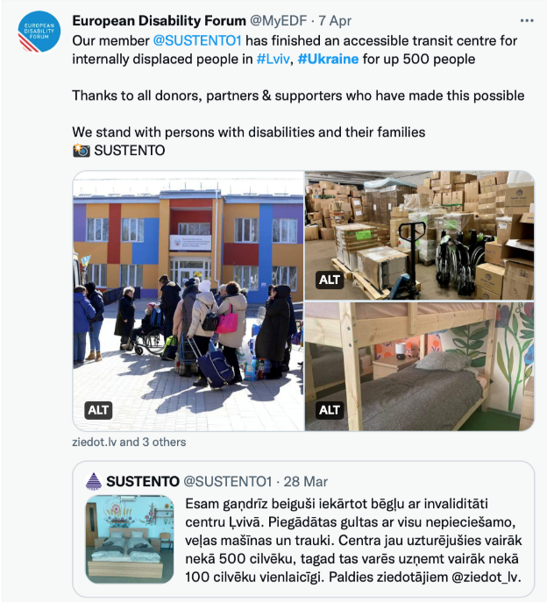

Media coverage and press conference

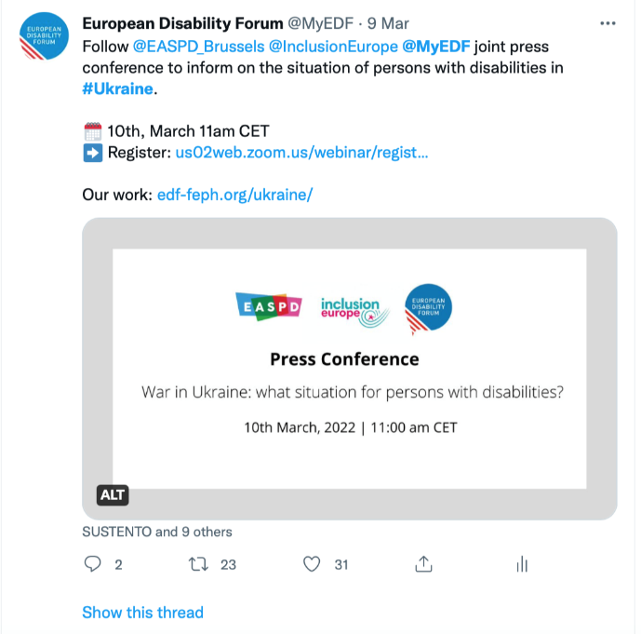
On March 10, EASPD, Inclusion Europe and EDF organized a press conference on the situation of persons with disabilities in Ukraine. During the press conference there were interventions by the National Assembly of People with Disabilities in Ukraine and All-Ukrainian NGO Coalition for Persons with Intellectual Disability. Watch the full press conference.

Regarding the media coverage, the first statement has been the key to start . Since its publication EDF has been mentioned or covered with interviews. The most outstanding ones have been:
- Al Jazeera: War in Ukraine: What support do people with disabilities need? 11 April 2022
- Reuters – Fate of Ukrainians with disabilities a ‘crisis within a crisis’. March, 11 2022
- CNN – Escaping the horror in Ukraine is not an option for many disabled children and their families. March, 12, 2022
- BBC – Visually impaired in Ukraine. March, 15 2022
- The New York Times – Evacuating Ukrainians with disabilities presents a range of difficulties. March, 11 2022
- Time – The Informal International Network Getting Disabled Ukrainians Out of the War Zone. March 31 2022
- Human Rights Watch – Under Shelling in Kharkiv. People with Disabilities Need to Evacuate Safely. March, 1 2022.
- CNN – People with disabilities and mobility issues find themselves trapped in Kyiv. March, 6 2022.
- Global News – Disabled people most vulnerable during war. March, 7 2022.
- BBC – Chaos, upheaval and exhaustion for Ukraine’s disabled children. March, 8 2022.
- MSNBC – Humanitarian efforts aren’t doing enough to evacuate Ukrainians with disabilities. March, 8 2022.
- FP2P – The Disabled Ukrainians Doing What the UN Can’t (or Won’t?). March, 9 2022.
- Independent – Millions with disabilities ‘abandoned’ in Ukraine, charities fear. March, 10 2022.
- The Washington Post – From Ukrainians with disabilities comes a desperate plea: ‘We have no chance without help’. March, 10 2022.
- Independent – Have you thought about how disabled Ukrainians are coping in this horrific war? March, 11 2022

Newsletters:
Since the beginning we have incorporated a specific section in our newsletter with the latest information from Ukrainian. In March, the Global Action newsletter focused exclusively on Ukraine: https://mailchi.mp/edf-feph/news-from-edf-global-action-2513780
In April, we co-created the newsletter with Autism Europe to cover the situation of autistic people in Ukraine: https://mailchi.mp/edf-feph/dvapril2022?e=e315825599

Ukraine – programme planning
EDF cooperates with two umbrella organisations from Ukraine: the National Assembly of People with Disability (NAPD) and the All-Ukrainian association of Organisations for Persons with Disabilities “The League of the strong”. Both organisations are DPOs, but they have also members organisations that work for people with disabilities. The NAPD is a new member of EDF.
We have developed two different projects with these organisations, to support persons with disabilities and DPOs in Ukraine. The proposed activities do not intersect; they also strengthen the ability of people with disabilities and Ukrainian DPOs to cope with crises, survive and improve their quality of life.
- Project 1: The NAPD's project includes more support for local transit centers for persons with disabilities, analysis of government policies and laws, and advocacy. This project also will undertake work with the UN Cash Working Group on providing cash transfers for persons with disabilities. This project is for three months. We will then see if NAPD wants to extend the project as NAPD is in demand from various organisations, including the UN.

- Project 2: The League's project is more focused on assessing the needs of DPOs and supporting them, including supporting their current activities (counseling, humanitarian aid, evacuation, information, treatment and rehabilitation, etc.), advocacy at various levels and monitoring the situation. The project is for 6 months, with possibility to extend.
Please see annex for more details about each project.

Rights of refugee children with disabilities from Ukraine
EDF is looking into organising a new project about rights of refugee children with disabilities from Ukraine. Financially, we have the capacity to do so thanks to our donors CBM and Wellspring. So far, we have noticed the following:
- The humanitarian system is insufficiently responsive to the needs and rights of people with disabilities.
- Children with disabilities are exceptionally vulnerable. They often fall through the cracks of three systems (refugee response; disability support; child protection and care systems). Unaccompanied children with disabilities - particularly those from institutions - are almost forgotten.
- 72% of the children in institutions in Ukraine have a disability; 98 % have parents- the total estimated number of institutionalised children in Ukraine before the war was 40 000.
- When moved to other countries - particularly Poland - they are being institutionalised in poor conditions almost as a default response
- The conventional child protection agencies that respond in humanitarian contexts are not used to responding to unaccompanied and separated children with disabilities. Therefore, these children are no-one's top priority
- This project provides an opportunity for EDF to:
  - ensure support reaches children with disabilities in Ukraine and neighbouring countries
  - strengthen its work regarding children with disabilities;
  - help join up disability rights, children's rights and refugee rights issues;
  - become more prepared to respond to future emergencies (Disaster Risk Reduction - DRR).
  - promote inclusive family-based support for children with disabilities from Ukraine and advocate for rebuilding of inclusive systems to replace the previous segregation which existed on a wide scale
The project:
In any humanitarian emergency, refugee children with disabilities are exceptionally vulnerable and marginalised. Before the war, 72% of children living in institutions in Ukraine had disabilities. To date, at least 4,000 children have been evacuated from Ukrainian institutions abroad, with 2,000 being placed in large institutions in Poland, where they are likely to suffer severe neglect and experience compound trauma. They are also likely to be at a higher risk of being trafficked than their peers without disabilities.
As a complement to the already agreed work with DPOs in Ukraine, the new project will:
- Address the needs and rights of refugee children with disabilities from Ukraine who have been evacuated to other countries
- Focus on unaccompanied and separated children (UASC) with disabilities, particularly children evacuated from institutions
- Through partner organisations in Poland (DPOs such as our member the Polish Disability Forum and Foster Family Care organisations), assess the current situation and advocate for rapid intervention to: immediately improve care, support and protection; develop a foster family care system for refugee children with disabilities (particularly those from institutions); and provide evidence of the cost and impact of foster family care versus institutional care.
Georgette Mulheir is available to lead this piece of work. She has already been approved by the executive to help us develop our work in Moldova. The project is planned for three months, with a budget of 50 000 US $, and possibility to extend (subject to approval and available funding).
The advocacy work:
With the knowledge gained from the rapid assessment, as well as the programme on the ground in Poland, and advocacy strategy will be developed, focused on the EU, UN agencies the Ukrainian government and member-state governments that:
- Highlights the specific concerns for refugee children with disabilities
- Demonstrates that family care for unaccompanied refugee children with disabilities is their right and that it is necessary, possible and affordable
- Urges responsible bodies to develop a coordinated response to ensuring family care and inclusion in the community for all refugee children with disabilities.

Recognition of disability for persons who left Ukraine in their host country
As of the 9th of May 2022, according to UNHCR, 5,6 million Ukrainians left the country due to the war. Bearing in mind that officially people with disabilities make up 6% of Ukraine’s total population, it can be estimated that at least 336 000 people with disabilities left the country. Presently, there's no official statistics on the number of people with disabilities who have successfully left Ukraine; few countries know how many people with disabilities have arrived and settled in their country.
Abroad, Ukrainians with disabilities face more challenges than Ukrainian refugees without disabilities. Lack of accessible information for people with visual, hearing or mental impairments, limited mobility, and dependence on accompanying persons are often added to the common language and cultural barriers.
To better navigate in the new country, a person with a disability should have information about the procedure for confirming his/her status as a person with a disability, possible benefits, and services, the actions to obtain them, and the necessary contacts. For example, a person coming to Poland has to declare his/her disability and confirm it according to local procedures with a doctor and got access to different services (some of them available for free).
Unfortunately, there is no such information now available in Ukrainian and our Ukrainian member would like to have it to share with its members. Ukrainian organisations have asked EDF to help gather this information in various European countries. Our new Ukrainian member, the National Assembly of Persons with Disabilities (NAPD) has prepared a list of questions to guide us. The responses by EDF member organisations will help to make such information accessible to Ukrainians with disabilities by posting it on the websites of NAPD, EDF, its members and other partners. To begin with, it is worth involving organisations from countries participating in EDF Ukraine programme (Latvia, Lithuania, Slovenia, Hungary, Poland, Romania, Moldova). Other suggestions by the Executive committee are welcome.

Annex – the two projects supporting DPO networks in Ukraine

The project by NAPD
- Country: Ukraine
- Partner name: Ukrainian Public Association “National Assembly of People with Disabilities” (NAPD)
- Type of organisation: DPO. NAPD is an umbrella organisation and before the war, it united 126 member organizations. NAPD is an associate member of the EDF
- Main focus of your regular work: protection of the rights of persons with disabilities
- Registration: (official details of the registered entity) Identification code of the legal entity - 26114037, date of initial registration – 10.01.2002
- Address: 8/5a Reytarska Street, Kyiv, 01054, Ukraine
- Contact people + email and phone: Larysa Bayda , +38050-334-86-40, bayda.naiu@gmail.com , office-naiu@ukr.net
- Website and social media: https://naiu.org.ua/ , https://www.facebook.com/vgonaiu/
- Geographical scope of the organisation: All of Ukraine
- Geographic scope of the programme of support: All of Ukraine
- Project duration: 3 months
- Budget: 62 630 euro
- Objectives of the NAPD:
  - To improve the situation of people with disabilities in Ukraine during the period of the war with Russia.
  - Build the capacity of disabled people’s organizations.
  - To carry out a needs assessment for people with disabilities in Ukraine and a feasibility assessment for cash support.
- Main activities:
  - To deliver training for DPO members who will participate in the surveys and the feasibility assessment.
  - To conduct a feasibility assessment for cash support and include questions on general needs of people with disabilities in Ukraine (men and women, families raising children with disabilities, people in care institutions, elderly people);
  - To support transit centres (7) established by DPOs.
  - To strengthen cooperation with international agencies and government authorities to ensure that people with disabilities are included into the government’s humanitarian programmes.
  - To maintain online information resources of NAPD to provide on-going updates on the situation, new legislative initiatives of the government indented to improve the situation of the people with disabilities, provide services and support, etc.
  - To provide consultations and advice to persons with disabilities on various aspects related to their daily living.
  - To facilitate capacity building for DPOs that have stayed and continue their work in Ukraine.
  - To enhance cooperation with NGOs, including women’s/feminist organizations, that are engaged in the protection of the rights of vulnerable groups to coordinate work on the distribution of humanitarian aid, participate in working groups and humanitarian clusters.
  - To strengthen cooperation with DPOs from the project countries to jointly advocate improvements in the situation of people with disabilities who flee from the war in Ukraine and to draft recommendations on implementing Article 11 of CRPD.

The new project by League of the Strong
- Country: Ukraine
- Partner name: All-Ukrainian Association of Organisations for People with Disabilities “The League of the Strong” (League of the Strong)
- Type of organisation: DPO
- Main focus of your regular work:
- Advocating on the rights of persons with disabilities and DPOs
- Improving the organisational capacity of DPOs
- Registration: (official details of the registered entity) Registration code 44432327, date of registration - December 24, 2021
- Address: Ukraine, 03127 Kyiv, 1 Akademika Glushkova Avenue, building 60.
- Contact people + email and phone: Sydorenko Daria, +380688984746, sydorenkodaria@gmail.com and info@ls.org.ua.
- Website and social media: https://www.facebook.com/ligasyla
- Geographical scope of the organisation: All of Ukraine
- Geographic scope of the programme of support: All of Ukraine
- Project duration: 6 months
- Budget: 300 000 euros
- Objectives of the League of the Strong
  - Coordinate work and strengthen the current activities of 11 DPOs to provide stable assistance to persons with disabilities during the Russian-Ukrainian war.
  - Advocate for the interests of persons with disabilities in evacuation programs and inform changes in legislation regarding the rights of persons with disabilities.
  - Improve the organisational capacity of 11 DPOs so that they have more organisational stability in order to respond to such situations now and in the future.
- Main activities: The League of the Strong is planning to involve our six founding organisations as well five partners, in order to reach more persons with disabilities in different Ukrainian regions. The six founding organisations have more than 10 years of experience in the rights and interests of persons with disabilities, as well as experience in managing grant. The activities will be:
  - Assist with funding 11 DPOs to improve and increase their employability in providing services and helping for people with disabilities (evacuation assistance, housing assistance, psychological assistance, legal support, technical assistance, travel assistance, travel abroad assistance, job search and adaptation assistance as well as provide the usual services for children with disabilities, teenagers and adults with mental illness and monitoring and assess current situation with people with disabilities)
  - Support contact and informational exchange between services providers, DPOs and people with disability; to share experience, best practices and information campaigns
  - Monitor the legislation concerning people with disabilities and preparing the explanation of changes to them
  - Collaborate with the public authorities to include the needs of people with disabilities in evacuation programs, questionnaires for people with disabilities to consider all their interests, and tracing the interests of people with disabilities in an inclusive environment (modular towns and future rebuilding)
  - Conduct training for 11 DPOs on accounting of services provided, accounting of clients, accounting members, preparation of primary documents, etc. as well as preparation and submission of documents for accounting
  - Prepare of a conclusion and recommendations for improving the organisational capacity of 11 DPOs
Develop a communication strategy and website

