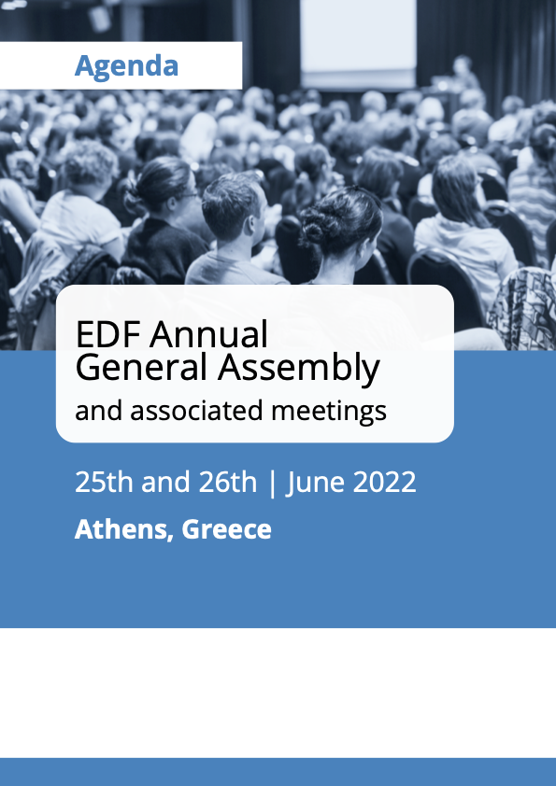
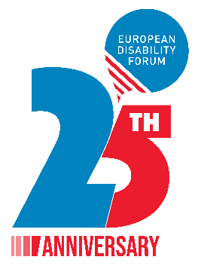
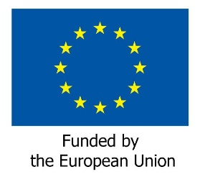

EDF Annual General Assembly and associated meetings

June 25th and 26th 2022

Athens, Greece
Venue: Titania Hotel Athens
Address: 52, Panepistimiou 10678, Athens, Greece
Telephone: +30 210 33 26 000

Thursday 23rd June

Arrival members of the Executive Committee

Friday 24th June
All day - Arrival of elected Board members and AGA participants
Room OMIROS-SOCRATES, 10th floor

09:00 – 15:00 Executive Committee meeting
Free evening

Saturday 25th June

Room NIKI-APOLLON-ATHINA, mezzanine level

08:00 – 08:45 Registration of participants

09:00 – 10:00 Official opening of the AGA
Keynote speeches
- Helena Dalli, Commissioner for Equality
- Dimitrios Papadimoulis, European Parliament Vice President

10:00 – 11:00 AGA Business session 1
Chairperson: Yannis Vardakastanis, EDF President
- Roll Call
- Adoption of the agenda
- Health protocol for the meeting + introduction from the Hotel management (DOC-AGA-22-06-01)
- Appointment of the Scrutiny Committee and presentation of elections procedure (DOC-AGA-22-06-02)
- Election of the EDF President
- Elections of Board members, Finance, and Membership and Credential Committees

11:00 – 11:30 Coffee break

11:30 – 13:00 AGA Business session 2
Chairperson: Yannis Vardakastanis EDF President
- Financial issues
- Adoption of EDF final accounts 2021 (DOC-AGA-22-06-03)
- Vote of discharge to the Board for 2021
- Appointment of internal auditors for 2022 (DOC-AGA-22-06-04)
- Adoption of EDF budget 2023 (DOC-AGA-22-06-05)
- Adoption of final activity report 2021 (DOC-AGA-22-06-06)
- Activity plan 2023 (DOC-AGA-22-06-07)
- Results of elections (possible second round at a time to be confirmed)

13:00 – 14:30 Lunch break

14:30 – 16:00 Policy Session
- War in Ukraine and persons with disabilities (DOC-AGA-22-06-08)
- Review of the EU by the CRPD committee (DOC-AGA-22-06-09)
- Policy update (DOC-AGA-22-06-10)
  - European Strategy on the Rights of Persons with Disabilities
  - Directive combatting gender-based violence
  - EU electoral law reform

16:00 – 16:30 Coffee break

16:30 – 18:00 AGA Business session 3
- Membership issues (DOC-AGA-22-06-11)
- Revision of EDF statutes (DOC-AGA-22-06-12)
- Adoption of terms of reference (TOR) for the EDF Women’s Committee and EDF Youth Committee after the AGA (DOC-AGA-22-06-13)

Evening Official dinner marking 25 years of EDF, with all Delegates and invited guests

Sunday 26th June

Room NIKI-APOLLON-ATHINA, mezzanine level

08:30 – 10:30 Meeting of the newly elected Board and election of the Executive Committee

10:30 – 11:00 Welcome coffee

11:00 – 13:00 AGA Business session 4. Policy Session
- Announcements of the Executive Committee elections
- 5th European Parliament of Persons with Disabilities (DOC-AGA-22-06-14)
- Disability and Sustainability – discussion and adoption of EDF Green Policy (DOC-AGA-22-06-15)
- Any other business
- Expense clams for the AGA
- Date of the next meeting
- Sending evaluation form for the General Assembly

13:00 End of the meeting and departure of participants

