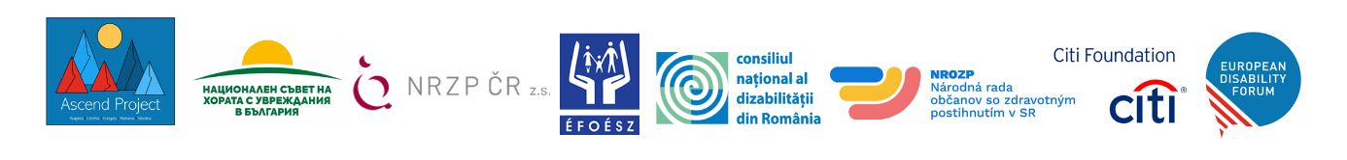

EDF Citi Foundation Ascend Activities by Country: Phase 2

Bulgaria Highlights: Art and Rural Reach!
- Training Workshops for youth on research, advocacy, EU instruments and disability rights (not just for YPD but for all youth)
- Conducting 1 three days training “Youth leadership” – out-site Sofia for YPD & YP.
- Conducting 3 Art workshops in 3 Bulgarian cities, on theme “Accessibility - a Bridge among Senses”, including YPD & YP.
- Conducting 5 Advocacy campaigns in 5 Bulgarian university centres, on various themes, important for the YPD inclusion.
- Website improvements – www.disability.bg
- Translation and dissemination of EDF tools on EU and International policy and programme documents and advocacy.

Czechia Highlights: Research and Design!
- Expert analysis and research on the conditions of transition of people with disabilities from education to the world of work and independent life with Palacký University in Olomouc, public university – expert team (head: prof. Mgr. Jan Michalík, Ph.D.). At least 250 respondents will be contacted as part of the research, and at least 10 experts will be surveyed.
- Exhibition of posters created by students Ladislav Sutnar Faculty of Design and Art: Respect, empathy, help are the basic ideas behind the selection of 55 posters for the NRZP ČR, created by students of the Graphic Design and Visual Communication studio designed with NRZP CR collaboration. The set of posters will be exhibited during the award ceremony of Mosty (https://nrzp.cz/cena-mosty/). NRZP ČR organises the Mosty (“Bridges”) award to encourage the creation of new and interesting projects, with the aim of improving the inclusion of persons with disabilities, increasing media presentation of disability issues and promoting public participation.
- Booklet comprising basic information for young people with disabilities: Taking the opportunity of the Ascend project to create, print and widely disseminate a clearly arranged booklet that would comprise all the necessary information for young people with disabilities – covering areas such as education, employment, public health, consultancy etc. To have this information in one comprehensible and accessible document would be very much needed and would cover a serious shortage.

Hungary Highlights: Convention on the Rights of Persons with Disabilities Country Advocacy Loading…
Creating a human-rights approach website dedicated to the UN CRPD and to the relevant UN, EU and domestic legal instruments, policies and programmes related with it.
Conducting research on the relevant UN, EU and Hungarian legal, policy and advocacy documents, and international and national legal cases related to the key topics (independent living, supported decision-making, access to political rights and self-advocacy)
Translating related documents into Hungarian for hosting on the website and making available to the Hungarian disability movement.
Preparing the information in accessible formats, including easy to read, including through audience user testing with self advocacy groups.
Launch the website at an event on the International Day of Persons with Disabilities on the 3rd of December 2023.
Implement a social media campaign before the launch of the website.

Romania Highlights: Youth Mentoring!
Develop a digital communications portal aimed at youth with disabilities in Romania, with info aimed at youth.
Capacitate young persons with disabilities through training and courses especially in universal applicable fields such as communications (learning a foreign language, public speaking and debate) and digital skills (using Office, electronic means of communication, online meetings, remote work etc.)
Create a structured online community where young persons with disabilities to talk about their challenges and plans, with set agenda and information.
Bring them together through periodical informal meetings where to exchange live ideas and build a united group without pre-planned agenda to allow for spontaneous, youth led dialogue.

Slovakia Highlights: Podcast and Newsletters and more comms, and more comms!
- Building on Phase 1, website updates, and making the web site even more accessible for deaf people and those with intellectual disabilities by involving video components with sign language translation of important web information, as well as easy-to-read format.
- Scale up of web accessibility audits and offer them to our member organizations as well, as well as training on accessible web and content offered to member orgs’ web admins.
- Several issues of our backbone newsletter “Magazine Mosty inkluzie” our members communication channel.
- New! The production of our very own podcast called ForUm. This would be truly effective, popular and modern way to spread information about disability issues to diverse audience. We plan to produce 6 episodes, one per month, with interesting topics.
- Translating policy and programme publications into Slovak and easy-to-read format.
- Youth meetings, workshops, webinars and more!

