EDF Annual report 2021

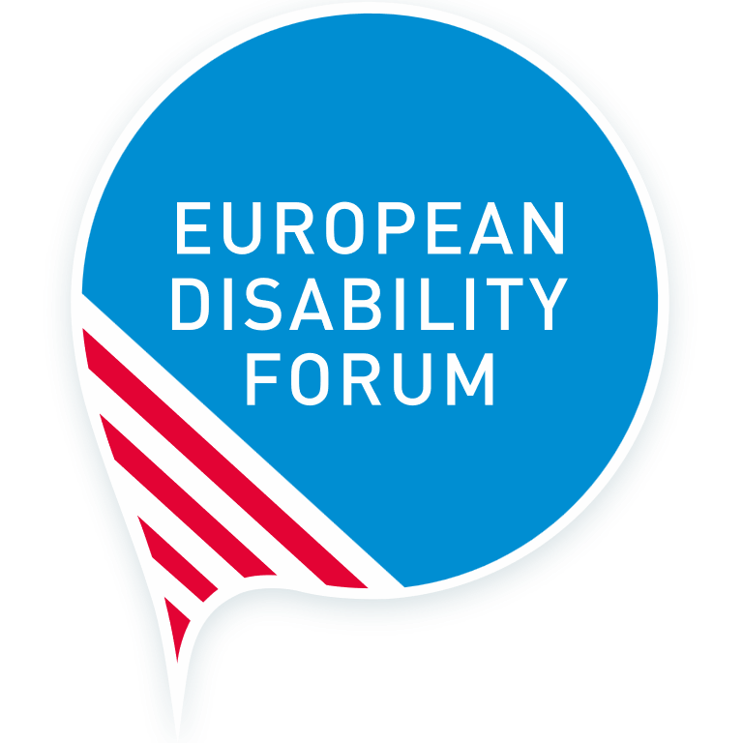
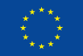

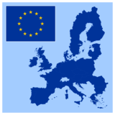

Easy Read Version

Message from Yannis Vardakastanis, the
EDF President
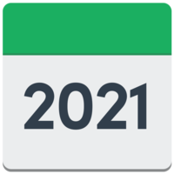 |  | He said 2021 was a special year for person with disabilities in Europe to get their rights.
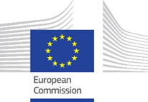 |  | The European Commission published a plan called the ‘Strategy for the Rights of Persons with Disabilities’. This plan is to improve the lives of 100 million Europeans with disabilities.
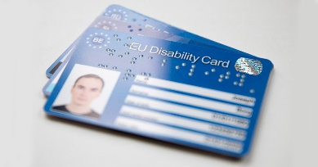 |  | The plan includes:  how the COVID-19 pandemic affected persons with disabilities  the plan for an EU-wide Disability Card  help for Member States about independent living  more paid jobs for persons with disabilities in the EU
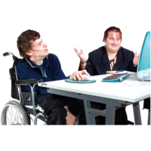 |  | He thanked all the members for working very hard in 2021. He also thanked the partners and supporters for working together.
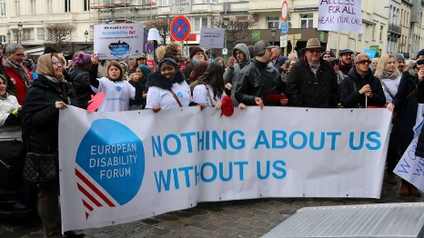 |  | He said we do not know what the future will be like, but we will work together for a Europe which includes everybody and where everyone enjoys their rights.

About EDF
 | The European Disability Forum is also known as EDF. It is made up of more than 100 organisations who speak up for persons with disabilities.
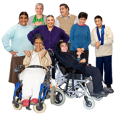 | It is run by persons with disabilities and their families.
 | EDF is a strong and united voice in Europe. Nothing about us without us!
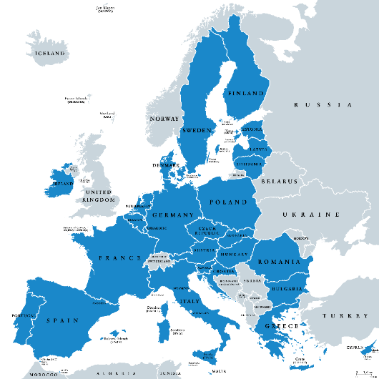 | EDF started in 1996 to make sure that decisions at European level about persons with disabilities are taken by persons with disabilities.
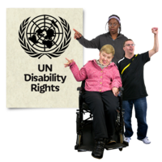 | EDF’s values are based on the United Nations’ Convention on the Rights of Persons with Disabilities (CRPD)

The structure of EDF
EFF members
|
General Assembly
|
President and Board of Directors
|
Executive Committee
|
EDF Staff team (Secretariat)

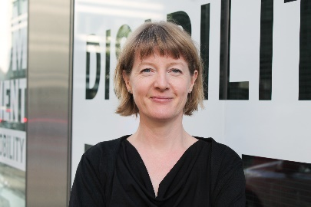 | Catherine Naughton is the Director of EDF
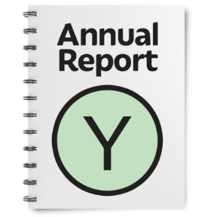 | Please see the main report for the names of the Executive Committee, board members and the staff team.

EDF Members
In 2021 EDF had 102 members. There were:
54 full members. These are national organisations and non-profit organisations.
10 Ordinary Members. These are European organisations for persons with disabilities that are consistent with EDF’s aims and objectives
35 Associate Members. These are non-profit organisations or companies that work with EDF’s aims.
Observer members of EDF are national organisations of persons with disabilities from countries in Europe who are outside of the European Union.
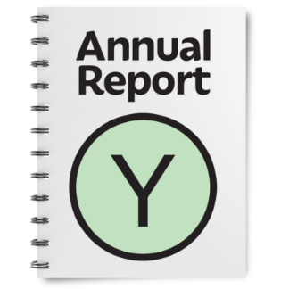 | You can read the full list of organisation names in the main report.

Committees and Expert Groups
 |  | EDF has 4 committees which run for 4 years.
 |  | Human Rights and Non-Discrimination Committee. It contributes to EDF’s work on human rights, equality, non-discrimination and especially on the United Nations Convention on the Rights of Persons with Disabilities (CRPD).
 |  | Social Policy and Inclusion Committee. It contributes to EDF’s work on social and employment policy. It supports its members by providing expertise on social rights, including the right to work and employment, social protection and full inclusion in society.
Women’s Committee
It makes sure the rights of women are in all EDF policies and documents. It raises awareness about the lives of women and girls with disabilities and works for the inclusion of women and girls with disabilities in society.

 | 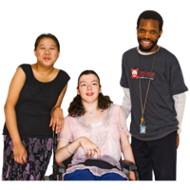 | Youth Committee  It makes sure that EDF’s work thinks about the needs of young persons with disabilities. It also supports young persons with disabilities in both EDF and external events.
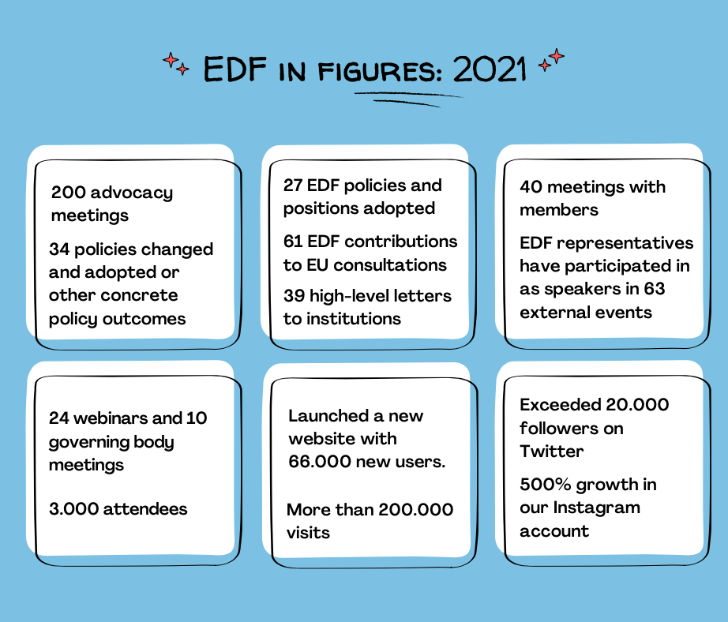

Our achievements in 2021
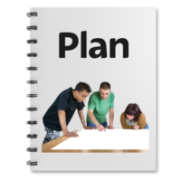 | Publication of the new Disability Rights Strategy 2021-2030. It includes most of the issues that EDF wanted.
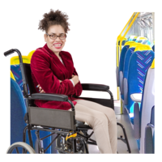 | Adoption of the recast of the Rail Passengers’ Rights Regulation (2021/782) following 5 years of asking. Now the pre-notification time for asking for assistance is 24 hours (before it was 48 hours).
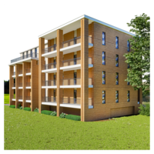 | Adoption of EN 17210 on accessibility of the built environment after 10 years of work. This provides guidelines on how to make buildings and spaces accessible.
 | The European Social Fund+ Regulations now includes physical accessibility, accessible ICT, employment, and access to housing for persons with disabilities. The final version also says a quarter of ESF+ money must be spent on improving the social inclusion of groups, including persons with disabilities.
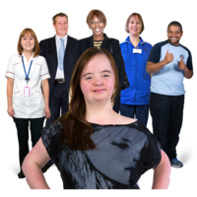 | Adoption of Erasmus+ and European Solidarity Corps .The new Erasmus+ Regulation includes a specific article on inclusion because of EDF advocacy work.
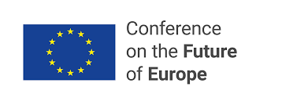 | EDF was part of the Conference on the Future of Europe.
 | Persons with disabilities and the CRPD are now included in the new EU budget for the global work of the EU.
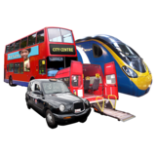 | Transport Accessibility Discrimination Database was launched on EDF’s website. It is the first collection of EU-wide data on this topic which will help EDF’s work.
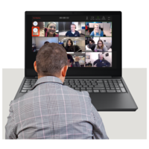 | There were some great online events. For example, the European Year of Rail, members’ workshops on the Disability Rights Strategy. They hosted meetings about how the Accessibility Act will work. The events reached out to the general public, members, and policy makers to raise awareness on disability issues.
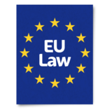 | Talking to EDF members about EC plans and new laws.
 | Regular “peer support meetings” of EDF members and experts on the Accessibility Act. Members helped each other and shared good examples.
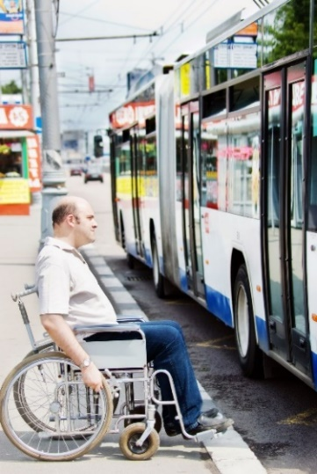 | EDF spoke up about good access to transport.  EDF was a partner in the “European Year of Rail 2021”.
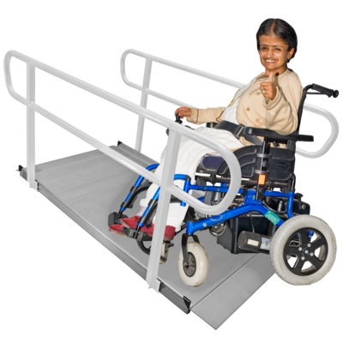 | EDF became official partner of the “New European Bauhaus” plan of the Commission to give better access to buildings and transport.
 | EDF works for equality and non-discrimination in the European Union, including victims’ rights, hate speech and hate crime, pay transparency and violence against women.
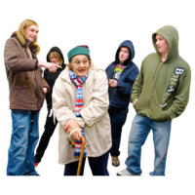 | EDF wrote a paper on Hate Speech and Hate Crime against Person with Disabilities. The Commission added hate speech and crime (on the grounds of disability) to the list of EU crimes, as recommended by EDF.
 | They published a Human Rights Report on the impact of COVID-19 on persons with disabilities.
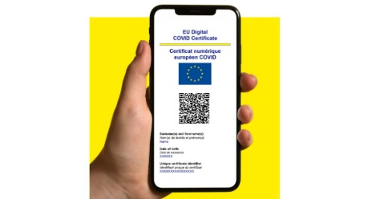 | They did work about health, including making the digital EU COVID certificate accessible.
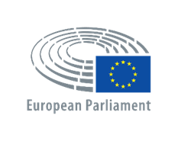 | They organised an important event in the European Parliament on countries working together.
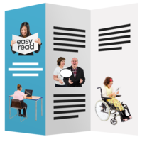 | They published 10 factsheets about disability inclusion in international working together for 10 European countries.
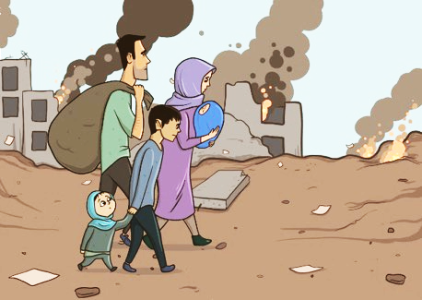 | Publication of “EDF toolkit on inclusion of refugees and migrants with disabilities in DPOs work”
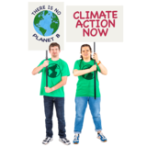 | EDF took part in the UN Climate Change Conference (COP26). They made a video on disability and climate change. This video helps to spread the message on climate action which includes persons with disabilities.
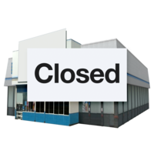 | EDF Co-Chaired the European Expert Group on the Transition from Institutional to Community-Based Care (EEG) where they are working to stop EU money being spent on institutional care.
 | EDF did a lot of work on violence against women and girls with disabilities in the EU. They organised 3 webinars about the rights of women and girls with disabilities. There was also a webinar on women and girls with disabilities who face trafficking and sexual crimes.
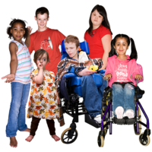 | EDF have also worked for the rights of young persons and children with disabilities. EDF organised and took part in 12 events attended by almost 180 participants.
 | They published a newsletter for the public Disability Voice on Youth in August 2021 with stories about independent living, the topic the Youth Committee decided to focus on during this year.
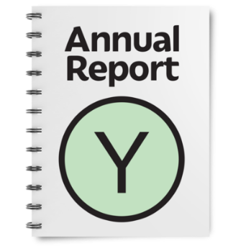
The full list of all the work EDF did in 2021 is in the main report.

Getting the messages out
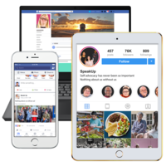 | In 2021 EDF reached around 80,000 persons through their website, social media, newsletters and press statements. At the end of 2021, there were 200,800 visits on the website.
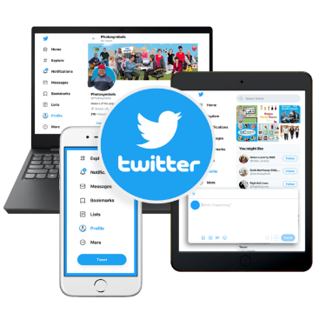 | The @MyEDF Twitter page has over 20,000 followers.  The EDF Facebook page has 13,960 fans.

EDF top campaigns
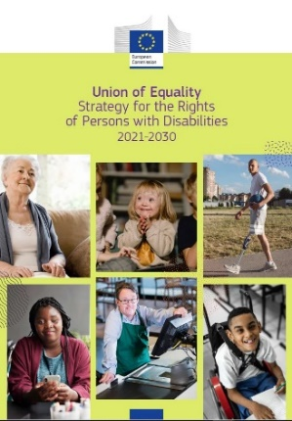 | Media coverage included EDF’s reaction to the EU Disability Rights Strategy and their demands on the Conference of the Future of Europe. Also the campaigns on EU rail passenger rights and the forced sterilisation of women and girls with disabilities.

Events
24 Webinars with 1,417 people taking part
9 Workshops with 276 people taking part

Financial report
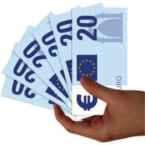 | In 2021, EDF had generous support from the European Union, the ONCE Foundation, Wellspring Philanthropic Fund, Leonard Cheshire, Sight Savers, Microsoft, Facebook, CBM, Siteimprove and Oracle.

 | 2020 | 2021
Total money spent | €1.713.980,76 | €1.855.098,83
Total money received | €1.763.235,42 | €1.917.619,35
Money left over for the next year | €49.254,66 | €62.520,52

