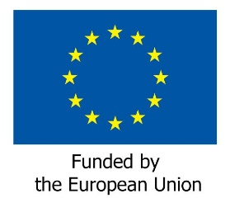
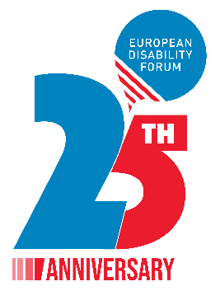
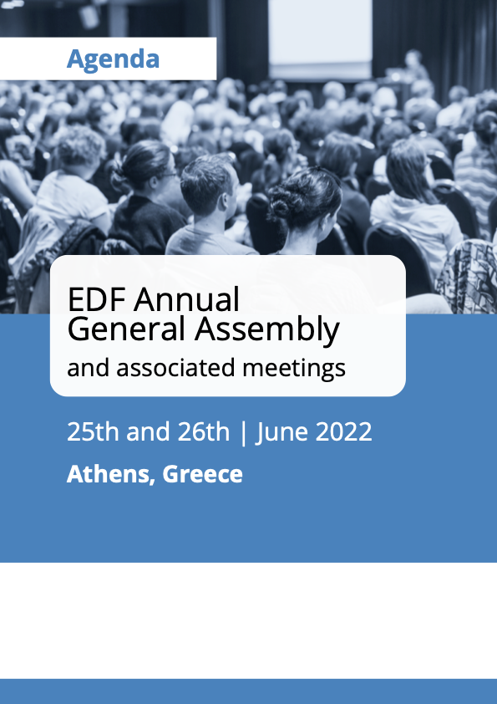

EDF Annual General Assembly and associated meetings

June 25th and 26th 2022

Athens, Greece
Venue: Titania Hotel Athens
Address: 52, Panepistimiou 10678, Athens, Greece
Telephone: +30 210 33 26 000

Thursday 23rd June

Arrival members of the Executive Committee

Friday 24th June
All day - Arrival of elected Board members and AGA participants
Room OMIROS-SOCRATES, 10th floor

10:00 – 13:30 Executive Committee meeting
Free evening

Saturday 25th June

Room NIKI-APOLLON-ATHINA, mezzanine level

08:00 – 08:45 Registration of participants

09:00 – 10:00 Official opening of the AGA
Keynote speeches
- Helena Dalli (video message), Commissioner for Equality
- Katarina Ivankovic-Knezevic, Director of DG Employment, Social Affairs and Inclusion
- Eva Kaili, European Parliament Vice President

- Dimitrios Papadimoulis, European Parliament Vice President
- Pietro Barbieri, President of the EESC Disability Rights Group (TBC)

10:00 – 11:00 AGA Business session 1
Chairperson: Yannis Vardakastanis, EDF President
- Roll Call
- Adoption of the agenda
- Health protocol for the meeting + introduction from the Hotel management (DOC-AGA-22-06-01)
- Appointment of the Scrutiny Committee and presentation of elections procedure (DOC-AGA-22-06-02 and Annex)
- Election of the EDF President
- Elections of Board members, Finance, and Membership and Credential Committees

11:00 – 11:30 Coffee break

11:30 – 13:00 AGA Business session 2
Chairperson: Yannis Vardakastanis EDF President
- Financial issues
- Adoption of EDF final accounts 2021 (DOC-AGA-22-06-03)
- Vote of discharge to the Board for 2021
- Appointment of internal auditors for 2023 (DOC-AGA-22-06-04)
- Adoption of EDF budget 2023 (DOC-AGA-22-06-05)
- Adoption of final activity report 2021 (DOC-AGA-22-06-06)
- Activity plan 2023 (DOC-AGA-22-06-07 and Annex)
- Results of elections (possible second round at a time to be confirmed)

13:00 – 14:30 Lunch break

14:30 – 16:00 Policy Session
- War in Ukraine and persons with disabilities (DOC-AGA-22-06-08)
- Review of the EU by the CRPD committee (DOC-AGA-22-06-09 and Annex)
- Policy update (DOC-AGA-22-06-10)
  - European Strategy on the Rights of Persons with Disabilities
  - Directive combatting gender-based violence
  - EU electoral law reform

16:00 – 16:30 Coffee break

16:30 – 18:00 AGA Business session 3
- Membership issues (DOC-AGA-22-06-11 and Annex)
- Revision of EDF statutes (DOC-AGA-22-06-12 and Annex)
- Political resolution guiding the upcoming Constitutional Review (DOC-AGA-22-06-13)
- Women’s committee
- Highlights from the outgoing Women’s committee
- Adoption of the Declaration on women and girls with disabilities (DOC-AGA-22-06-14)
- Adoption of new terms of reference (TOR) for the EDF Women’s Committee (DOC-AGA-22-06-15)
- Youth Committee
- Highlights from the outgoing Youth Committee
- Adoption of new terms of reference (TOR) for the EDF Youth Committee (DOC-AGA-22-06-16)

20:00 Titania Hotel, Mezzanine level. Official dinner marking 25 years of EDF, with all Delegates and invited guests

Sunday 26th June

Room NIKI-APOLLON-ATHINA, mezzanine level

08:30 – 10:30 Meeting of the newly elected Board and election of the Executive Committee

10:30 – 11:00 Welcome coffee

11:00 – 13:00 AGA Business session 4. Policy Session
- Announcements of the Executive Committee elections
- 5th European Parliament of Persons with Disabilities (DOC-AGA-22-06-17)
- Disability and Sustainability – discussion and adoption of EDF Green Policy (DOC-AGA-22-06-18)
- Any other business
- Expense clams for the AGA
- Date of the next meeting
- Sending evaluation form for the General Assembly
13:00 End of the meeting and departure of participants

Elections
The elections will take place on Saturday for:
- The president 1 candidate 1 seat
- The Board
  - National Councils 17 candidates for 16 seats
  - European NGOS 17 candidates for 12 seats
  - Ordinary members 4 candidates for 2 seats
- The Finance Committee
  - National Councils 2 candidates for 2seats
  - European NGOs 3Candidates for 2 seats
- Membership and Credentials Committee
  - National Councils 2 candidates for 2 seats
  - European NGOs 2 candidates for 2 seats
On Sunday the newly elected board will elect the Executive Committee
- National Councils 6 candidates for 5 seats
- European NGOs 8 candidates for 5 seats
and the portfolios of:
- Vice presidents
- Treasurer
- General Secretary
114 Delegates have rights to vote and will participate in person or remote to the meeting.
The scrutiny Committee is composed as follows:
- Marthese Mugliette from MFOPD Malta
- Federico Camporesi ARFIE
- Marion Steff EDF staff
- Marine Uldri EDF staff
Loredana Dicsi and Raquel with the person from Choice Voting Remotely will watch over the running of the electronic vote.
The president is elected via acclamation, thus we will not use the electronic voting system.
On Saturday for the Board will be run 3 elections, one for each list: National Council, European NGO and Ordinary Members. These will be run at the same time.
Then two elections are run for the Finance Committee and 2 for the Membership Committee.
We will leave 15 minutes for the first elections time to vote, as it is the first one and ten for the following ones.
If necessary, a second round will be organised after lunch.
The electronic system allows a quick count of vote so we will announce after coffeebreak the results, this, if we manage to keep the timing. The results will be announced by the Scrutiny Committee.
Do the voting take longer, Some items may be runned after the coffea Break in which case the results will be announced before the lunch break.
On Sunday morning the newly elected board meets to elect the Executive Committee. All is set for this election, except the list of voters that we know only after the elections of the Board.
There is foreseen on Saturday afternoon a time to input the list of voters to be ready for the election.
For the portfolios as there are not more candidates the elections are run on place with persons in the room or online
If the Executive thinks that for these ones also the electronic voting system should be used we can arrange.

