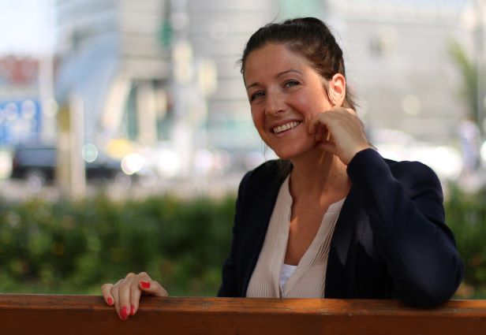

BIOGRAPHY
Christina Wurzinger
born March 18th 1980
Vienna (Austria)

Christina Wurzinger has studied law in Vienna and Bologna (Italy) and completed the postgraduate European Master Programme on Human Rights at the European Inter-University Centre for Human Rights and Democratisation in Venice (Italy) and Thessaloniki (Greece) in 2007. Being as well a certified trainer, she was counselling and working with young people with disabilities in the field of employment.
Since February 2011 she is in charge of the International and European Department of the Austrian National Council of Persons with Disabilities in Vienna. She is, inter alia, responsible for all international and European policies including the coordination of the civic alternative reporting processes to the human rights bodies at the UN and the European level. She is representing the Austrian National Council of Persons with Disabilities at the European Disability Forum (EDF) where she was elected into the Board in early 2014 and re-elected in 2018. At the same time she was also elected into the EDF Membership and Credentials Committee.
Wurzinger has been active as university lecturer on various occasions including the postgraduate Human Rights Master Programme of Vienna and courses at the University of Applied Social Studies of St. Pölten.
Since 2011 she is a member of the Austrian Independent Monitoring Committee for the Implementation of the UN Convention on the Rights of Persons with Disabilities (CRPD) where she overtook the chairwomanship from June 2015 to April 2018. It is the national monitoring mechanism according to Article 33 CRPD.
Since January 2017 she is also an independent member of the Children’s Rights Board, a counselling body of the Federal Chancellery providing expertise on the situation of children with disabilities in Austria.

