AGENDA

EDF BOARD MEETING

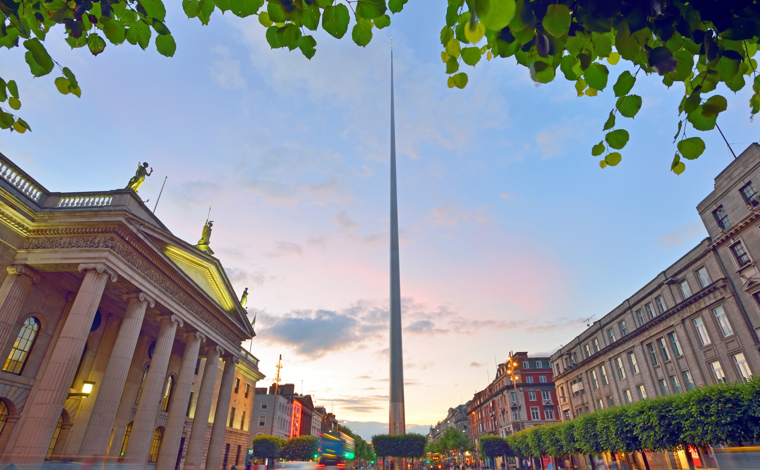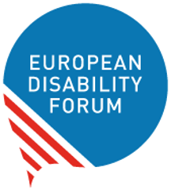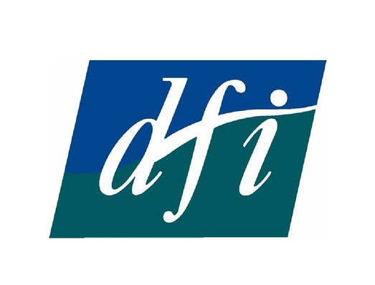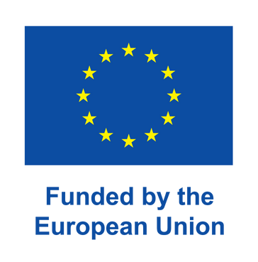November, 19 & 20
Dublin, Ireland | 2022

Board Meeting and Conference

19th and 20th November 2022
Dublin. Ireland

Venue: Clayton Hotel Cardiff Lane
Address: Sir John Rogerson’s Quay, D02 YT21, Dublin, Ireland.
Telephone: +353 (0)1 643 9500

Thursday 17th November

Arrival members of the Executive Committee

Friday 18th November

All day - Arrival of elected Board members

Room:

09:30 – 10:00 Welcome coffee

10:00 – 13:00 Executive Committee meeting
13:00 – 14:30 Lunch break (for Executive Committee members)

14:30 – 17:00 Parallel meetings of Committees

Finance Committee (Room)
- Membership and Credentials Committee (Room)

Free evening

Saturday 19th November
Room:

08:00 – 09:00 Registration and welcome of participants

09:00 – 09:20 Opening and keynote speeches

Mr Fran Brennan, Chair of the Disability Federation of Ireland

Mr Yannis Vardakastanis, President of the European Disability Forum

09:20 – 10:30 Conference on “From Signing Conventions to achieving full citizenship” Part 1
10:30 – 11:00 Coffee break

11:00 – 12:30 Conference on “From Signing Conventions to achieving full citizenship” Part 2

12:30 – 14:00 Lunch break

14:00 – 16:00 Board Session 1
- Adoption of the Board agenda
- President and Executive Committee report (DOC-BOARD-22-11-01)
- Report on 2022 main achievements (DOC-BOARD-22-11-02)
- Cost of living crisis- National and European responses (DOC-BOARD-22-11-03)
- War in Ukraine- update on situation of Ukrainians with disabilities (DOC-BOARD-22-11-04)
- Accession to the EU and advancing the rights of persons with disabilities (DOC-BOARD-22-11-05)
16:00 – 16:30 Coffee Break

16:30 – 18:00 Parallel meetings of Committees
- Human Rights and Non-Discrimination Committee (Room)
- Social Policy and Inclusion Committee (Room)

18:00 End of the meetings and evening activity TBC

Sunday, 20th November

Room:

09:00 – 11:00 Board Session 2
- Policy update (DOC-BOARD-22-11-06)
- Employment Package (DOC-BOARD-22-11-07)
- European Parliament of Persons with Disabilities (DOC-BOARD-22-11-08)
- Council Presidencies (DOC-BOARD-22-11-09)
- EU electoral law and rights of mobile EU citizens (DOC-BOARD-22-11-10)
11:00 – 11:30 Coffee Break

11:30 – 13:00 Board Session 3
- EDF finances (DOC-BOARD-22-11-11)
- Membership update (DOC-BOARD-22-11-12)
- Update on the Youth and Women’s Committees (DOC-BOARD-22-11-13)
- Evaluation of the Board
- Any other business
13:00 End of the meeting and departure of participants

