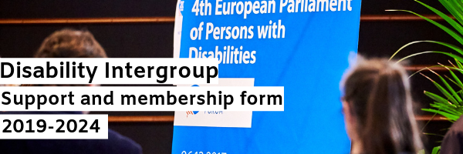

I, ……………………………………….. (Name and Surname), Member of the European Parliament for the term 2019- 2024 hereby certify that (check appropriate boxe(s) – in case of doubt contact alejandro.moledo@edf-feph.org):

☐ I wish to join the Disability Intergroup as a member
☐ I wish to be added to the Disability Intergroup Newsletter mailing list

Signature: ……………………………………………….

Email of the responsible staff member (when applicable):
………………………………………………………..

