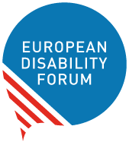

EDF Youth Committee

2021 Annual Report
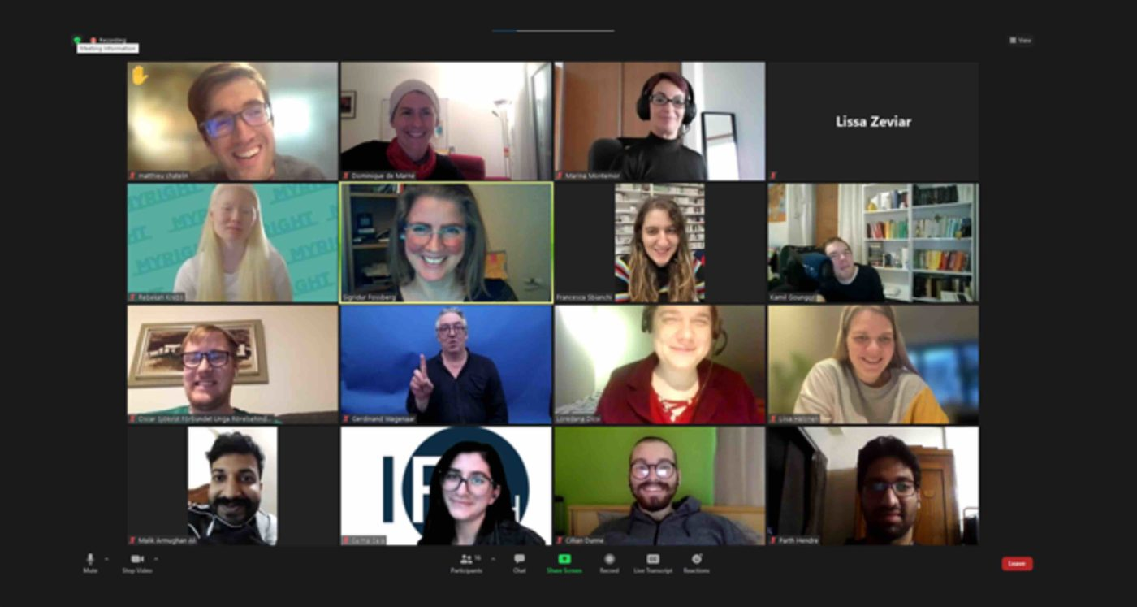
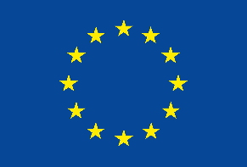 | This publication has received financial support from the European Union. The information contained in this publication does not necessarily reflect the official position of the European Commission.

Table of Contents
Table of Contents 2
Introduction 2
Easy to Read 3
Activities in 2021 5
Representation and Participation of EDF Youth Committee 6
The Youth Committee as a Resource 8
Bringing the Youth Perspective in EDF Work and Policy 8
Publications 9
The EDF Youth Committee 10
Document credits 14

Introduction
For 2021 the youth Committee held its activities under the topic of the Independent Living and housing. The COVID-19 pandemic obliged us to continue organizing our activities online, but never discouraged us to strive for our independence it made us cherish our independent living.
The Committee organised two webinars, one workshop, two statutory meetings and took the floor in other events. The Committee also wrote a report on Independent Living, a newsletter on Youth, and messages for Youth Day and the European Day of Persons with Disabilities. Members of the Committee participated in various events, one very interesting and unique was the Connecting Europe Express where two of our youth committee members jumped in. And of course, we did not miss the European Youth Event this year neither, we were precautious and organised our activity online and if the sanitary situation allows in 2023, we will be in person.
In June the Youth Committee joined the Global movement of young people with disability. The International Disability Alliance set up its Youth Committee, Kamil Goungor our chair joined this group and participated actively in its activities.

Easy to Read
The EDF Youth Committee is a group of young people with disabilities.
They talk about
- Problems of young people with disabilities.
- How to make things better for young people with disabilities.
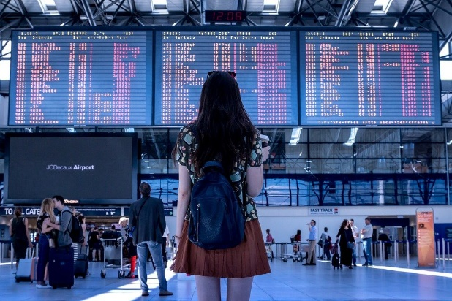 |  | In 2021 the Youth Committee talked about Independent Living and housing.  Independent Living is being able to leave where and with whom you want.  All the meetings were online because of coronavirus.
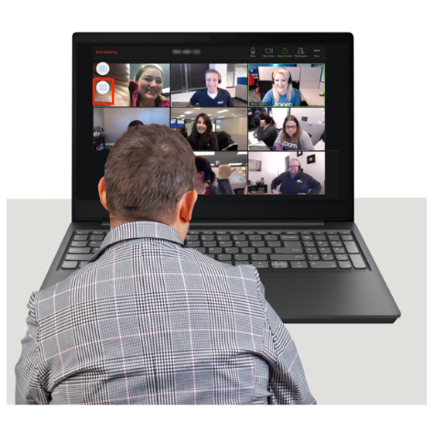 |  | The Youth Committee organised  - 2 talks  - 1 training  - 1 meeting at the European Youth Event.  The European Youth Event is a big meeting for young people.  The Youth Committee took part in many European and international meetings.
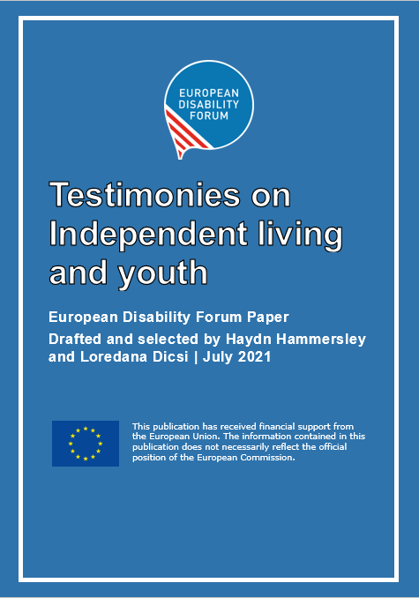 |  | The Youth Committee wrote  - A report about Independent Living and young people.  - A newsletter about young people.  - A message on International Youth Day.  - A message of the European Day of Persons with Disabilities.
 |  | The Youth Committee helped the European Union make new rules.
 |  | If you want more of this document in Easy to Read, go to our website
+ 32 2 329 00 56 | info@edf-feph.org | You can phone us at  + 32 2 329 00 56  Or email us at  info@edf-feph.org

Activities in 2021
Independent Living and housing was chosen as a topic for several reasons first because it is a right that all persons with disabilities have no matter their age, as foreseen in the Convention on the rights of persons with disabilities. Very few young people know about this right and the member states despite all have adopted and ratified the Convention on the Rights of Persons with Disabilities, the testimonials we received show that living independently in its own house is not a reality. Second the pandemic that is still part of our lives shown more than ever the lack or precarity of the services in place to support independent living. From one day to the other people were left without support and the only option for many was to go in an institution to get the necessary services to survive. And third and last to raise awareness among our decision makers that Independent Living and access to housing is a key for young people to be part of this society and that the EU can do more for its youth. Thus, our two major activities with high level presence were dedicated to the subject and a short questionnaire allowed us to collect some personal stories from young people, or how some leaved their youth in regards to Independent Living.
2021 was also the first time in the history that the EU organised a large consultation within its citizens in the framework of the Conference on the Future of Europe. The Conference itself was unfortunately not very inclusive, but a project financed by the European Parliament and under the coordination of the European Youth Forum provided more opportunities. The 25% Project where we learned how young people can be impowered and be real change makers.
In the second half of the year our Commissioner President Ursula von der Leyen decided to dedicate 2022 to young people. We could not miss the opportunity and thus we sent around a short survey to find out what people wanted for the year ahead. And of course, we did not miss to send feedback to the European Commission and meet the Coordinator at the European Commission for the European Year of Youth and their team which resulted in us and some of our members joining the Stakeholders Group on the European Year of Youth that allows a continuous dialog with the decision makers.
Other activities were organised by the Youth committee that can be considered from three perspectives:
- Representation and participation
- The youth committee as a resource: giving workshops and taking the floor
- Bringing the youth perspective in policy work

Representation and Participation of EDF Youth Committee
In 2021 the Committee organised or co-organised 2 webinars or online meetings, 2 Committee meetings, gave 1 workshop and took the floor in 12 events. In 3 of the events high level persons were present, in the webinars on the Inclusive Universities Working for inclusion Conference, Representatives of the European Commission and in two other online events of which one within the European Youth Event EYE2021 MEP Katrin Langensiepen was part of the programme and the event we organised within the Fundamental Rights Forum 2021 Katerina Ivankovic-Knezevic Director of DG Employment took the floor to explain how the Commission was working on independent living.
Below are some of the Important event where the Youth Committee has participated represented by one or more members and often took the floor.
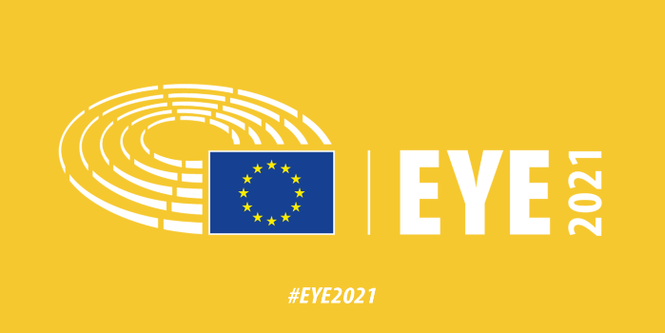
- Independent Living so basic and yet so impossible a webinar within the European Youth Event attended by almost 180 participants with the presence of MEP Katrin Langensiepen
- Independent Living of Young Persons with Disabilities a panel debate within the Fundamental Rights Forum an event with hundreds of parallel activities with the presence of Katarina Ivankovic Knezevic Director of DG Employment and Social Affairs
- The Change Maker Workshop given by the EDF Youth Committee
- Participated in 4 Meetings of the IDA Youth Committee, set up in June 2021, where EDF Youth Committee is represented by its chair Kamil Goungor
- Stake holders group meeting on DiscoverEU Programme online in October.
- Participated in the Council of Members of the European Youth Forum December 2021
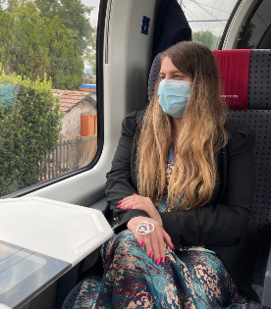
- Participated in Consortium meeting of the 25% Project on Empowering Young People and participation in the Conference on the Future of Europe
- Online meetings of the Youth Committee on June 4th and November 30th.
- Francesca Sbianchi and Kamil Goungor jumped in the Connecting Europe Hop on hop off express to discuss with commissioners within the European Year of Rail to present the difficulties young and not young disabled persons are facing when taking the train. Read Francesca’s experience in an interview she gave us.

Our youth committee is part of:
- European Commission’s stakeholders’ group on the European year of youth
- Erasmus+ Coalition and attended its 4 meetings in January, April, June, and September
- Representing EDF at the External Advice Mechanism of European Climate Pact, and attended meeting on 16th November
- Co-Chair of the Constituency of persons with disabilities within the regional civil society engagement mechanism (RCEM) of the Economic Commission for Europe
- Inclusive Mobility Alliance
- Advisory Group developing the training courses for future volunteers in the European Solidarity Corps.

The Youth Committee as a Resource
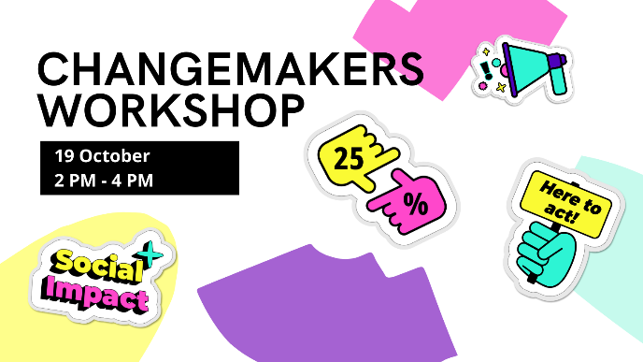
The members of the EDF Youth Committee can provide interventions, trainings, or workshops.
This year some members of the Youth Committee were trained by the European Youth forum within the 25% Project to provide workshop on empowering young people in active participation. The Workshop, “Change makers was then provided to the any young people who wanted to join on October 27 and members could ask to have organize it during one of their activities..

Bringing the Youth Perspective in EDF Work and Policy
The main mission of the Youth Committee is to bring the youth perspective within EDF and within the disability movement in general. Here are some items and publications where the Youth Committee brought its contribution.
- General Comment on Article 27 of the Convention on the Rights of Persons with Disabilities (CRPD), on employment
- Gave feedback in the shadow Report EDF made for the upcoming second review of the EU by the CRPD Committee
- Answered a Consultation on volunteering of young people in the EU
- Provided input on a Resolution of the European Parliament on employment and young people
- Provided feedback via a survey on the European Year of Youth 2022

Publications
- Messages for the International Youth Day 2021
- Disability Voice 6 Dedicated to youth
- Report on COVID and Young people with disabilities
- Messages from the Youth Committee & IF on the European Day of Persons with Disabilities 2 -3 December 2021.
- Our Analysis of the proposal for the European Year of Youth in 2022
- Handbook to Activism a guide to change within the 25% Project.

The EDF Youth Committee

What is the Youth Committee?
The Youth Committee is an advisory governing body of EDF. It is composed of eight members aged 25 to 35 from all over Europe who represent all categories of disability. It is chaired by one of its members, who is supported by one of the Executive members and by a staff from the secretariat to achieve its plans. The Youth Committee is devoted to representing the interests of young persons with disabilities – within the EDF and throughout Europe.

Members of the Youth Committee
Below you can get to know the members of the Youth Committee.
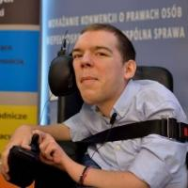 | Kamil Goungor was born in 1988 in Athens, Greece, where he lives. He has studied communication, media and culture. He is actively involved in the Independent Living movement in Greece and abroad, as well as in the fields of disability and youth in general. He is working as the Development Officer of our member ENIL (European Network on Independent Living), and he is a co-founder and board members of i-living, the Independent Living Organization of Greece.
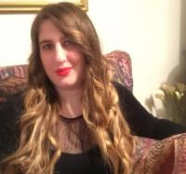 | Francesca Sbianchi, partially sighted, was born in 1987 in Assisi. She has a master degree in International Relations, and currently is an employee at the Umbria Regional Government.  Since 2010 she has been involved in the Italian and international disability movement. At national level she is a member of the National Council of the Italian Union of the Blind and Partially Sighted (UICI), of the Board of Directors of the Institute for Research, Training and Rehabilitation (I.Ri.Fo.R.), and the Coordinator of the International Relations Office of the UICI Head Office. Francesca is also active within the UICI Regional Council in Umbria. At the international level, she represents the European Union of the Blind (EBU) in the Youth Committee of the World Blind Union (WBU) and the Italian Disability Forum (FID) in the Youth Committee of the European Disability Forum (EDF).  Since 2021 she has been closely involved in the organization of the annual “Accessibility Days” event in Italy, aimed at promoting accessibility and inclusivity of digital technologies, and she is currently the Vice-President of the “Accessibility Days” association. She is also very involves in organising accessible cultural activities in her country and abroad.
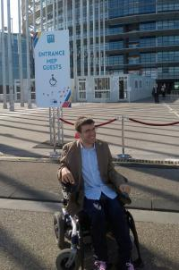 | Matthieu Chatelin is a 28 year old EU Citizen of French Origin who represents the Cerebral Palsy European Communities' Association (unincorporated branch of I.C.P.S). He has a master’s in human Rights and a master’s in International Affairs, Civil Society Development and Conflict Resolution.
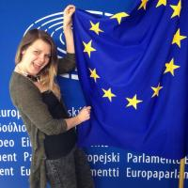 | Liisa Halonen was born in 1989 in Finland. She lives in Ghent in Belgium. She graduated as a Community Educator from the bachelor’s degree program of Civic Activities and Youth Work. She is working as a Secretary General in the European Union of the Deaf Youth (EUDY). At the age of 3 Liisa was diagnosed as profoundly deaf. When advocating for the rights of persons with disabilities, she always states that the persons with disabilities themselves are the best experts in the disability issues.
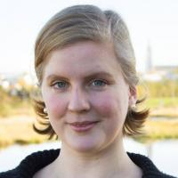 | Sigridur Fossberg Thorlacius was born in 1987 in Reykjavik, the capital of Iceland. She lives in Reykjavik and is a student of culture and web communication. Her motto is "Be open to new experiences, you never know what you might discover!". Sigridur is a human rights activist with a background in education studies, language, and culture.
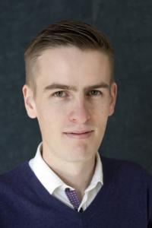 | Victor Rehn was born in Espoo, Finland in 1989 and lives in Helsinki, Finland. He is a master’s student at the University of Helsinki in political science with a focus on social work and social politics. He has been involved in the hard of hearing scene in Finland for a long time and continues to be. Internationally he is involved in the European Federation of Hard of Hearing and the International Federation of Hard of Hearing Young People.
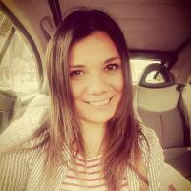 | Erika Becerra is a Designer from Rome based in York, UK. She is a person with autism. Since 2011 she has campaigned for Disability Rights and is a pioneer of the Autistic Pride Movement, establishing in Italy the first Not-for-Profit Self Advocacy organisation for Autism and Learning Difficulties. She joined the EDF Youth Committee in 2012 and takes active part in the discussions of the Forum. Erika Becerra has dedicated her whole life to the Human Rights and the Charitable Causes and is interested in designing new strategies to support the minorities and Solving Poverty. She built her career inter-disciplining visual communication, design, campaign with lived experience working in contact with the Health and Social and Charity Sector. www.erikabecerra.co.uk
$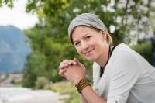 | Dominique de Marné was born in 1986 in Munich, Germany. She is a freelance – Writer and Mental Health Advocate. Dominique was diagnosed with Borderline Personality Disorder, Depression and Addiction in 2013 after living with it for almost half her life. She has since worked hard – alone and with help – and is now on the mission to change how we talk about mental health. Not all disabilities, specialties and impairments are visible, nor are people's wishes and needs – even if they share a diagnosis. Only if we start and learn to talk – AND listen – more openly to one another do we have a chance to initiate change. Communication is the ultimate weapon!

Document credits
This document was prepared by Loredana Dicsi with the contribution of the EDF Youth Committee

The European Disability Forum
Mundo Madou
Avenue des Arts 7-8
1210 Brussels, Belgium.
www.edf-feph.org
info@edf-feph.org
This publication has received financial support from the European Union. The information contained in this publication does not necessarily reflect the official position of the European Commission.

