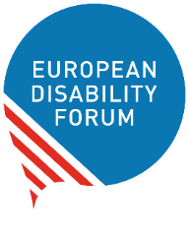
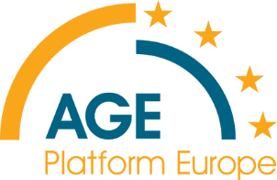
Better protection for EU passengers and their rights

Joint AGE and EDF meeting to gather input for the European Commission’s Public Consultation

Date and time:
7 November 2022
14 :00 – 15 :30 CET

Registration:

Registration link.

Concept and background:
Passenger rights have been key to ensure that everyone can move freely and equally throughout the European Union. To tackle some of the existing gaps and consider the need for additional policy action, the European Commission launched a public consultation on the current passenger rights legislative framework for all transport modes (Air, Rail, Bus and Coach and Waterborne Transport). To ensure that the voice of passengers with reduced mobility, including people with disabilities and older people, is heard, AGE and EDF organize a meeting to gather input and experiences from its members and experts. Some of the issues we will discuss during the meeting are reimbursement of tickets, multimodal journeys, enforcement mechanisms and accessibility requirements.

Indicative Agenda:

14:00 – 14.15h
- Welcome by AGE / EDF
- House Rules/logistics and presentation of the agenda
- State of play of Passenger Rights in the EU
- Introduction to the ongoing European Commission’s Public Consultation

14:15-14:25 Ice breaker using the Survey Functionality of Zoom

14:25 – 15.25h
- Open discussion among AGE / EDF members and experts

15.15– 15.30h
- Closing

Accessibility and house rules:
The language of the online discussion is English. We will provide International Sign interpretation and real-time captioning (English). Real-time captioning in other languages will also be provided if requested through the registration form.
We do not plan to publish the recording of the meeting. Therefore, if you are working on the topic, we encourage you or a colleague from your organisation to participate.
A written summary of the meeting will be provided to people who register for the meeting. If you can’t participate but would like to get the meeting notes, please register anyway.

Contact:
If you have any questions, write to Daniel, EDF Accessibility Officer, or Julia, AGE Policy Manager on Healthy Ageing and Accessibility

Useful Resources:

EDF Feedback to Commission Call for Evidence on EU Passengers' Rights Regulations (January 2022)
EU website dedicated to passengers’ rights (available in all EU languages):

