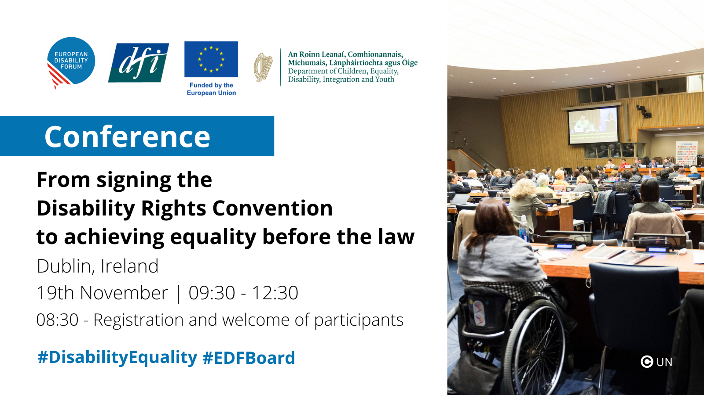

Introduction
The United Nations Convention on the Rights of Persons with Disabilities (CRPD) is one of the most widely signed and ratified international human rights conventions, including every EU member state and the European Union itself. It outlines the range of measures that governments need to put in place to ensure equal rights and articulate very clearly the importance of meaningful participation of persons with disabilities through their representative organisations. Equality before the law is an important part of having full rights in society, and yet this remains far from reality for people with disabilities everywhere.

Archaic laws in Europe still persist, these allow for the denial of the right to vote and stand for election, the denial of the right to decide for yourself to consent to medical treatment, to sign a contract or manage your own money. These archaic laws can be found all around the world.

This conference we will explore how well we advanced towards equality before the law in line with article 12 of the CRPD, which barriers still exist and how we can work together to make equality before the law a reality.

Programme
09:30 - 10:00 Opening of the conference

Grainne O'Leary Vice Chairperson, Disability Federation of Ireland

Yannis Vardakastanis, President of the European Disability Forum
- Erin McGreehan, Senator and Chair of the Oireachtas Disability Matters Committee

Gerard Quinn, UN Special Rapporteur on the Rights of Persons with Disabilites (video)

10:00 – 11:00 Panel discussion: Equality before the law in Europe
Moderator: John Dolan – CEO of the Disability Federation of Ireland
- Markus Schefer: Evolution in European countries – view from the UN CRPD Committee

Niall Brunnell, Principle Officer for Disability Policy, Department of Children, Equality Disability, Integration and Youth
- Aine Flynn, Director of Supported Decision-Making Service: legal capacity and supported decision making in Ireland- the path to emancipation

11:00 – 11:30 Coffee break

11:30 – 12:20 Update from members: development and promising examples of supported decision-making
- List of speakers from EDF membership on key issues in their country
- Questions and answer session

12:20 – 12:30 Closing of the conference by Pat Clarke, EDF Vice President

