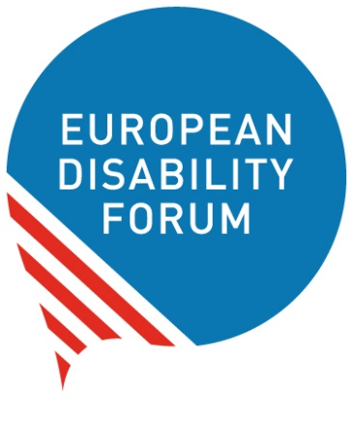
European Parliament
of Persons with Disabilities
23 May 2023
Information and programme
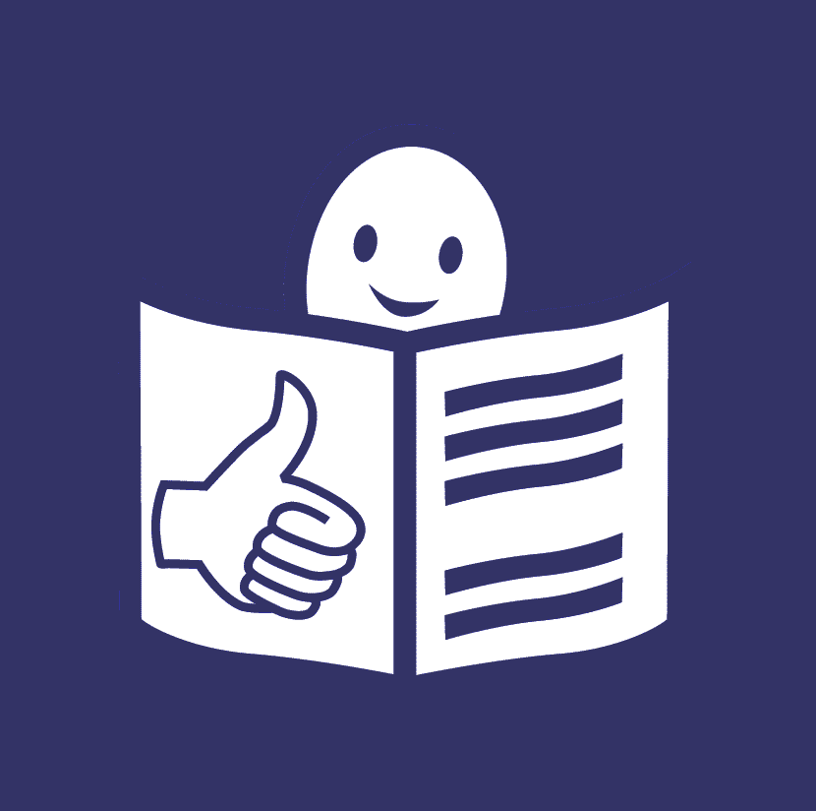
Easy-to-read version
Easy-to-read is information
that is written in a simple way
so that all people can understand it.
You can find more information
about easy-to-read at:
www.inclusion-europe.eu/easy-to-read.

Welcome to the European Parliament
of Persons with Disabilities
This is a big meeting
that brings together people with disabilities
and people who make decisions in Europe.
In this meeting,
we can tell people who make decisions in Europe
what we want them to do for the rights of people with disabilities.
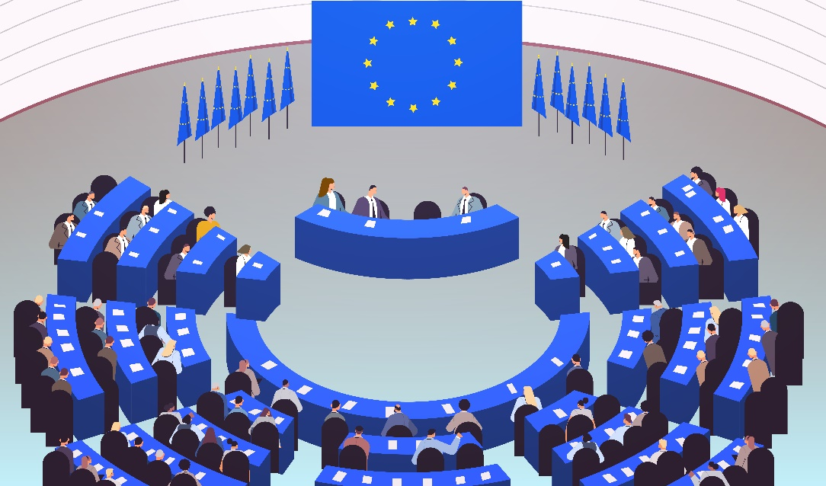
In the next few pages,
you will find all the information
and the programme of the meeting.
The difficult words are marked in bold
and you can find their explanation
at the end of this booklet on page 13.

Getting information on your mobile phone
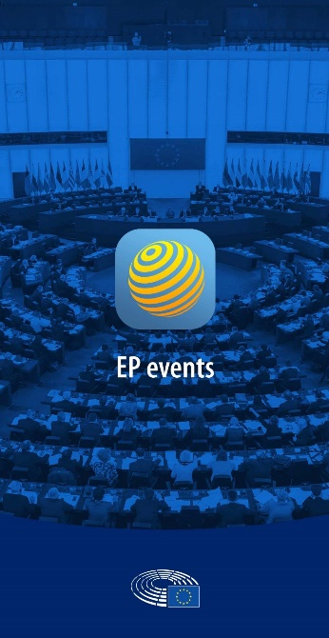
You can get all the information about the meeting
on your mobile phone by downloading an app.

With this app,
you can also chat with other people
who take part in the meeting like you.

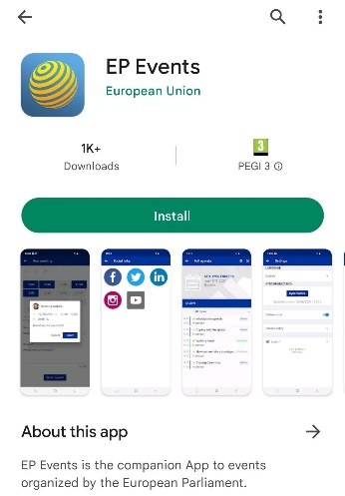
To download the app,
you should have internet connection
on your mobile phone.
Then you should follow these steps:
- Open Google Play or Apple Store
on your phone
- Search for the app: ‘EP events’
- Choose ‘Install’
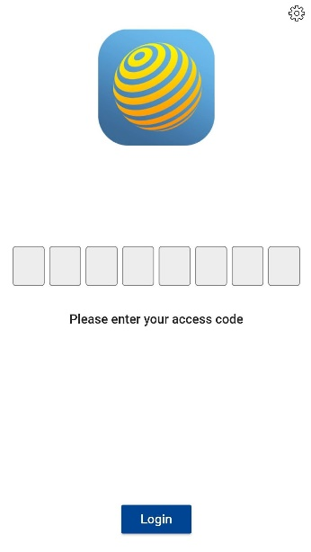
Once the app is ready to use:
- Open the app
- Fill in the code to sign in.
You will get this code in your email sent
by the European Parliament before the meeting.
If you have problems to use the app,
ask the staff at the information desk of the meeting
for help.

Programme of the day
09:00 - 09:30 Information about how the meeting will work
09:30 - 10:00 Welcome messages by:
- Roberta Metsola
President of the European Parliament
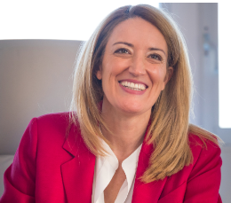
- Yannis Vardakastanis
President of the European Disability Forum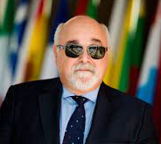

10:00 - 11:00 PART 1: THE RIGHT TO MOVE FREELY IN EUROPE
In this part, we will talk about
how making things and services accessible in Europe
will help people with disabilities
to move freely and take part in the community.
We will also talk about
the European Disability Card
and the right to take part in the European elections.
Speakers:
- Salvatore De Meo
Member of the European Parliament
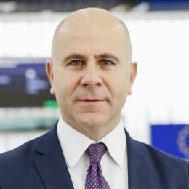
- Humberto Insolera
Member of the European Disability Forum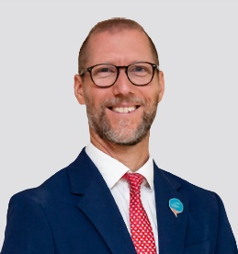
- Vera Jourová
Vice President of the European Commission
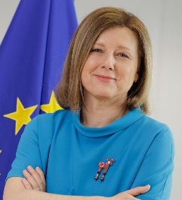
- Emily O’Reilly
European Ombudsman
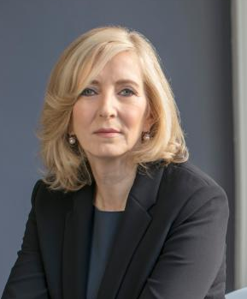
- Karine Lalieux
Member of the government of Belgium
working on the rights of people with disabilities
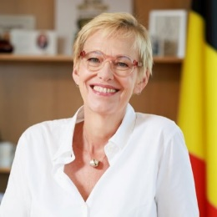
- Julia Farrugia Portelli
Member of the government of Malta
working on inclusion
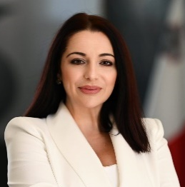
- Martin Conway
Member of the government of Ireland
working on the right to take part in the elections
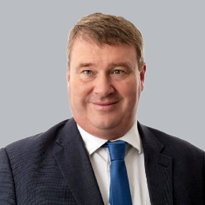
11:00 - 11:30 Break
11:30 - 12:25 Discussion among the speakers and the audience

12:25 - 12:30 Voting on the Manifesto on the European elections
We will vote if we agree with what is written in the manifesto.
Speakers:
- Yannis Vardakastanis
President of the European Disability Forum
- Alexandre Gomez
Vice President of the French organisation
of people with disabilities ‘CFHE’
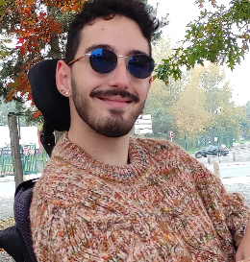
12:30 - 14:00 Break for lunch

14:00 - 15:00 PART 2: FIGHTING FOR EQUAL RIGHTS
In this part, we will talk about how to make sure
that people with disabilities can live independently, study, work
and have enough money to have a good life.
Speakers:
- Marc Angel
Member of the European Parliament
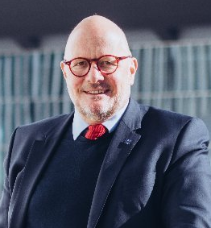
- Nadia Hadad
Member of the European Disability Forum
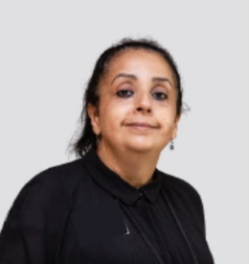
- Helena Dalli
European Commissioner working to make sure
all people in Europe have the same chances in life
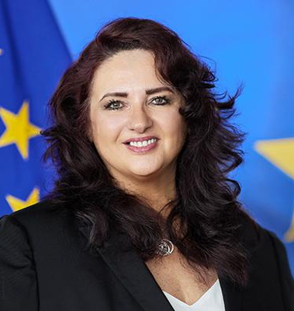
- Tamara Byrne
Member of Inclusion Europe
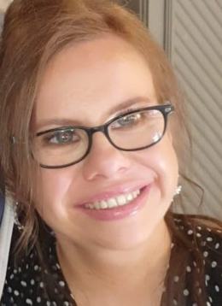
- Carlos Susias
Member of the European Anti-Poverty Network
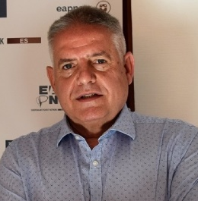
- Tamás Kádár
Member of Equinet
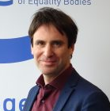
- Markus Schefer
Member of the UN Committee on the Rights
of Persons with Disabilities
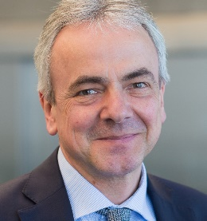
15:00 - 16:00 Discussion among the speakers and the audience
16:00 - 16:30 Break

16:30 - 17:15 PART 3: HELPING PEOPLE WITH DISABILITIES
IN URGENT SITUATIONS
In urgent situations like a pandemic or war,
people with disabilities are at higher risk of being left out.
In this part,
we will talk about how to protect people with disabilities
in these urgent situations.
Speakers:
- Katrin Langensiepen
Member of the European Parliament
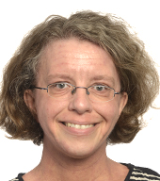
- Gunta Anca
Member of the European Disability Forum
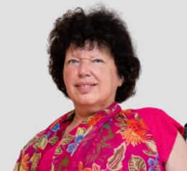

- Janez Lenarčič
European Commissioner working on protecting people in urgent situations of crisis
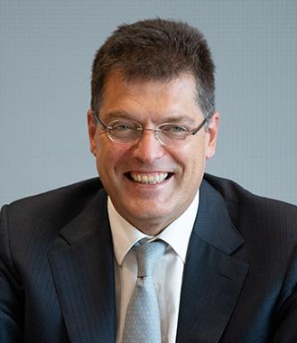
- Valerii Sushkevych
Member of the National Assembly
of Persons with Disabilities in Ukraine
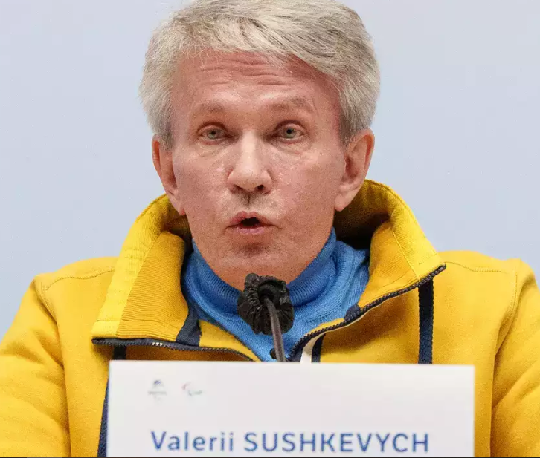
- Paola Albrito
Director of the UN Office for Disaster Risk Reduction
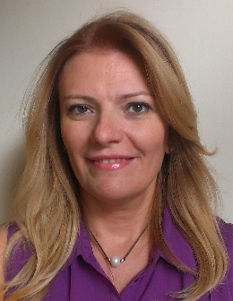
- Idriss Maïga Alzouma
Member of the African Disability Forum
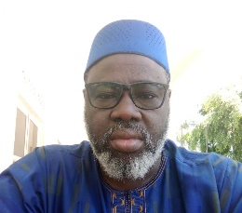
17:15 - 18:00 Discussion among the speakers and the audience
18:00 - 18:30 Closing of the meeting
Speakers:
- Dragoș Pîslaru
Member of the European Parliament
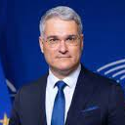
- Pat Clarke
Member of the European Disability Forum
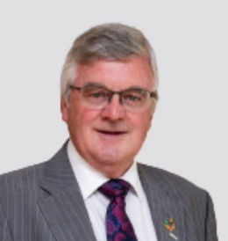

Explanation of difficult words

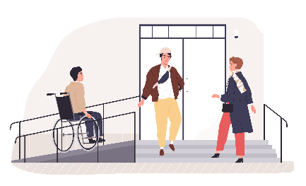
Accessible
Things are accessible
when they are easy to use
for people with disabilities and all people.
For example, when buildings have ramps
that people in wheelchairs can use to get in.
Or when information is easy to read
and people with intellectual disabilities
can understand it.

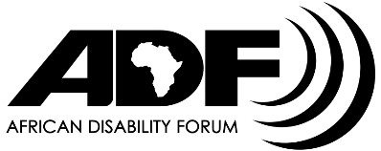
African Disability Forum
The African Disability Forum
is an organisation that works to protect
the rights of people with disabilities in Africa.

Equinet
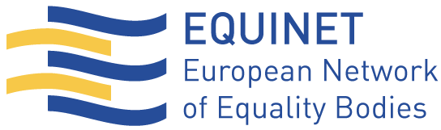
‘Equinet’ is an organisation in Europe
that fights for the right of all people
to be treated fairly.

European Anti-Poverty Network
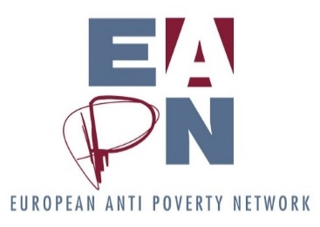
The European Anti-Poverty Network
is an organisation in Europe
that works to make sure that all people in Europe
have the chance to have a good life
and to be part of the community.
In short, this organisation is called ‘EAPN’.

European Commission
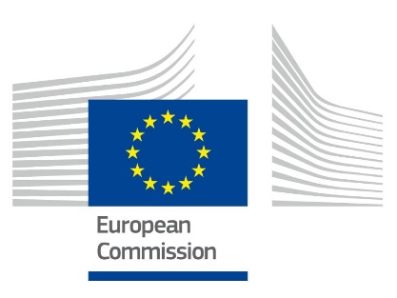
The European Commission
is the body of the European Union
that suggests laws that make a difference
in the lives of people in Europe.
It also does all the day-to-day work
of the European Union.

European Commissioner
A European Commissioner is a person
who is responsible for a field of work
at the European Commission.

European Disability Card
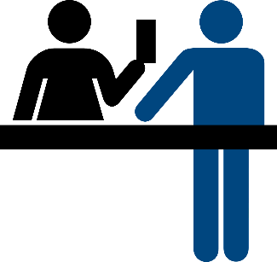
The European Disability Card
Is a card that people with disabilities
can use when they visit or live in another country
of the European Union.
Thanks to this card,
countries can recognise their disability
and give them some advantages
in culture, sports and other activities.
For the moment,
only a few countries in the European Union
use this card.

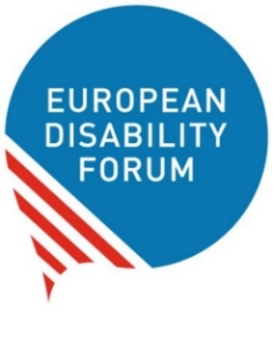
European Disability Forum
The European Disability Forum
is an organisation that protects the rights
of all people with disabilities in Europe.
In short, it is called ‘EDF’.

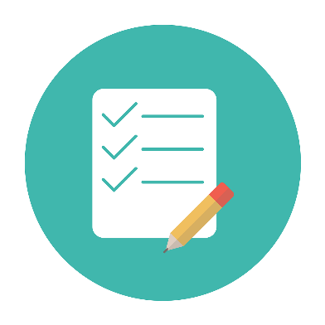
European Disability Strategy
The European Disability Strategy
is a plan that says
how the European Commission will work
to protect the rights of persons with disabilities
from 2010 until 2030.

European elections
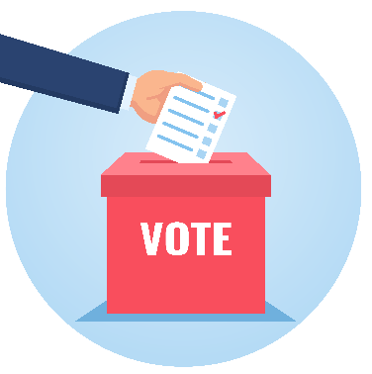
Every 5 years,
the people who live in the European Union
vote who they want to be Members
of the European Parliament.
The members of the European Parliament
are called ‘MEPs’, in short.
MEPs make important decisions
and speak for all the people of the European Union.
The next European elections will be in 2024.

European Ombudsman
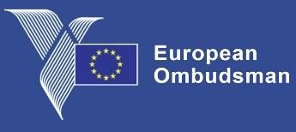
The European Ombudsman
helps people who have complaints
against the European Union.
People can contact the European Ombudsman
if they or someone they know feel
they are treated wrongly by an office
of the European Union.

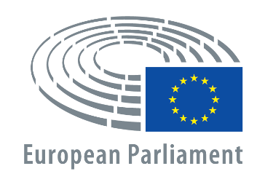
European Parliament
The European Parliament is a place
where important decisions and laws
of the European Union are made.

European Parliament of Persons with Disabilities
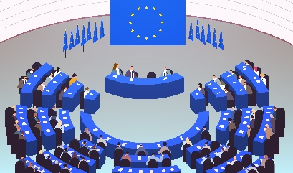
The European Parliament
of Persons with Disabilities
is a big meeting that takes place
every 5 years in Brussels.
In this meeting,
people with disabilities
and people who make laws and decisions in Europe
come together and talk about:
- How things are for people with disabilities
in Europe,
- What can be done better.

European Union
The European Union is a group of 27 countries in Europe.
These countries came together
to make things better, easier and safer for people.
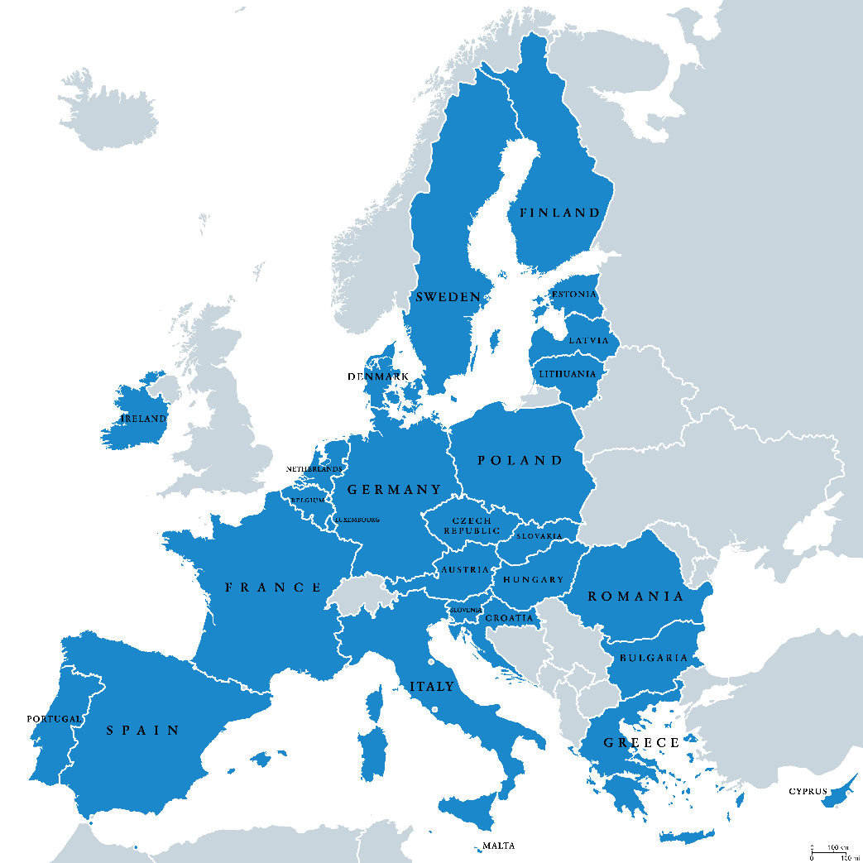

Inclusion Europe
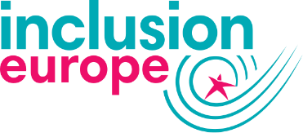
Inclusion Europe is an organisation
that protects the rights
of people with intellectual disabilities
and their families in Europe.

Institutions
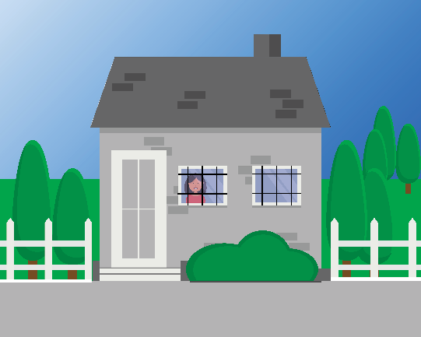
Institutions are places
where some persons with disabilities live
away from other people.
People who live in institutions
may not be able
to make their own choices in life.

Manifesto on the European elections
This is a list of things
we want people who make laws
and decisions in Europe
to do for people with disabilities.

National Assembly of People with disabilities in Ukraine
This is an organisation that works to protect
the rights of people with disabilities in Ukraine.
Right now, there is war in Ukraine
and people’s lives are in danger.
Things are even harder for people with disabilities.

Pandemic
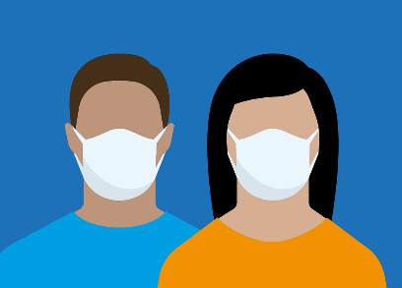
A pandemic is when a disease
passes very easily and fast among people.
For example, COVID-19 is a pandemic.
In the last years, too many people in the world
have been ill from COVID-19.

Refugees
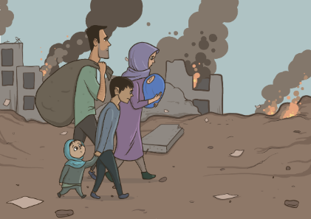
Refugees are people
who leave their countries and their homes
because it is not safe for them
to live there anymore.
For example,
they may have war in their countries
and their lives may be in danger.
In recent years,
many refugees have come to Europe
hoping for a better life.

UN Committee on the Rights of Persons with Disabilities
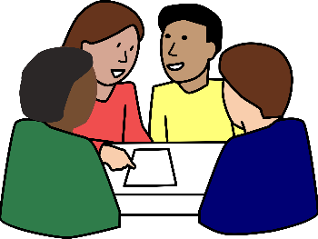
The UN Committee
on the Rights of Persons with Disabilities
is a group of people that checks
what countries do to respect the rights
of the UN Convention.

UN Convention
The UN Convention on the Rights
of Persons with Disabilities is an agreement
that many countries in the world have signed.
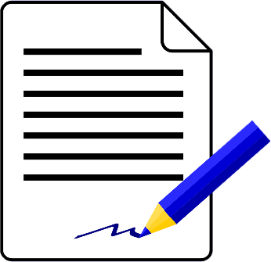
It says persons with disabilities
have the same rights as everyone else.
It also says how countries
can protect these rights.
In short, we call it ‘the UN Convention’
or ‘the CRPD’.
The European Union and all its countries
have signed the UN Convention.
That means that they have agreed to work
to make it happen and to protect the rights
of all persons with disabilities.

UN Office for Disaster Risk Reduction
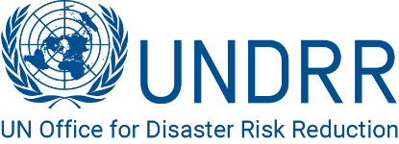
This is an office that works to protect
the lives of people from disasters.
A disaster is something that happens
and has a bad impact on many people’s lives.
For example,
when a big earthquake happens in a place
and many people are killed or hurt.

You can find more explanation of difficult words online at:
https://www.inclusion-europe.eu/easy-to-read-term/

More information
If you have any questions,
you can send us an email at: info@edf-feph.org.

