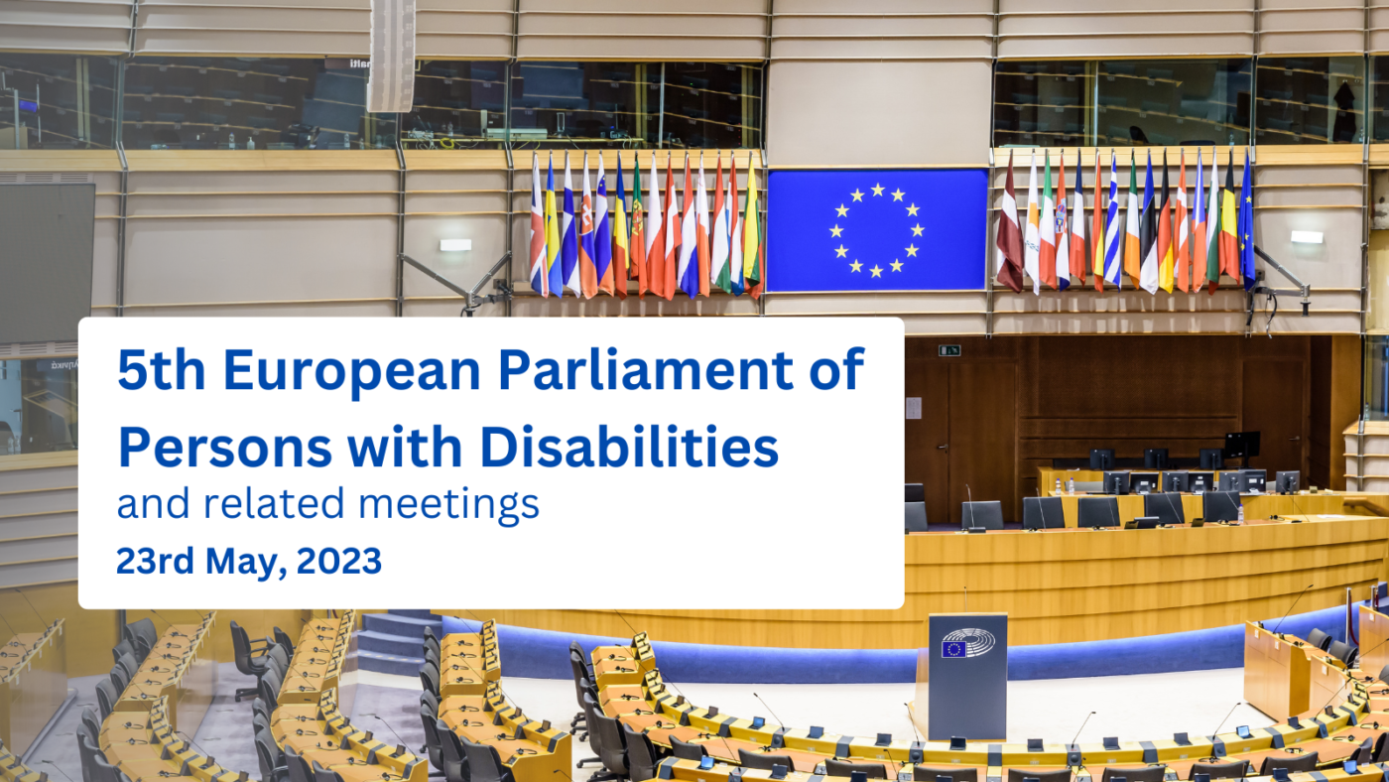
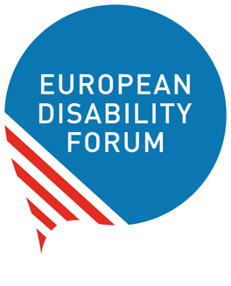

To EDF National Councils

5th European Parliament of Persons with Disabilities
(Tuesday, 23 May 2023 –)

Guidance to EDF national Councils about
setting up delegations

adopted by EDF executive committee
Index
Summary: 2
Quick facts about the event 3
Guidelines to set up delegations from EDF membership 3
Who can participate? 3
All National Councils are invited to form a delegation 3
The number of participants for each national delegation 4
Include European NGOs 5
High-level representation 5
Representativity 5
Mandate to vote 6
Contacts - EDF Secretariat 6

Version 12 – December 2022

Dear members,

We invite you to decide on the composition of your national delegation to the 5th European Parliament of Persons with Disabilities (EPPD) on 23 May 2023. You are kindly asked to provide EDF’s secretariat with the names of the participants in your delegation by 15 March 2023.

This document will assist you by providing guidance on the composition of delegations. You should follow these guidelines to the best possible extent. It will ensure that the disability movement will be fully represented.

Summary

- The event will take place on 23 May 2023 at the European Parliament in Brussels. Please send details about your national delegation to our secretariat by 15 March 2023.
- You should contact Members of the European Parliament $(especially the members of the Disability Intergroup) to reserve spots on their visitors list as soon as possible. They are the ones that will allow you to enter the Parliament (and will provide funding). Beware as MEPs have a quota of visitors per year.
- We ask you to ensure a diverse, representative delegation including European NGOs. The event has limited capacity – please consider, as guidance, bringing as many Members as there are MEPs from your country Check the number of the MEPs in your country.

Quick facts about the event

- When: Tuesday, 23 May 2023 - full day.
- Where: Hemicycle of the European Parliament, in Brussels.

Guidelines to set up delegations from EDF membership

Who can participate?
The participants should be members of the EDF member organisations and represent the European disability movement in its diversity.

As in 2017, EDF National councils have a steering role in forming and sending delegations from EDF’s membership to the EPPD. This is because the main way to fund travel to Brussels is by being sponsored by Members of the European Parliament (MEPs) through their official visitors’ programme.

All National Councils are invited to form a delegation

These delegations will be sponsored by their national MEPs. Each MEP is only entitled to sponsor a certain number of visitors per year. National Councils must contact their national MEPS as soon as possible to ensure they get into their quota of visitors. We advise you to reach to members of the Disability Intergroup from your country first. However, if you have good relations with other MEPs, anyone will do!
Please note that MEPs can also sponsor people who are not from their Member State.

Please note that to be funded, you will need to provide a report of the day to the European Parliament Visitors’ Programme. We will support you on this.

You can already access the template document (checklist and instructions) to head of delegations (Word - read the instructions to log in to the members’ area). Be aware that some instructions on the section “during event” may not apply.

There is a standard funding rate from the European Parliament that can be supplemented by the MEPs. Unofficially, these are the indicative rates (subject to change in 2023) includes:
- Travel - 0.09 € per kilometer/per person
- Accomodation – around 100 euros that can be increased around 50% for disability-related support.
However, the MEP that sponsors you will provide you the official information.

The number of participants for each national delegation

While national councils retain flexibility and autonomy in the setting up of their delegations, it is crucial to bear in mind the following constraints:
- The plenary chamber in Brussels has about 850 seats. Around 200 seats will be reserved for MEPs, speakers from EU institutions and other guests. That leaves around 650 for national delegations.
- Under European Parliament rules, the plenary chamber will be granted to us only if the size of the EDF delegation justifies it. The event should aim to gather a minimum of 400 participants.
- If your national delegation seeks sponsorship from MEPs under the European Parliament’s visitors’ programme, bear in mind that such sponsored group must include at least 10 people.
- The size of your national delegations should be also reflect the number of MEPs that represent your country (including personal assistants).

Include European NGOs
As the funding for the event will mainly come from individual MEPs, all EDF delegates to the event will come as part of national delegations. National Councils are invited to include European NGOs’ representatives. National members of European NGOs shall be included in the delegations formed by the National Councils. The NGOs have been asked to contact the National Councils.

High-level representation

The European Parliament of Persons with Disabilities will be a high-level event, in which key EU decision-makers will participate (EDF will invite the Presidents of the 3 main EU institutions – European Council, European Parliament and European Commission). The European disability movement should therefore be represented at the highest level. Presidents of EDF member organisations are urged to attend. Each delegation needs to nominate a contact person to coordinate with organisers.

Representativity

The delegation should be representative of the disability movement. You are encouraged to achieve a good balance between the various members of the National Council and to represent fairly the various disability groups. We further ask you to include people needing more intensive support and people with intellectual and psychosocial disabilities.

Mandate to vote

Please note that the EPPD may be concluded by the adoption of resolution(s) and the EDF Manifesto for the 2024 European elections.

Thank you for your efforts in planning your participation in the 5th European Parliament of Persons with Disabilities.

The EDF Secretariat will keep you informed of all developments leading up to the event via its Members area on the EDF website as well as via the internal newsletter to members - the members mailing. Please do not hesitate to contact the secretariat should you require further clarification or information.

Contacts - EDF Secretariat

- Catherine Naughton: catherine.naughton@edf-feph.org – General overview.
- Muriel Da Via: muriel.davia@edf-feph.org – Finances.
- Raquel Riaza: raquel.riaza@edf-feph.org – Contact with EP logistics.
- Loredana Dicsi: loredana.dicsi@edf-feph.org – Support to EDF members.
- Alejandro Moledo: alejandro.moledo@edf-feph.org – Contact with MEPs and agenda.
- André Félix: andre.felix@edf-feph.org – Communications.

