AGENDA

EDF BOARD MEETING

31st March – 1st April
Stockholm, Sweden | 2023
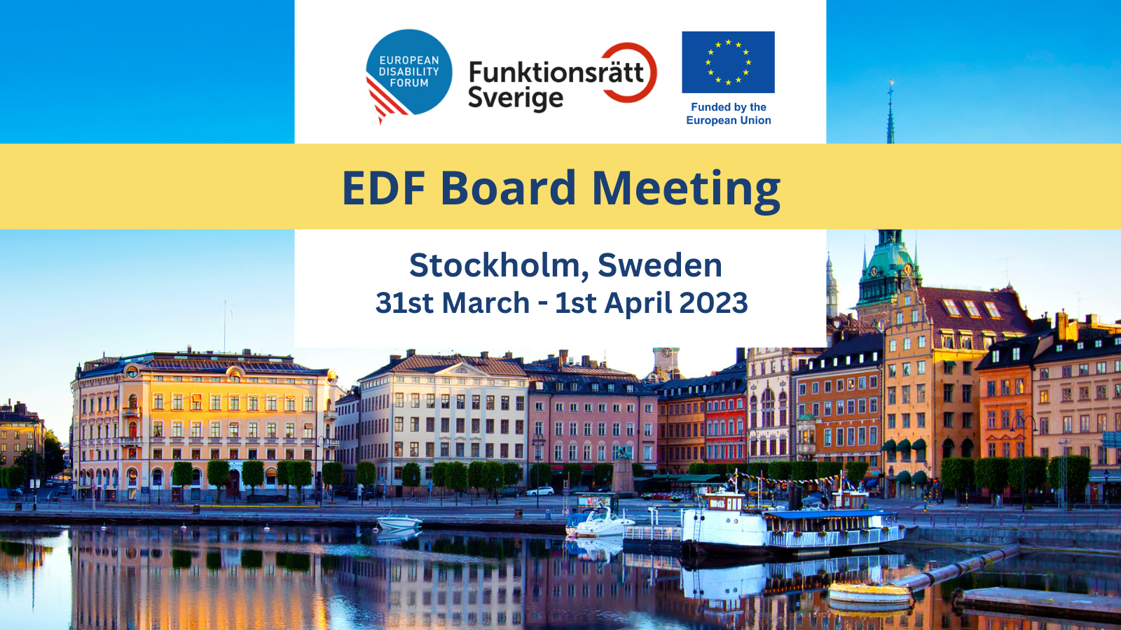

Board Meeting and Conference

31st and 1st April 2023
Stockholm. Sweden

Venue: Quality Hotel Globe
Address: Arenaslingan 7 12177 Stockholm, Sweden
Telephone: +46 8 686 63 00

Thursday, 23rd March

10:00 – 12:00 Human Rights and Non-Discrimination Committee Online
14:00 – 16:00 Social Policy and Inclusion Committee Online

Wednesday, 29th March

Arrival members of the Executive Committee

Thursday, 30th March

All day - Arrival of elected Board members

09:00 – 13:30 Executive Committee meeting Room: Venus
13:30 – 15:00 Lunch break (for Executive Committee members)

15:00 – 16:30 Parallel meetings of Committees

Finance Committee Room: Venus
- Membership and Credentials Committee Room: Neptunus

17:30 – 19:00 Optional Workshop with EDF member: the International Association of Accessibility Professionals (IAAP) Room: Venus

Friday, 31st March

Room: Galaxen

08:45 – 09:30 Registration and welcome of participants

09:30 – 10:00 Official opening of the Conference

Helena Dalli, EU Commissioner for Equality, European Commission
- Camilla Waltersson Grönvall, Minister of Social Services, Sweden
- Elisabeth Wallenius, President, Swedish Disability Rights Federation
- Yannis Vardakastanis, President, European Disability Forum

10:00 – 11:00 Conference session 1. Disability Rights in Europe - the Way Forward
Moderator: Fredrik Malmberg, Director, Swedish National Human Rights Institute
- Katarina Ivankovic-Knezevic, Director of DG Employment, Social Affairs & Inclusion, European Commission
- Abir Al-Sahlani, Member of the European Parliament, Sweden
- Gerard Quinn (online), Special Rapporteur on the Rights of Persons with Disabilities, United Nations
- Alejandro Moledo, Deputy Director, European Disability Forum
11:00 – 11:30 Coffee break

11:30 – 12:30 Conference session 2. Accessible EU - Reaching Local Communities
Moderator: Humberto Insolera, Executive Committee Member, European Disability Forum
- Inmaculada Placencia Porrero, Senior Expert on Disability, European Commission
- Zuzanna Raszkowska, Director. Ministry of Funds and Regional Policy, Poland
- Jesús Hernández Galán (online), Accessibility Director, ONCE Foundation
- Anna Quarnström, President, Disability Rights Stockholm City

12:30 – 14:00 Lunch break

14:00 – 14:50 Conference Session 3. Who Makes Decisions About your Life - the Human or the Algorithm?
Moderator: Catherine Naughton, Director, European Disability Forum and Elias Tebibel, Chair, Youth Committee, European Disability Forum
- Gerard Quinn (online), Special Rapporteur on the Rights of Persons with Disabilities, United Nations
- Jutta Treviranus (online), Professor, Faculty of Design, OCAD University
- Kave Noori, Artificial Intelligence Officer, European Disability Forum
14:50 – 15:30 Coffee Break

15:30 – 16:30 Conference Session 4. Artificial Intelligence Act – Legal Protection of Rights
Moderator: Stefan Larsson, Associate Professor in Technology and Social Change, Department of Technology and Society, Lund University
- Brando Benifei (online), Member of the European Parliament, Italy
- Karolina Iwanska (online), Digital Civic Space Advisor, European Center for Not-For-Profit Law ECNL
- Maureen Piggot, Executive Committee member, European Disability Forum
16:30 – 16:45 Break
16:45 – 17:15 Conference Session 5. Sustainable Artificial Intelligence – Leaving No One Behind
- Stefan Larsson, Associate Professor in Technology and Social Change, Department of Technology and Society, Lund University
- Anna Felländer, Founder, Anch AI
17:15 – 17:30 Conclusion & Closing Session
- European Disability Forum resolution Gunta Anca, Vice-president, European Disability Forum
- Closing speech Nora Bednarski, Cabinet member for European Commissioner for Equality

17:30 End of the meetings

19:00 Official dinner

Saturday, 1st April

Room: Galaxen

09:00 – 11:00 Board Session
- Adoption of the Board agenda
- President and Executive Committee report (DOC-BOARD-23-03-01)
- 2024 workplan (DOC-BOARD-23-03-02)
- EDF constitutional review (DOC-BOARD-23-03-03)
- Policy update (DOC-BOARD-23-03-04)
11:00 – 11:30 Coffee Break

11:30 – 13:30 Board Session
- CRPD update including the CRPD committee elections 2024 (DOC-BOARD-23-03-05)
- European Parliament of Persons with Disabilities (DOC-BOARD-23-03-06)
- Council Presidencies (DOC-BOARD-23-03-07)
- EDF finances (DOC-BOARD-23-03-08)
- Membership update (DOC-BOARD-23-03-09)
- Any other business
  - AGA 2023 Draft agenda
  - Draft Board resolution on Artificial Intelligence
- Evaluation of the Board

13:30 End of the meeting and departure of participants

