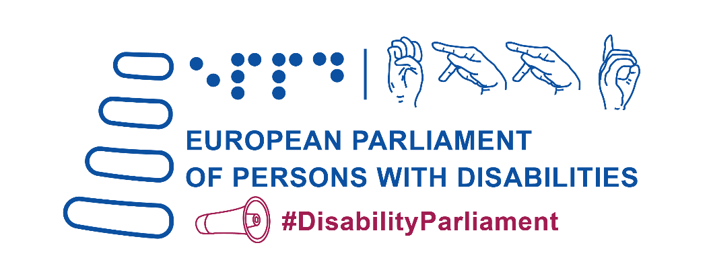
5th European Parliament of Persons with Disabilities

“Building an inclusive future for persons with disabilities in the EU”

Tuesday 23 May 2023
European Parliament Hemicycle | Brussels

Draft agenda

9:00 – 9:30 Presentation by the European Parliament’s Visitors Programme

9:30 – 10:00 Official Opening
Roberta Metsola, President of the European Parliament (confirmed)
Ursula von der, Leyen, President of the European Commission (invited)
Charles Michel, President of the European Council (invited)
Yannis Vardakastanis, President of the European Disability Forum (EDF)

10:00– 11:00 Breaking barriers: free movement and full participation

Co-chaired by MEP and EDF executive committee member.

Speakers:
- Vera Jourová, European Commission Vice President Values and Transparency (confirmed)
- Emily O’Reilly, European Ombudsman (confirmed)
- Ione Belarra Urteaga, Minister for Social Rights and the 2030 Agenda, Government of Spain (invited)
- Julia Farrugia Portelli, Maltese Minister for Inclusion, Voluntary Organisations and Consumer Rights (confirmed)
- Martin Conway, member of the Irish Senate and vice chair of the Advisory Panel on political participation of persons with disabilities, Office for Democratic Institutions and Human Rights, Organisation for Security and Cooperation in Europe (confirmed)

11:00 – 11:30 Break

11:30 – 12:25 Plenary debate 1: interventions by Members of the European Parliament and delegates of the European disability movement

12:25 – 12:30 Adoption of EDF Manifesto on the 2024 European elections

12:30 – 14:00 Lunch break - for official delegates and MEPs only

14:00 – 15:00 Fighting for our rights: combating inequality, social exclusion and poverty

Co-chaired by MEP and EDF executive committee member.
Proposed speakers
- Helena Dalli, European Commissioner for Equality (confirmed)
- Tamara Byrne, Inclusion Europe and EDF Youth Committee (confirmed)
- Carlos Susias, President of the European Anti-Poverty Network (confirmed)
- Tena Šimonovic Einwalter, Chair of Equinet (confirmed)
- Markus Schefer, member of the UN Committee on the Rights of Persons with Disabilities (invited)

15:00 – 16:00 Plenary debate 2: interventions by Members of the European Parliament and delegates of the European disability movement

16:00 – 16:30 Break

16:30 - 17:15 Disability-inclusive resilience
Co-chaired by MEP and EDF executive committee member.

Proposed speakers
- Janez Lenarčič, European Commissioner for Crisis Management (invited)
- Valeriy Sushkevych, Head of the National Assembly of Persons with Disabilities (NAPD), Ukraine (confirmed)
- Paola Albrito, Director of the United Nations Office for Disaster Risk Reduction (confirmed)
- Idriss Maïga Alzouma, Chairperson, African Disability Forum (ADF) and Second Vice-President of the International Disability Alliance (IDA) (confirmed)

17:15 - 18:00 Plenary debate 3: interventions by Members of the European Parliament and delegates of the European disability movement

18:00 - 18:30 Concluding remarks:
Dragos Pislaru, chair of the Employment and Social Affairs Committee (confirmed)
Camilla Waltersson Grönvall, Minister of Social Services, Government of Sweden – Swedish Presidency of the EU (invited)
EDF Vice President

Background

The European Parliament of Persons with Disabilities (EPPD) is a one-day event that reunites roughly 700 disability advocates, policymakers and other stakeholders. It is co-hosted by the European Parliament and the European Disability Forum (EDF), in Parliament’s plenary Chamber.

The 5th EPPD will conclude the 25th anniversary of EDF, which was created to bring together representative organisation of persons with disabilities from across Europe to build a strong, united voice for the 100 million Europeans with disabilities. EDF works to ensure that decisions concerning persons with disabilities are taken with persons with disabilities, through their active involvement in policy and decision-making. This is the basis of the motto ‘nothing about us without us’.

The conference does just this; It serves as a platform to discuss the rights of persons with disabilities and to decide on the political demands of the European Disability Movement. It achieves this by fostering dialogue between Members of the European Parliament, EU decision makers and delegates of diverse organisations of persons with disabilities.

Rationale

Emphasising the spirit and objectives of the Conference on the Future of Europe, the 5th EPPD is truly a timely event. Ahead of the 2024 European elections, it aims to highlight enduring issues of accessibility, as preconditions to full and independent political and civic participation.

Alongside the EU’s second review by the CRPD Committee, the event aims to foster discussion on the greatest threats to the rights of persons with disabilities and how, despite the lack of progress in certain areas, there is still hope for positive change in the near future.

Finally, against a backdrop of intersecting natural, political and public health crises, the event will facilitate a deep dive into the rights and inclusion of persons with disabilities in humanitarian action and crisis management.

In the face of all these challenges, the 5th EPPD is an opportunity to move forward as a united European community. Only by bringing persons with disabilities to the decision-making table can we build an inclusive and resilient Union.

Rules of Proceeding

The EPPD aims to foster a dialogue between delegates of organisations of persons with disabilities and EU policy-makers, including Members of the European Parliament. Therefore, each of the three main sessions include a ‘plenary debate’. These debates will use rules of procedure similar to those governing European Parliament plenary sessions: lists of speakers will be agreed and allocated in advance of the event. The organisers will ensure that the speakers’ lists will be inclusive of the most marginalised persons with disabilities - women and young people with disabilities, people with intellectual or psychosocial disabilities, and people in need of high-level support. The sessions will be co-chaired by Members of the EDF Executive Committee and Members of the European Parliament.

PRACTICAL INFORMATION

- Spoken Interpretation in all official EU languages
- International Sign interpretation
- Velotypist (speech-to-text) in English
- Livestreaming in accessible format on the European Parliament TV (www.europarl.europa.eu/ep-live)
- Meeting documents available in English, Easy To Read and Braille

