Ascend Project – Your Rights in the EU:
Youth, Accessibility Act and Transport

a presentation by Loredana Dicsi, notes taken by Phillipa Tucker

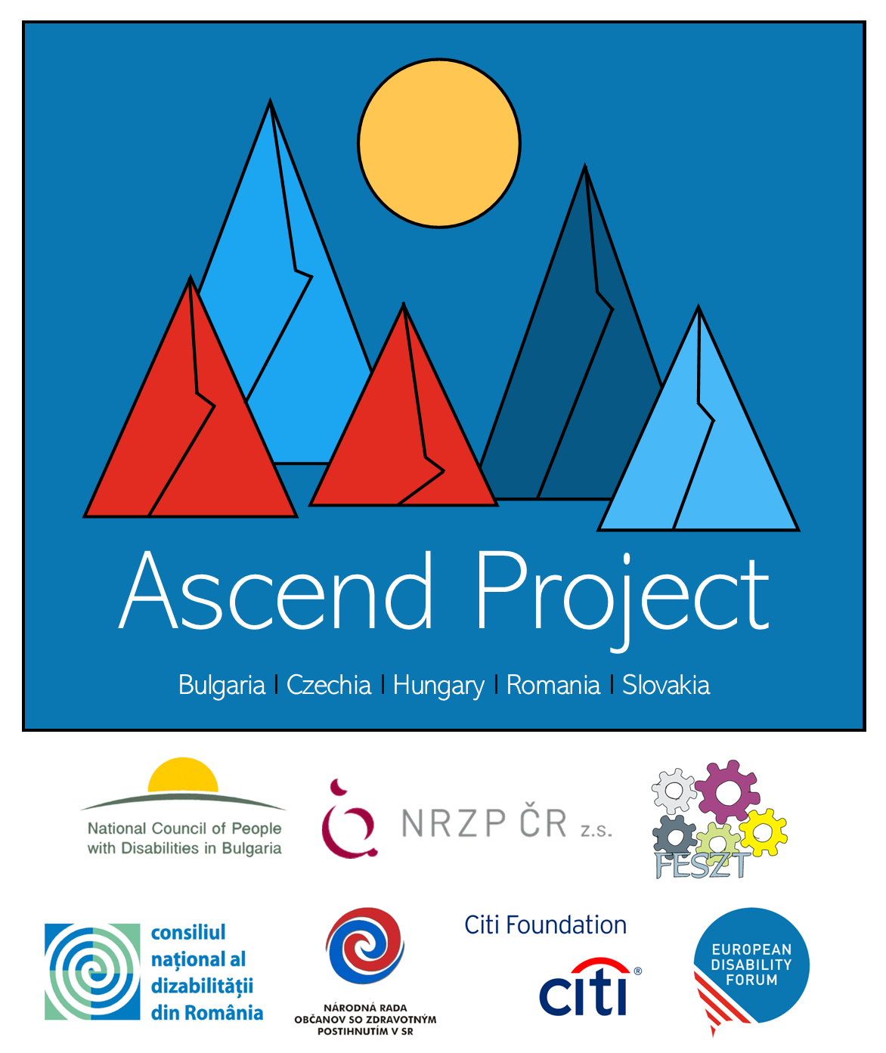

Table of Contents

Ascend Project – Your Rights in the EU: Youth, Accessibility Act and Transport 1
a presentation by Loredana Dicsi, notes taken by Phillipa Tucker 1
Introduction 3
EU Youth Strategy 3
Erasmus+ 3
Why is it important for young people with disabilities? 3
European Solidarity Corps 3
The Youth Guarantee 4
European Youth Card 4
ALMA programme 4
European Accessibility Act 4
Transportation 4

Introduction

I have partially sighted and almost blind so no PowerPoint from me.
Today I will speak about Youth, Access to products and services, and transport.
And to make it more understandable I will not insist on the laws but on the rights that come out of these laws.
So, I will start to talk about youth policies and related rights.

EU Youth Strategy
There is a strategy on Youth, which goes until 2030 and it highlights training, education, youth participation and empowering young people. Sadly, there is nothing about disability in it at all. The other policies linked to youth are the ones linked to programmes for young people. I would like to mention the mobility programme, Erasmus Plus, and European Solidarity Corps.

Erasmus+
Erasmus Plus allows students, pupils, and staff to go on mobility, to either study, have job exchange or internship or non-formal education between countries. The most well-known is the student exchange for students who travel to another EU country for one semester to study.

Why is it important for young people with disabilities?
Often there came up the problem of the cost linked to having a disability. Someone in a wheelchair who wishes to go study abroad will need to make sure that the cost and money from the university are enough to pay for their accessibility needs like accessible accommodation or that they can also get the support they need for studying, (examples such as braille, sign language interpretation, etc.). And this is what we have insisted on and the programme provides financial support related to disability. We went even further because often the problem was that with Erasmus that you had to pay upfront and be reimbursed after the tour. Now, in the new programme, institutions, organisations and universities can ask for a pre-finance related to any accessibility needs for disability.

European Solidarity Corps
The next programme is more or less similar to Erasmus Plus. The European Solidarity Corps. This is the volunteering programme of the EU for young people aged 18 years to 30 years. A young person can go and volunteer for one year maximum in another country and the EU pays for their travel, accommodation and some money to cover a daily cost plus a small allowance. In the same as for Erasmus, costs linked to disability are covered.
For those programmes to be even more exclusive, some guidelines were developed. For example, before starting your mobility, you can have a preparatory visit to the host country. And there also the travel costs of the young person and an accompanying person are covered. There are also other measures like mentoring, inclusion support funds and others that help young people with disabilities to participate in this programme.

The Youth Guarantee
The Youth Guarantee is an initiative that offers young people under 30 years to receive a good offer of employment, continuous education, traineeship, or apprenticeship. And within a period of four months within the period of unemployment started or education finished. This scheme is different in each EU state and there is a problem in some EU countries because you need to choose between the funds of the Youth Guarantee and the disability grants. So, of course, what do you choose between something you get for a few months or something longer?

European Youth Card
Another interesting right for young people in the EU is a scheme called the European Youth Card. This is a card for all young people, in most countries, up to 30 years old. It gives reductions on cultural activities, eating out, transport, accommodation, and shopping generally. It is now available in more than 40 countries and goes beyond even the EU. For accommodation that reduction is available in sports centres accommodation, youth hostels, youth hotels and such. Not such places at the Hilton hotel, don’t expect that! There are some new ones published recently by the EU and the European Disability Forum will keep you informed through your national teams.

ALMA programme
The ALMA programme helps young people in employment. The programme has provisions for people with disabilities, but it is not yet in place, so we will update you when we know the final.

European Accessibility Act
The European Accessibility Act was adopted in April 2019. This must be put into national law by all national states by 28 June 2022. As you can see, the deadline passed! To this date, only 4 EU countries have implemented it.
This law must be put into practice by June 2025. But there are some exceptions. To install the European emergency number, they have an extended deadline such as 2030 to do so. The European Accessibility Act sets new minimum requirements for products and services. It is not a solution to cover all our difficulties, but it is for sure a step forward. And this piece of legislation covers some products and services, mainly in the digital domain. For example, smartphones, tablets, computers and their operating systems, like windows, ticketing and check-in machines, all payment terminals, smart television and access to tv channels and on-demand channels, all need to be accessible to us all. Banking services and ATMs, E-books and E-readers, online shopping, websites and mobile applications, telephony services, including calling in an emergency (112), and certain elements of air, rail, bus and water and other transport services, except for urban and suburban regional transport services. For this, only the ticketing machines are covered. So, these products are covered by the Act. So, a person with a wheelchair can buy a ticket but not reach the transport if there are stairs, so must change is still needed. And linked to this, all public websites need to be accessible too.

Transportation
We are speaking only about long-distance transport. From 250 kms. Air, rail, coach/bus, and boats. There is the right for access for persons with disabilities. This is free of charge, and we are obliged to display your disability proof to get this assistance. Here we had a campaign “turn up and go” and it is linked to the pre-notification of assistance. It was advised to pre-notify for assistance days before. We managed to change it to 24 hours for air, boats and trains, and 36 hours for buses.
Another important thing is that they can deny you boarding if it is unsafe for you to travel. And then if your wheelchair or mobility vehicle cannot fit on the transport, then they can also refuse you. When you travel, if your equipment is damaged you can get a total reimbursement by train, bus, and boat, and on the plane a maximum of 1100 Euros.
The last thing is that you can take an accompanying person with you for free on train, boat and bus. And in our booklet, Your Rights in the EU, we list other rights for when you travel that are available to all.

