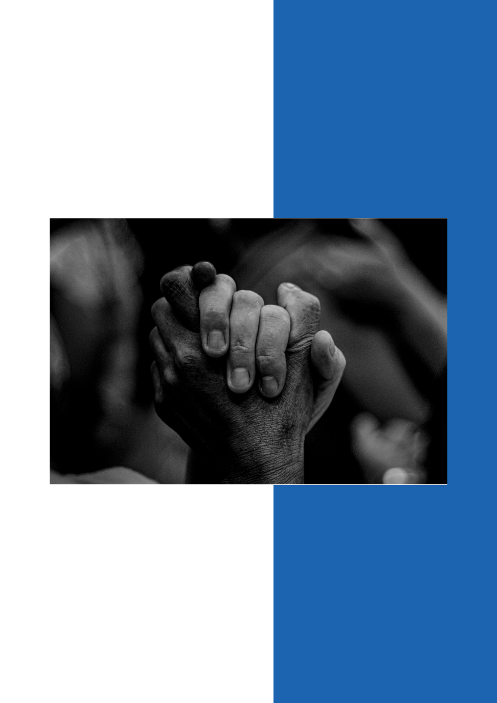
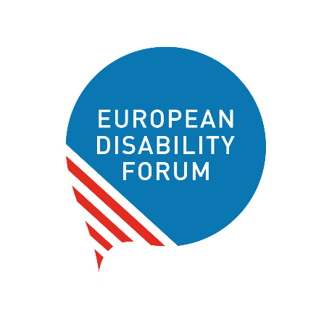
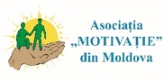
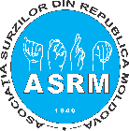
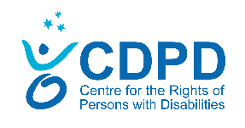
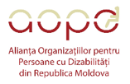
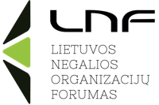
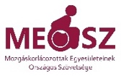
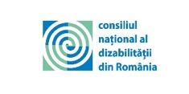
2.7 million
How EDF and partners are supporting persons with disabilities impacted by the war in Ukraine
October 2022

Contents

The war in Ukraine and persons with disabilities 3
Our response to the war in Ukraine in objectives 4
Objective 1: Addressing the immediate needs of persons with disabilities 4
Objective 2: Influencing the wider humanitarian response to make it disability-inclusive 4
Objective 3: Strengthening the disability movement 5
Our partners 6
Our work in numbers 7
What we have done in the past seven months 7
Objective 1: Immediate needs 7
Objective 2: Advocacy 9
Objective 3: The future of our programme 13

The war in Ukraine and persons with disabilities

On February 24th, 2022, Russia launched a full-scale invasion of Ukraine, causing a humanitarian crisis that has seen over 6.9 million people internally displaced in Ukraine and 7.2 million refugees in the neighbouring countries. In Ukraine, over 2.7 million persons with disabilities were registered before the war; by July 2022, it was estimated that 13% of the families fleeing Ukraine had at least one member with a disability. The war has had a disproportionate impact on the safety and well-being of persons with disabilities from the country: persons with disabilities often face life-threatening barriers such as the lack of accessible shelters and inclusive evacuation plans and humanitarian corridors, alongside lack of access to food, information and healthcare. The situation of children and adults with disabilities in residential institutions is particularly concerning due to the high numbers of people living in segregated institutions, some of which are in occupied areas and conflict zones.

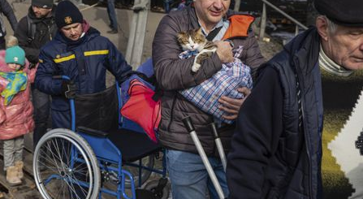

Photo credit: © Mikhail Palinchak. The image is from Irpin, Kyiv region. It was taken at the beginning of March, 2022

Our response to the war in Ukraine in objectives

Objective 1: Addressing the immediate needs of persons with disabilities
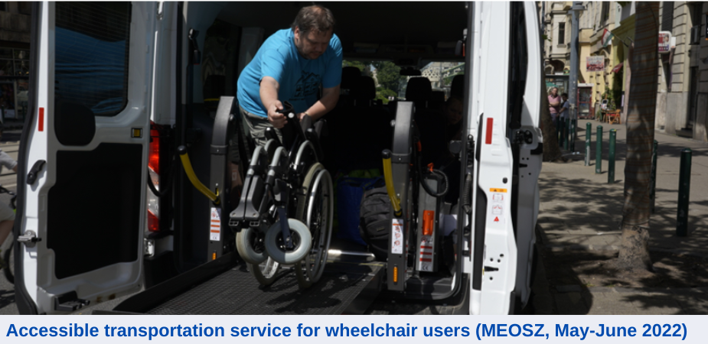

- Including, food and essential items;
- Accessible information and assistive technology;
- Accessible transport to and from shelters, borders and transit shelters.

Objective 2: Influencing the wider humanitarian response to make it disability-inclusive

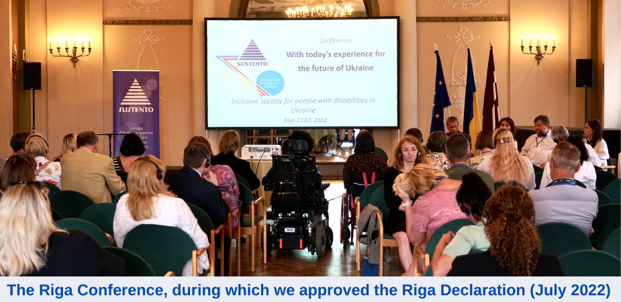
Advocating for disability inclusion in the work of larger humanitarian organisations, national governments and EU/UN agencies.

Objective 3: Strengthening the disability movement
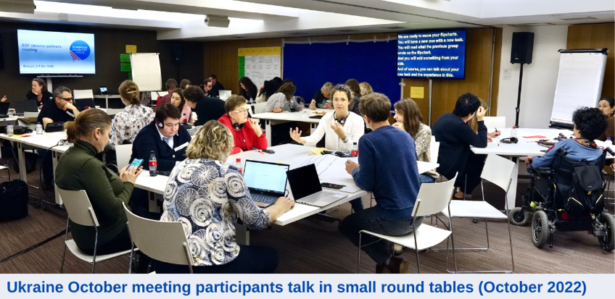

Including training, data gathering, and using our members’ expertise to promote disability inclusion within the wider humanitarian community.

Our partners

We are an organisation of persons with disabilities (DPO) implementing this work together with 12 other DPOs
Our partners are:

- Ukraine - National Assembly of Persons with Disabilities (NAPD) and the League of the Strong
- Latvia - Latvian Umbrella Body for Disability Organisations (SUSTENTO)
- Lithuania - Lithuanian Disability Forum (LDF)
- Poland - Polish Disability Forum (PFON)
- Slovakia - Slovak Disability Council (NROZP)
- Hungary - National Federation of Organisations of People with a Physical Disability (MEOSZ)
- Romania - Romanian National Disability Council (CNDR)
- Moldova - Motivatie, the Centre for the Rights of Persons with Disabilities (CDPD), the Society for Deaf Republic Moldova (ASRM), the Alliance of Organisations for Persons with Disabilities (AOPD)
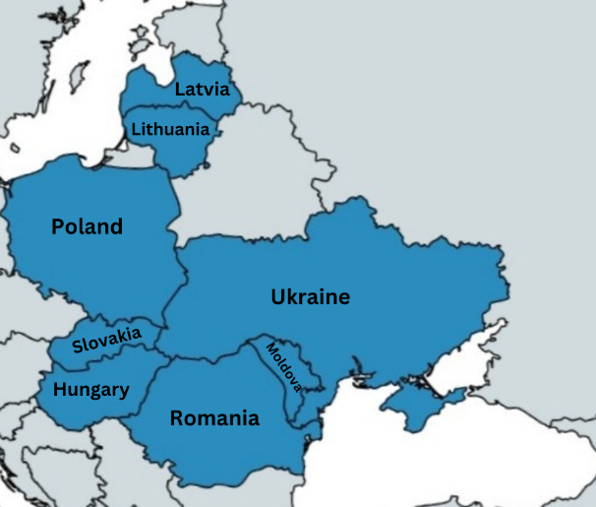
We work in eight countries to support Ukrainians with disabilities and their families who are in Ukraine but who also left the country

Our work in numbers

In seven months, the joint effort of EDF and its programme partners has reached 20422 people.
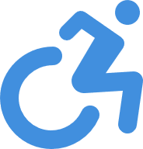
Disaggregated data is available for about 3720 of these:
65% are persons with disabilities
44% identify as female
15% are children
(under 18 years)

What we have done in the past seven months

Objective 1: Immediate needs

After the escalation of the war, EDF partners quickly started working in aid of Ukrainian asylum seekers and refugees with disabilities, addressing their immediate needs, including access to accommodation, health and other basic services. During the first phase of the project, the bulk of the activities have been focused on these direct interventions.
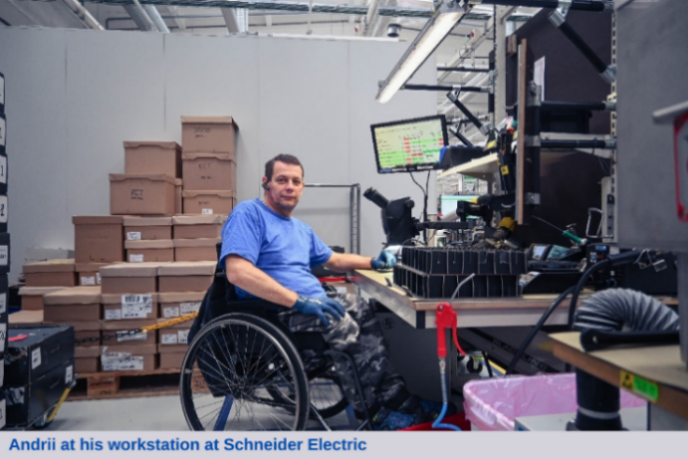
In Latvia, Poland, Hungary, Romania, Slovakia and Ukraine we cooperate with local organizations to address the immediate needs of persons with disabilities who fled Ukraine, including food, accessible accommodation and hygiene materials.

The activities are also planned to respond to their wellbeing and right to independent living. As examples:
- Language courses to facilitate integration and independence;
- Accessible transportation services across borders to reunite refugees with disabilities and their families who had spread because of the need to move quickly;
- Items to improve the quality of living of the in the temporary accommodation centres, including trampolines, books and materials to make them accessible to wheelchair users;
- Job search support and mentoring;
- Support to a transit centre for Ukrainian refugees with disabilities in Uzhhorod, Ukraine;
- Psychological assistance, counselling and integrated trauma release exercises;
- Individual assistance with legal and medical requests.
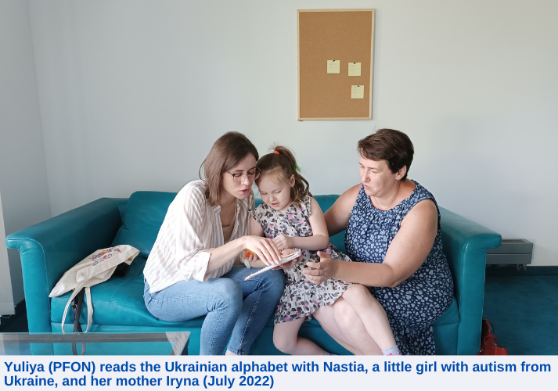
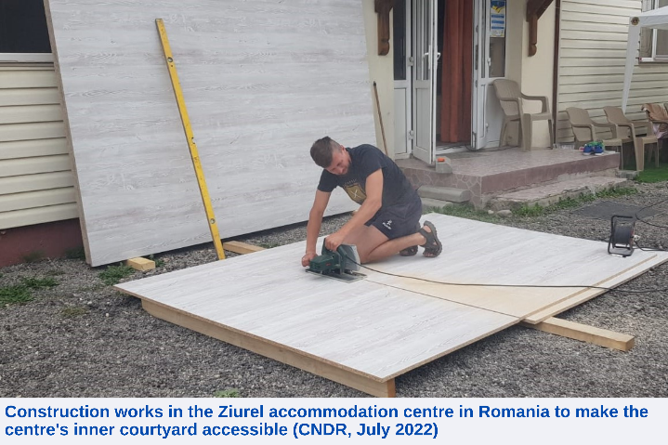
“Most of the times, what we are trying to do besides the humanitarian response is connecting with the people [we assist]”
Sorin Ţaţa, CNDR

Objective 2: Advocacy

In these past seven months we have also been very active in influencing government departments, larger humanitarian organisations and other international organisations including the European Union (EU) and United Nations (UN), to promote the meaningful participation and inclusion of persons with disabilities in planning and implementing their humanitarian response in Ukraine, as well as the reconstruction effort.
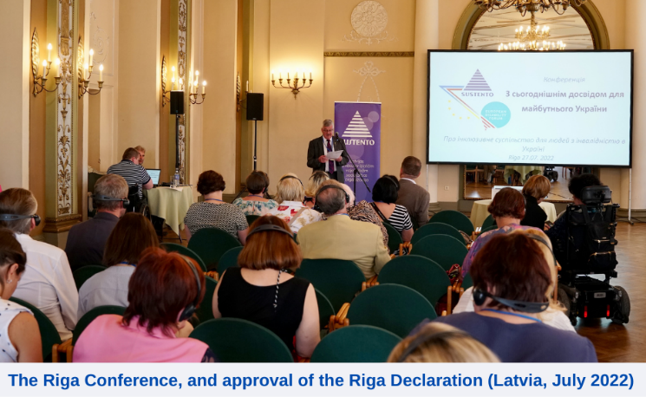

In July, with SUSTENTO, we ratified the Riga Declaration, a joint statement in which we define our basic requests to make the response and recovery process in Ukraine disability-inclusive, including:
- Meaningful participation of DPOs;
- Protection and access to evacuation for persons with disabilities;
- Accessibility as a key component of the reconstruction process
- Deinstitutionalisation inside and outside of Ukraine.
“[Ukraine's reconstruction] strategy must be underpinned by human rights and with full consultation of civil society, including meaningful participation of persons with disabilities through their representative organisations”
The Riga Declaration

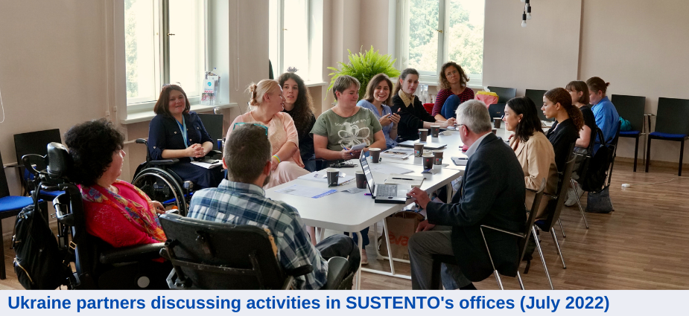
In August, together with our partners, we provided inputs for the Committee on the Rights of Persons with Disabilities (CRPD) special report on Ukraine. The report voices our concern for the situation of persons with disabilities in institutions in Ukraine, and provides recommendations on accessibility of shelter, evacuation and reconstruction; deinstitutionalization; meaningful consultation of persons with disabilities and DPOs in the humanitarian effort.
In response to the concerning situation of Ukrainian refugee children with disabilities, especially those evacuated from institutions, we are working to ensure key decision makers develop appropriate immediate and longer term strategies:
- We are disseminating four studies on children evacuated from institutions; with birth families; with foster families; and one report on international adoption and trafficking;
- we have developed a pilot programme with the Ukrainian government to assess and improve care of Ukrainian children in institutions in Poland;
- we have worked closely with the CRC and CRPD to achieve a joint statement about the children at the greatest risk.
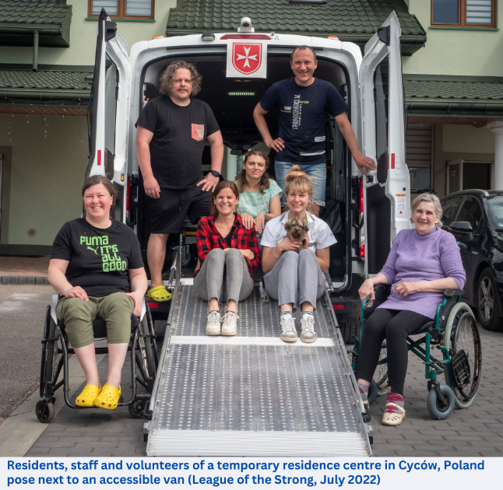
Our advocacy is also directed towards receiving countries’ governments and national-level actors: in Romania, Hungary and Slovakia, our partners are working with their national governments to make the humanitarian response, social assistance and temporary protection procedures inclusive of persons with disabilities.
In Ukraine we are strengthening the cooperation with local authorities and wider humanitarian community and advocating for more disability-inclusive relief and recovery strategies thanks to the work of our partners - the National Assembly of Persons with Disabilities (NAPD) and the League of the Strong. As examples of some of their work:
- The NAPD is involved in Ministerial working groups on disability, where they advocate amending the regulatory acts on cash-based assistance for persons with disabilities. They have already conducted a survey and developed a feasibility study on cash support.
- The League of the Strong works with the Ministry of Social Policy and is advocating for the accessibility of newly built accommodation for internally displaced people (IDPs) in Ukraine. They analysed 11 modular towns in 3 regions, that will host up to 3400 people.
- Both organisations are representing Ukrainian DPOs in the UN Age and Disability Technical Working Group.

Objective 3: The future of our programme

As we are entering phase two of the project, we will concentrate on the long-term goal of strengthening the disability movement.
This takes many forms but includes development of clear mid and long-term strategies, strengthening sustainable governance structures (human resources), building relationships between DPOs and government and non-government organisations, and identifying sources of funding. Several of our partners have already moved forward in this direction, and others have concrete plans to be put into action.
“[After the escalation of the war in Ukraine] we are talking more about accessibility, about the way new cities are made accessible to everyone, we are talking more about social services: people [with disabilities] do need social services, they do need support in the community to feel independent”
Gunta Anča, SUSTENTO

As an example, our partners in Lithuania, the Lithuanian Disability Forum, have already started their advocacy to make disaster risk reduction practices and regulations more disability-inclusive. From September, they started their training programme for professionals working with war refugees, that will result in the production of a response methodology for disaster situations that is mindful of the specific requirement of persons with disabilities.
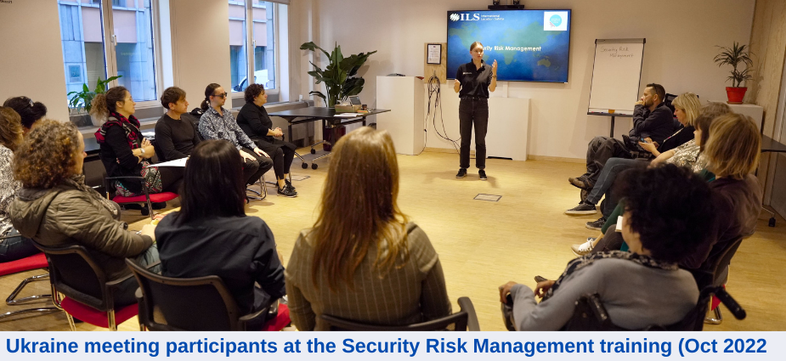
In September we have expanded our partnership to four DPOs in Moldova – together we will work to promote the participation of persons with disabilities in the country. The new projects will focus on building their leadership and capacity, removing the barriers to their access to humanitarian programmes, and advocating for disaggregated data on refugees from Ukraine to monitor their inclusion.

In October, EDF ran a one-week partners’ meeting in Brussels, where we hosted approximately 30 representatives from our members and partners in all eight countries working of this response. During these days, we attended trainings on personal safety awareness, security risk management and stress management, we met with representatives from for EU and UN agencies to discuss disability-inclusive response and reconstruction, and we exchanged our experiences, competences and lessons learnt in six months of Ukraine project.
One of the key benefits of this week, identified by participants, is that it brought them together, giving them time to discuss and identify future collaborations. We will take this message forward as fundamental in all our plans.

We thank CBM International for their
financial support
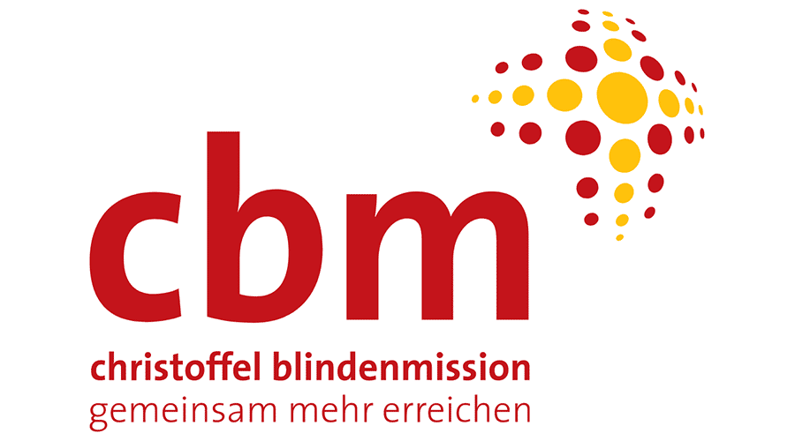

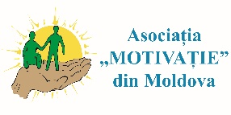
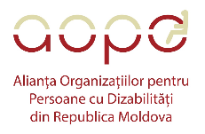
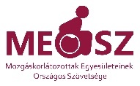
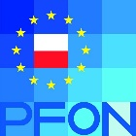
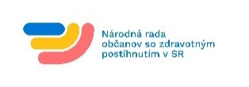
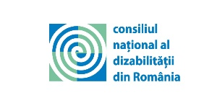

It is important to note that 1) methodology of identification of disability status varies between countries 2) numbers are still being checked and consolidated - where there is doubt, estimates are conservative, e.g. family size is not accounted for, although in many cases all family members will benefit from some interventions 3) these figures do not take into account people reached through advocacy work.

