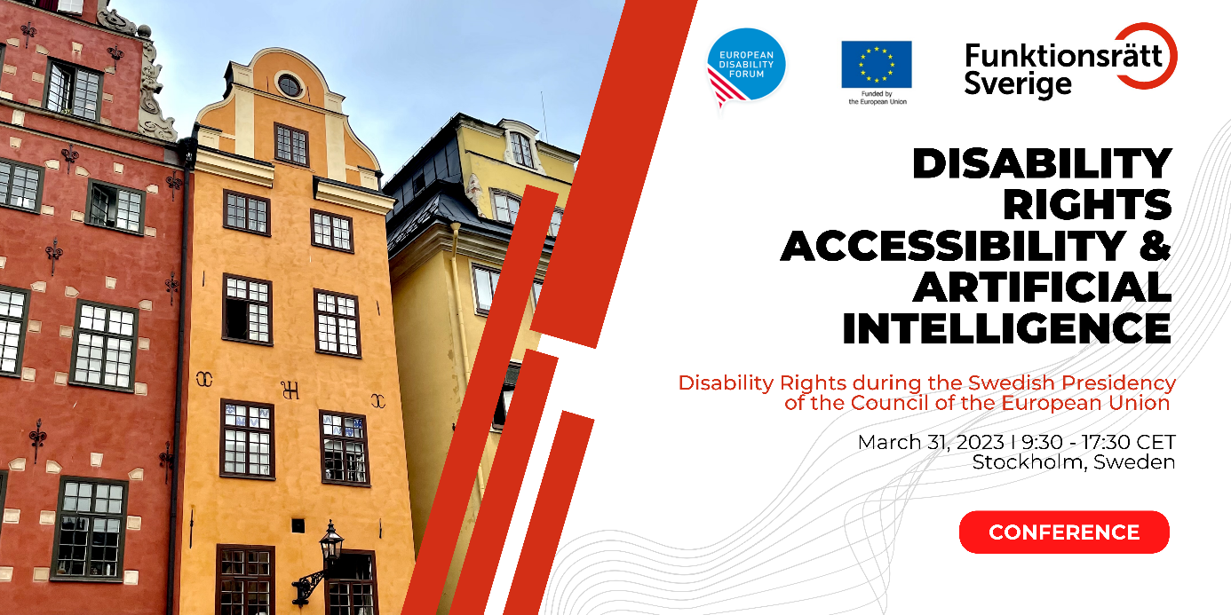

Introduction

Accessibility, is one of the general principles in the The United Nations Convention on the Rights of Persons with Disabilities (CRPD), ratified by 186 states, including every EU member state and the European Union. The strict application of Universal Design to all new technology, including Artificial Intelligence (AI), is needed to ensure full, equal, and unrestricted access for persons with disabilities in society.

Welcome to a conference hosted by the Swedish Disability Rights Federation (Funktionsrätt Sverige) in collaboration with the European Disability Forum on Disability Rights, Accessibility and Artificial Intelligence on March 31, 2023 at the Quality Hotel Globe in Stockholm or online. The hybrid conference will highlight equality and disability rights in current EU legislative and policy issues.

Draft Program

08:45 – 09:30 Registration of Participants

09:30 – 10:00 Official Opening of the Conference

- General Moderator: Lotta Håkansson, board member the Swedish Disability Rights Federation

- Helena Dalli (video)
EU Commissioner for Equality, European Commission
- Camilla Waltersson Grönvall,
Minister of Social Services, Sweden
- Nicklas Mårtensson
Director, Swedish Disability Rights Federation
- Pat Clarke
President, European Disability Forum

10:00 – 11:00 Disability Rights in Europe - the Way Forward

In this panel we will explore disability rights in Europe today and the European Disability Rights Strategy. The panel will also look ahead and discuss what the future of disability rights will look like in Europe and across the globe.

- Moderator: Fredrik Malmberg
Director, Swedish National Human Rights Institute
- Gerard Quinn (online)
Special Rapporteur on the Rights of Persons with Disabilities, United Nations
- Katarina Ivankovic-Knezevic
Director of DG Employment, Social Affairs & Inclusion, European Commission
- Abir Al-Sahlani
Member of the European Parliament, Sweden
- Alejandro Moledo
Deputy Director, European Disability Forum
11:00 – 11:30 Coffee Break

11:30 – 12:30 Accessible EU - Reaching Local Communities

In this panel we will discuss how the Accessible EU Center will work to assist member states to implement European accessibility regulations and fulfil obligations in relation to accessibility and universal design in the UN CRPD and how to improve the use of European funding for an inclusive society.

- Moderator: Humberto Insolera
Executive Committee Member, European Disability Forum
- Inmaculada Placencia Porrero
Senior Expert on Disability, European Commission
- Anna Quarnström
President, Disability Rights Stockholm City

- Jesús Hernández Galán (online)
Accessibility Director, ONCE Foundation

12:30 – 14:00 Lunch Break

14:00 – 14:50 Who Makes Decisions About your Life - the Human or the Algorithm?

In this panel we explore how digitalisation, Artificial Intelligence and automated decision-making has an impact on daily lives of persons with disabilities. We will hear from experts about ways to mitigate the risks for exclusion and discrimination.

- Moderators:
  - Catherine Naughton, Director, European Disability Forum
  - Elias Tebibel, Chair of the Youth Committee, European Disability Forum
- Jutta Treviranus (online)
Professor, Faculty of Design, OCAD University
- Gerard Quinn (online)
Special Rapporteur on the Rights of Persons with Disabilities, United Nations
- Kave Noori
Artificial Intelligence Officer, European Disability Forum

14:50 – 15:30 Coffee Break

15:30 – 16:30 Artificial Intelligence Act – Legal Protection of Rights

In this panel we will talk about how to ensure human rights, including disability rights, in the European Artificial Intelligence Act and offer appropriate tools for implementation of the legislation.

- Moderator: Stefan Larsson
Associate Professor in Technology and Social Change, Department of Technology and Society, Lund University
- Brando Benifei (video)
Member of the European Parliament, Italy
- Karolina Iwanska (online)
Digital Civic Space Advisor, European Center for Not-For-Profit Law ECNL

- Maureen Piggot
Executive Committee member, European Disability Forum
16:30 – 16:45 Break

16:45 – 17:15 Sustainable Artificial Intelligence – Leaving No One Behind

This session will focus on concrete tools for inclusive design of users at risk of exclusion in development of Artificial Intelligence and emerging technologies.

- Stefan Larsson
Associate Professor in Technology and Social Change, Department of Technology and Society, Lund University
- Anna Felländer
Founder and CEO, anch.AI
- Jutta Treviranus (online)
Professor, Faculty of Design, OCAD University
17:15 – 17:30 Conclusion & Closing Session

European Disability Forum- Resolution

- Gunta Anca
Vice-president, European Disability Forum
Closing Speech

- Nora Bednarski
Cabinet member for European Commissioner for Equality
Conference hashtag
#InclusiveAI

Conference Sponsors

The Swedish Disability Rights Federation and the European Disability Forum thanks the funders for supporting the 2023 Disability Rights, Accessibility and Artificial Intelligence conference.

- The European Commission
- The Ministry of Health and Social Affairs (Swedish: Socialdepartementet)
- The Swedish Post and Telecom Authority

