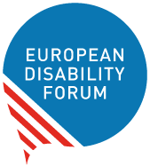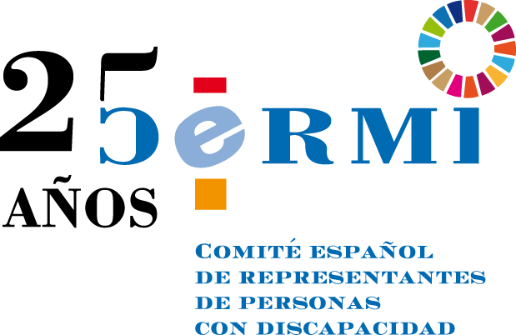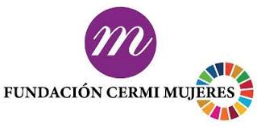
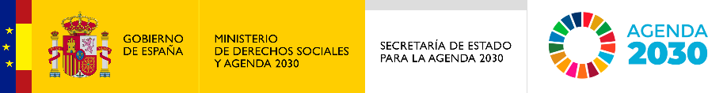

Report of the online conference

#OurFuture of and on women and girls with disabilities

Contents
Summary 1
Presentations and discussions 1
Current state of play for women and girls with disabilities in Europe 2
Reflecting on the inclusion of women and girls with disabilities in the European movement and #OurFuture 4
Recommendations for #OurFuture 5
About us 5
Contact 6

Summary
This online conference was organised by the European Disability Forum, CERMI and CERMI Women’s Foundation on 22nd of April 2022. It was designed to feed into the Conference on the Future of Europe and EDF’s work on the rights of women and girls with disabilities in light of the 25th year anniversary of the organisations.
The conference gathered 93 participants, and speakers from the European Parliament, the European Institute on Gender Equality and the disability and feminist movement. It offered a platform to organisations of persons with disabilities, women with disabilities and women providing support to relatives with disabilities to interact with policy-makers, and raise their concerns to contribute to the future of Europe.

Presentations and discussions
The webinar was conducted and moderated by Ana Peláez Narváez, EDF Vice-President, with the support of Marine Uldry, EDF Human Rights Officer.
The conference started with a video message from EDF President, Yannis Vardakastanis. Explaining the exclusion still faced by women and girls with disabilities, he stressed the importance to ensuring their participation in public debates, including in the development of laws, policies and initiatives at all levels. He explained that women’s rights and gender equality are at the core of the work of EDF and that the organisation is renewing its commitment to the rights of women and girls with disabilities in all their diversity in light of EDF’s 25th anniversary. He invited participants to share their issues and recommendations during and after the conference.

Current state of play for women and girls with disabilities in Europe
The first part of the conference focused on the state of play for women and girls with disabilities in Europe. Three speakers were invited to give their takes on the current situation:
- Gunta Anca, European Disability Forum Executive
- Katrin Langensiepen, Member of the European Parliament, Vice-Chair of Committee on Employment and Social Affairs and Chair of the Disability Intergroup
- Dr.Jolanta Reingarde, EIGE Senior researcher, Research and Statistics team leader, European Institute for Gender Equality (EIGE)

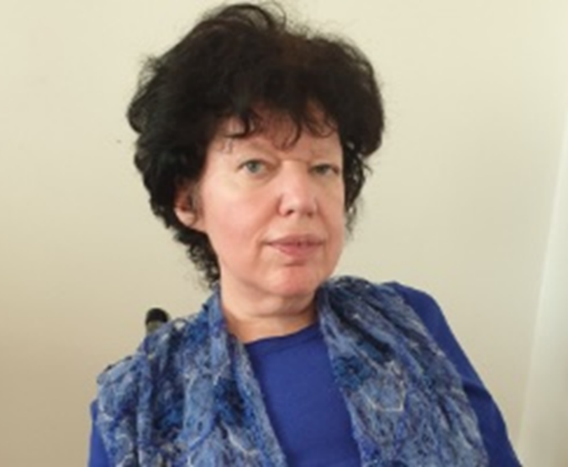
Representing the disability movement, Gunta Anca gave an overview of the multitude of human rights violations still faced by women and girls with disabilities across Europe, from violence to discrimination, unemployment and poverty. “There is no one country where we can say they don’t face discrimination comparing to men with disabilities and women without disabilities” she explained. She also reflected on the progresses made in the past 25 years, highlighting the role of EDF to ensure the representation of women with disabilities in the disability movement. She gave as example the first manifesto on women with disabilities adopted by EDF in 1997, with a second manifesto adopted in 2011 (noting that a third manifesto would be adopted by EDF next year). She ended her presentation by stressing the importance to continue to advocate, work with policy makers and make the disability and women’s movements more inclusive and accessible – taking as example the crucial advocacy work related to the proposal of a directive on combating violence against women and domestic violence to ensure it benefits women and girls with disabilities.
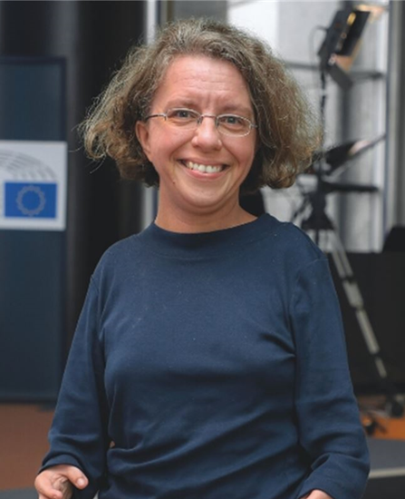
MEP Katrin Langensiepen addressed the work and role of the European Parliament in the advancement of the rights of women and girls with disabilities. She explained that before, she was the only woman MEP with a visible disability in the European Parliament and that representation stays very low. She explained that it is a shame for the political system and that more role models are needed. She talked about her role in ensuring the proposed legislation and policies being examined by the European Parliament are inclusive of persons with disabilities, mentioning for example the Pay Transparency Directive and the Minimum Wage Directive that is important also to ensure that persons with disabilities, women with disabilities, get equal salaries. She also mentioned the importance of the upcoming discussion on the proposed Directive on violence against women, that will be crucial for women and girls with disabilities. She also talked about allyship with civil society organisations, including organisations of persons with disabilities and women with disabilities, which is very important for the work of the European Parliament.
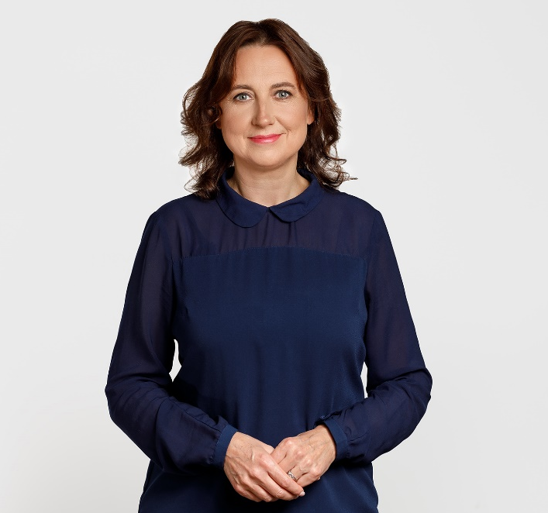
Dr.Jolanta Reingarde presented the work of the European Institute on Gender Equality (EIGE). She explained that EIGE continues to reveal the complex intersections of inequalities and many different experiences of women and men, by applying the intersectional approach in all studies of the Institute, giving as example the Gender Equality Index that provides disaggregated information by disability in all EU Member States on a variety of topics such as employment, health and money. “While all people with disabilities are more likely to live in poverty, women with disabilities are likely to be poorer than men with disabilities, are less likely to be employed, and (in general) to have lower income from employment”, she said. She also highlighted the situation of carers, in particular women including those with disabilities. The Gender Equality Index shows that women do the bulk of the cooking, household tasks and care work. Women with disabilities are engaged in everyday household tasks two times more than men (79 % do housework every day, compared to 41 % of men with disabilities). She also highlighted that data also show that disability substantially increases women’s vulnerability to violence, especially from a close or intimate partner and in institutions. FRA’s violence against women survey shows that about a third of women with disabilities (34 %) suffered from intimate partner violence, compared to 19 % of women without a disability. She ended her intervention by emphasising the need to collect more data in areas, which traditionally fall outside the mainstream policy areas, such as data on gender relations in the private sphere (unpaid care, intimate partner violence, power relations in the family, including income and decision-making sharing in the family) or data on disadvantaged groups in traditional policy areas.

Reflecting on the inclusion of women and girls with disabilities in the European movement and #OurFuture
The rountable discussion involving representatives of organisations of women with disabilities and of persons with disabilities started with the intervention of the Executive Director of CERMI, Pilar Villarino, from Spain. She recalled the lack of visibility of women and girls with disabilities, as well as caregivers, in the European disability policy agenda, and therefore in European public policies. She however explained that thanks to EDF and the Women’s Committee, many progresses happened but there is not yet a full inclusion and consideration. She, for example, explained that women are little referred to in the activities of the Conference of the Future of Europe, and women with disabilities are not considered at all. She referred to a political document submitted to the Conference on the future of Europe entitled “Europe: building inclusion”, where all the demands of CERMI for the conference are collected and which is available on CERMI's website.
From France, Claire Desaint, representing the organisation Femmes Pour le Dire, Femmes pour Agir, reiterated the invisibility faced by women and girls with disabilities and repeated the needs of data and statistics. She has also highlighted the complicated situation of women with disabilities in France in relation to employment, as well as financial autonomy (as the AAH disability allowance is linked to the partner's income, and despite the unanimous request, the government did not want to deconjugate it). Other issues that she mentioned were related to violence, access to justice and access to healthcare.
From Greece, Antonia Pavli representing the National Confederation of Disabled People shared the challenges faced by women in that country and denounced, among others, the lack of official data. “There are no quantitative or qualitative data; and without them, adequate policies cannot be created to combat it”, she said indicated.
The Croatian Union of Associations of Persons with Disabilities (SOIH), represented by Marica Miric, showed the activity carried out by herorganisationto defend for the rights of women with disabilities in Croatia. Likewise, sheindicated the challenges women and girls with disabilities face in her country and in Europe, as well as recommendations that allow them to protect and work for the empowerment of women with disabilities.
The statement of Luisa Bosisio, from the Italian Disability Forum, was read by EDF Secretariat. She explained that in the last decade Italian women have increased awareness of their situation. However, sheinsisted on the need to work on the collection of disaggregated data because "when they are not collected data, situations of discrimination are not detected and are not eliminated”.
Finally, the organisation Feminists against Ableism, from the Netherlands, represented by Jacquies Davis reflectedon misogyny and transphobia, asking for their future to be inclusive and accessible.
At the end, the coordinator of the CERMI Mujeres Fundacion, Isabel Caballero, shared the main conclusions of her organisation. Among them, she also urged to have official data to carry out suitable public policies and to work so that the future European directive on violence takes into consideration the demands of women with disabilities, with special attention to non-consensual sterilisation being considered as a form of violence against women.

Recommendations for #OurFuture
Based on the intervention of the speakers and participants, 3 recommendations for the Future of Europe for the EU and its Member States are to:
- Adopt stronger legislation and policies on combating gender-based violence, including violence against women and girls with disabilities; including through the adoption of the proposed legislation on combating violence against women and domestic violence and the ratification of the Istanbul Convention by the EU and all its Member States
- Enhance the participation of women with disabilities in political and public life, ensuring they have the opportunity to participate in public dialogues; and are encouraged and supported to do so
- Collect disaggregated data on the situation of women and girls with disabilities in all areas of life, including violence, access to justice and access to healthcare services

About us
The European Disability Forum (EDF) is an umbrella organisation of persons with disabilities that defends the interests of over 100 million persons with disabilities in Europe. Run by persons with disabilities and their families, EDF is a strong united voice of persons with disabilities in Europe.
The CERMI Women’s Foundation is a non-profit organisation whose main objective is to favor the conditions for women and girls with disabilities, as well as women and mothers who assist persons with disabilities, to enjoy fully and on equal terms all the human rights and fundamental freedoms.

Contact
For information or question on content, please contact Marine Uldry, EDF Senior Human Rights Officer: marine.uldry@edf-feph.org.

