


Recommendations on the integration of accessibility and universal design in higher education curricula.

Funded by the European Union. Views and opinions expressed are however those of the author(s) only and do not necessarily reflect those of the European Union or the European Education and Culture Executive Agency (EACEA). Neither the European Union nor EACEA can be held responsible for them.

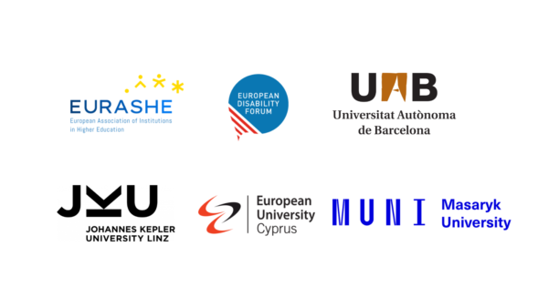

ATHENA Project: Bringing Accessibility and Universal Design into Higher Education Curricula

This document provides recommendations to integrate Accessibility and Universal Design into Higher Education (HE) curricula. Different sets of recommendations have been developed targeting different stakeholders: policymakers, quality agencies, educational leaders, programme creators, instructors, and user representatives. These recommendations aim to ensure that Accessibility and Universal Design become an integral part of HE.

The proposals address legal frameworks, financial support, curriculum design, staff training, and student learning outcomes, promoting inclusivity across various fields of knowledge. Specific strategies for programme creators and instructors are provided, alongside suggested learning outcomes tailored to diverse academic disciplines.

Defining Universal Design and Accessibility

- The project defines ‘Universal Design’ as the creation of products and environments that can be used by all to the greatest extent possible, without requiring specialised adaptations.

- ‘Accessibility’ is understood as the removal of barriers to ensure equal access for individuals with disabilities to environments, goods, and services.

To policy makers and governments

- Include Accessibility and Universal Design training as legal requirements for any HE curricula.

- Create national accessibility advisory committees for higher education that include representatives from universities, industry, organisations of people with disabilities, and accessibility experts. These committees should provide ongoing guidance on integrating Accessibility and Universal Design into curricula and monitoring implementation progress.

- Include Accessibility and Universal Design in the Guideline to Environmental, Social and Governance (ESG) standard 1.2 (Design and approval of programmes).

- Establish recognition programmes that highlight excellence in accessibility education, such as awards for innovative teaching methods or successful curriculum integration. These programmes can incentivise institutions to prioritise Accessibility and Universal Design principles in education and share best practices.

- Provide financial resources to include Accessibility and Universal Design in HE curricula and to implement such curricula.

- Develop frameworks for international cooperation in accessibility education, facilitating knowledge exchange between institutions and countries. This could include funding for students and faculty mobility programmes focused on accessibility studies.

To educational leaders

- Promote initiatives aimed to raise awareness about Accessibility and Universal Design, involving diverse stakeholders such as organisation of persons with disabilities, accessibility experts, and disability rights advocates.

- Embed Accessibility and Universal Design in the university policies, procedures, and strategic plans.

- Embed Accessibility and Universal Design in the university policies, procedures, and strategic plans.

To quality agencies and accreditation bodies

- Include the integration of Accessibility and Universal Design in curricula as a mandatory requirement for the approval of HE programmes.

- Establish specific metrics to evaluate the effectiveness of accessibility and universal design integration in HE curricula, including both quantitative and qualitative measures. These metrics should assess not only the presence of accessibility content but also its impact on student learning outcomes.

- Require regular accessibility audits that examine both the content and the teaching methods.

- Create specialised accreditation pathways for accessibility-focused programmes and courses, similar to existing specialised accreditations in other fields.

- Make clear what the expectations are with regards to integrate Accessibility and Universal Design in HE programmes.

To programme creators

- Include Accessibility and Universal Design principles across all fields of knowledge, raising awareness about key concepts, user needs, and solutions.

- Integrate Accessibility and Universal Design into all aspects of programmes design, from learning objectives to assessment methods, rather than treating it as an add-on component.

- Develop modular Accessibility and Universal Design content that can be adapted for different disciplines while maintaining core principles and standards.

- Develop interdisciplinary collaboration on Accessibility and Universal Design projects, helping students understand how different fields contribute to comprehensive accessibility solutions.

- Include diverse range of stakeholders (e.g., Organisations of People with Disabilities, student organisations, accessibility experts) in the design, implementation and evaluation of HE programmes.

To instructors

- Take part in training programmes on Accessibility and Universal Design aimed at HE instructors.

- Include the concept and principles of Accessibility and Universal Design in the training activities and materials as well as in the curriculum.

- Ensure that your course delivery is accessible and inclusive for students with disabilities, so you implement a ‘teach by example’ approach.

- Incorporate regular feedback from students with disabilities to improve course content.

- Create communities of practice where instructors can share experiences, resources, and strategies for teaching Accessibility and Universal Design concepts.

To stakeholders (such as user representatives and employers)

- Work with local institutions to enrich professional field committees and similar bodies by including advocates for accessibility and representatives from diverse communities.

- Get involved in designing, implementing, and evaluating HE curricula.

- Establish connections with educational leaders and programme creators. For instance, invite them for events you organise or ask for opportunities as guest lecturer.

- Provide opportunities for student internships and practical training in Accessibility and Universal Design implementation.

- Contribute to developing case studies and real-world examples that can be used in teaching.

ATHENA Partners
Authors: Marta Brescia Zapata, Anna Matamala
Co-authors: Reinhard Koutny, Roberta Lulli, Katerina Mavrou, Katrin Nuppenau, Radek Pavlíček, Matilde Revelli, Eleni Theodorou.
Accessibility check: Roberta Lulli
Graphic Design: EURASHE


Co-funded by the European Union. Views and opinions expressed are however those of the author(s) only and do not necessarily reflect those of the European Union or the European Education and Culture Executive Agency (EACEA). Neither the European Union nor EACEA can be held responsible for them.
