Toolkit: Accessible PowerPoints

This toolkit was originally developed by Roberta Lulli, EDF Digital Accessibility Trainer on the VIVID-T Project and represents a collaboration with many partners.

This publication has received financial support of Interreg: European Territorial Co-operation of the European Union. The information contained in this publication does not necessarily reflect the official position of the European Commission.

Introduction
Accessible PowerPoint means that your entire audience is going to be able to fully engage with it and learn from the content you are creating.
- Not create them for you but for your audience
- PowerPoint slides are not notecards
They are not for you at all. They are for your audience!

Make your check list!

Is my PowerPoint accessible to all people who might use it?

The following list includes the important elements and actions you should consider when you create PowerPoint presentations.
- Organise your content and make it accessible
- Consider slide design/layout templates
- Fonts and size fonts
- Check Colour contrast
- Meaningful Hyperlink
- Images, tables and charts with AL TEXT
- Use Accessibility checker

Accessible content
The slides are a supplement to your speech, not a transcript.
Less is more!
- Do not overcrowd your slides with text
- Highlight ‘bullet’ points
- Use clear and concise language
- Support text with images
- Copy all text into the notes below

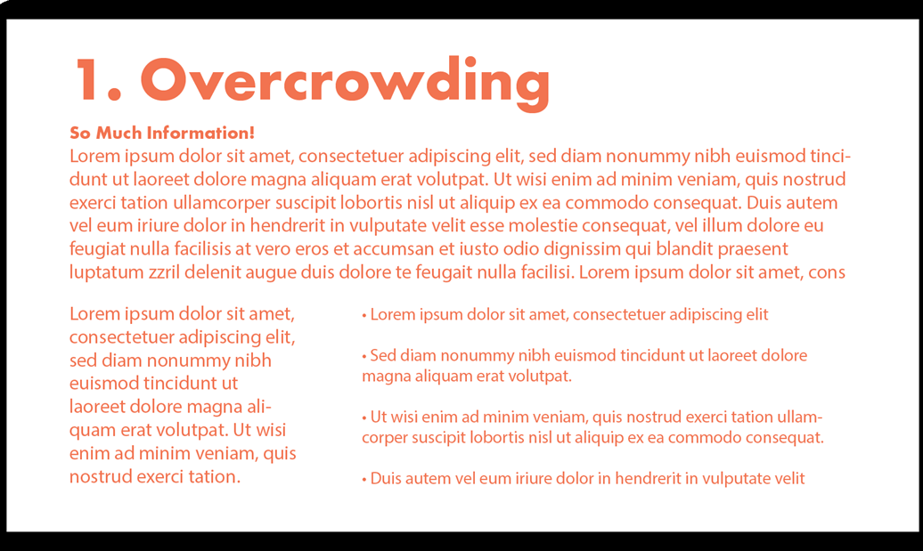

Did you know… Sharing slides in advance with your audience is very important. They can use them for:
- Preparatory reading
- Printed handouts
- Preload slides on laptop
- Preparation of Sign Language Interpreter and Captioning

Slide’s design and structure
The correct slide layout is probably the most significant step that can be taken to ensure that the slideshow will be accessible.
- Pre-set layouts on PowerPoint are designed with accessibility in mind. They are pre-approved for screen readers and can be easily navigated.
- There is no need to create a custom template when there are
already many to choose from.

Accessible Layout

To use a pre-set slide layout, in the Home tab, choose New Slide, then pick one of the layouts that makes sense for that slide.

Home tab> New slide >
Title and content
(Placeholders)

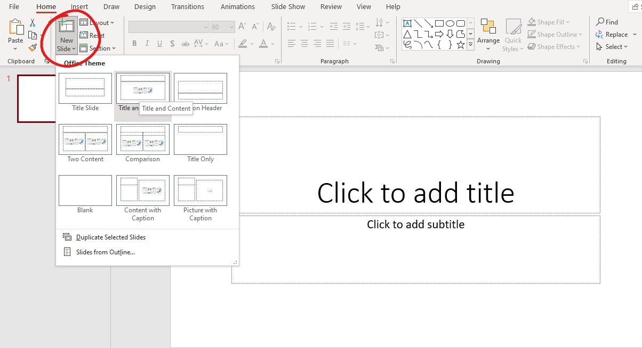

Titles and Content Placeholders

Slide titles provide heading structure. They are essential for screen reader users to navigate the slides and find the information they need.
- Each slide should have a unique title
- Avoid duplicates titles
- If multiple slides refer to the same topic, add Title 1. Title 2.
- Single text Placeholders per slide makes content more compatible with external software.

Use Outline View

To ensure that the Title and body text are identified correctly in each slide check the Outline view.
View > Outline view
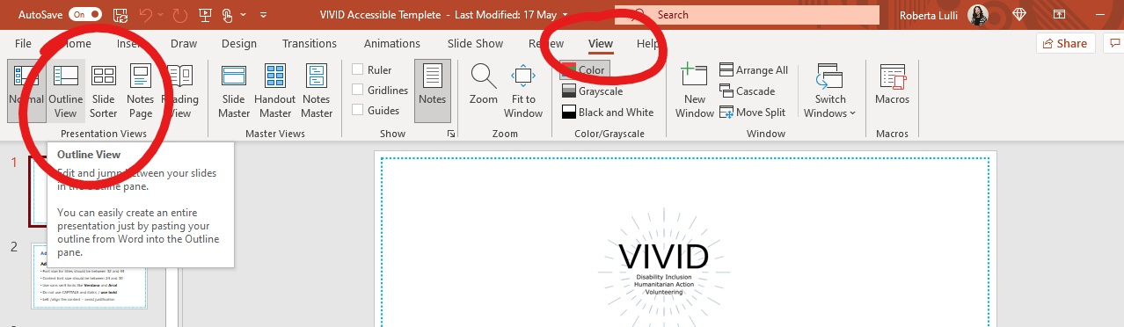
- Outline view showing only title and text
- The screen reader will follow this reading order
- Text can also be changed directly in the Outline view
- Any text not in pre-existing Content Placeholders will not appear in the Outline view.

Accessible Styles
- Font size for titles should be between 32 and 44
- Content font size should be between 24 and 30
- Use sans serif fonts like Verdana and Arial
- Do not use CAPITALS and italics / use bold
- Avoid abbreviations and acronyms
- Left /align the content – avoid justified text

Animations and Transitions
- Limit the use of animation and transitions
- They can be distracting to the reader
- Screen reader might get confused and re/read animated text
- Can read parts of the slide out of order
- Animations and transitions can go too quickly

Check colour contrast
- Provide sufficient colour contrast on all of the slides
- Simple background allows high contrast differentiation with the text making it easier to read
- Text and background colours have a contrast ratio of at least 4.5:1
- Use a free colour contrast analyser. This is software that measures whether the contrast is adequate for people with colour-blindness.

Images and Alt Text
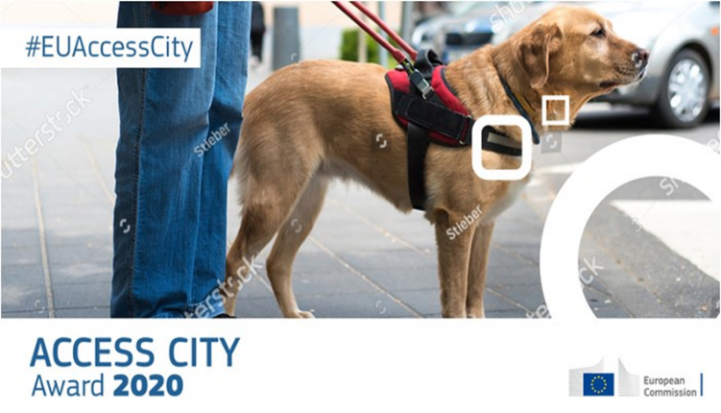
Add the Alternative Text (including text in the image) and copy it into the notes.
- Do not overlap the image with other elements
- Verbally describe all meaningful visual content

Do not confuse the audience!

- Use relevant images that fit the context of the slide and caption them if necessary.
- This is a photo of a Quiz about nature and agriculture added to show how confusing images can be without context.
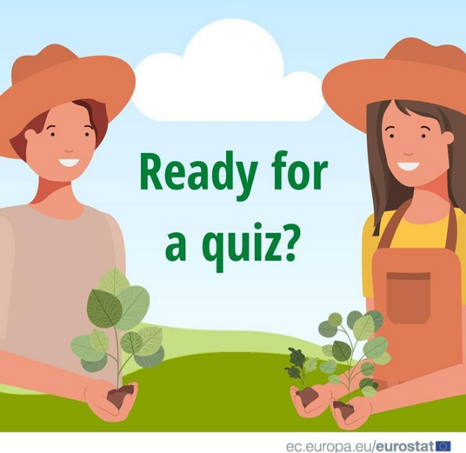

Statistics and tables
Good to use statistics and tables to transmit information and numbers.
- Avoid complicated data tables and charts
- Keep them as simple as possible
- Add links to more information
- Verbally transmitting the information when you present them
- For every chart, map, or table write alternative text

Statistics and tables example

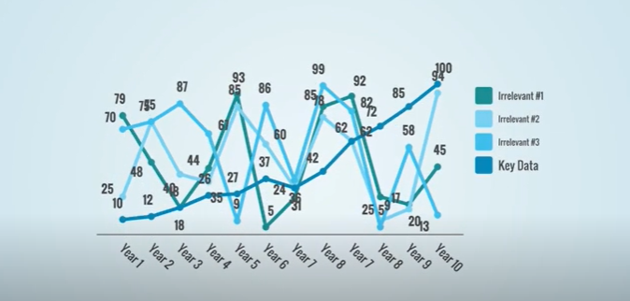

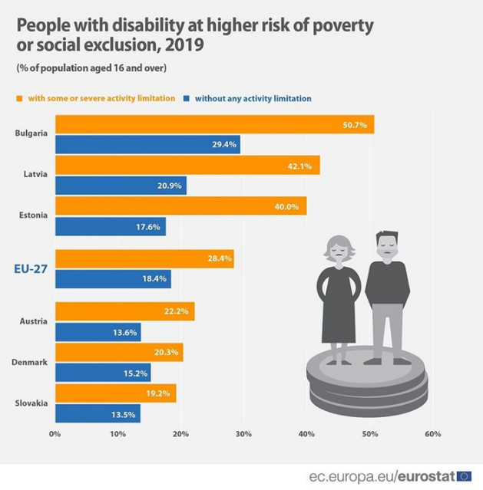

Meaningful Hyperlink Text
✔ Text link should be descriptive and meaningful
✔ Keep it concise and clear
✔ Should be visual distinct (blue and underlined)
✖ Avoid words: Click here; Read more; Learn more, More info
✖ Avoid the word “Link” in your link and naked URL:

- Link to https://www.edf-feph.org/
- Do not capitalize links: WWW.EDF-FEPH.ORG

Example of hyperlinks

Not accessible ✖ Click here for a EDF article on accessible links
Accessible ✔ EDF’s article on accessible links

Not Accessible ✖ Read more about accessible link requirements:
https://www.w3.org/WAI/WCAG21/quickref/#link-purpose-in-context
Accessible ✔ WCAG accessible link requirements

Not Accessible ✖ EDF's website has tips for writing good headings
Accessible ✔ EDF’s website has tips for writing good headings
(Here it is better to link the last part).

Use the Accessibility Checker
PowerPoint has a built-in accessibility feature that you can find under the Review tab >Accessibility Checker.
It will highlight elements including:
- Missing alternative text for images
- Missing slide titles
- The reading order of the elements for screen readers

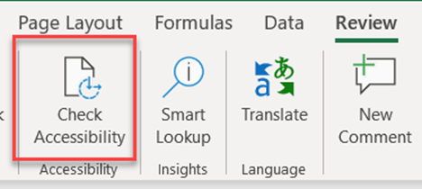

Keyboard Shortcuts
Keyboard shortcuts are keys or combinations of keys that provide an alternative way to do something that you'd typically do with a mouse.
Not all people are using a mouse to work with their computer. It is important that what they make is operable with a keyboard.
Important: Shortcuts may be different from language to language.

Shortcuts in PowerPoint
Create a new presentation: press Ctrl + N
Save a presentation: press Ctrl + S
Play the presentation from the start: press F5
Play the presentation from the current slide: press Shift + F5

Supporting Resources
- How to create accessible PowerPoints by Perkins School for the Blind
- Digital Accessibility Toolkit by CBM
- Make your PowerPoint presentations accessible to people with disabilities by Microsoft Office
- Creating and delivering PowerPoint Presentations, By Ahead
- How to Make Your Presentations Accessible to All, by W3C
- WebAIM contrast checker for testing text colors for accessibility.
- Contrast checker based on Web Content Accessibility Guideline.
- 10 Tips for choosing accessible fonts, by FontSmith
- Effective Alternative Text by WebAIM
- WebAIM contrast checker for testing text colors for accessibility.
- Contrast checker based on Web Content Accessibility Guideline.
- Color Oracle a colour blindness simulator.
- Fonts readability by WebAIM

The European Disability Forum
Avenue des Arts 7-8
1210 Brussels, Belgium.
www.edf-feph.org
info@edf-feph.org

