End the nightmare:
Passengers with disabilities deserve to travel by air
European Disability Forum’s call for the EU’s revision of its passenger rights’ legislation to end the repeated violations of the rights of travellers with disabilities, especially during air travel.

End the nightmare:
Passengers with disabilities deserve to travel by air
European Disability Forum’s call for the EU’s revision of its passenger rights’ legislation to end the repeated violations of the rights of travellers with disabilities, especially during air travel.

European Disability Forum
Nothing About Us Without Us
More at: edf-feph.org/transport

European Disability Forum
Nothing About Us Without Us
More at: edf-feph.org/transport

Index

Introduction 2
Our demands 3
Illustrative stories 4
Denial of boarding – Air travel 5
Damaged or destroyed assistive equipment 8
Obligation to travel with an accompanying person 10
Lack of quality assistance 11

Introduction

The European Disability Forum – the umbrella organisation of persons with disabilities that defends the interests of over 100 million persons with disabilities in Europe – renews its demands for EU legislation to better protect passengers with disabilities – especially when travelling by air.

Air travel is by far the transportation mode in which persons with disabilities experience the most difficulties and human rights violations: compared to the legislation covering other modes, the current regulation protecting the rights of passengers travelling by air is incomplete.

We call for strong legislation that eradicates denial of boarding for “safety reasons” related to their disabilities - still very present in all transport modes, especially in air travel.

Additionally, if they get to travel, persons with disabilities face other disproportionate obstacles: damaged and destroyed mobility equipment and assistive devices (wheelchairs, oxygen bottles, etc); assistance not showing up; lack of multimodal connections; and inaccessible infrastructure among other reasons.

Our demands

We call on the European Commission to revise regulation (EC) No 1107/2006 on the rights of disabled persons and persons with reduced mobility when travelling by air as part of their upcoming revision of passenger rights’ regulations, in order to:

- Eradicate the common cases of denial of boarding that still happen to persons with disabilities;
- Introduce the right to a swift and fair compensation if the air carrier still denies boarding;
- Oblige the air carrier to provide a ticket free of charge if they request an accompanying person (as it is the case in other transport modes)

The European Commission should also establish the companies’ full liability for damaged and lost mobility equipment, which often costs tens of thousands of euros and that under the current regulation is only classified as luggage. We ask the European to Commission to include this provision in the aforementioned regulation or in other appropriate regulations.

Additionally, we call on the European Commission to ensure that the set of revisions to Passengers’ Rights Regulations includes:

- Enhanced Enforcement, including automatic reimbursement for denied boarding in all transport modes;
- That National Enforcement Bodies have increased powers, including power to prosecute;
- That a single point of contact to arrange assistance on multimodal transport is established;

Illustrative stories

The complaints listed below have been collected to illustrate how persons with disabilities still have their rights violated on a regular basis when travelling by air.

Their stories highlight only a part of the numerous obstacles that persons with disabilities face while travelling. They show how these are a consequence of loopholes and grey areas in the regulation on the rights of passengers.

Much of the discrimination faced by passengers with disabilities is in fact due to a lack of specifics in the current legislation on what qualifies as legitimate and justified safety reasons to deny boarding and the requirements for the mobility devices that can be carried on board.

Revising regulations to ensure clear principles and requirements would avoid the problems and serious disruption to the lives of travellers with disabilities created by the different policies that European air carriers and service companies apply to similar circumstances. Similarly, ensuring that national enforcement bodies have standard resources, powers and competencies will improve their right to seek redress.

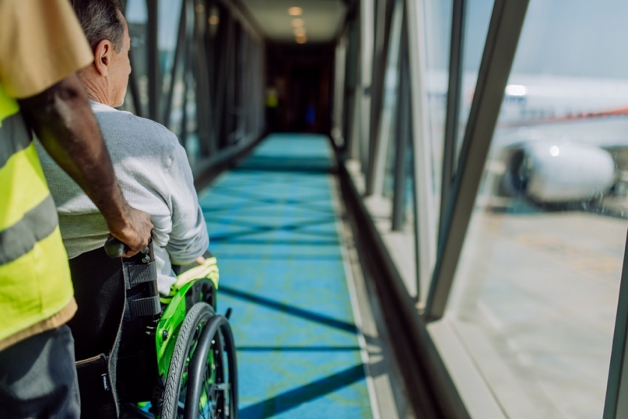
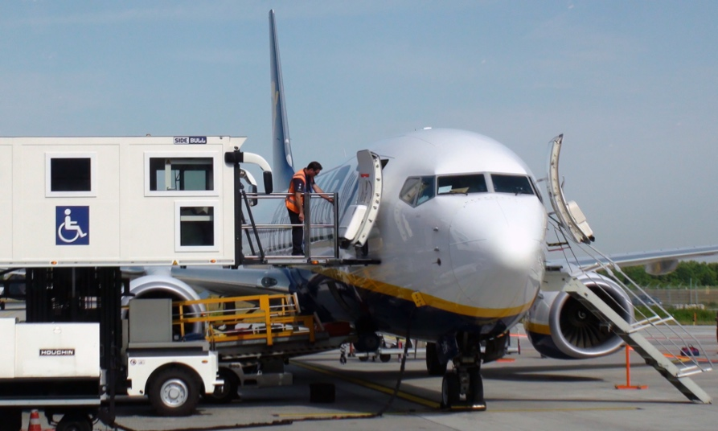

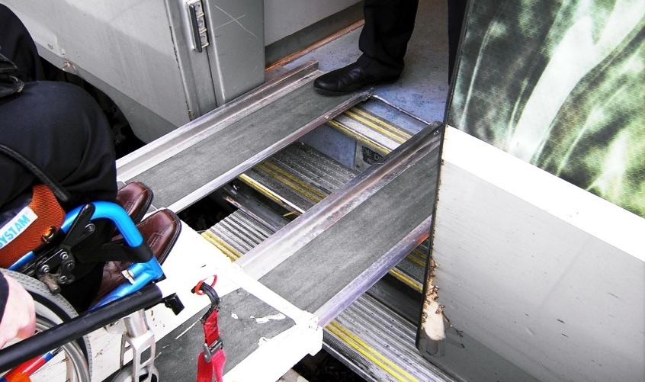
Denial of boarding – Air travel

Passengers travelling with a mobility device or assistance dogs need to notify the airline in advance to ensure that they can be transported onboard (cabin or hold). However, safety rules applied by airlines vary significantly, and they are often difficult to find and interpret (in particular those related to the transport of batteries, electric wheelchairs and oxygen), which can result in passengers with disabilities being denied boarding.

A complaint we received from a frequent flyer who is a wheelchair user is a clear example of the issue: he explained that with companies like Brussels Airlines his wheelchair is allowed on board of Airbus321 planes or even smaller models, like Airbus 319 planes. However, when booking a trip with a different company on an Airbus321, he was told that his wheelchair could not be loaded, as it exceeded the maximum set height of 100cm.

Denial of boarding due to refusal of guide dog
Netherlands to Zambia (Qatar/Emirates Airline)

“I have been trying to book a flight with my internationally accredited assistance dog from Amsterdam to Lusaka (for work) and both Qatar and Emirates refuse to take us. They say that Zambia doesn’t allow assistance dogs in cabin. Which is not the case as I can fly with Kenya air. The two airlines are willing to take my on the first flight. This episode shows the loopholes in the EU legislation.”
EDF Accessibility Discrimination database, 13 April 2022

Denial of boarding due to refusal of guide dog
Spain (Ryanair)
“Pedro Esquiva, along with his guide dog and his partner, traveled on July 16 from Madrid to Mallorca to enjoy a few days of vacation. They arrived with Iberia, but the return, on July 19, was scheduled with Ryanair. This visually impaired passenger was vetoed from entering the plane because “my dog’s vaccination record was not at hand, despite the fact that the law allows travel on domestic flights without requiring this documentation.”

EDF Accessibility Discrimination database, 16 July 2020
Pedro Esquiva, 23 July 2020, Ultima Hora (News article in Spanish)

Denial of boarding due to wheelchair use
Greece to Israel (EL AI)
“I was flying from Athens to Tel Aviv, the EL Al agents would not allow me to take my mobility scooter on the plane. I always travel with it as I have multiple health issues that cause me to need it. They wanted me to leave it in storage in Athens for a fee. I do not live in Athens, I live in the United States. Because of them delaying me, I had to take a flight on Arkia Airlines on 29/09/22. They boarded my scooter with no problem.”

EDF Accessibility Discrimination database, 28 September 2022

Denial of boarding due to wheelchair use
United Kingdom to Spain (Ryanair)
“Last November, Brandon Aughton was denied boarding to his Ryanair flight from the UK’s East Midlands Airport to Malaga in Spain, when ground handlers decreed that his wheelchair was too heavy. The airline had approved his chair in advance, but handling agents Swissport declined to load it. Swissport did not respond to a request for comment.”

CNN: The airline passengers getting ‘unacceptable’ treatment, 20 November 2020

Denial of boarding due to wheelchair use
Russia to Germany (Air Berlin)

MP Vladimir Krupennikov, travelling from Moscow to Dusseldorf as a wheelchair user, said the airline refused to let them board at the very last minute.
“At the very last moment, after we had passed passport control and customs, and we were waiting at the gate, the pilot in command said he could not take so many wheelchair users on board out of safety considerations and suggested they should be flown out over two days, with two individuals in wheelchairs per flight,” said the MP.”

Vladimir Krupennikov, Global Accessibility News, 9 October 2012

Denial of boarding due to wheelchair use
U.S. to Italy (Lufthansa)
In 2022, US Congressman, Rep. Jim Langevin made plans to travel to military bases in Italy, calling ahead to make sure his power wheelchair would be permitted on the flight. As reported by the Washington Post, “when airline staff learned that his wheelchair used lithium-ion batteries, they refused to let him bring it on the flight. Although federal and international aviation officials have ruled that the batteries can be transported safely, Lufthansa employees at Boston Logan International Airport wrongly cited safety concerns that the battery could overheat and catch on fire.”

Washington Post - “A congressman wasn’t allowed on a flight — because of his wheelchair”, 12 September 2022

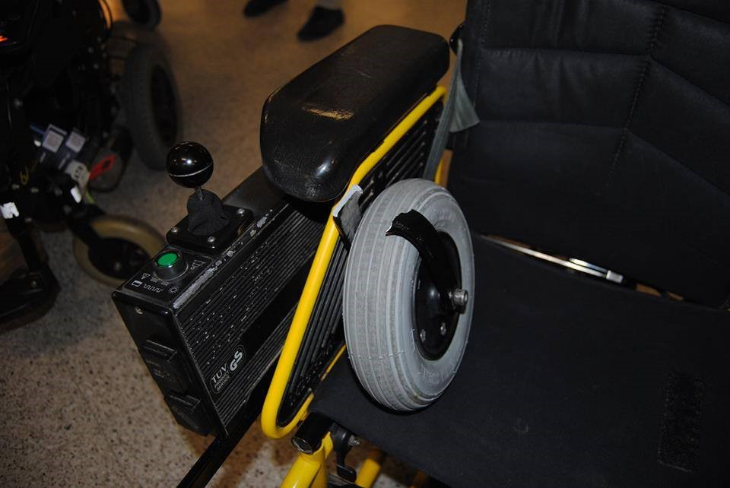
Damaged or destroyed assistive equipment

Mobility equipment is crucial for passengers with reduced mobility. While in the majority of EU Passenger Rights Regulations (rail, bus and boat), transport operators are liable for 100% of the cost of any mobility devices that are damaged during the trip, the same does not apply to air travel.

In air transport, the legislation that regulates it relies on the Montreal Convention, which foresees a basic compensation for damaged or destroyed luggage of around 1500 EUR). This value does not even begin to cover the replacement of most wheelchairs – not to mention the enormous inconvenience, curtailing of rights and other high cost faced by passengers with disabilities whose mobility equipment becomes damaged or unusable.
Damaged wheelchair
Sharm-El-Sheikh to Brussels
When they asked us at the Sharm-El-Sheikh airport to flatten the back of my electric wheelchair, I started to worry. I knew my custom-made wheelchair was going into the hold as luggage. When I arrived, the back of my wheelchair was broken. I could not sit. I was stuck laying down in my wheelchair. I could not see anything. I could not manoeuvre my wheelchair. Just to be taken home in a taxi, we had to improvise support with my luggage — dizzying and dangerous. My independence was taken away and I had to pay to get it back. According to EU law, airlines are allowed consider wheelchairs as luggage, and airlines' legal liability is limited to up to €1,500 - otherwise people travelling with a wheelchair can pay a surcharge to create a "Special Declaration of Interest" (I was once quoted €890 for a round trip). It is left to persons with disabilities to cover the rest. So, I shouldered the cost and hoped for reimbursement — which I still haven't received.

Nadia Hadad, EU Observer, 2 January 2023

Damaged wheelchair
Flight from Beirut (EgyptAir)
In late June 2019, Gordon Rattray of the European Disability Forum had his wheelchair damaged on an EgyptAir flight from Beirut, Lebanon. After several weeks and an e-mail exchange with EgyptAir’s customer service, the company offered him to pay for about 50% of the repair costs for his wheelchair. As of August 2019, his further requests for full compensation had remained unanswered.

Gordon Rattray, Twitter, 2 July 2019

Damaged wheelchair
Copenhagen to Keflavik, Iceland
“On 5 September 2021 I flew from Copenhagen airport to Keflavik, Iceland. When I arrived, my wheelchair was badly damaged and looked like it had fallen from a great height. The wheels of the wheelchair were functioning, however the damage made it painful to sit in. When I tried to register the damage with the airline, I was told that I would have to wait 8 to 10 weeks before they handled my complaint. The national aviation authorities sent me a message, subtly questioning whether I might have made the damage myself and stating they would pay according to the Montreal convention, which is 1/10 of the actual wheelchair cost. The travel insurance company would not cover the cost of the wheelchair, as it is owned by local authorities.
Part of my job is to travel, but for more than three months that has not been possible due to a damaged wheelchair.”

Sif Host, EDF Accessibility Discrimination Database, 5 September 2021

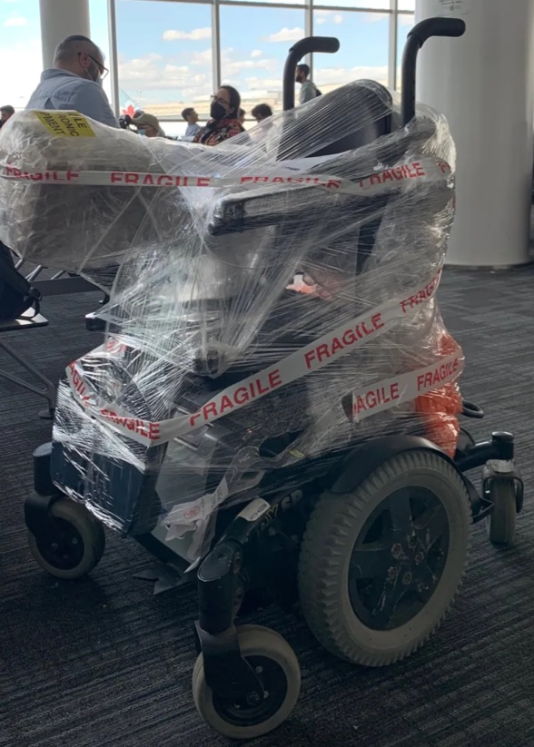

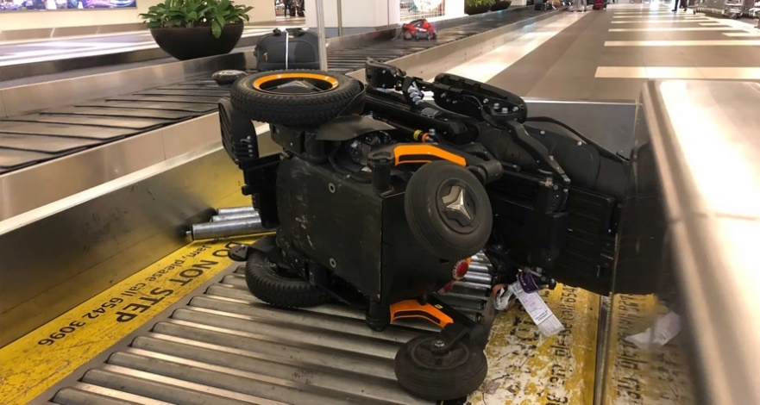

Obligation to travel with an accompanying person
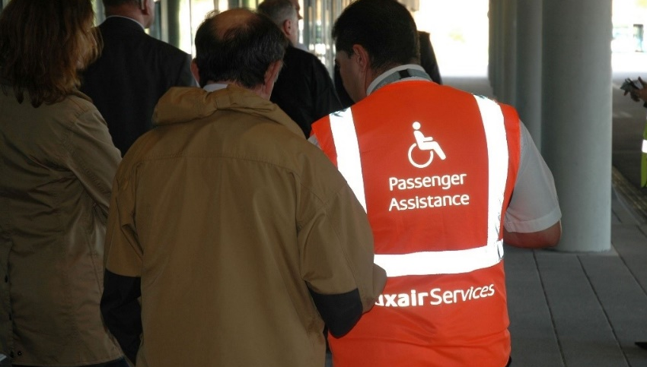

To comply with safety requirements, airlines can request passengers with disabilities to travel with an accompanying person. Unlike on other transport modes, in air travel passengers with disabilities who are required to travel accompanied are responsible for purchasing the additional ticket and can therefore incur very high costs. Additionally, the regulation gives airlines the power to decide who needs to be accompanied without any clear guidelines or verification, increasing the cases denied boarding.

Lack of free personal assistance
Flight to New York (Brussels Airlines)
“In January 2019, I was planning a trip to New York with Brussels Airlines. Because of his disability, he had to buy a wider seat in business class. As tickets to business class are very expensive, to save money I had planned to buy an economy class ticket for my personal assistant in the row right behind the curtain, at an additional cost. However, Brussels Airlines denied my request, stating that my personal assistant must sit next to me.”

E-mail to EDF, 17 January 2019

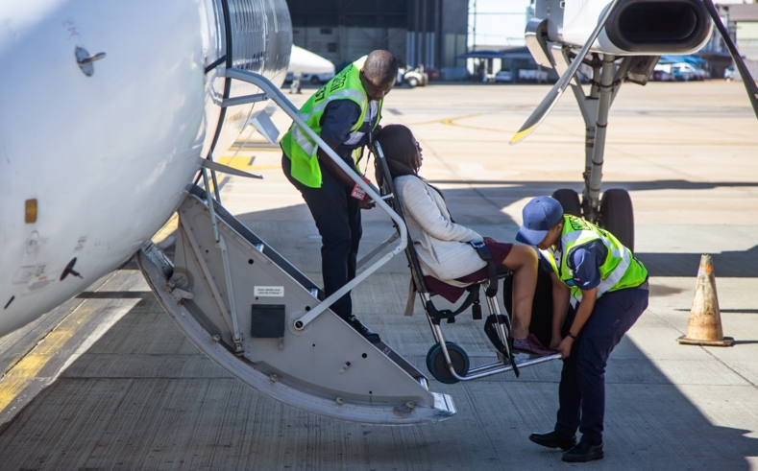
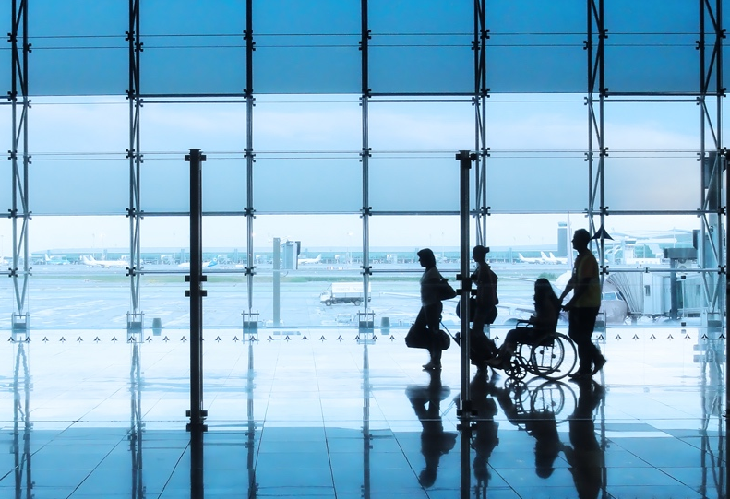

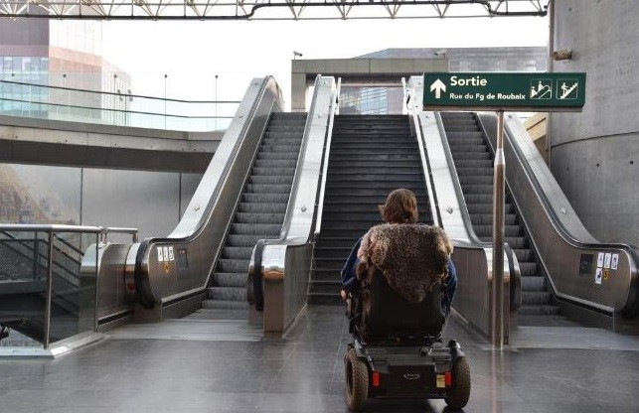

Lack of quality assistance

The provision of free-of-charge, quality assistance is a key enabler for the right of passengers with disabilities to travel on equal conditions as others. However, poor quality and unavailability of this assistance can affect the traveler's capacity to travel comfortably. It even leads to miss flights. Adequate pay and work conditions, training for assistance staff, sufficient resources and quality of assistance equipment are necessary investments to preserve the health and safety of the passengers, as well as their right to travel independently.

Denied assistance
San Francisco-Warsaw-Munich (Lufthansa)
“I ordered mobility assistance a month before my journey. I received it in San Francisco and Warsaw but nobody showed up to help me during my connecting flight to Munich International Airport. The transit between terminals requires climbing the stairs for a long walk”.

EDF Discrimination Database, January 2023

Denied assistance
London Gatwick to Dublin (Ryanair)

“On 9 May I booked on a Ryanair flight from London Gatwick to Dublin and the flight left at 14.50. Ryanair were advised at the time of booking that I required assistance. At the departure gate myself and three other people also requiring assistance were put into a minibus by a driver who was assisting us. She drove the minibus as close as she could to the aeroplane, then left the minibus and it was some minutes before she returned. As she returned, she took us back to the departure area for passengers with disabilities, and we were told that our booking had changed and we were being moved on the 21:00 flight Aer Lingus flight to Dublin”.

EDF Discrimination Database, 5 September 2019

Lack of quality assistance
Flight to Tromso, Norway
“I was changing between planes. Airport staff tried to reassemble my wheelchair for the layover and, to do so, they jammed bolts into place, which made it difficult to disassemble the chair again for the next flight.
As a result, when we arrived in Tromso, I was left for half an hour waiting outside, at the top of a flight of stairs, at -1 degrees, as ground staff attempted to reassemble my chair”.
EDF Discrimination Database, 14 December 2021

Delayed assistance
Milan Linate to Brussels Zaventem (Brussels Airlines)
I was travelling from Milan Linate to Brussels Zaventem on a Brussels Airlines flight. As usual, I had requested special assistance one week before my trip. When I landed in Brussels Zaventem, me and another passenger who had requested special assistance had to wait for over 30 minutes to be disembarked, long enough to delay the flight after ours, and after several calls from the flight’s personnel and pilot. When assistance arrived, they were not aware that the people to disembark were in fact two.

E-mail to EDF, 4 October 2018

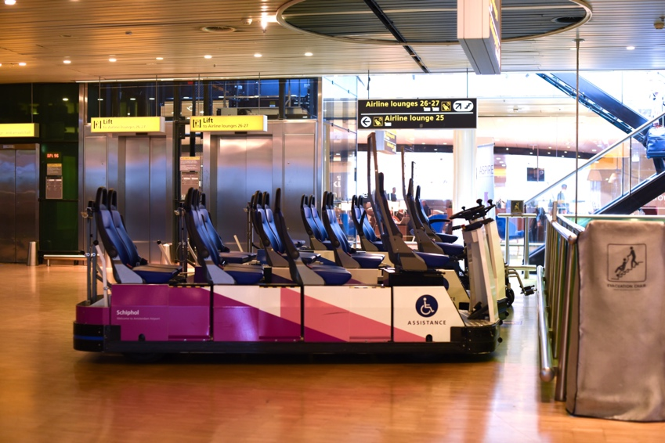
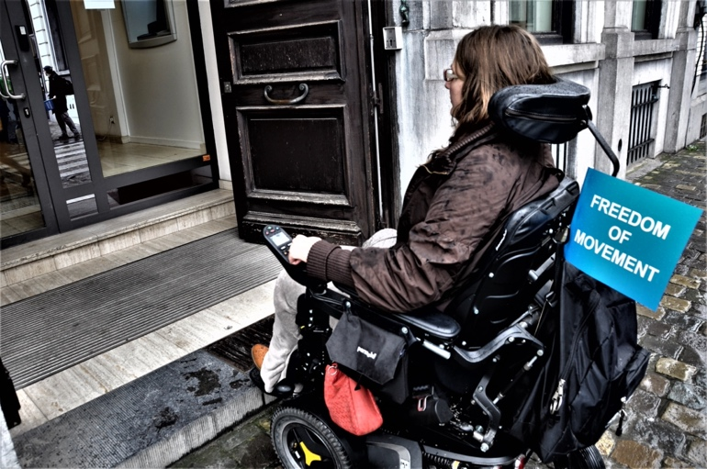

European Disability Forum
Avenue des Arts 7-8, 1210 Brussels, Belgium
Email: info@edf-feph.org
Follow us: @MyEDF
More at: edf-feph.org

Regulation 261/2004 on compensation and assistance for delay, cancelation and denied boarding, already provides for this for the other categories of passengers who are denied boarding. EDF believes that persons with disabilities should be entitled to the same right.
The evaluation of regulation 1107 explains that ‘safety rules of airlines vary significantly, and they are often difficult to find and interpret (in particular those related to the transport of batteries of mobility equipment, electric wheelchairs and oxygen) leaving PRM exposed to the risk of denied boarding. In general, PRM are unlikely to be able to research applicable safety legislations and airline rules comprehensively, or to assert their rights with confidence at the gate given this level of information asymmetry For more information, check the 2021 COMMISSION STAFF WORKING DOCUMENT EVALUATION of Regulation (EC) No 1107/2006 of the European Parliament and of the Council of 5 July 2006 concerning the rights of disabled persons and persons with reduced mobility when travelling by air - https://ec.europa.eu/info/law/better-regulation/have-your-say/initiatives/11896-Air-passenger-rights-people-with-disabilities-reduced-mobility-evaluation-_en

