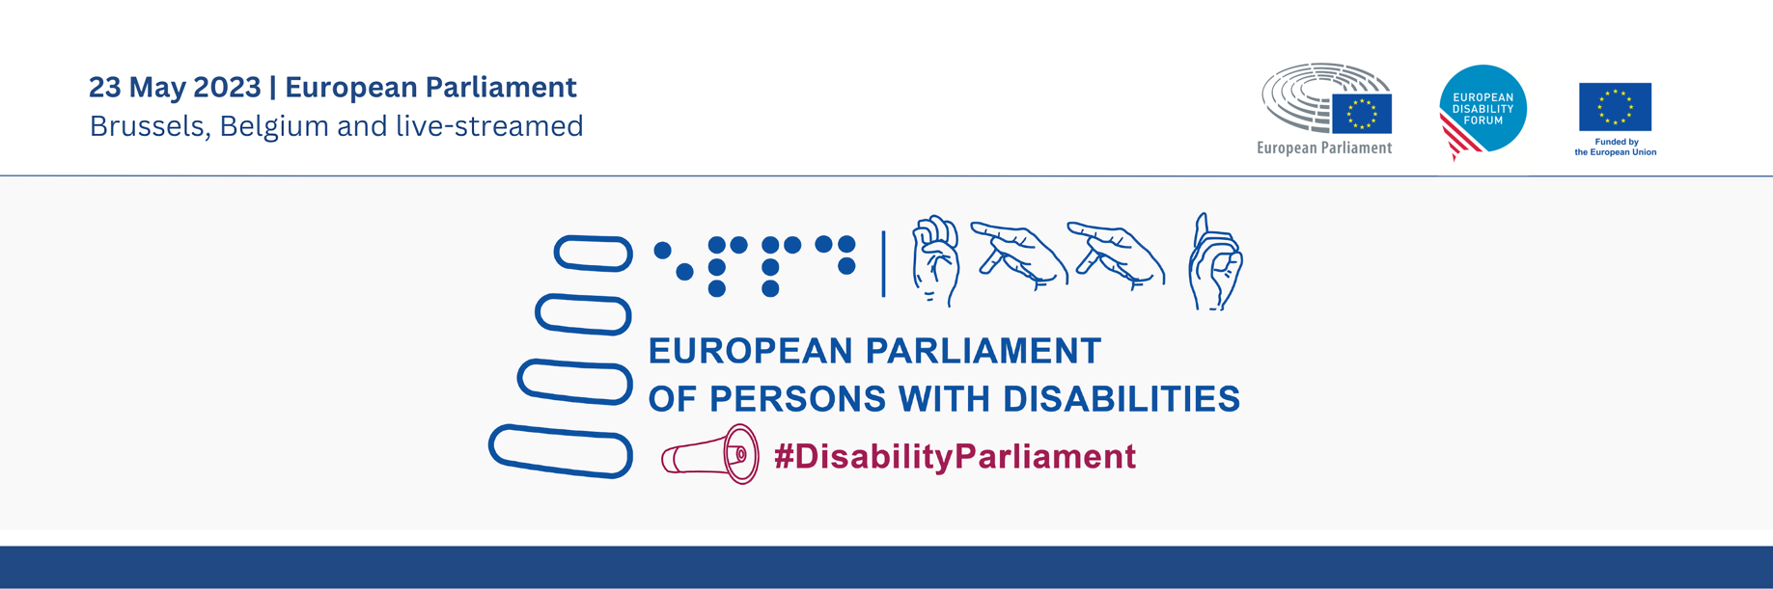

5th European Parliament of Persons with Disabilities
“Building an inclusive future for persons with disabilities in the EU”

Tuesday 23rd May 2023
09:00 – 18:30 CET (Brussels time)
European Parliament Hemicycle | Brussels

Speakers include:
- Roberta Metsola, President of the European Parliament
- Yannis Vardakastanis, President of the European Disability Forum (EDF)
- Vera Jourová, European Commission Vice President Values and Transparency
- Helena Dalli, European Commissioner for Equality
- Janez Lenarčič, European Commissioner for Crisis Management
- Karine Lalieux, Minister of Pensions and Social Integration, Belgian Federal Government
- Julia Farrugia Portelli, Maltese Minister for Inclusion, Voluntary Organisations and Consumer Rights
- Emilly O’Reilly, European Ombudsman
- MEP Dragoș Pîslaru, chair of the European Parliament’s Employment and Social Affairs Committee
- MEP Katrin Langensiepen, chair of the CRPD network
- Valerii Sushkevych, Head of the National Assembly of Persons with Disabilities (NAPD), Ukraine
- Tamara Byrne, self-advocate for persons with intellectual disabilities, representing Inclusion Europe and the EDF Youth Committee
- Carlos Susias, President of the European Anti-Poverty Network
- Paola Albrito, Director of the United Nations Office for Disaster Risk Reduction
- Markus Schefer, member of the UN Committee on the Rights of Persons with Disabilities

Agenda

09:00 – 09:30 Introduction by the European Parliament’s Visitors Programme

09:30 – 10:00 Official opening
- Roberta Metsola, President of the European Parliament
- Yannis Vardakastanis, President of the European Disability Forum (EDF)

10:00 – 11:00 Breaking barriers - free movement and full participation

Co-chaired by MEP Salvatore De Meo, chair of the Constitutional Affairs Committee, and Humberto Insolera, EDF executive committee member
Speakers:
- Vera Jourová, European Commission Vice President Values and Transparency
- Emilly O’reilly, European Ombudsman
- Karine Lalieux, Minister of Pensions and Social Integration, Belgian Federal Government
- Julia Farrugia Portelli, Maltese Minister for Inclusion, Voluntary Organisations and Consumer Rights
- Martin Conway, member of the Irish Senate and vice chair of the Advisory Panel on political participation of persons with disabilities, Office for Democratic Institutions and Human Rights, Organisation for Security and Cooperation in Europe

11:00 – 11:30 Break

11:30 – 12:25 Plenary debate 1
Interventions by Members of the European Parliament and delegates of the European disability movement

12:25 – 12:30 Adoption of EDF Manifesto on the 2024 European elections
Speakers:
- Yannis Vardakastanis, President of EDF
- Alexandre Gomez, Conseil Français des personnes Handicapées pour les affaires Européennes et internationales (CFHE) and EDF Youth Committee member

12:30 – 14:00 Lunch break - for official delegates and MEPs only

14:00 – 15:00 Fighting for our rights - combating inequality, social exclusion and poverty
Chaired by MEP Marc Angel, Vice President of the European Parliament, and Nadia Hadad, EDF Executive Committee
Speakers:
- Helena Dalli, European Commissioner for Equality
- Tamara Byrne, self-advocate for persons with intellectual disabilities, representing Inclusion Europe and the EDF Youth Committee
- Carlos Susias, President of the European Anti-Poverty Network
- Tamás Kádár, Co-Director of Equinet
- Markus Schefer, member of the UN Committee on the Rights of Persons with Disabilities

15:00 – 16:00 Plenary debate 2
Interventions by Members of the European Parliament and delegates of the European disability movement

16:00 – 16:30 Break

16:30 – 17:15 Disability-inclusive resilience
Co-chaired by MEP Katrin Langensiepen, chair of the CRPD network, and Gunta Anca, EDF Vice-President

Speakers:

- Janez Lenarčič, European Commissioner for Crisis Management
- Valerii Sushkevych, Head of the National Assembly of Persons with Disabilities (NAPD), Ukraine
- Paola Albrito, Director of the United Nations Office for Disaster Risk Reduction
- Idriss Maïga Alzouma, Chairperson, African Disability Forum (ADF) and Second Vice-President of the International Disability Alliance (IDA)

17:15 – 18:00 Plenary debate 3
Interventions by Members of the European Parliament and delegates of the European disability movement

18:00 – 18:30 Concluding remarks
- Dragoș Pîslaru, chair of the European Parliament’s Employment and Social Affairs Committee
- Pat Clarke, EDF Vice President

Background

The European Parliament of Persons with Disabilities (EPPD) is a one-day event that reunites roughly 700 disability advocates, policymakers and other stakeholders. It is co-hosted by the European Parliament and the European Disability Forum (EDF), in Parliament’s plenary Chamber.

The 5th EPPD will conclude the 25th anniversary of EDF, which was created to bring together representative organisation of persons with disabilities from across Europe to build a strong, united voice for the 100 million Europeans with disabilities. EDF works to ensure that decisions concerning persons with disabilities are taken with persons with disabilities, through their active involvement in policy and decision-making. This is the basis of the motto ‘nothing about us without us’.

The conference does just this; It serves as a platform to discuss the rights of persons with disabilities and to decide on the political demands of the European Disability Movement. It achieves this by fostering dialogue between Members of the European Parliament, EU decision makers and delegates of diverse organisations of persons with disabilities.

Rationale

Emphasising the spirit and objectives of the Conference on the Future of Europe, the 5th EPPD is truly a timely event. Ahead of the 2024 European elections, it aims to highlight enduring issues of accessibility, as preconditions to full and independent political and civic participation.

Alongside the EU’s second review by the CRPD Committee, the event aims to foster discussion on the greatest threats to the rights of persons with disabilities and how, despite the lack of progress in certain areas, there is still hope for positive change in the near future.

Finally, against a backdrop of intersecting natural, political and public health crises, the event will facilitate a deep dive into the rights and inclusion of persons with disabilities in humanitarian action and crisis management.

In the face of all these challenges, the 5th EPPD is an opportunity to move forward as a united European community. Only by bringing persons with disabilities to the decision-making table can we build an inclusive and resilient Union.

Rules of Proceeding

The EPPD aims to foster a dialogue between delegates of organisations of persons with disabilities and EU policy-makers, including Members of the European Parliament. Therefore, each of the three main sessions include a ‘plenary debate’. These debates will use rules of procedure similar to those governing European Parliament plenary sessions: lists of speakers will be agreed and allocated in advance of the event. The organisers will ensure that the speakers’ lists will be inclusive of the most marginalised persons with disabilities - women and young people with disabilities, people with intellectual or psychosocial disabilities, and people in need of high-level support. The sessions will be co-chaired by Members of the EDF Executive Committee and Members of the European Parliament.

Practical information

- Spoken Interpretation in 22 official EU languages and Ukrainian; Maltese and Gaelic not available
- International Sign interpretation
- Velotypist (speech-to-text) in English
- Livestreaming in accessible format on the European Parliament TV (www.europarl.europa.eu/ep-live)
- Meeting documents available in English, Easy To Read and Braille

