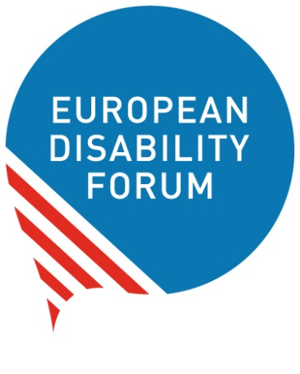

What we ask
people who make decisions in Europe
to do for people with disabilities

Our manifesto on the European elections

Easy-to-read version
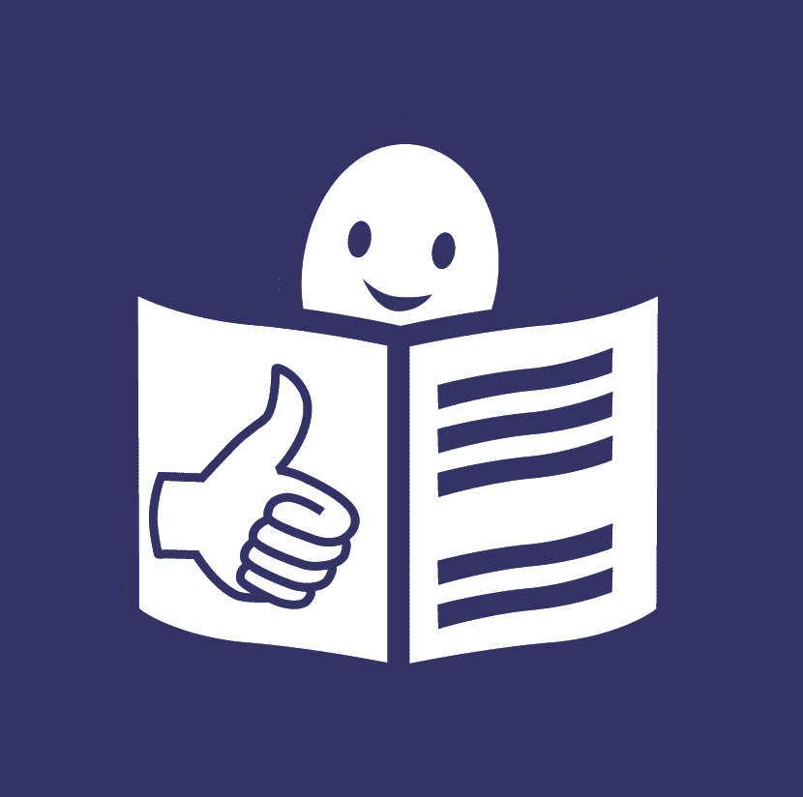
Easy-to-read is information
that is written in a simple way
so that all people can understand it.
You can find more information
about easy-to-read at:
www.inclusion-europe.eu/easy-to-read.

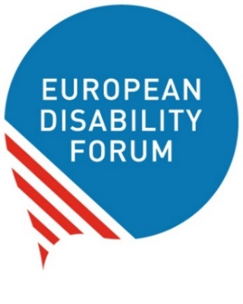
Who we are
We are the European Disability Forum.
We are an organisation
of people with disabilities in Europe.
In short, we are called ‘EDF’.
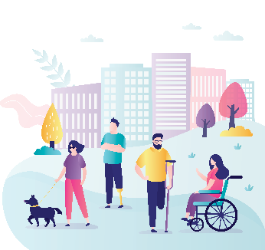
At EDF, we work to protect the rights
of all people with disabilities in Europe.
We think that people with disabilities
should have the same chances in life
and be part of the community
like everyone else.

What this booklet is about
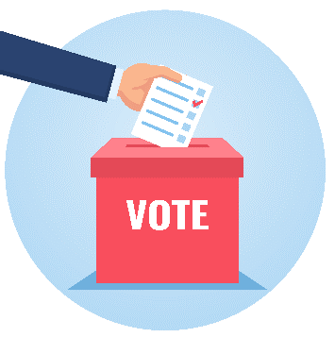
In 2024, there will be European elections.
In the European elections,
people who live in the European Union
vote who they want to make laws and decisions
in Europe.
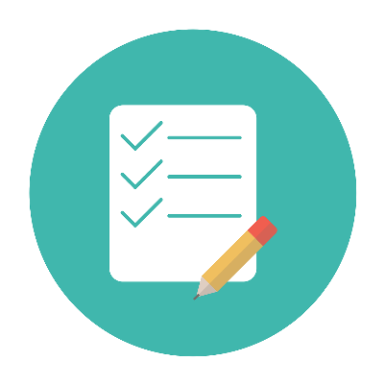
With the European elections coming next year,
we prepared a list with the things we want people who make laws and decisions in Europe to do
for people with disabilities.
We call this list
‘Manifesto on the European elections’.
In the next few pages of this text,
you will read the list of things we ask
people who make laws and decisions in Europe
to do for people with disabilities.
The difficult words in the text are marked in bold
and you can find their explanation
at the end of this booklet on page 9.

What we ask people who make decisions in Europe
to do for people with disabilities
Amongst others, we ask people who make laws and decisions in Europe to:
- Make the UN Convention happen in Europe.
They should take into account
all the rights of the UN Convention
in every law and decision they make.
- Have teams of people that work specifically
on the rights of people with disabilities
in all the offices and bodies of the European Union.
- Make sure that people with disabilities
can take part in the European elections.
People with disabilities should have
the right to vote and stand for elections.
Their voice counts like everyone else’s! 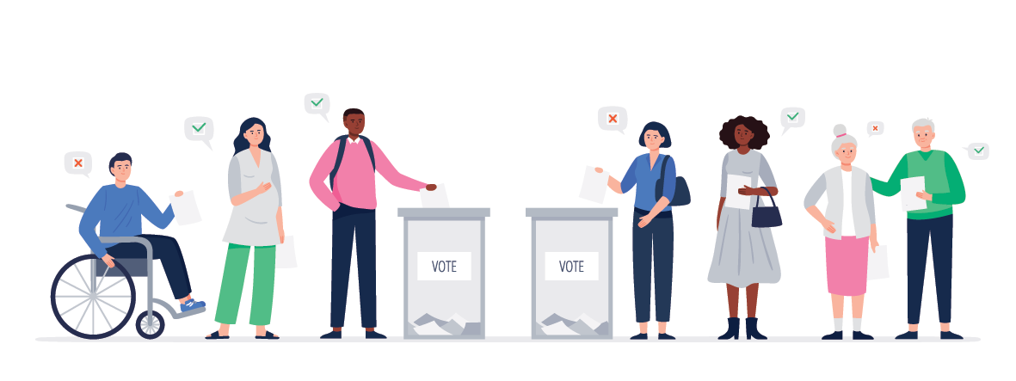
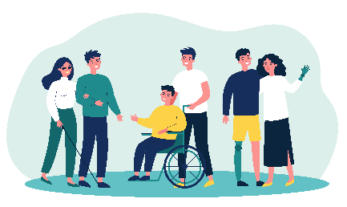
- Give people with disabilities the right support
to be able to live independently
and make their own choices in life.
People with disabilities should have the right to decide where, how and with whom
they want to live.
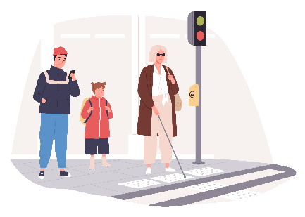
- Make things and services in Europe accessible
and create an office that works specifically
to make this happen.
For example:
  - Streets, buildings, trains and buses
should be accessible
so that people with disabilities
can get around without problems.
  - Information should be easy to read
so that people with intellectual disabilities
can understand it.
  - Books should be accessible
so that blind people can read them.
- Check how they are getting on
with the European Disability Strategy.
People who make decisions in Europe
should make sure they do their best
to make the goals of the Strategy happen
by 2030.
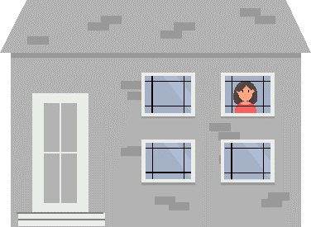
- Collect useful information and numbers
about people with disabilities in Europe.
For example, it is important to know
how many people with disabilities
still live in institutions
and how things are for them.
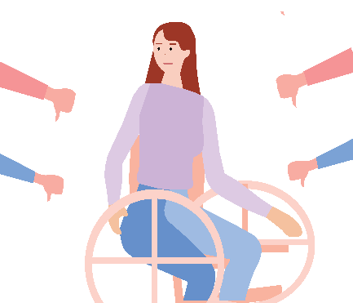
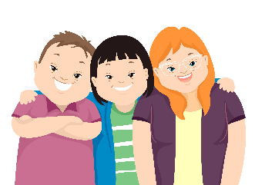
- Protect the rights of women with disabilities.
Women with disabilities are at high risk
of being treated badly or unfairly.
They may also be forced
to have an operation that makes it
impossible for them to have children.
This needs to stop.
- Protect the rights of children with disabilities
and give support to them and their families.
- Make sure that people with disabilities
have the same chances
to study and grow their skills
like everyone else.
- Support the right of people with disabilities
to work.
This can be by:
  - Giving trainings
to people with disabilities
so that they can learn new skills,
  - Making workplaces accessible
so that people with disabilities
can work there too,
  - Making sure everyone who works
gets a fair salary.
- Protect the rights of people with disabilities
who are at even higher risk of being left out.
For example:
  - People with intellectual disabilities,
  - People who have more than 1 type
of disability.
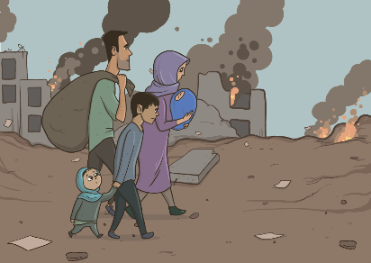
- Support refugees with disabilities
and people who are unsafe in their countries.
For example,
people with disabilities in Ukraine
where there is war right now.
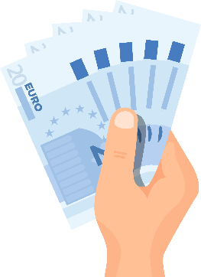
- Make sure countries in Europe
use the money they get
from the European Union
to make things better
for people with disabilities.
- Make it possible for people with disabilities
to move freely in the European Union.
This can happen by:
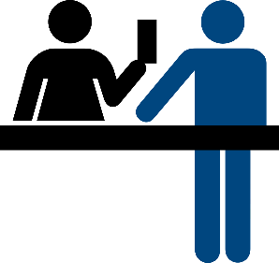
  - Making sure the European Disability Card
is used by all countries in Europe
to make a difference in the lives
of people with disabilities.
  - Giving support to people with disabilities
to be able to travel by plane, train
or other types of transport
without problems.

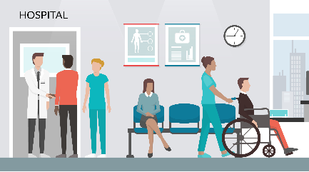
- Make sure people with disabilities
can get good health care
when they need to go to the hospital
or see a doctor.
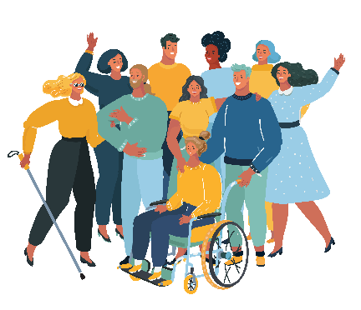
- Protect the right of people with disabilities.
to be in a relationship, marry
and have children,
if they want to.
- Spread the word about the rights
of people with disabilities.
People with disabilities
should not be looked down by others
or have fewer chances in life
because they have a disability.
- Listen to people with disabilities
and their organisations
when making laws and decisions
about their lives.
Nothing should be decided about us
without us!

Explanation of difficult words

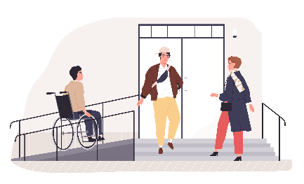
Accessible
Things are accessible
when they are easy to use
for people with disabilities and all people.
For example, when buildings have ramps
that people in wheelchairs can use to get in.
Or when information is easy to read
and people with intellectual disabilities
can understand it.

European Disability Card
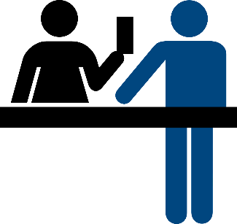
The European Disability Card
is a card that people with disabilities
can use when they visit or live in another country
of the European Union.
Thanks to this card,
countries can recognise their disability
and give them some advantages
in culture, sports and other activities.
For the moment,
only a few countries in the European Union
use this card.

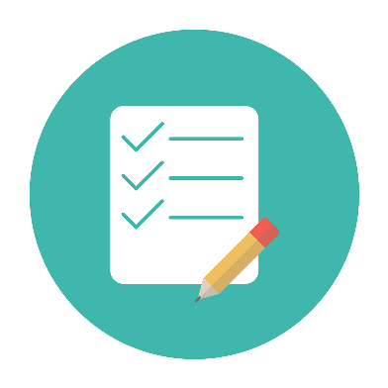
European Disability Strategy
The European Disability Strategy
is a plan that says
how the European Commission will work
to protect the rights of persons with disabilities
from 2021 until 2030.

European elections
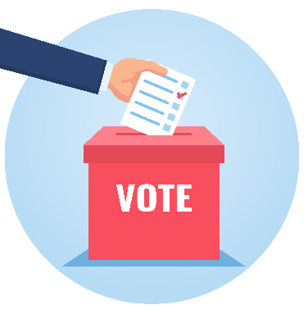
Every 5 years,
the people who live in the European Union
vote who they want to be Members
of the European Parliament.
The members of the European Parliament
are called ‘MEPs’, in short.
MEPs make important decisions
and speak for all the people
of the European Union.
The next European elections will be in 2024.

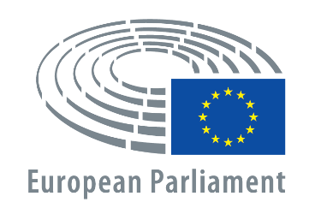
European Parliament
The European Parliament is a place where important laws of the European Union
are decided.

European Union
The European Union is a group of 27 countries in Europe. These countries came together
to make things better, easier and safer for people.
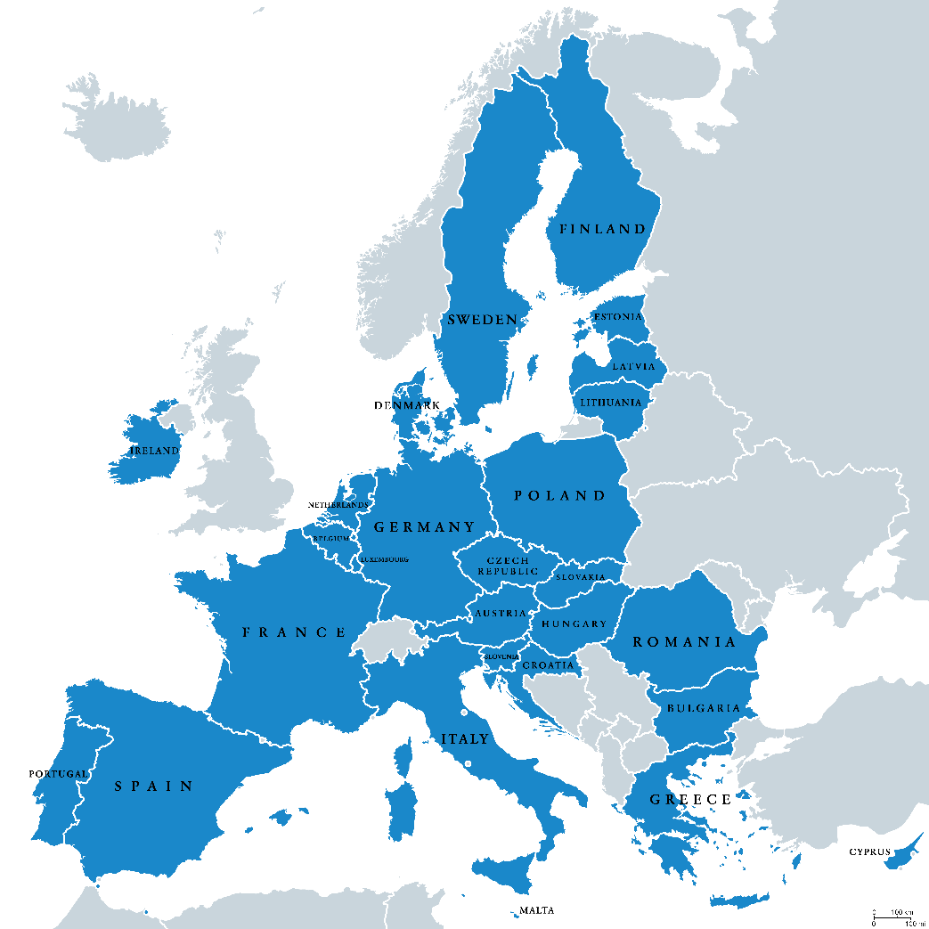

Institutions
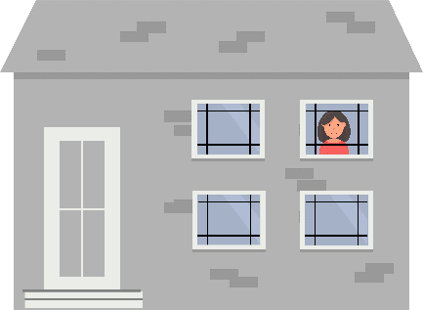
Institutions are places
where people with disabilities often live
away from other people
and from the community.
Often people who live in institutions
must follow the rules of the institution
and cannot decide for themselves.

Manifesto on the European elections
This is a list of things
we want people who make laws
and decisions in Europe
to do for people with disabilities.

Refugees
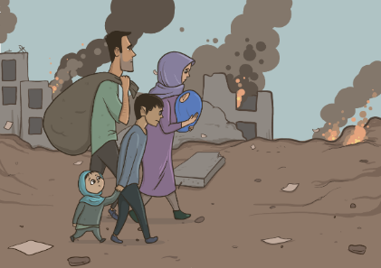
Refugees are people
who leave their countries and their homes
because it is not safe for them
to live there anymore.
For example,
they may have war in their countries
and their lives may be in danger.
In recent years,
many refugees have come to Europe
hoping for a better life.

The right to vote and stand for elections
To vote in the elections means
you can choose which people
will represent you
and make decisions and laws
in Europe.
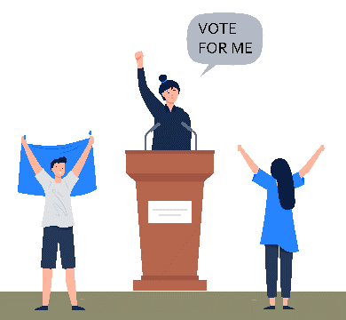
To stand for elections means
you ask people to vote for you
so that you can represent them
and make decisions and laws
in Europe.

UN Convention
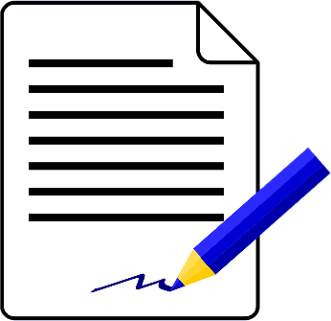
‘The UN Convention on the Rights
of Persons with Disabilities’
is an agreement that many countries in the world have signed.
It says persons with disabilities
have the same rights as everyone else.
It also says how countries
can protect these rights.
In short, we call it ‘the UN Convention’
or ‘the CRPD’.

You can find more explanation of difficult words online at: https://www.inclusion-europe.eu/easy-to-read-term/

More information
If you have any questions,
you can send us an email at: info@edf-feph.org.

Our manifesto on the European elections
Easy-to-read version
Easy-to-read is information
that is written in a simple way
so that all people can understand it.
You can find more information
about easy-to-read at:
www.inclusion-europe.eu/easy-to-read.

