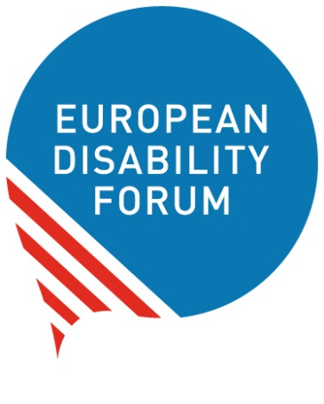

Human rights report on

The right to work
Easy-to-read version
Easy-to-read is information
that is written in a simple way
so that people with intellectual disabilities
and all people can understand it.
You can find more information
about easy-to-read at:
www.inclusion-europe.eu/easy-to-read.

Who we are
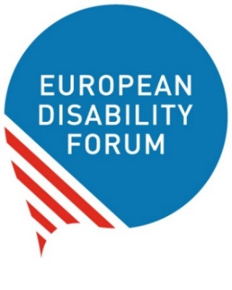
We are the European Disability Forum.
We are an organisation
of people with disabilities in Europe.
In short, we are called ‘EDF’.
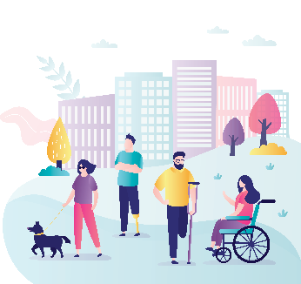
At EDF, we work to protect the rights
of all people with disabilities in Europe.
We think that people with disabilities
should have the same chances in life
and take part in the community
like everyone else.
We also think that people with disabilities
should decide about their lives.
Nothing should be decided about us
without us!

What this booklet is about
Every year, EDF makes a booklet
that talks about important rights
of people with disabilities.
We call these booklets ‘Human rights reports’.
This year, our human rights report talks
about the right to work.
In the next few pages,
you can read more about:
- What makes it hard
for people with disabilities to get a job,
- What the European Union and its countries do to promote the right to work,
- What should be done better.
All the difficult words in the text
are marked in bold
and you can find their explanation
at the end of this booklet.

The right to work
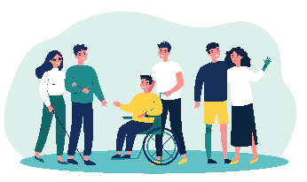
People with disabilities have the right to work
like all other people.
They should not be left out
because they have a disability.
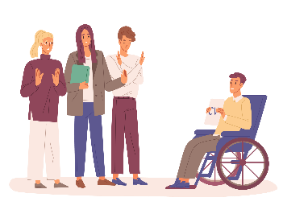
However, in practice,
almost half of people with disabilities in Europe
do not have a job.
But even people with disabilities
who have a job:
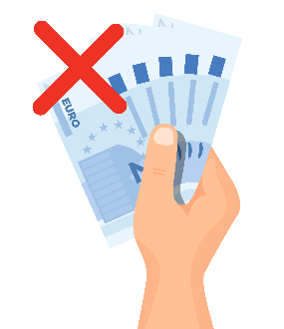
- May get a lower salary
than people without disabilities
or no salary at all.
- May get jobs only for short times.
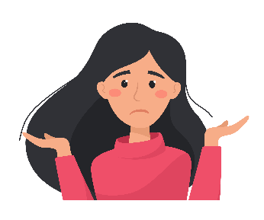
- May not be trusted to do jobs
of high skills or responsibilities.
- May be treated unfairly in their work.
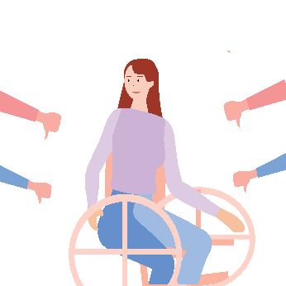
- May work in workshops
away from the community.
Things are even harder
for women with disabilities,
young people with disabilities
and people with disabilities
who need more support in their every day lives.
It is even less likely for them to get a job.
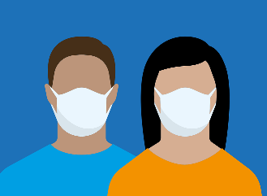
COVID-19 made things much worse.
It had a bigger impact on people with disabilities than on other people.
Due to COVID-19,
many people with disabilities lost their jobs
and struggle to earn enough money to live on.

What makes it hard or impossible
for people with disabilities to work
Many things make it hard
for people with disabilities
to enjoy the right to work like other people.
Amongst others:
- Workplaces may not meet their needs
so people with disabilities
cannot work there.
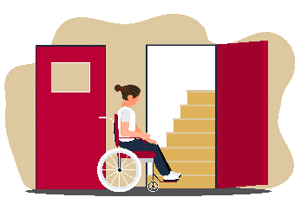
- Metros, buses, streets, buildings
and other things in the community
may not be accessible.
If things are not accessible,
people with disabilities cannot use them
to get around like other people.
- Other people may not want to work
with people with disabilities
because they think people with disabilities
cannot do the job right.
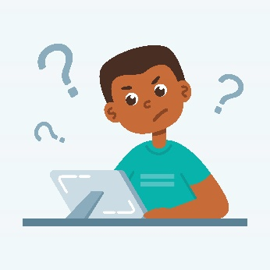
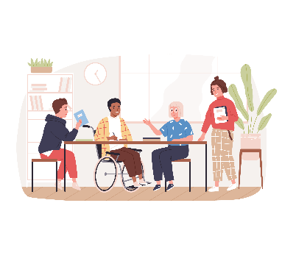
- The process and information
to apply for a job
may not be accessible.
This means that people with disabilities
will not be able to apply for this job
like other people.
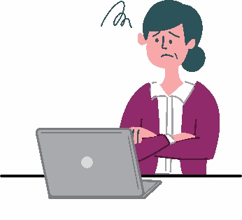
- People with disabilities
often do not have the chance
to finish school, study at university
or do trainings that will help them
grow their skills and get a job later.
- Many people with disabilities
do not have access to the internet.
If they cannot use the internet,
they will not be able to apply for jobs online like other people.
- When people with disabilities move
to another country of the European Union,
it may take a long time
before they get the support they need
to be able to live and work in this country.

What the European Union does
to promote the right to work
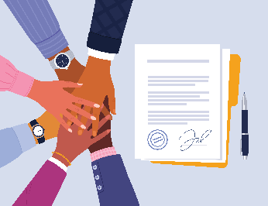
The European Union and all its countries
have signed the UN Convention.
This means they have agreed to work
to make the rights in the UN Convention happen.
Among others,
the UN Convention says
that all people with disabilities
have the right to work like other people.
So the European Union works to make sure
people with disabilities enjoy the right to work
like everyone else.
Amongst others:
- The European Union made a plan
on how they will work to protect
the right to work and other rights
of people with disabilities by 2030.
This plan is called ‘Strategy for the Rights
of Persons with Disabilities 2021-2030’.
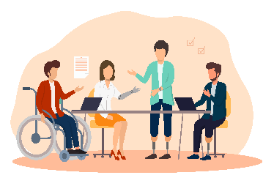
- The European Union made a law that says
that people with disabilities
should not be treated unfairly in their work.
This law also says that workplaces
should adapt to the needs
of people with disabilities.
This way, people with disabilities
could work there like everyone else.
- The European Union is working
on a new law that says
everyone who works should be paid
enough money to live on.
The aim of this law is to make sure
that people in the European Union
do not get less money than what is fair
for their work.

How countries in Europe protect
the right of people with disabilities to work
Countries in Europe take measures
to promote the right to work
for people with disabilities.
Amongst others:
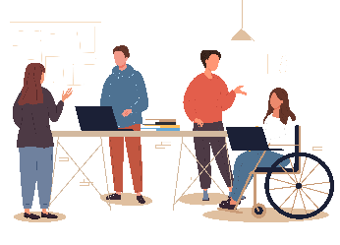
- Most countries ask workplaces
to have a minimum number
of people with disabilities working in them.
For example, 5 in 100 people
who work in them
must be people with disabilities.
- Most countries give money to workplaces
so that they can adapt to the needs
of people with disabilities.
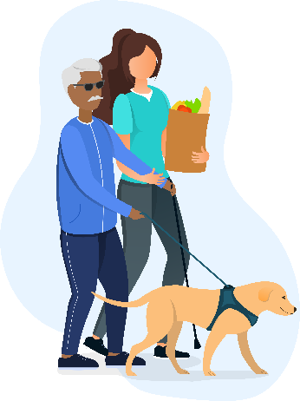
- Most countries give money
to people with disabilities
to pay for the extra costs they have
for living with a disability.
For example, they can use this money
to buy medicine and other things they need,
or pay for a support person to help them
with everyday tasks.
Sadly, many countries stop giving this money or give less of this money
to people with disabilities
when they get a job and start getting a salary.
This is unfair.
Apart from their normal salary,
people with disabilities need this extra money to pay for the extra costs of disability.

What should be done better
The work that the European Union
and its countries have done so far
to promote the right to work
is not enough.
Sadly, too many people with disabilities
in Europe
are still not able to get a job
or are treated unfairly in their work.
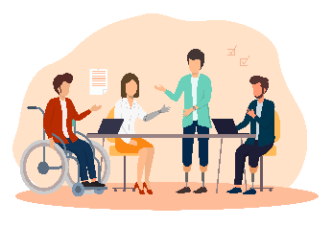
At EDF, we think that
the European Union and its countries
should work harder to make sure
that people with disabilities
have the same chance to work as other people.
Amongst others, the European Union
and its countries should:
- Make sure that
people with disabilities can get a job
and be treated fairly in their work.
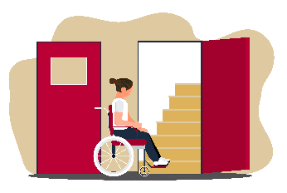
- Continue to give money
to people with disabilities when they get a job.
People with disabilities need this extra money to pay for costs they have
for living with a disability.
For example, they can use this money
to buy medicine and other things they need,
or pay for a support person to help them
with everyday tasks.
- Make sure workplaces change
to meet the needs of people with disabilities
so that they can work there like other people.
- Punish companies that do not hire people because they have a disability,
or treat people with disabilities unfairly.
This can be by making these companies
pay a fine for not respecting the rights
of people with disabilities.
- Make sure that people with disabilities
get a fair salary from their work
that allows them to have a good life.
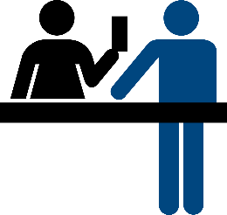
- Make a European Disability Card
that people with disabilities can use
when they move to another country
of the European Union
to get the support they need
to live and work in this country.
- Spread information about the right
of people with disabilities to work,
and how workplaces can respect this right.

More information
For more information
about EDF and our work,
you can visit our website at
www.edf-feph.org.
You can also send us an email at
info@edf-feph.org.

Explanation of difficult words

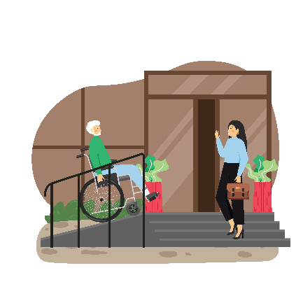
Accessible
Things are accessible when they are easy to use
for people with disabilities.
For example,
when buildings have ramps
that people in wheelchairs can use to get in.
Or when information is easy to read
and people with intellectual disabilities
can understand it.

COVID-19
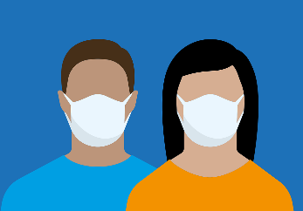
‘COVID-19’ is a disease
that can pass easily from one person to another.
Sadly, in recent years,
too many people in the world
have been ill from coronavirus.
Most of the people recover
but many people die from it.

European Union
The European Union is a group
of 27 countries in Europe.
These countries work together
to make things better for their people.
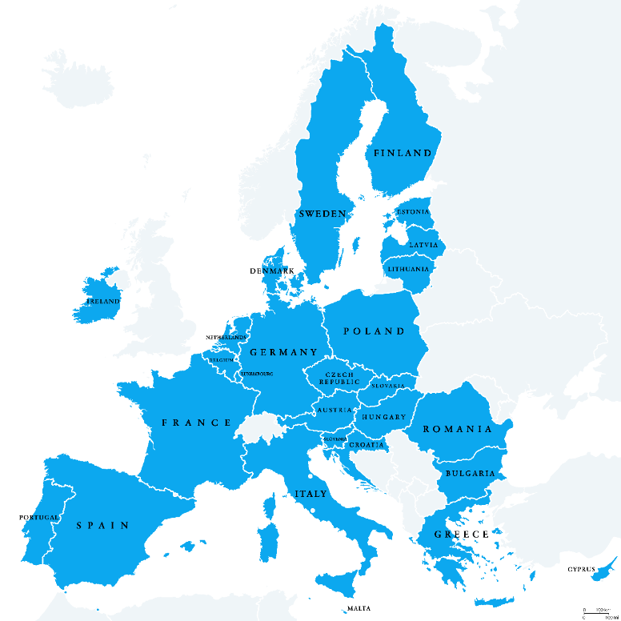

UN Convention
on the Rights of Persons with Disabilities
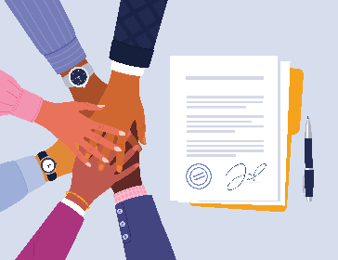
This is an agreement
that many countries in the world have signed.
It says what rights people with disabilities have
and how countries can protect these rights.
In short, we call it ‘the UN Convention’
or ‘the CRPD’.
You can find more explanations of difficult words at: https://www.inclusion-europe.eu/easy-to-read/#explanations.

