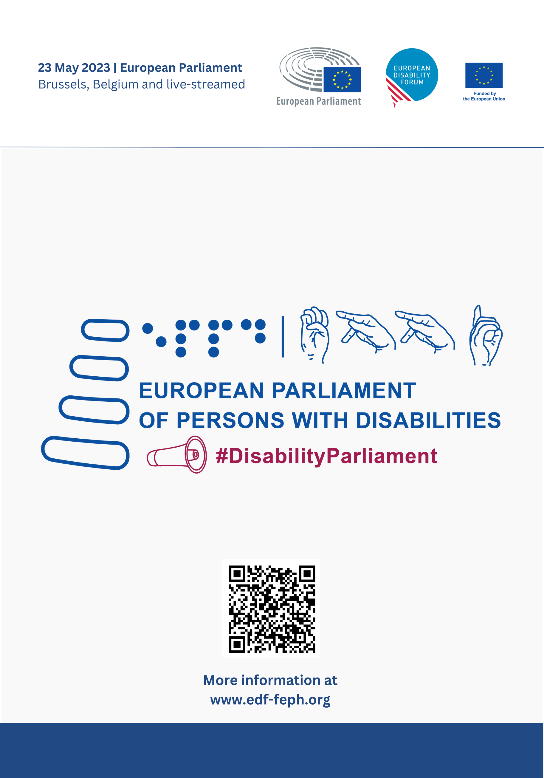

Guide of the Day

Content

Introduction 3
Event “App” 4
Links to download the app in your device: 4
You can also scan the following QR codes: 4
Agenda 5
The sessions 8
1. Breaking the barriers: free movement and full participation 8
2. Fighting for our rights: combating inequality, social exclusion and poverty 9
3. Disability-inclusive resilience 10

Introduction

Dear Delegate,

Welcome to the 5th European Parliament of Persons with Disabilities. A day where the demands of the European disability movement - your demands – will be brought directly to some of the most important European decision-makers.

The European Union (EU) has the power to improve our lives and protect our rights. But it can only do so due to the activism and advocacies of its citizens. The ratification of the UN Convention on the Rights of Persons with Disabilities, the Web Accessibility Directive, the European Accessibility Act and the upcoming proposal for an EU Disability Card were only possible because of your advocacy. This is why I want to thank you for your presence at this important event, which allows the European disability movement to show its united front and demonstrate to policymakers that we are here, and we deserve full equality.

This is also why I ask you to support us in adopting our manifesto. In it, we call for an inclusive future for persons with disabilities in the EU, with five key areas:

- Guarantee the participation of persons with disabilities in the political and public life of the EU.
- Realising a Union of Equality for persons with disabilities with the CRPD as its compass.
- Becoming a more social Europe.
- Embracing accessibility – allowing free movement in Europe.
- Protecting persons with disabilities in Europe and beyond.
A united movement is a strong movement. This is why we also encourage you to meet and connect with delegates from other countries during the breaks and lunch.

Nothing about us without us!
Yannis Vardakastanis,
President of the European Disability Forum

Event “App”

The European Parliament developed a digital mobile application “EP events” for its large-scale events – it is available on Google Play and Apple Store.

This app will be used for the European Parliament of Persons with Disabilities.

There, you will find the Wi-Fi code, updated agendas, information on the sessions, floor plans, relevant digital publications, accreditation information.

The app is available on Google Play and the Apple Store.

- You should have received an e-mail with instructions to download and also a unique and individual 8-digit code.
- You must download the app and then, use the code to have access to the event information.

Links to download the app in your device:

- Google Play
- Apple Store

You can also scan the following QR codes:
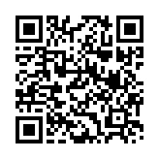
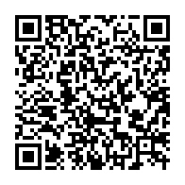
Scan to download the app on Apple Store
Scan to download the app on Google Play

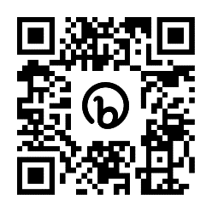
Agenda

You can find the final agenda with updated list of speakers on the event app and on our website.
Scan the QR code to consult the agenda on your phone.

09:00 – 09:30 Introduction by the European Parliament’s Visitors Programme

09:30 – 10:00 Official opening
- Roberta Metsola, President of the European Parliament
- Yannis Vardakastanis, President of the European Disability Forum (EDF)

10:00 – 11:00 Breaking barriers - free movement and full participation

Co-chaired by MEP Salvatore De Meo, chair of the Constitutional Affairs Committee, and Humberto Insolera, EDF executive committee member.
Speakers:
- Vera Jourová, European Commission Vice President Values and Transparency
- Emilly O’reilly, European Ombudsman
- Karine Lalieux, Minister of Pensions and Social Integration, Belgian Federal Government
- Julia Farrugia Portelli, Maltese Minister for Inclusion, Voluntary Organisations and Consumer Rights
- Martin Conway, member of the Irish Senate and vice chair of the Advisory Panel on political participation of persons with disabilities, Office for Democratic Institutions and Human Rights, Organisation for Security and Cooperation in Europe
11:00 – 11:30 Break

11:30 – 12:25 Plenary debate 1
Interventions by Members of the European Parliament and delegates of the European disability movement.
12:25 – 12:30 Adoption of EDF Manifesto on the 2024 European elections
Speakers:
- Yannis Vardakastanis, President of EDF
- Alexandre Gomez, Conseil Français des personnes Handicapées pour les affaires Européennes et internationales (CFHE) and EDF Youth Committee member

12:30 – 14:00 Lunch break - for official delegates and MEPs only

14:00 – 15:00 Fighting for our rights - combating inequality, social exclusion and poverty
Chaired by MEP Marc Angel, Vice President of the European Parliament, and Nadia Hadad, EDF Executive Committee.
Speakers:
- Helena Dalli, European Commissioner for Equality
- Tamara Byrne, self-advocate for persons with intellectual disabilities, representing Inclusion Europe and the EDF Youth Committee
- Carlos Susias, President of the European Anti-Poverty Network
- Tamás Kádár, Co-Director of Equinet
- Markus Schefer, member of the UN Committee on the Rights of Persons with Disabilities
15:00 – 16:00 Plenary debate 2
Interventions by Members of the European Parliament and delegates of the European disability movement.

16:00 – 16:30 Break

16:30 – 17:15 Disability-inclusive resilience
Co-chaired by MEP Katrin Langensiepen, chair of the CRPD network, and Gunta Anca, EDF Vice-President
Speakers:
- Janez Lenarčič, European Commissioner for Crisis Management
- Valerii Sushkevych, Head of the National Assembly of Persons with Disabilities (NAPD), Ukraine
- Paola Albrito, Director of the United Nations Office for Disaster Risk Reduction
- Idriss Maïga Alzouma, Chairperson, African Disability Forum (ADF) and Second Vice-President of the International Disability Alliance (IDA)

17:15 – 18:00 Plenary debate 3
Interventions by Members of the European Parliament and delegates of the European disability movement

18:00 – 18:30 Concluding remarks
- Dragoș Pîslaru, chair of the European Parliament’s Employment and Social Affairs Committee
- Pat Clarke, EDF Vice President

The sessions

Breaking the barriers: free movement and full participation

During this session, we will discuss how full and independent participation of persons with disabilities in society can become a reality. Our participation is greatly shaped by our means to access the physical environment, transportation, information and digital technologies, and this is why the United Convention on the Rights of Persons with Disabilities (UNCRPD) recognizes accessibility as a tool to guarantee equal opportunities and enjoy full rights and freedoms.

Even if free movement of persons is one of the core values of the European Union, persons with disabilities still face many barriers to studying, travelling or working abroad.

Similarly, European Citizens with disabilities still face obstacles to enjoying their right to vote and to stand as candidates in municipal and European elections on an equal basis with others.

This session will focus on:
- Poor accessibility of transport and the built environment.
- Lack of recognition of one’s disability between EU Member States.
- The upcoming proposal for the creation of an EU Disability Card.
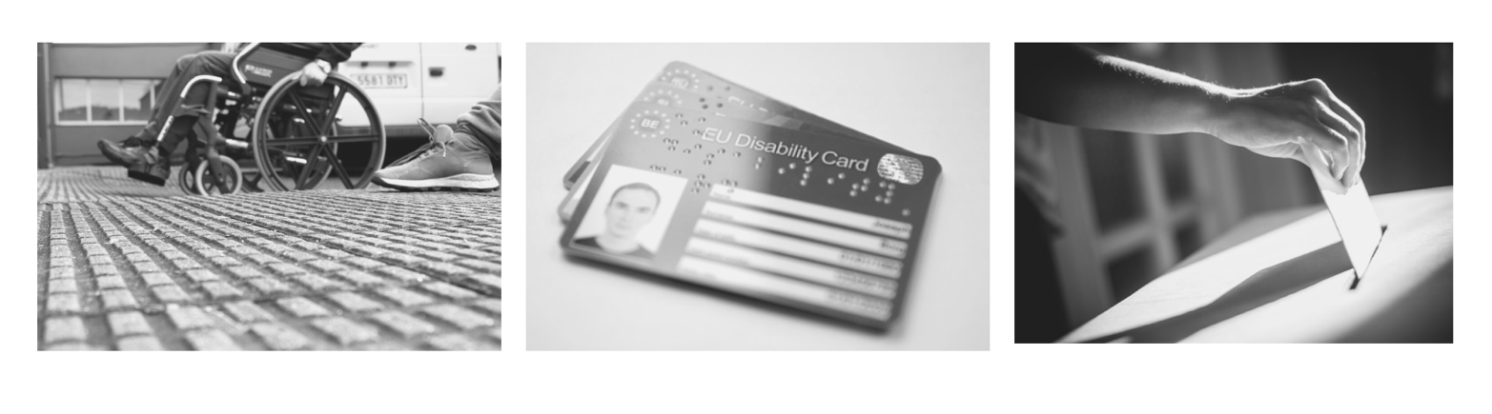
- Policies supporting participation in political and public life.

Fighting for our rights: combating inequality, social exclusion and poverty

This second panel will look at issues caused by the barriers and lack of inclusion of persons with disabilities.

We will discuss:
- The growing problem of poverty
- Social exclusion
- Increased cost of living
- Independent living
- Inclusion in education and in the labour market

Throughout the discussion of these topics, we will discuss why certain groups, such as women and girls with disabilities and persons with high support needs, are particularly impacted.

We will look at solutions to these problems and what commitments policymakers can make to finally put an end to them.

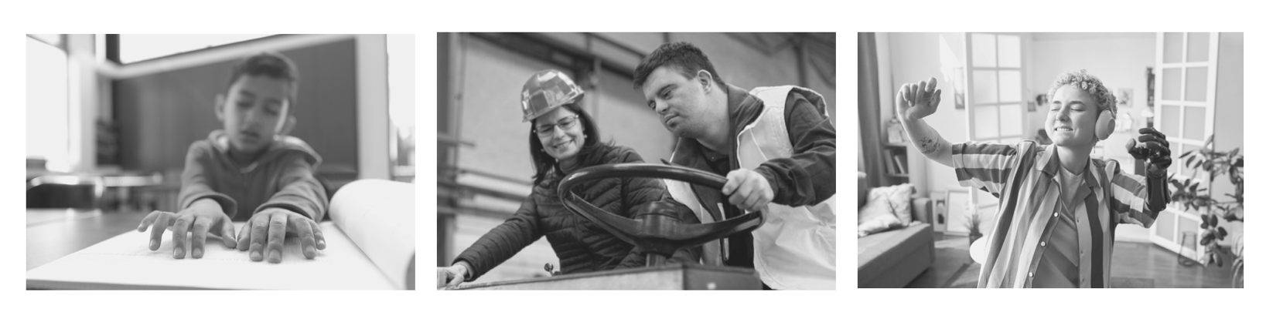

Disability-inclusive resilience

When disaster strikes, we repeatedly see that persons with disabilities are among those most impacted and least involved. They are missed out during evacuations. Emergency shelter, transport, and life-saving aid are often inaccessible. Disability inclusion is still seen as something for specialised organisations, with the result that humanitarian aid doesn’t reach them.
This panel will discuss the impact of these challenges during humanitarian crises on persons with disabilities. It will look at how prepared countries are regarding disability inclusion in emergency response and how involved persons with disabilities need to be in this work.
This panel will discussed:
- The COVID-19 pandemic
- The ongoing Russian aggression of Ukraine
- Inclusion of persons with disabilities in emergency preparedness
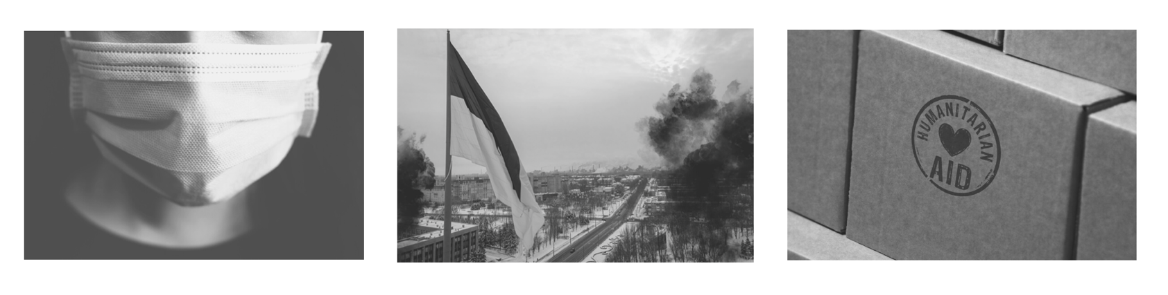
- Commitments at international level on disability-inclusion and the role of the international disability movement

