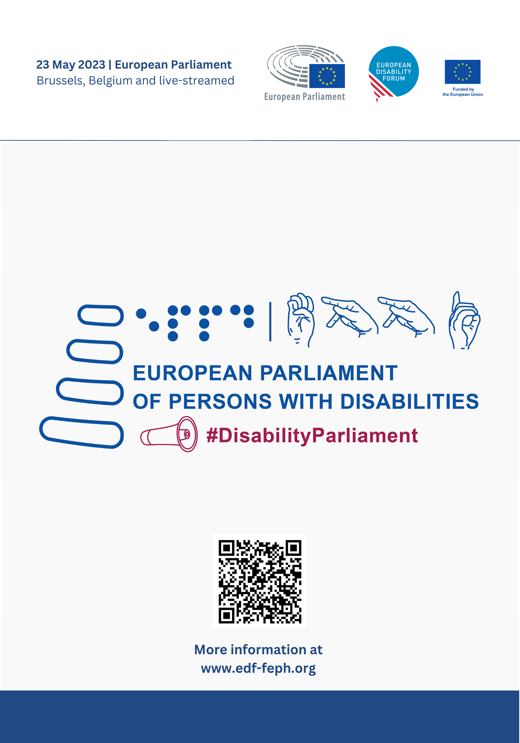

Practical information and logistics
Contents
Venue and accommodation 2
How to get there 2
Accreditation 3
Accessibility and interpretation 5
Meals 5
Useful documents and agenda 5
Livestream 6
European Parliament event App 7
Reimbursement of expenses 7
Contacts 8
Tourism in Brussels 8

Venue and accommodation

Accommodation has been booked by participants to the European Parliament of Persons with Disabilities. A list of recommended accessible hotels has been shared in EDF dedicated page.
The event will take place in the Hemicycle at the European Parliament from 09:00 to 18:30 CET (Brussels time).
All regular participants will enter through the main entrance, the Simone Veil entrance facing Place du Luxembourg, after having completed the accreditation at the Info Hub (next to the entrance).

How to get there
We advise taking public transport, where possible, in line with our green policy. It is also possible to take taxi or Uber taxi from the airport to the hotel and return.
The official taxis will be waiting for you when you leave the arrivals hall. You can recognize an official taxi by the T- license plate and the blue-yellow symbol at the front of the taxi. For more information please check on the dedicated page of Brussels Airport.
By Train
Brussels-Luxembourg serves the European Parliament.
More information available in SNCB Website.
By Bus
Lines 22, 27, 34, 38, 64, 80 and 95 all stop at the European Parliament. Lines 12 and 21 also connect to Brussels Airport.
By Metro
The nearest stops are Maelbeek and Schuman on lines 1 and 5, and Trone on lines 2 and 6.
More information in STIB-MIVB Website.

Accreditation
Accreditation, signature of attendance and distribution of access badges will take place at the Info Hub (see indications on the map below) on May 23rd 2023 from 07:00 to 12:00 CET (Brussels time).
Please note that all participants signatures will be compulsory to attest your attendance to the event. Desks will be organized following alphabetical order in the Info Hub.
After signing the attendance list and accrediting your participation all participants will be given an access badge and a lanyard.
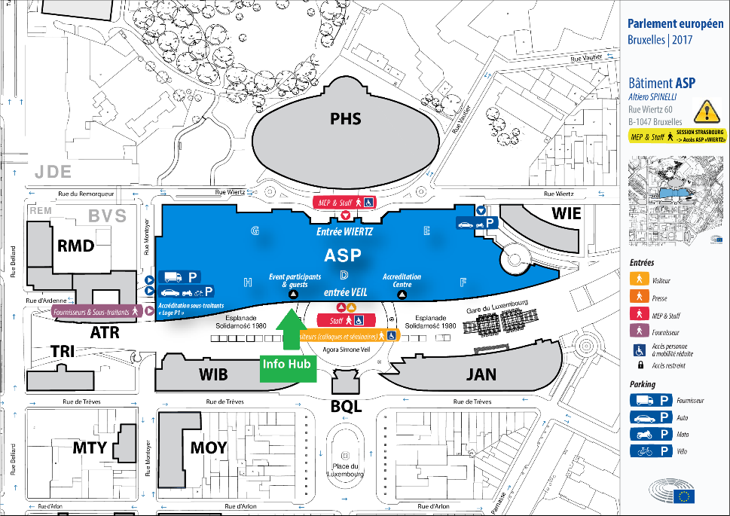
Please note that it takes at least 20 minutes to complete the security check and to arrive to the Hemicycle where the event will start at 09:00 CET (Brussels time).
All participants:
- Are required to show a valid passport or ID card before entering the building. The document needs to be the same one indicated in the registration form, otherwise access to the Parliament will not be approved.
- Are required to undergo security controls at the entrance area.
- Are advised to carry the invitation letter or any other document clearly indicating their participation to the event.
- Are requested to bring as little luggage as possible in order to facilitate and speed up the security checks.
- Are advised to prepare your belongings before the security control point: remove your coat, scarf and hat; remove your belt, jewellery and keys; prepare your phone, computer and other electric devices.
- Please arrive as early as possible.
Participants must ensure that their access badge is clearly visible throughout their stay at the European Parliament.
Upon arrival to the Hemicycle, all participants will be seated according to their delegations indicated spots. Ushers will be available at the entrance and will help everyone in finding their seats.

Accessibility and interpretation
- Spoken Interpretation in 22 official EU languages and Ukrainian; Maltese and Gaelic not available.
- International Sign interpretation.
- Velotypist (speech-to-text) in English.
- Speech-to-text in 22 official EU languages and Ukrainian (Maltese and Gaelic not available) available through this Text-On-Tap link. Please be aware that in order to access the real-time automatic captions in other languages you will need to bring your own device and there are no plugs available so bring your power banks if needed.
- Livestreaming in accessible format on the European Parliament TV (www.europarl.europa.eu/ep-live).
- Meeting documents available in English, Easy To Read and Braille.
- Induction loops available

Meals
On Tuesday 23rd May, lunch will be provided from 12:30 to 14:00 CET (Brussels time) at the Yehudi Menuhin space for all participants to the European Parliament of Persons with Disabilities.
Coffee breaks will be provided for participants at the Hemicycle Bar from 11:00 to 11:30 CET and from 16:00 to 16:30 CET.
There is no dinner foreseen on Tuesday 23rd May.

Useful documents and agenda
All useful links, documents and agenda are available in EDF dedicated page for the European Parliament of Persons with Disabilities.
- Agenda (Word and PDF)
- Guide of the day (Word and Easy to read versions)
- Manifesto (Word and Easy to read versions)
- Communication package (PPT)
Additionally, an Info Desk with printed documents will be placed in front of the Hemicycle. Limited copies of the following will be available:
- Braille version of the Guide of the day
- Braille version of the EDF Manifesto for the European Elections 2024
- Human Rights Report 2023 – Right to work
- Human Rights Report 2022 – Political Participation
- Human Rights Report 2021 – COVID
- Human Rights 2020 – Poverty and Social Exclusion
- Human Rights Report 2019 – Equality and non-discrimination
- Forced Sterilisation
- Riga declaration

Some publications from the European Parliament Research service (not affiliated with the European Disability Forum) will be available:
- Towards equal rights for persons with disabilities
- Russia's war on Ukraine: People with disabilities
- Political participation of persons with disabilities
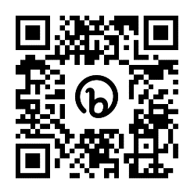
Scan the QR code to consult the agenda on your phone.

Livestream
The event will be streamed live in accessible format via the European Parliament’s multimedia centre

European Parliament event App
The European Parliament developed a digital mobile application “EP events” for its large-scale events – it is available on Google Play and Apple Store. This app will be used for the European Parliament of Persons with Disabilities.
There, you will find the Wi-Fi code, updated agendas, information on the sessions, floor plans, relevant digital publications, accreditation information.
The app is available on Google Play and the Apple Store.
- You should have received an e-mail with instructions to download and also a unique and individual 8-digit code.
- You must download the app and then, use the code to have access to the event information.

Links to download the app in your device:

- Google Play
- Apple Store

You can also scan the following QR codes:
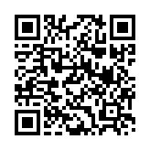
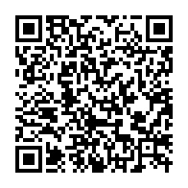
Scan to download the app on Apple Store
Scan to download the app on Google Play

Reimbursement of expenses
Only applicable to the delegations sponsored by the Visitor’s Program of the European Parliament:
The reimbursement will be received after the process set up by the European Parliament. After the event, the head of delegation will gather the documents from the whole delegation and will fill in the European Parliament reimbursement form. The EP will examine the documents received and, if accepted, will send the global reimbursement to the head of delegation that will redistribute the money received to the members.
The delegation coordinator will need to gather all invoices, complete the financial report and send it to the Service, maximum 30 days after the visit. After that, the service will pay the amount of money to which the delegation is entitled and that is adequately justified.
For the European Parliament of Persons with Disabilities, the Visitor’s Programme will finance: 2 nights of stay per persons; travel cost of 9 cents/KM – train or plane (lowest class); 400€ for other costs for the whole group; and 400€ per person for disability-related costs.
The Visitors Programme reimburses 110€ per night per single occupancy and 220€ for double occupancy. For an accessible room you can cover the difference from the disability budget.

Contacts
- Logistics: Raquel Riaza
- Delegations: Loredana Dicsi
- Agenda and contact with Members of the European Parliament: Alejandro Moledo
- Communications: André Félix

Tourism in Brussels
If you would like to visit Brussels in your free time, please find here some useful links:
- https://be.brussels/culture-tourism-leisure/brussels-for-all?set_language=en
- https://www.visit.brussels/en/visitors

