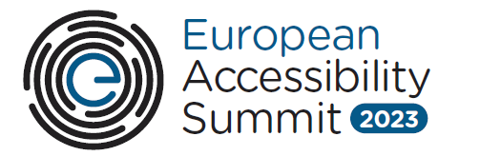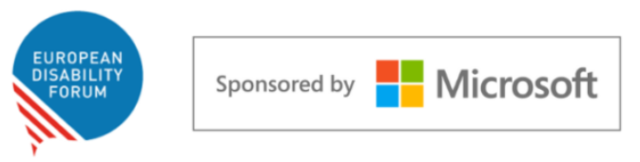

European Accessibility Summit 2023:
The future of digital accessibility: technology that works for all

Date and Time: 8 June 2023
Location: Hybrid (registration link) & Microsoft forum, Rue Montoyer 51, 1000 Brussels (in-person participation upon invitation only).

Draft agenda:

Time | Agenda item
09:30 – 10:00 | Registrations and breakfast
10:00 – 10:10 | Introductory remarks  - Nanna-Louise Linde, Vice President, European Government Affairs, Microsoft  - Catherine Naughton, Director, European Disability Forum (EDF)
10:10 – 10:20 | Welcome remarks  - Video message from Nicolas Schmit, European Commissioner for Jobs and Social Rights
10:20 – 11:20 | Designing devices for all  - Tommy Zonnekein, Accessibility Program Manager, SNCB  - Radha Gohil, Data Ethics and Digital Standards Lead, Shell  - Gurpreet Kaur, Vice President, Accessibility and Inclusive Design, Mastercard  - Ali Dehghanpour, Design Lead, Zettle by PayPal  - Anna Drabarz, Board member, European Disability Forum (EDF)  Moderator: Lissa Shook, Assistant General Counsel, Accessibility Regulation, Privacy and Regulatory Affairs, Microsoft
11:20 – 11:40 | Break
11:40 – 12:00 | The uptake of accessibility in Europe: Perspectives from Microsoft and EDF  Jenny Lay-Flurrie, Chief Accessibility Officer, Microsoft and Alejandro Moledo, Deputy Director, European Disability Forum (EDF)
12:00 – 13:00 | Seamless and accessible communication and information  - Bianca Prins, Global Head of Accessibility, ING  - Tom Van Den Bosch, Chief Product Officer, itsme  - Jan-Jaap Hamers, Project Leader Digital Inclusion, KPN  - Lidia Best, President, European Federation of Hard of Hearing  Moderator: Rylin Rodgers, Disability Policy Advisor, Microsoft
13:00 – 14:00 | Lunch break
14:00 – 14:30 | Artificial Intelligence and Accessibility  - Hector Minto, Senior Accessibility Evangelist, Microsoft
14:30 – 15:20 | A Conversation on Standards and the AccessibleEU Center  - Inmaculada Placencia Porrero, Senior Expert in Disability and Inclusion, European Commission,  - Susanna Laurin, Chief Research and Innovation Officer, Funka  - Fernando Machicado, Stakeholder Engagement Coordinator, Spanish Association for Standardization (UNE)  - Shadi Abou-Zahra, Principal Accessibility Standards and Policy Manager, Amazon  Moderator: Alejandro Moledo, Deputy Director, European Disability Forum
15:20 – 15:40 | Break
15:40 – 16:30 | Enabling an accessible digital work environment  - Laura Davis, Chief Executive, British Association for Supported Employment (BASE)  - Bárbara Martín Muñoz, Vice President, European Blind Union (EBU)  - Daphne Nathalie Ahrendt, Senior Research Manager, Eurofound  - Bruce Roch, Global Head of Inclusion, The Adecco Group  Moderator: Nadia Hadad, Executive Committee member, European Disability Forum (EDF)
16:30 – 16:55 | Demo session on the new Microsoft Adaptive Accessories  John Helmes, Senior Designer, Microsoft
16:55 – 17:00 | Closing remarks  - Esa Kaunistola, Director, Microsoft  - Catherine Naughton, Director, European Disability Forum (EDF)
17:00 – 18:00 | Networking reception in Brussels

