Save the date - #COSP16 Side Event
Ending forced sterilisation of persons with disabilities and promoting sexual and reproductive rights

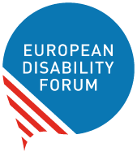
Organisers: United Nations Economic and Social Committee for Western Asia, (UN ESCWA), Malta and the European Disability Forum
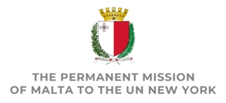
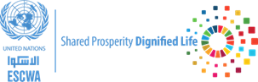

Co-sponsored by: Spain, Sweden, European Union, Women Enabled International
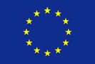
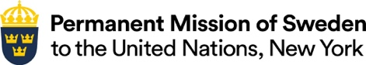

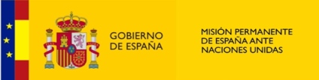
- Tuesday 13th of June, 9:45-11.00 AM EST
- UN Headquarters - Conference Room C
- International Sign interpretation and Live-captioning
Forced and coerced sterilisation of people with disabilities is a human rights violation that has been and continues to be protected as a matter of law, policy and custom throughout the world. Despite the obligations created by the UN Convention on the Rights of Persons with Disabilities (CRPD) this practice still happens, with no to little provision of accessible sexual education, measures for awareness raising and services for sexual and reproductive health.
This side-event will provide a state of play on the issue and discuss commitment and future actions to make the end of forced sterilisation of persons with disabilities a reality. Alarming instances drawn from current policy and practice will also be tackled.
This will be coupled with presentations on new knowledge, and models, including those used at domestic level, aimed at preventing people from being exposed to this form of violence, such as through legislation and policies, and measures fostering self-awareness on sexual and reproductive rights. Concrete follow-up steps to these measures will also be discussed, as well as new commitments such as a UN Resolution.

Agenda

Moderator – Anastasia Holoboff, Senior Legal Advisor, Women Enabled International
Opening remarks
- H.E. Ambassador Vanessa Frazier, Permanent Representative of Malta
- Representative of UN ESCWA (video message)
State of Play: what we know about forced and coerced sterilisation today
- Nadia Hadad, Executive member, European Disability Forum
- Sara Rocha, European Council of Autistic People
- Rosemary Kayess, Vice-Chair of the UN Committee on the Rights of Persons with Disabilities
Existing measures to combat coerced and forced sterilisation and protect the reproductive autonomy of persons with disabilities

- Spain: Jesús Martin Blanco, General Director of Rights of Persons with Disabilities, Ministry of Social Rights and Agenda 2030
- Sweden: Maria Melin, National expert, Swedish Agency for Participation
- Malta: Alistair De Gaetano, Directorate for Disability Issues
Interventions from State Parties and civil society, including organisations of persons with disabilities. (10 minutes)
Looking forward
- Helena Dalli, Commissioner for Equality, European Commission

